American University of Central Asia

REPORT

PROJECT I
Algebraic interpolation
(Interpolation by the Lagrange interpolating polynomial)

Student: Saparaliev Elzar
Program: Applied Math and Informatics
Course: Numerical methods
Instructor: Zabinyakova Olga

2026
List of the Contents

- Introduction
1.1 Background
1.2 Project Objectives
1.3 Test Functions
1.4 Parameters
- Project Description
2.1 Theoretical Foundation
2.2 Grid Generation
2.3 Software Implementation
- Analysis of Numerical Calculation Results
3.1 Function Investigation
3.2 Comparison of the Grid Types
3.3 Visual Analysis
- Conclusion
4.1 Summary of Findings
4.2 Final Remarks

Introduction

1.1 Background
Interpolation is a fundamental technique in numerical analysis that allows us to estimate values between known data points. Among classical methods of interpolation is the Lagrange interpolating polynomial that constructs a polynomial through all given points. This report serves to present the results of Project I, which was devoted to the investigation of behaviour of Lagrange interpolation for different types of functions, grid configurations, and parameter variations.
1.2 Project objectives
The primary goals of this project are:
- To implement Lagrange interpolation using the standard formula
- To compare interpolation performance (convergence/divergence) on uniform and Chebyshev grid
- To analyse the convergence properties as the number of nodes increases
- To evaluate the interpolation error and its dependence on function parameters
- To provide visual representation of the results for comprehensive analysis
1.3 Test functions
For this investigation, 5 test functions with diverse characteristics were selected:
Function index | Mathematical Expression |  | Characteristics
 | Name | View
f1(x) | function with the boundary layer near point x=0 | 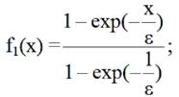 | Boundary level behavior
f6(x) | x·sin(πx/ε) | 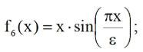 | Oscillatory with parameter-dependent frequency
f8(x) | { 0, x=0; e^(-(1-x)x/ε), 0<x≤1; 1, otherwise } | 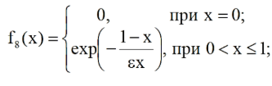 | Piecewise with exponential decay
f11(x) | “Step” function | 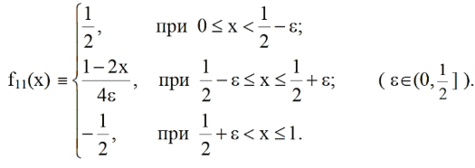 | Discontinuous derivative
f14(x) | Individually developed function | sin(4x * PI) * e^(-2x) | Decreasing oscillations

1.4 Parameters
The investigation explores:
- ε values: {0.005, 0.05, 0.5, 1.0}
- n values: {3, 9, 21, 33, 65, 135}
- Grid types: Uniform and Chebyshev
II. Project Description
2.1 Theoretical Foundation
- Lagrange Interpolation Formula:
Given n+1 data points (xᵢ, f(xᵢ)), the Lagrange interpolating polynomial is:
Pₙ(x) = Σᵢ₌₀ⁿ f(xᵢ) · Lᵢ(x)
where the Lagrange basis polynomials are:
Lᵢ(x) = Πⱼ₌₀,ⱼ≠ᵢⁿ (x - xⱼ)/(xᵢ - xⱼ)
- Interpolation Error Formula:
The interpolation error is given by:
Eᵣᵣ(f) = max_{x∈[0,1]} |f(x) - Pₙ(x)| / max_{x∈[0,1]} |f(x)|
- Neville's Algorithm:
Neville's algorithm provides a recursive method for evaluating the interpolating polynomial:
Pᵢ,ⱼ(x) = [(x - xᵢ)Pᵢ₊₁,ⱼ(x) - (x - xⱼ)Pᵢ,ⱼ₋₁(x)] / (xⱼ - xᵢ)
This approach is numerically more stable for evaluating at specific points.
2.2 Grid Generation
- Uniform Grid
xᵢ = i·h, where h = 1/(n-1), i = 0, 1, ..., n-1
- Chebyshev Grid
xᵢ = 0.5[1 - cos((2i+1)π/(2n))], i = 0, 1, ..., n-1
Chebyshev nodes are clustered near the boundaries, which helps mitigate Runge's phenomenon.
2.3 Software Implementation
The project was implemented in C# with ZedGraph for visualization.
2.3.1 Core Classes
‘lagrange’ - Implements Lagrange interpolation
‘CalculateError’: Computes various error metrics

2.3.2 User Interface Features
- Parameter selection (ε, n, function index)
- Grid type selection (uniform/Chebyshev)
- Real-time graph plotting
- Error display and scaling options

III. Analysis of Numerical Calculations Results
3.1 Function Investigation
3.1.1 Function f1(x): Boundary layer Function
Convergence at eps = 0.05 (approximate values):

n | Error (Uniform) | Error (Chebyshev)
3 | 3.63e-1 | 9.48e-2
9 | 2.76e-2 | 9.1e-3
21 | 4.79e-7 | 3.78e-9
33 | 1.77e-2 | 1.67e-15
65 | 8.75e-1 | 2.77e-15
135 | 2e+21 | 5.1e-15

Observations:
- The Chebyshev grid consistently outperforms the uniform one
- Convergence is faster on the Chebyshev grid (approx. )
- The Boundary layer at x = 0 requires more nodes for accurate resolution

On uniform grid, as number of nodes increases, as counterintuitive as it may sound, error may actually increase due to the oscillations near the sides:
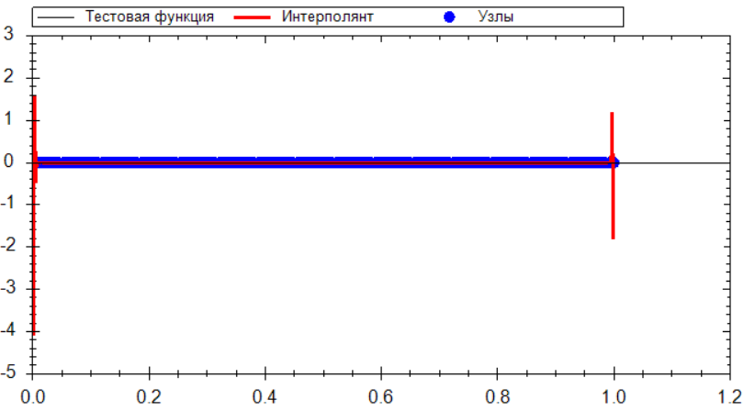
(n=135, eps=1, Chebyshev grid)

This phenomenon is called the Runge’s Effect. One way to minimize the effect is to use Chebyshev grids:
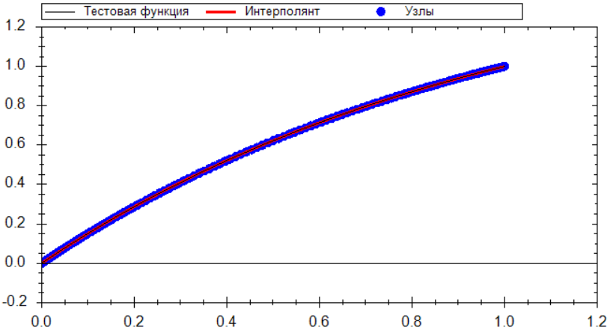
(n=135, eps=1, Chebyshev grid)
On the Chebyshev grid, the gap between nodes fluctuates, decreasing at ends of the function. That feature allows the interpolant to suffer from the Runge’ Effect to a much less degree.

3.1.2 Function f6(x): Oscillatory Function
Error Analysis for varying eps (n = 21):

eps | Error (Uniform) | Error (Chebyshev) | Notes
1.0 | 4.08e-13 | 3.6e-16 | Well-resolved
0.5 | 2.56e-13 | 7.77e-16 | Adequate
0.05 | 9.75e-1 | 1.46e+0 | Severe oscillations
0.005 | 1.46e-11 | 1.92e+0 | Complete failure

Important Observation: When eps becomes smaller than the grid spacing, the function oscillates faster than the sampling rate, which leads to increase in interpolation errors:
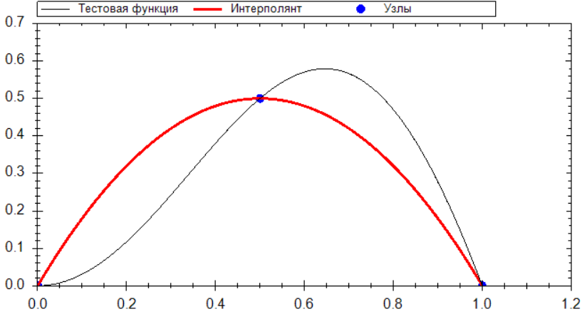
(n=3, eps=1)
Error – 1.98e - 001
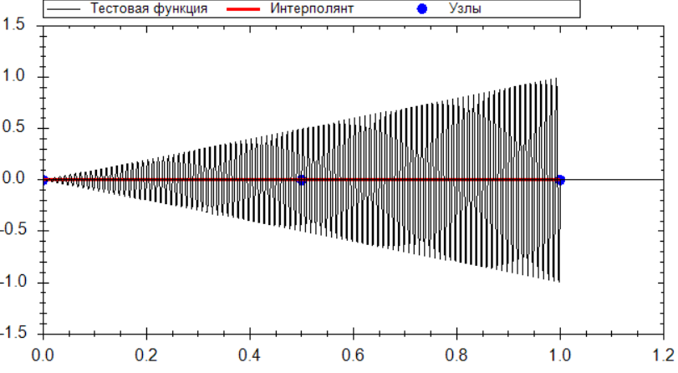
(n=3, eps=0.05)
Error – 2.13e - 014
3.1.3 Function f8(x): Exponential Decay
Convergence comparison for eps = 1:

n | Error (Uniform) | Error (Chebyshev)
3 | 3.7e-1 | 2.77e-3
9 | 1.96e-1 | 2.44e-8
21 | 1.25e-1 | 1.77e-15
33 | 9.93e-2 | 1.33e-15
65 | 8.833e-1 | 2.33e-15
135 | 1.48e+21 | 6.99e-15

In this case, both grids show good convergence, though Chebyshev maintains its advantage.

3.1.4 Function f11(x): Piecewise Linear with Transition
Error near the transition region at eps = 0.05 (values are approximate):

n | Error (Uniform) | Error (Chebyshev)
3 | 5.63e-1 | 5.63e-1
9 | 7.19e-1 | 4.46e-1
21 | 2.64e+2 | 1.91e-1
33 | 4.83e+5 | 2.33e-1
65 | 3.89e+14 | 2.41e-1
135 | 8.16e+34 | 2.57e-1

The discontinuity in the derivative causes Gibbs-like phenomena near the transition point. Chebyshev nodes help by providing higher resolution near the boundaries, which indirectly helps with the inferior transition:
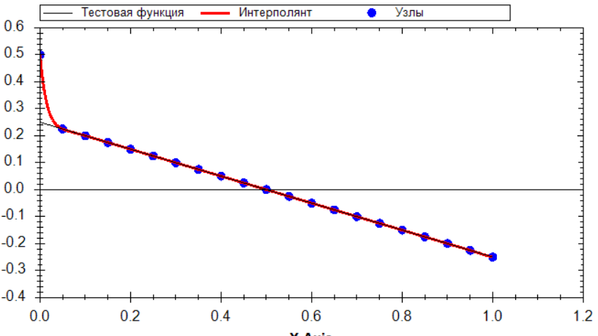
(n=21, eps=1)
3.1.5 Function f14(x): The Individually Developed Functio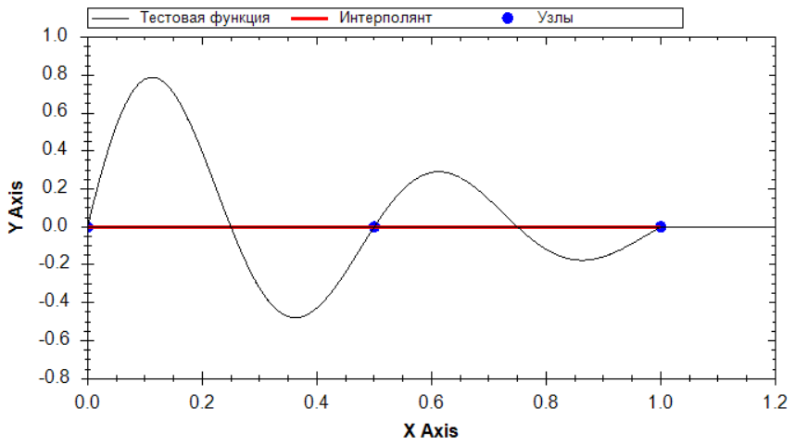
(n=3, eps=1, Uniform Grid)
Error: 1.74e-16
Similarly to function 1, this function falls victim to the Runge’s Effect:

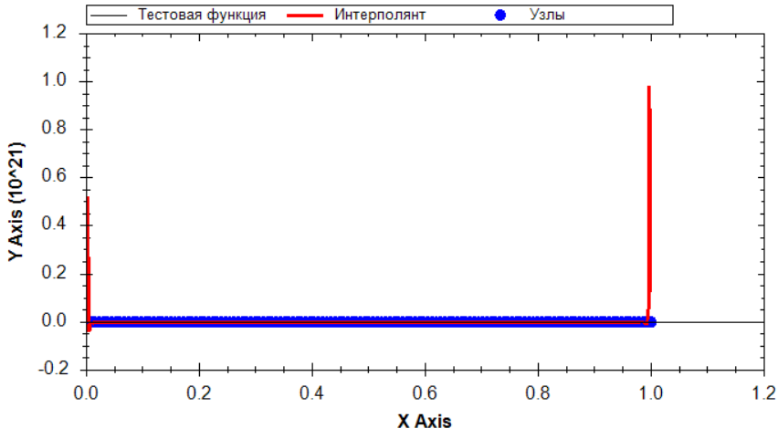
(n=135, eps=1, Chebyshev grid)
Error: 2.92e+20
And just like with other functions, this problem can be avoided by using the Chebyshev grid:
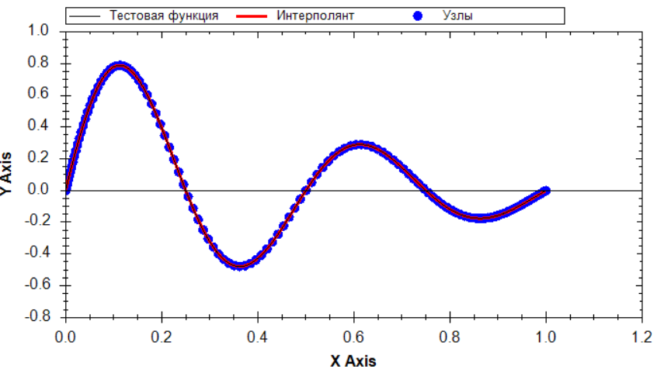
3.2 Comparison of the Grid Types
Error Ratio (eps = 1):
Uniform:
Function | n=3 | n=9 | n=21 | n=33 | n=65
f1 | 8.08e-3 | 8.19-11 | 5.18e-13 | 1.02e-15 | 3.64e-1
f6 | 1.98e-1 | 6.61e-6 | 4.08e-13 | 7.1e-10 | 9.85e-1
f8 | 3.69e-1 | 1.96e-1 | 1.25e-1 | 8.83e-1 | 1.58e+21
f11 | 9.38e-2 | 4.9e-2 | 3.13e-1 | 9.93e-2 | 1.91e-19
f14 | 1.74e-16 | 1.1e-1 | 6.08e-8 | 4.33e-1 | 2.92e-20

Chebyshev:
Function | n=3 | n=9 | n=21 | n=33 | n=65
f1 | 5.19e-3 | 2.08e-11 | 3.33e-16 | 1.22e-16 | 1.88e-15
f6 | 1.35e-1 | 1.69e-6 | 3.6e-16 | 7.77e-16 | 9.99e-16
f8 | 2.77e-3 | 2.44e-8 | 1.77e-15 | 1.33e-15 | 2.33e-15
f11 | 1.38e-17 | 1.38e-16 | 3.6e-16 | 2.5e-16 | 7.49e-1
f14 | 4.9e-1 | 2.48e-2 | 3.48e-1 | 4.44e-16 | 1.55e-15

The advantage of Chebyshev nodes becomes more pronounced as n increases, especially for functions with boundary layers or oscillations (f1, f6, f14).

3.3 Visual Analysis
Runge’s Phenomenon:
For functions with steep gradients, the uniform grid exhibits pronounced oscillations near boundaries, especially for higher n. The Chebyshev grid effectively eliminates this phenomenon.

IV. Conclusion
4.1 Summary of Findings
4.1.1 Convergence Analysis
On uniform grids:
- Convergence is observed for all test functions as n increases
- Rate of convergence depends strongly on function smoothness
- Runge’s phenomenon appears for functions with steep gradients
- The error is not monotonic for highly oscillatory functions due to aliasing
On Chebyshev grids:
- Superior convergence rates for all test functions
- Dramatically better for functions with boundary layers (f1) and oscillations (f6)
- Minimax optimal property ensures uniform error distribution
- Effectively eliminates Runge’s phenomenon

4.2 Final Remarks
In the process of developing the project, I have developed a software application implementing Lagrange interpolation, conducted systematic numerical experiments across five test functions with varying parameters of epsilon and number of nodes, and analysed convergence patterns on uniform and Chebyshev grids.
Through this work, I gained:
- Understanding of interpolation theory and the critical role of distribution
- Practical skills in C# programming and numerical algorithms implementation
- Experience in data analysis and scientific visualization
- Skill to write reports for such kind of projects
The project has demonstrated that Chebyshev grids consistently outperform uniform grids, especially for functions with steep gradients or oscillations, and highlighted the importance of matching sampling density to function variation rates. This experience has significantly enhanced my understanding of both the power and limitations of polynomial interpolation methods.

