Practical 8: MySQL Schema Design, ER Model, PDO Connectivity, and Prepared Statements
Problem Definition | Design the database for StudentHub with students, events and registrations. Create PHP database connection using MYSQL statements.
A. Theory
1. Is the schema normalized properly?
Answer: Yes. The database is designed using separate tables for students, events, and registrations to reduce redundancy.
2. Are primary keys and foreign keys correctly defined?
Answer: Yes. Primary keys uniquely identify records and foreign keys establish relationships between related tables.
3. Is the database connection handled securely?
Answer: Yes. PHP PDO and prepared statements can be used to handle database connections and queries securely.
B. Implementation / Output / Result
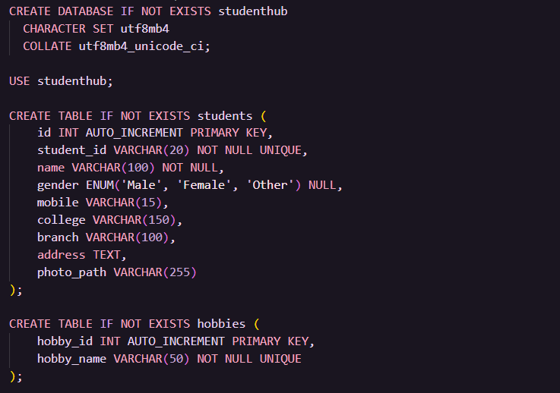
C. Evidence of Work (Screenshots)
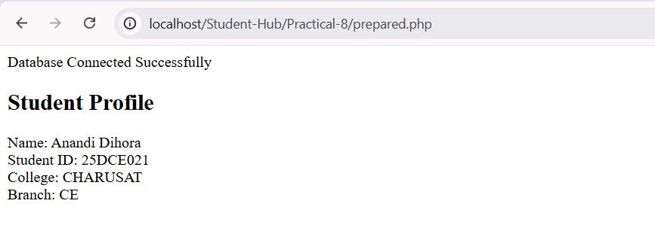
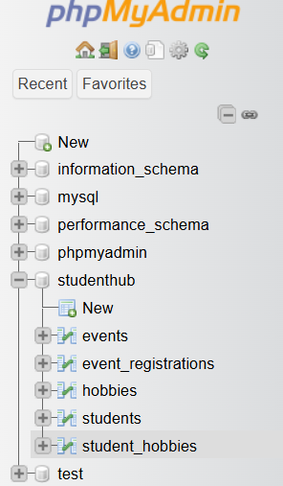
D. GitHub Repository Link
https://github.com/AD-9218/Student-Hub/tree/main/Practical-8
E. Challenges Faced
Write the database connection, schema design, foreign key, or prepared statement issues faced during implementation and how they were solved.

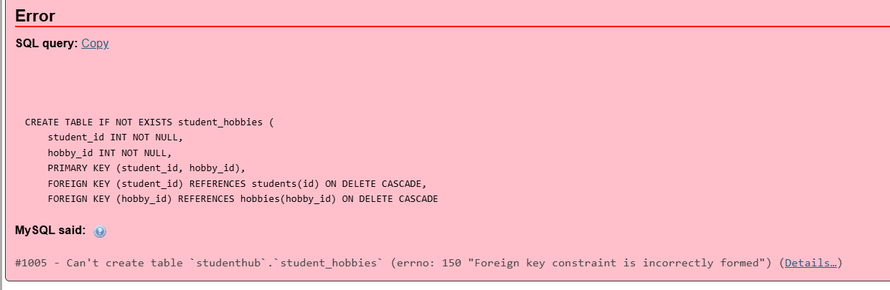
F. Learning Outcomes
I learned how to design a normalized MySQL database, connect PHP with MySQL using PDO, and use prepared statements for secure database operations.
Faculty Remarks:

