Practical 9: Secure User Registration with Database Insert, Duplicate Email Check, and Password Hashing
Problem Definition | Implement secure user registration by inserting user details into MySQL using MySQLi. Validate input on frontend and backend, check duplicate email/username, hash passwords using password_hash(), and display appropriate messages.
A. Theory
1. Is password_hash() used before storing passwords?
Answer: Yes. Passwords are hashed using password_hash() before they are stored in the database.
2. Is duplicate email/username checked?
Answer: Yes. The registration process checks whether the email or username already exists before inserting a new user.
3. Are frontend and backend validations consistent?
Answer: Yes. Input validation is performed on both frontend and backend to ensure valid and secure registration data.
B. Implementation / Output / Result
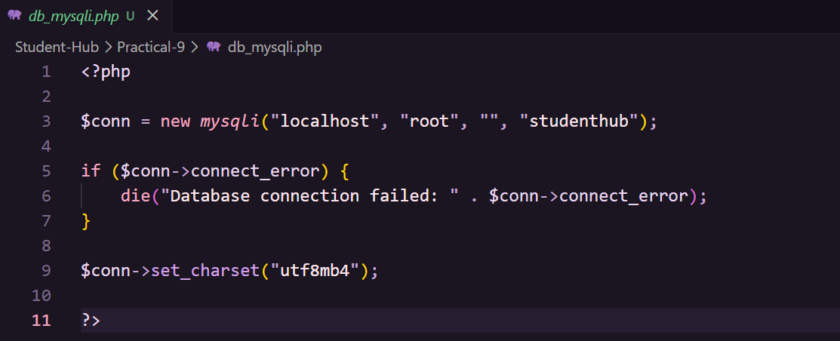
C. Evidence of Work (Screenshots)
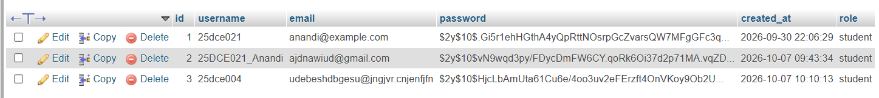
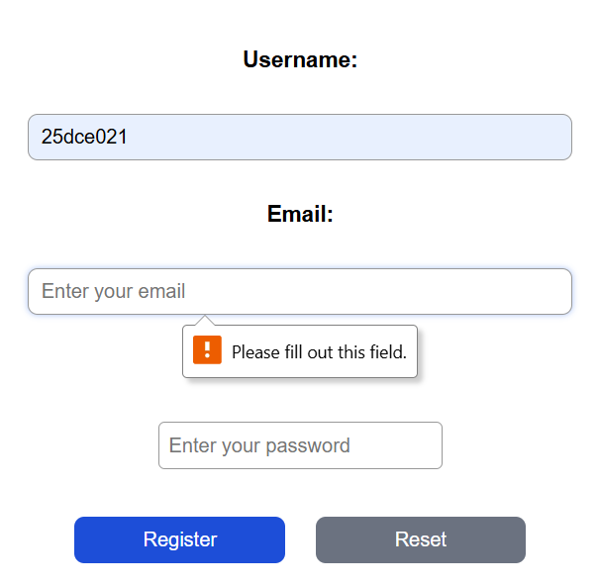
If Username or Email repeated and resister Again Then give me ,
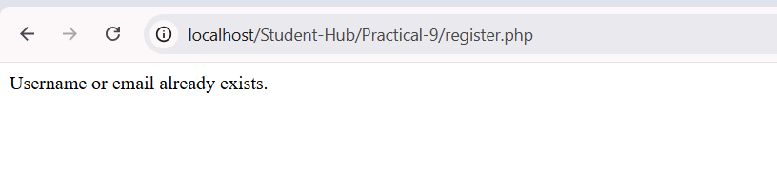
D. GitHub Repository Link
https://github.com/AD-9218/Student-Hub/tree/main/Practical-9
E. Challenges Faced
I don’t Star MYSQL in Xampp Control Panel so give Error,
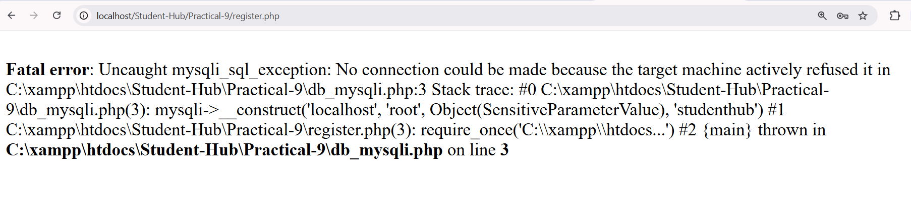
F. Learning Outcomes
I learned how to implement secure user registration using PHP and MySQLi. I also learned input validation, duplicate checks, password hashing using password_hash(), and secure database insertion.
Faculty Remarks:

