Practical – 2

Problem Definition : Initiate the semester-long StudentHub portal by identifying the problem scope, user roles, key modules, navigation flow, and minimum 10 pages. Create a sitemap, low-fidelity wireframe, project folder structure, README file, and GitHub repository.

Screen shot of Html pages :
1.index.html :
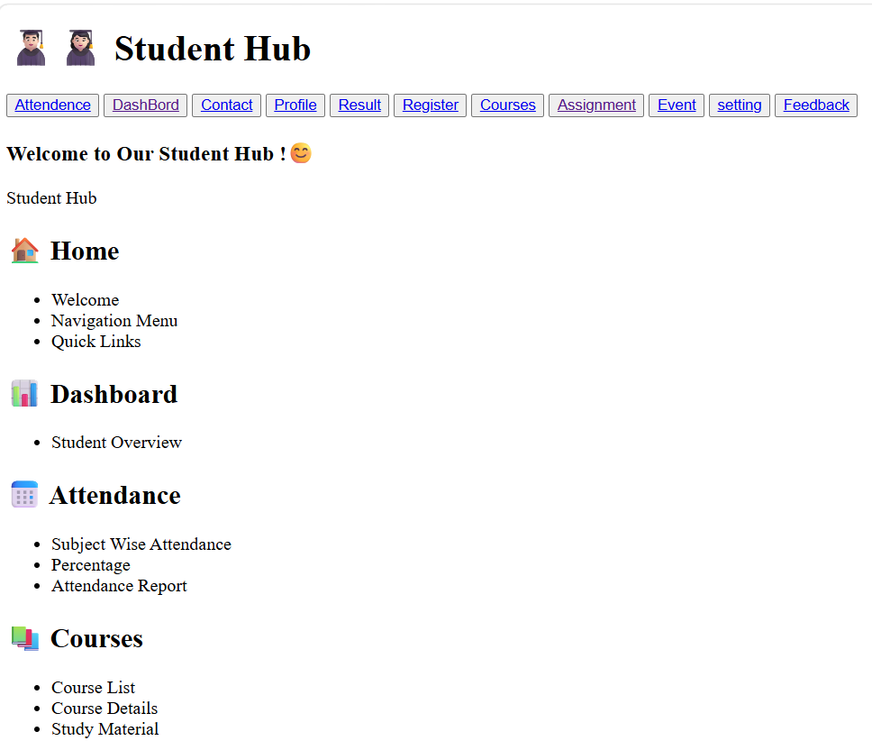
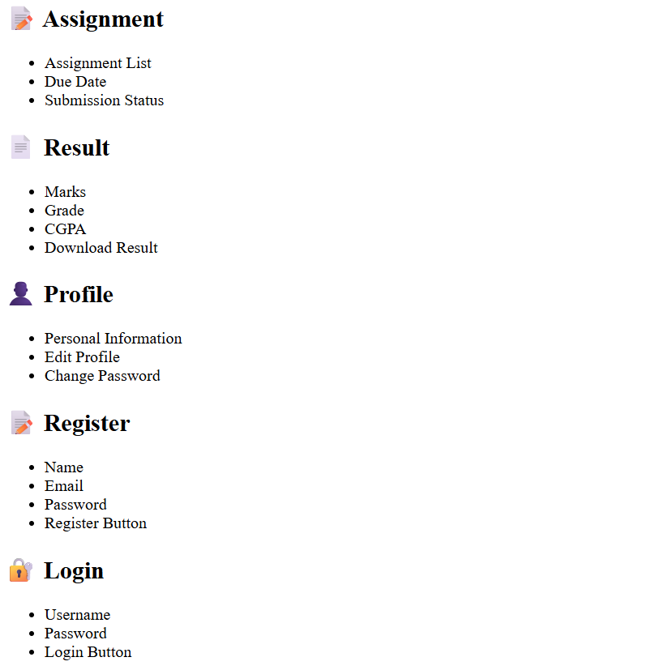
2. Attedance.html
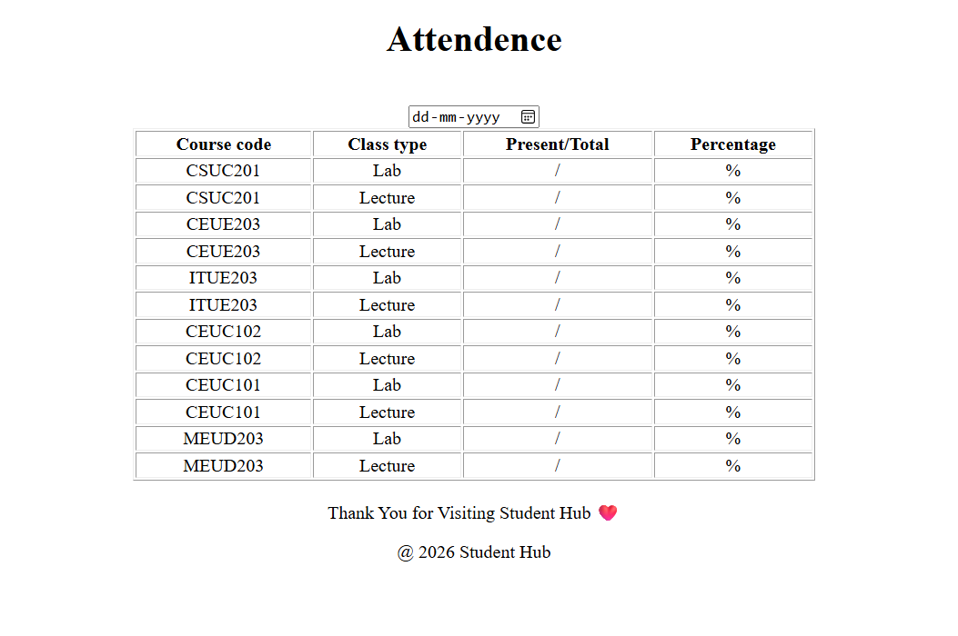
3.Contact.html
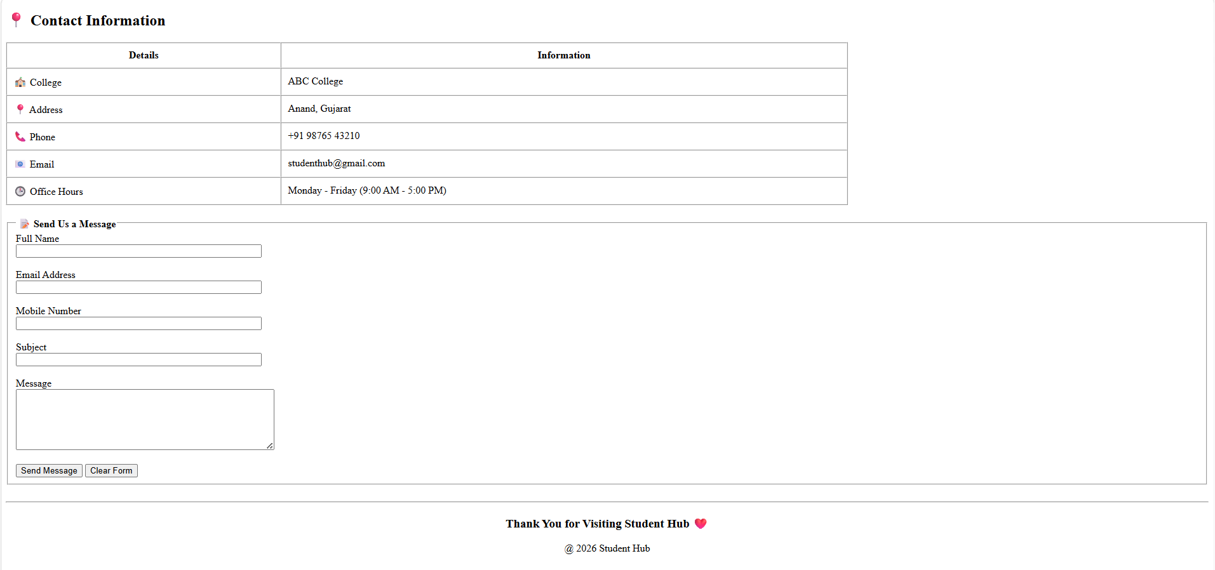
4.Profile.html
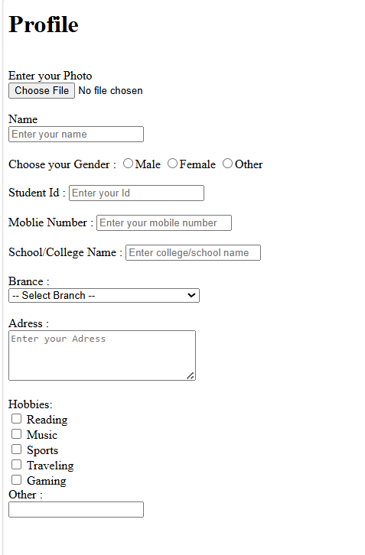
5.Result.html
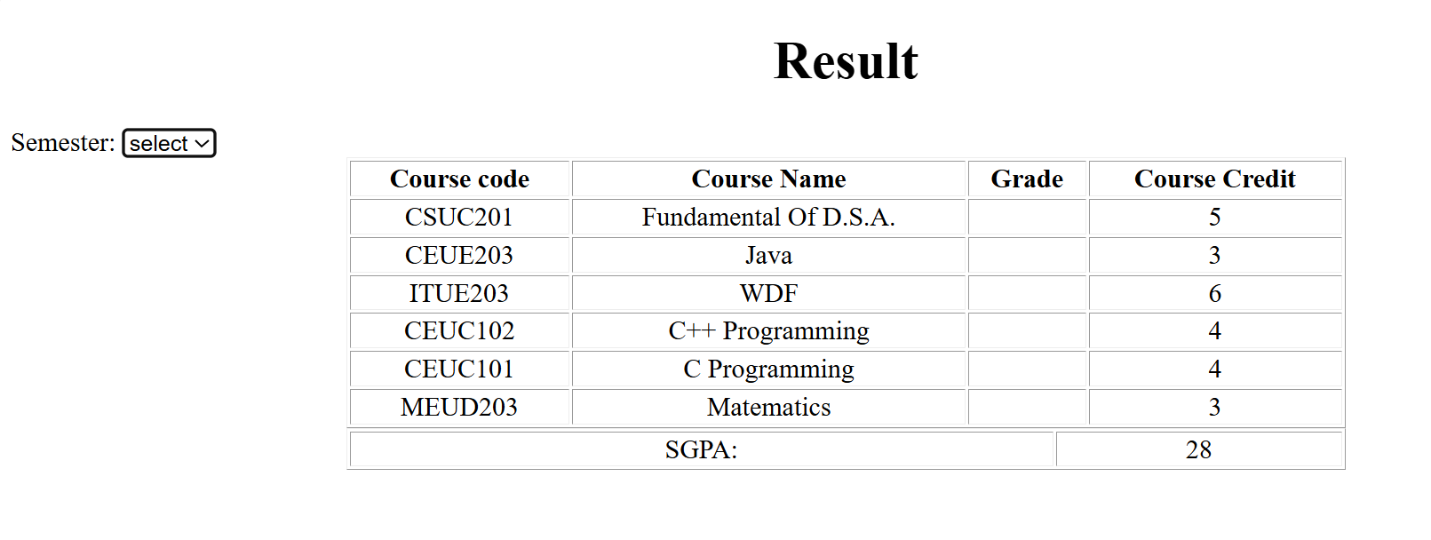
6.Registration.html
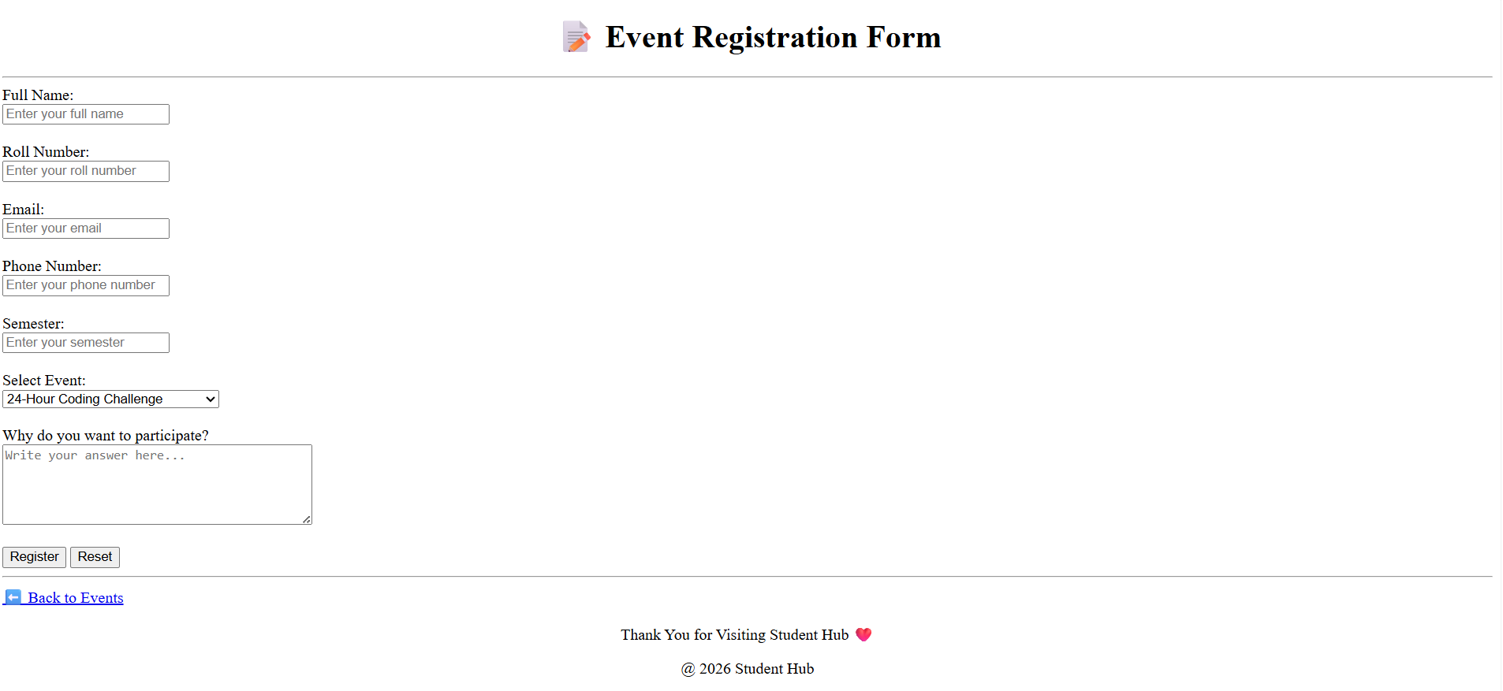
7.Course.html
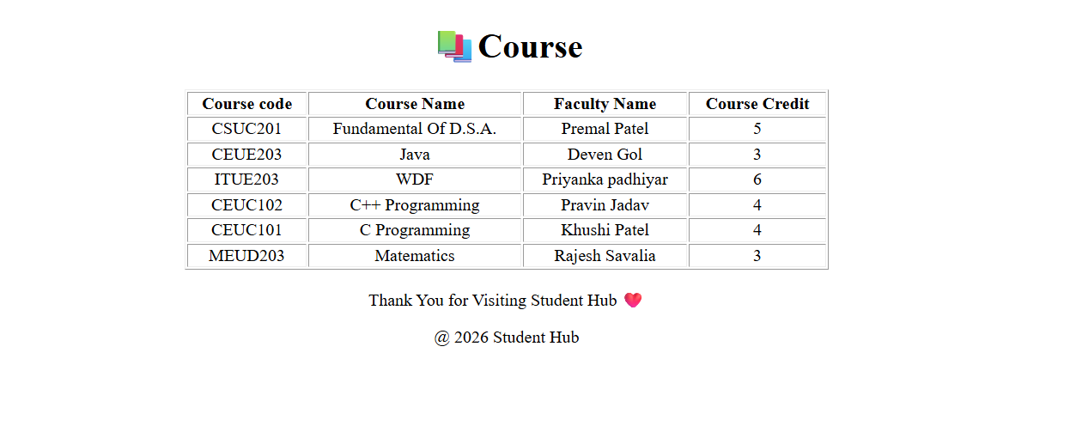

8.Assignment.html
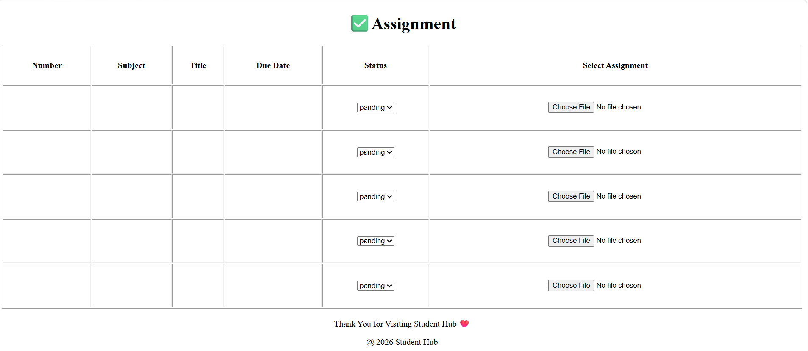
9.Event.html
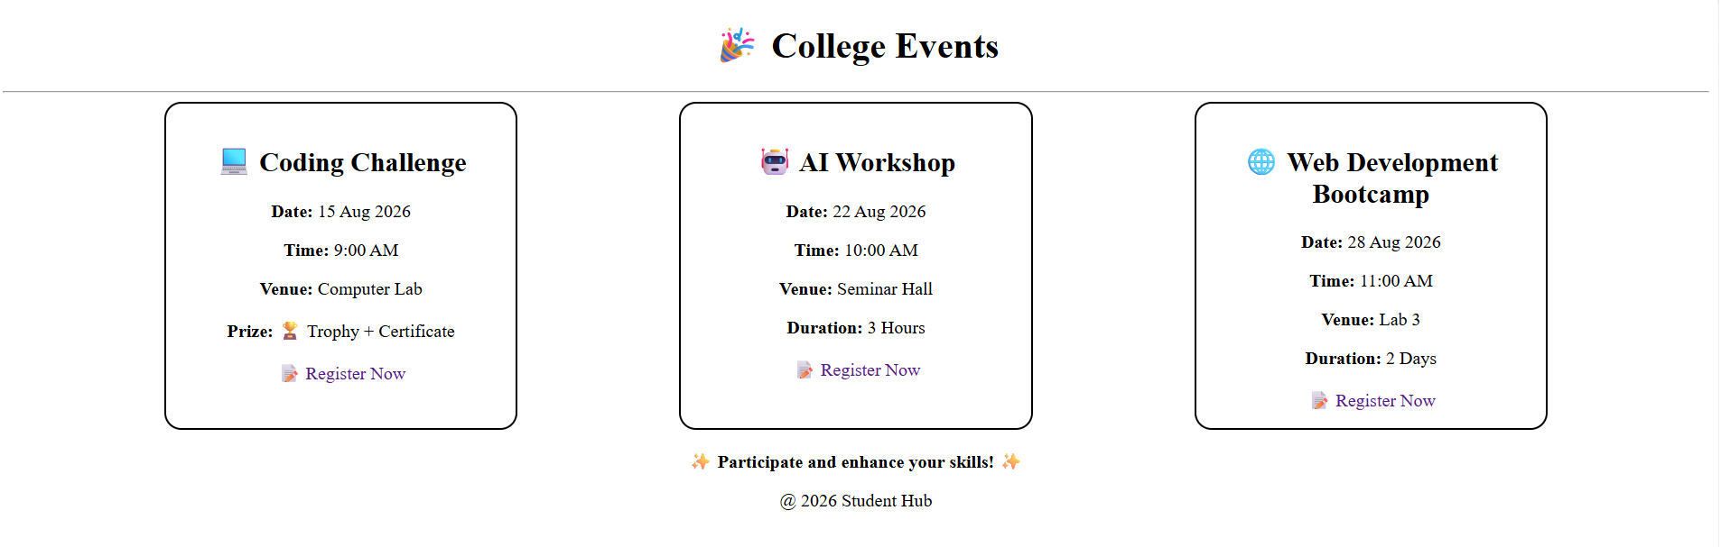
10.Setting.html
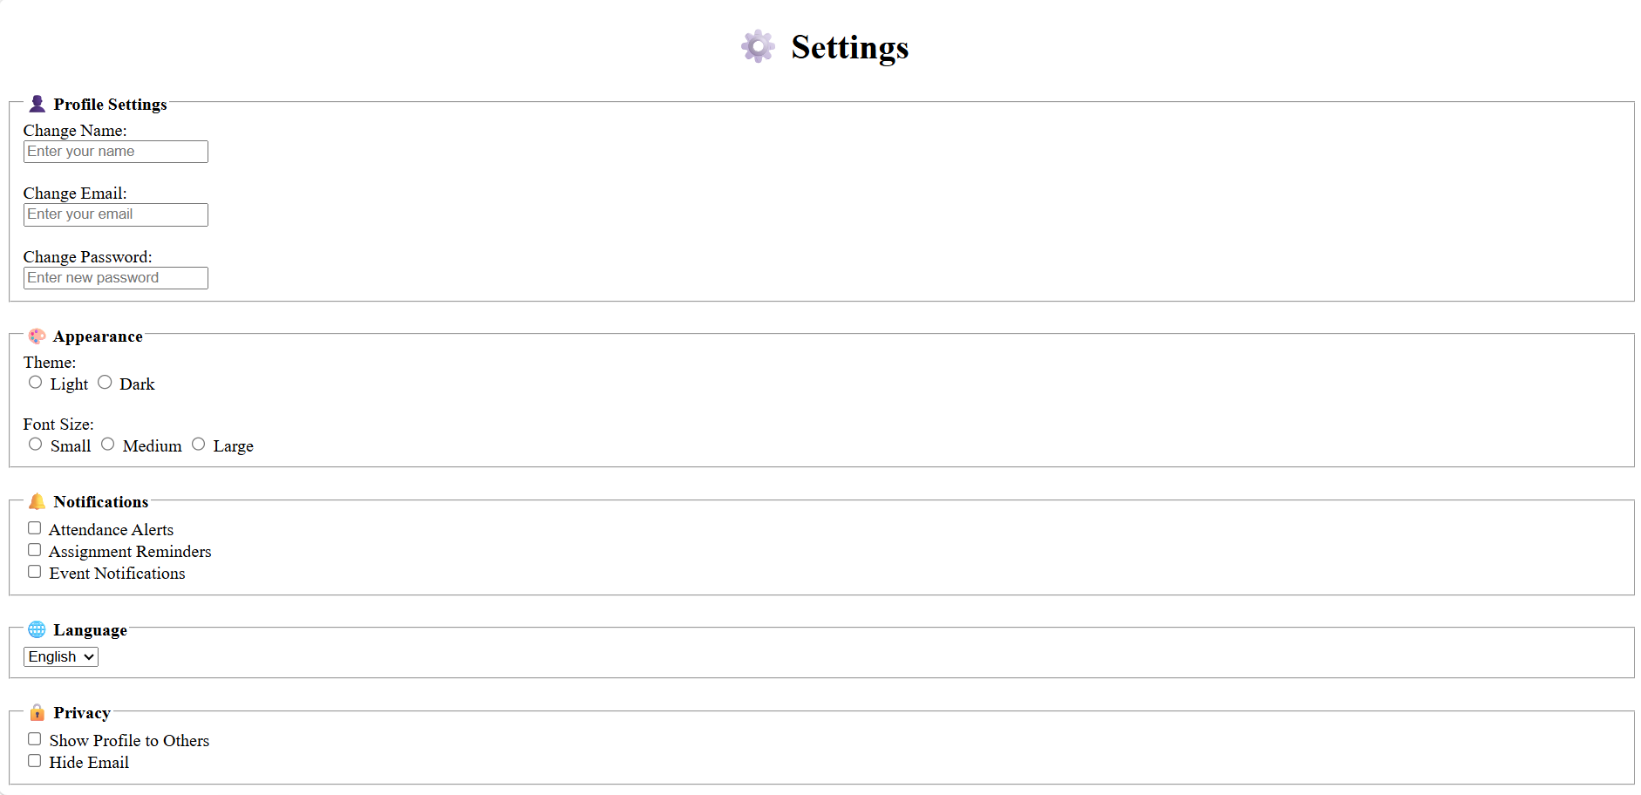
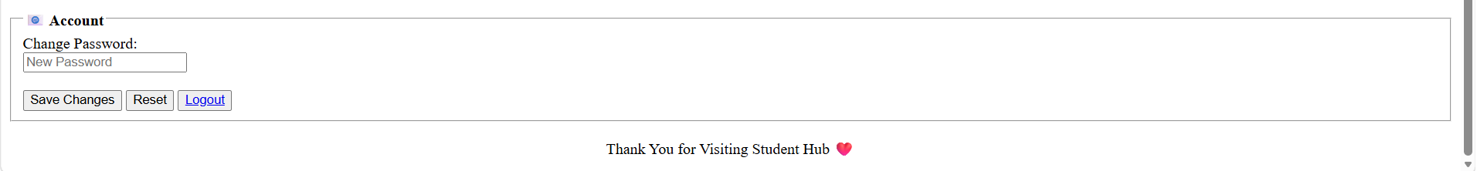
11.Feedback.html
