Workload Model Design
Workload Model Design Document
Scenarios Covered:
• 50 Users
• 100 Users
• 500 Users
Performance Test Types:
1. Load Test – Steady predictable traffic.
2. Stress Test – Increasing load until system breaks.
3. Endurance Test – Long-running stability validation.
4. Spike Test – Sudden surge in traffic.
Each test includes workload diagrams and explanation.

Load Test Workload (50, 100, 500 Users)
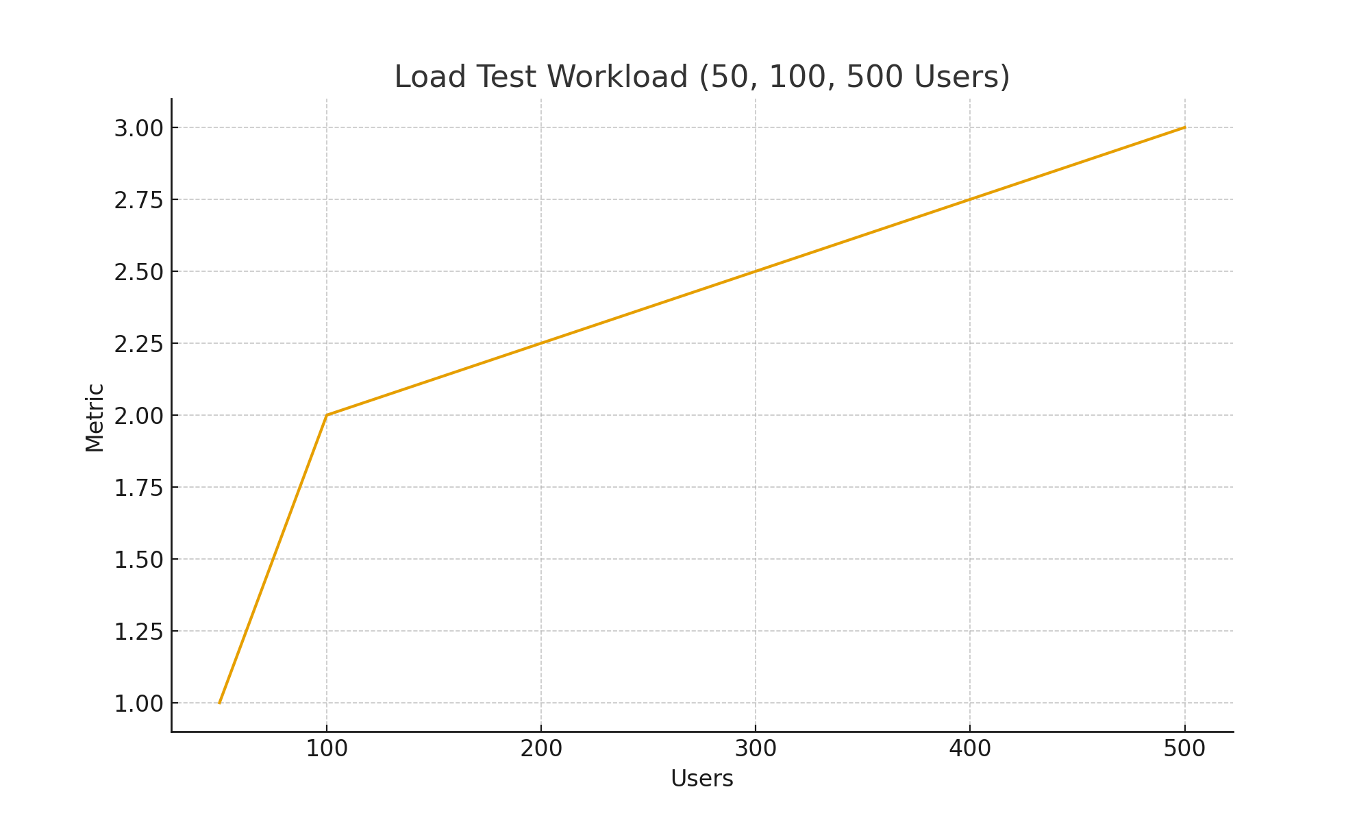

Stress Test Workload (Beyond 500 Users)
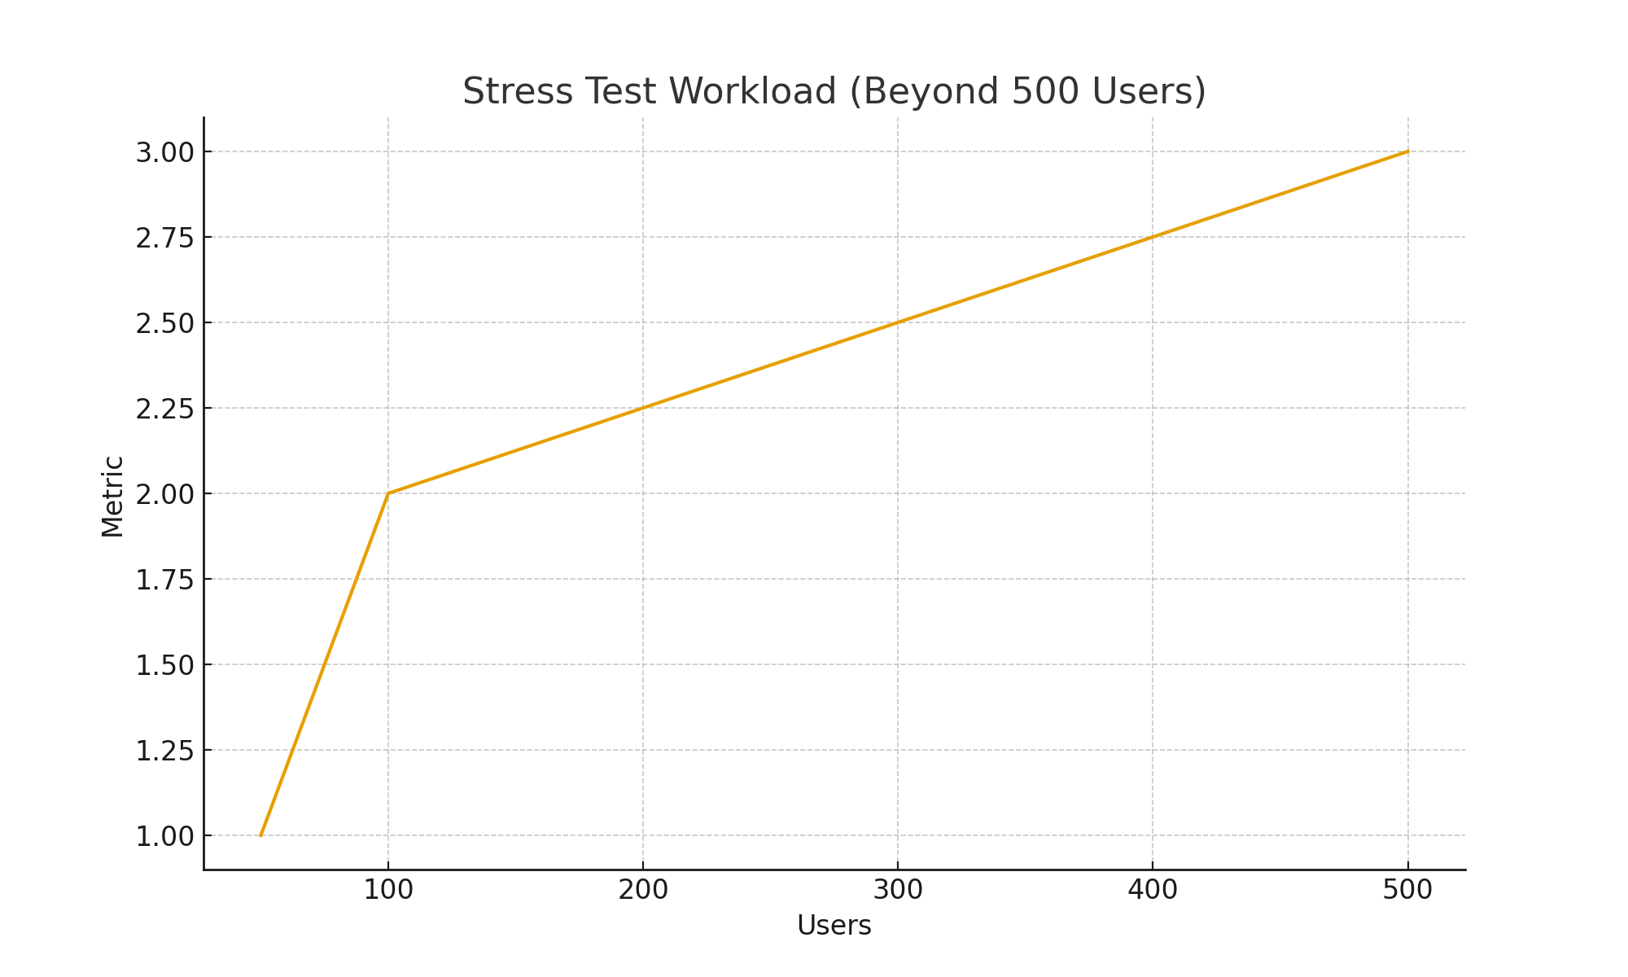

Endurance Test Trend (Long Duration)
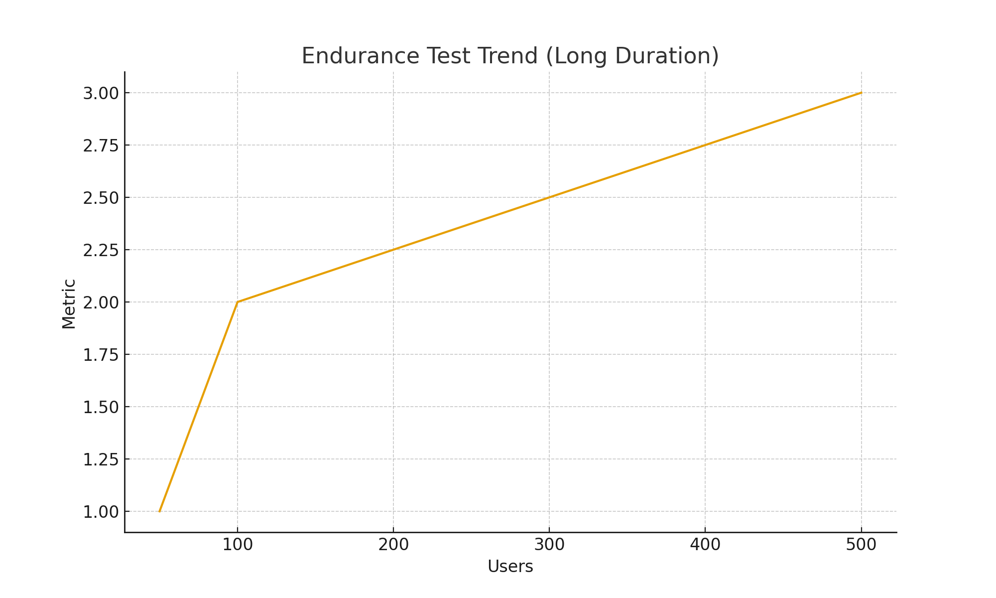

Spike Test Pattern (50 → 500 Sudden Jump)
