Microservices with Spring Boot 3 and Spring cloud

**Microservices with API gateway**:

Creating Microservices for account and loan:

**AccountApplication.java:**

**package** com.cognizant.account;

**import** org.springframework.boot.SpringApplication;

**import** org.springframework.boot.autoconfigure.SpringBootApplication;

@SpringBootApplication

**public** **class** AccountApplication {

**public** **static** **void** main(String[] args) {

SpringApplication.*run*(AccountApplication.**class**, args);

}

}

**AccountController.java:**

**package** com.cognizant.account.controller;

**import** org.springframework.web.bind.annotation.*;

@RestController

**public** **class** AccountController {

@GetMapping("/accounts/{number}")

**public** Account getAccount(@PathVariable String number) {

**return** **new** Account(number, "savings", 234343);

}

**record** Account(String number, String type, **double** balance) {}

}

**Account.java:**

**package** com.cognizant.account.controller;

**public** **class** Account {

**private** String number;

**private** String type;

**private** **double** balance;

**public** Account(String number, String type, **double** balance) {

**this**.number = number;

**this**.type = type;

**this**.balance = balance;

}

// Getters and Setters

**public** String getNumber() { **return** number; }

**public** **void** setNumber(String number) { **this**.number = number; }

**public** String getType() { **return** type; }

**public** **void** setType(String type) { **this**.type = type; }

**public** **double** getBalance() { **return** balance; }

**public** **void** setBalance(**double** balance) { **this**.balance = balance; }

}

OUTPUT:

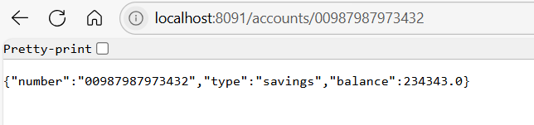

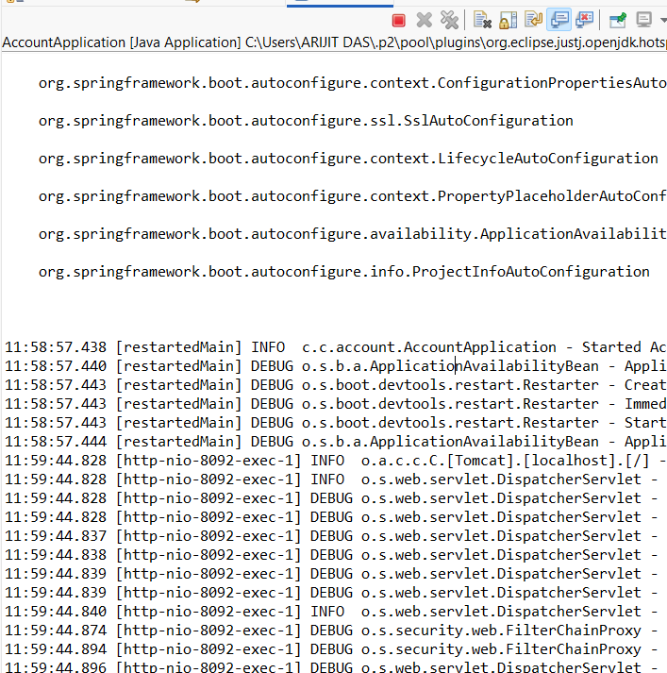

**LoanApplication.java:**

**package** com.cognizant.loan;

**import** org.springframework.boot.SpringApplication;

**import** org.springframework.boot.autoconfigure.SpringBootApplication;

@SpringBootApplication

**public** **class** LoanApplication {

**public** **static** **void** main(String[] args) {

SpringApplication.*run*(LoanApplication.**class**, args);

}

}

**LoanController.java:**

**package** com.cognizant.loan.controller;

**import** org.springframework.web.bind.annotation.*;

@RestController

**public** **class** LoanController {

@GetMapping("/loans/{number}")

**public** Loan getLoan(@PathVariable String number) {

**return** **new** Loan(number, "car", 400000, 3258, 18);

}

**record** Loan(String number, String type, **double** loan, **double** emi, **int** tenure) {}

}

**Loan.java:**

**package** com.cognizant.loan.controller;

**public** **class** Loan {

**private** String number;

**private** String type;

**private** **double** loan;

**private** **double** emi;

**private** **int** tenure;

// Constructors

**public** Loan() {}

**public** Loan(String number, String type, **double** loan, **double** emi, **int** tenure) {

**this**.number = number;

**this**.type = type;

**this**.loan = loan;

**this**.emi = emi;

**this**.tenure = tenure;

}

// Getters and Setters

**public** String getNumber() {

**return** number;

}

**public** **void** setNumber(String number) {

**this**.number = number;

}

**public** String getType() {

**return** type;

}

**public** **void** setType(String type) {

**this**.type = type;

}

**public** **double** getLoan() {

**return** loan;

}

**public** **void** setLoan(**double** loan) {

**this**.loan = loan;

}

**public** **double** getEmi() {

**return** emi;

}

**public** **void** setEmi(**double** emi) {

**this**.emi = emi;

}

**public** **int** getTenure() {

**return** tenure;

}

**public** **void** setTenure(**int** tenure) {

**this**.tenure = tenure;

}

}

OUTPUT:

