**React**

1. **React-Js HOL:**

**App.js:**

import logo from './logo.svg';

import './App.css';

function App() {

  return (

    <h1>Welcome the first session of React</h1>

  );

}

export default App;

**OUTPUT:**



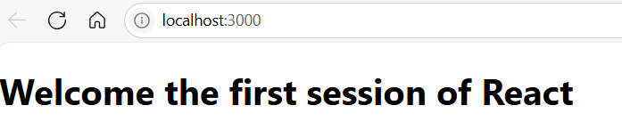

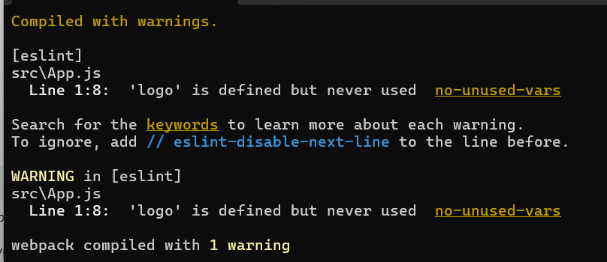

1. **React-Js HOL:**

**Home.js:**

import React, { Component } from 'react';

class Home extends Component {

  render() {

    return (

      <div>

        <h3>Welcome to the Home Page of Student Management Portal</h3>

      </div>

    );

  }

}

export default Home;

**About.js:**

import React, { Component } from 'react';

class About extends Component {

  render() {

    return (

      <div>

        <h3>Welcome to the About Page of Student Management Portal</h3>

      </div>

    );

  }

}

export default About;

**Contact.js:**

import React, { Component } from 'react';

class Contact extends Component {

  render() {

    return (

      <div>

        <h3>Welcome to the Contact Page of Student Management Portal</h3>

      </div>

    );

  }

}

export default Contact;

**OUTPUT:**

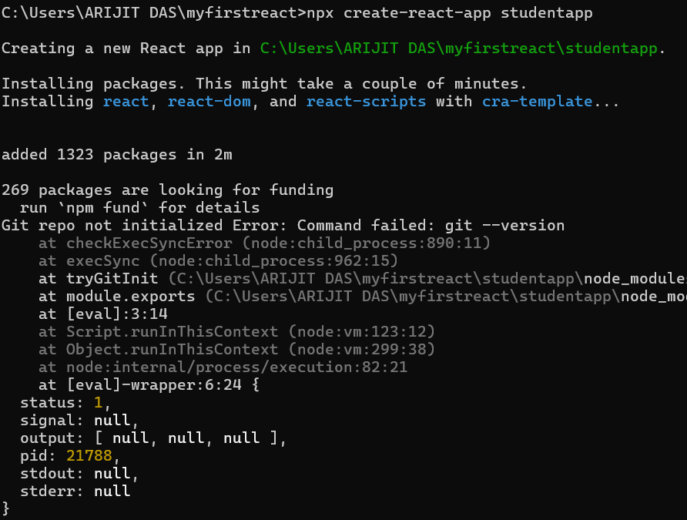

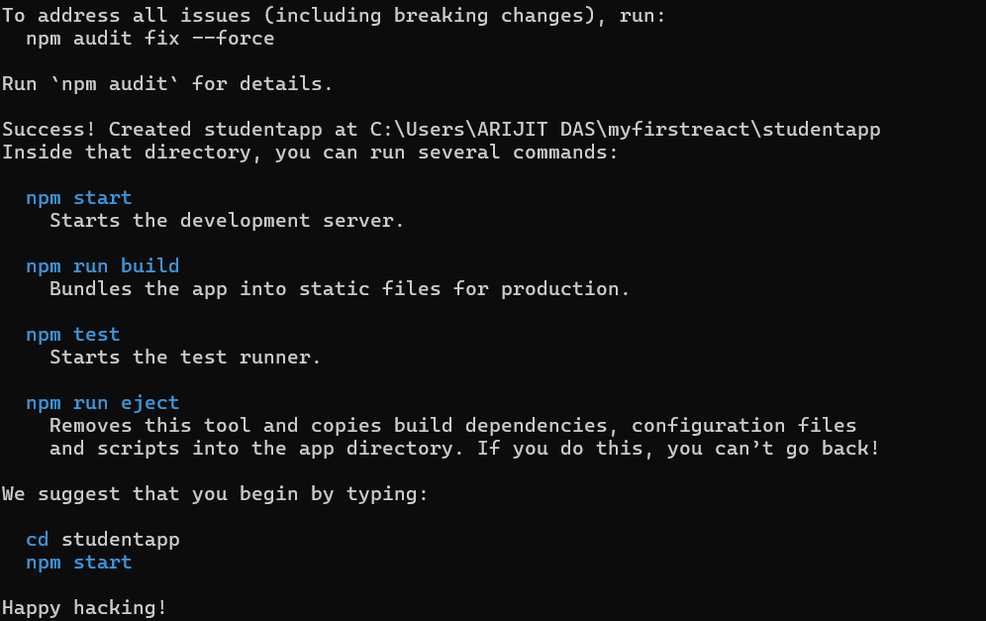

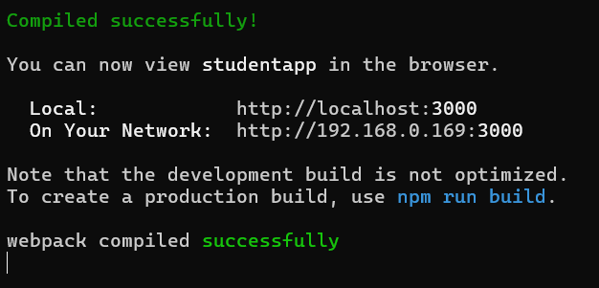

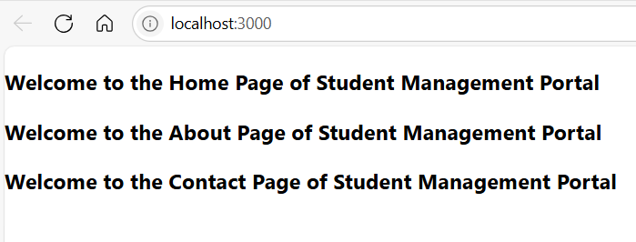

1. **React-Js HOL:**

**CalculateScore.js**

import '../Stylesheets/mystyle.css';

const percentToDecimal = (decimal) => {

  return decimal.toFixed(2) + '%';

};

const calcScore = (total, goal) => {

  return percentToDecimal(total / goal);

};

function CalculateScore() {

  return (

    <div className="formatstyle">

      <h2>Student Details:</h2>

      <p className="Name">Name: Steeve</p>

      <p className="School">School: DNV Public School</p>

      <p className="Total">Total: 284 Marks</p>

      <p className="Score">Score: {calcScore(284, 300)}</p>

    </div>

  );

}

export default CalculateScore;

**mystyle.css:**

.Name {

  font-weight: 300;

  color: blue;

}

.School {

  color: crimson;

}

.Total {

  color: darkmagenta;

}

.formatstyle {

  text-align: center;

  font-size: large;

}

.Score {

  color: forestgreen;

}

**App.js:**

import './App.css';

import CalculateScore from './Components/CalculateScore';

function App() {

  return (

    <div className="App">

      <CalculateScore />

    </div>

  );

}

export default App;

**OUTPUT:**

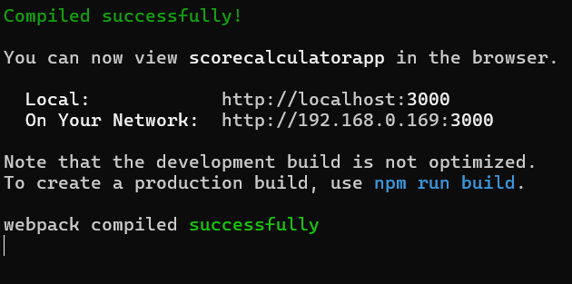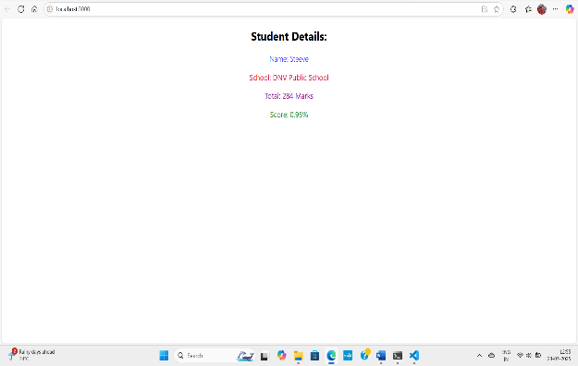

1. **React-Js HOL:**

**Post.js:**

class Post {

  constructor(id, title, body) {

    this.id = id;

    this.title = title;

    this.body = body;

  }

}

export default Post;

**Posts.js:**

import React from 'react';

import Post from './Post'; // Import the Post class

class Posts extends React.Component {

  constructor(props) {

    super(props);

    // 5. Initialize the component with a list of Post in state

    this.state = {

      posts: [],

      error: null, // For error handling

    };

  }

  // 6. Create a new method in component with the name as loadPosts()

  loadPosts = async () => {

    try {

      const response = await fetch('https://jsonplaceholder.typicode.com/posts');

      if (!response.ok) {

        throw new Error(`HTTP error! status: ${response.status}`);

      }

      const data = await response.json();

      // Map the fetched data to instances of your Post class

      const loadedPosts = data.map(

        (post) => new Post(post.id, post.title, post.body)

      );

      this.setState({ posts: loadedPosts });

    } catch (error) {

      console.error("Failed to fetch posts:", error);

      this.setState({ error: error }); // Store the error in state

    }

  };

  // 7. Implement the componentDidMount() hook to make calls to loadPosts()

  componentDidMount() {

    this.loadPosts();

  }

  // 8. Implement the render() which will display the title and post of posts

  render() {

    const { posts, error } = this.state;

    if (error) {

      // Display a message if there's an error and componentDidCatch doesn't handle it

      return <div>Error loading posts: {error.message}</div>;

    }

    return (

      <div>

        <h1>Blog Posts</h1>

        {posts.length > 0 ? (

          posts.map((post) => (

            <div key={post.id}>

              <h2>{post.title}</h2>

              <p>{post.body}</p>

              <hr />

            </div>

          ))

        ) : (

          <p>Loading posts...</p>

        )}

      </div>

    );

  }

  // 9. Define a componentDidCatch() method

  componentDidCatch(error, info) {

    // You can log the error to an error reporting service

    console.error("Component did catch an error:", error, info);

    // Display an alert message

    alert(`An error occurred in the Posts component: ${error.message}`);

    // Optionally, update state to display an error UI

    this.setState({ error: error });

  }

}

export default Posts;

**App.js:**

import React from 'react';

import './App.css';

import Posts from './Posts'; // Import the Posts component

function App() {

  return (

    <div className="App">

      <header className="App-header">

        {/* You can remove or modify default React content here */}

        <Posts /> {/* Render the Posts component */}

      </header>

    </div>

  );

}

export default App;

**OUTPUT:** 