1. Handson-9:

App.js:

import ListofPlayers from './components/ListofPlayers';

import Scorebelow70 from './components/Scorebelow70';

import { OddPlayers } from './components/OddPlayers';

import { EvenPlayers } from './components/EvenPlayers';

import ListofIndianPlayers from './components/ListofIndianPlayers';

import { players, IndianPlayers, IndianTeam } from './data/playersData';

function App() {

  const flag = false; // Set false to test second view

  if (flag === true) {

    return (

      <div>

        <h1>List of Players</h1>

        <ListofPlayers players={players} />

        <hr />

        <h1>List of Players having Scores Less than 70</h1>

        <Scorebelow70 players={players} />

      </div>

    );

  } else {

    return (

      <div>

        <div>

          <h1>Indian Team</h1>

          <h2>Odd Players</h2>

          <OddPlayers players={IndianTeam} />

          <hr />

          <h2>Even Players</h2>

          <EvenPlayers players={IndianTeam} />

        </div>

        <hr />

        <div>

          <h1>List of Indian Players Merged:</h1>

          <ListofIndianPlayers IndianPlayers={IndianPlayers} />

        </div>

      </div>

    );

  }

}

export default App;

index.js:

import React from 'react';

import ReactDOM from 'react-dom/client';

import App from './App';

const root = ReactDOM.createRoot(document.getElementById('root'));

root.render(

  <React.StrictMode>

    <App />

  </React.StrictMode>

);

playersData.js:

export const players = [

  { name: "Jack", score: 50 },

  { name: "Michael", score: 70 },

  { name: "John", score: 40 },

  { name: "Ann", score: 61 },

  { name: "Elisabeth", score: 61 },

  { name: "Sachin", score: 95 },

  { name: "Dhoni", score: 100 },

  { name: "Virat", score: 84 },

  { name: "Jadeja", score: 64 },

  { name: "Raina", score: 75 },

  { name: "Rohit", score: 80 }

];

export const T20Players = ['First Player', 'Second Player', 'Third Player'];

export const RanjiTrophyPlayers = ['Fourth Player', 'Fifth Player', 'Sixth Player'];

export const IndianPlayers = [...T20Players, ...RanjiTrophyPlayers];

export const IndianTeam = ['Sachin1', 'Dhoni2', 'Virat3', 'Rohit4', 'Yuvaraj5', 'Raina6'];

ListofPlayers.js:

export default function ListofPlayers({ players }) {

  return (

    <ul>

      {players.map((item, index) => (

        <li key={index}>

          Mr. {item.name} <span>{item.score}</span>

        </li>

      ))}

    </ul>

  );

}

Scorebelow70.js:

export default function Scorebelow70({ players }) {

  const players70 = players.filter(item => item.score <= 70);

  return (

    <ul>

      {players70.map((item, index) => (

        <li key={index}>

          Mr. {item.name} <span>{item.score}</span>

        </li>

      ))}

    </ul>

  );

}

OddPlayers.js:

export function OddPlayers({ players: [first, , third, , fifth] }) {

  return (

    <div>

      <li>First: {first}</li>

      <li>Third: {third}</li>

      <li>Fifth: {fifth}</li>

    </div>

  );

}

EvenPlayers.js:

export function EvenPlayers({ players: [, second, , fourth, , sixth] }) {

  return (

    <div>

      <li>Second: {second}</li>

      <li>Fourth: {fourth}</li>

      <li>Sixth: {sixth}</li>

    </div>

  );

}

ListofIndianPlayers.js:

export default function ListofIndianPlayers({ IndianPlayers }) {

  return (

    <ul>

      {IndianPlayers.map((player, index) => (

        <li key={index}>Mr. {player}</li>

      ))}

    </ul>

  );

}

OUTPUT:

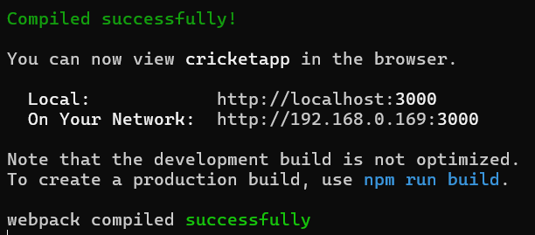

flag=true flag=false

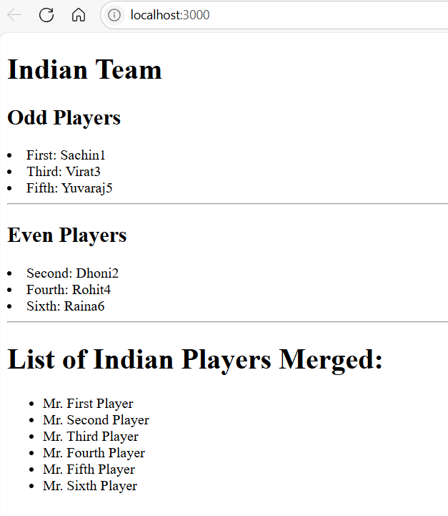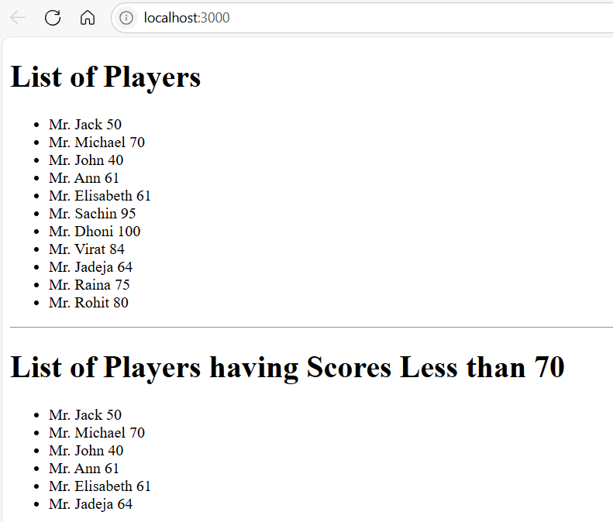

1. Handson-10:

App.js:

import './App.css';

function App() {

  const element = "Office Space";

  const sr = "https://images.unsplash.com/photo-1570129477492-45c003edd2be"; // any office image URL

  const officeList = [

    { Name: "DBS", Rent: 50000, Address: "Chennai" },

    { Name: "WeWork", Rent: 70000, Address: "Bangalore" },

    { Name: "Innov8", Rent: 60000, Address: "Delhi" }

  ];

  return (

    <div>

      <h1>{element}, at Affordable Range</h1>

      {officeList.map((ItemName, index) => {

        const colors = ItemName.Rent <= 60000 ? "textRed" : "textGreen";

        return (

          <div key={index}>

            <img src={sr} width="25%" height="25%" alt="Office Space" />

            <h2>Name: {ItemName.Name}</h2>

            <h3 className={colors}>Rent: Rs. {ItemName.Rent}</h3>

            <h3>Address: {ItemName.Address}</h3>

            <hr />

          </div>

        );

      })}

    </div>

  );

}

export default App;

App.css:

.textRed {

  color: red;

}

.textGreen {

  color: green;

}

index.js:

import React from 'react';

import ReactDOM from 'react-dom/client';

import App from './App';

const root = ReactDOM.createRoot(document.getElementById('root'));

root.render(<App />);

**OUTPUT:**

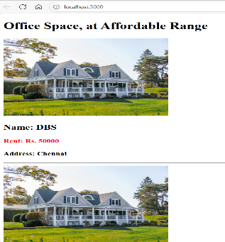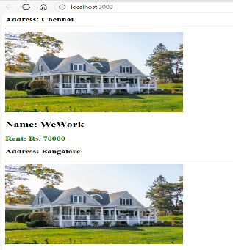 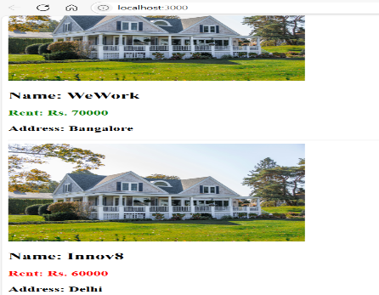

1. Handson-11:

App.js:

import React, { useState } from 'react';

import CurrencyConvertor from './CurrencyConvertor';

function App() {

  const [count, setCount] = useState(0);

  const increment = () => {

    setCount(count + 1);

    greetUser();

  };

  const decrement = () => {

    setCount(count - 1);

  };

  const greetUser = () => {

    alert('Hello! Member1');

  };

  const sayWelcome = (msg) => {

    alert(msg);

  };

  const handleClick = (e) => {

    alert('I was clicked');

  };

  return (

    <div style={{ margin: '20px' }}>

      <div>{count}</div>

      <button onClick={increment}>Increment</button><br/>

      <button onClick={decrement}>Decrement</button><br/>

      <button onClick={() => sayWelcome("welcome")}>Say welcome</button><br/>

      <button onClick={handleClick}>Click on me</button>

      <CurrencyConvertor />

    </div>

  );

}

export default App;

CurrencyConverter.js:

import React, { useState } from 'react';

function CurrencyConvertor() {

  const [amount, setAmount] = useState('');

  const [currency, setCurrency] = useState('');

  const handleSubmit = (e) => {

    e.preventDefault();

    if (currency.toLowerCase() === 'euro') {

      let converted = parseFloat(amount) * 80;

      alert(`Converting to  ${currency} Amount is ${converted}`);

    } else {

      alert('Only Euro conversion is supported');

    }

  };

  return (

    <div>

      <h2 style={{ color: 'green' }}>Currency Convertor!!!</h2>

      <form onSubmit={handleSubmit}>

        <label>Amount: </label>

        <input

          type="text"

          value={amount}

          onChange={(e) => setAmount(e.target.value)}

        /><br/>

        <label>Currency: </label>

        <input

          type="text"

          value={currency}

          onChange={(e) => setCurrency(e.target.value)}

        /><br/>

        <button type="submit">Submit</button>

      </form>

    </div>

  );

}

export default CurrencyConvertor;

**OUTPUT:**

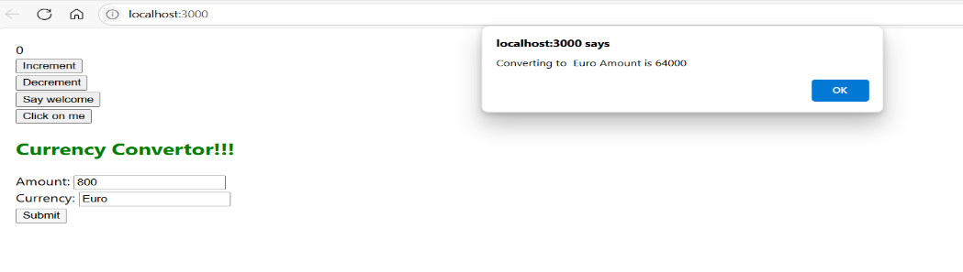

1. Handson-12:

App.js:

import React, { useState } from "react";

import LoginButton from "./LoginButton";

import LogoutButton from "./LogoutButton";

import Greeting from "./Greeting";

import FlightDetails from "./FlightDetails";

import TicketBooking from "./TicketBooking";

function App() {

  const [isLoggedIn, setIsLoggedIn] = useState(false);

  const handleLoginClick = () => setIsLoggedIn(true);

  const handleLogoutClick = () => setIsLoggedIn(false);

  return (

    <div>

      <Greeting isLoggedIn={isLoggedIn} />

      {isLoggedIn ? (

        <LogoutButton onClick={handleLogoutClick} />

      ) : (

        <LoginButton onClick={handleLoginClick} />

      )}

      <FlightDetails />

      {isLoggedIn && <TicketBooking />}

    </div>

  );

}

export default App;

LoginButton.js:

import React from "react";

function LoginButton(props) {

  return <button onClick={props.onClick}>Login</button>;

}

export default LoginButton;

LogoutButton.js:

import React from "react";

function LogoutButton(props) {

  return <button onClick={props.onClick}>Logout</button>;

}

export default LogoutButton;

Greeting.js:

import React from "react";

function UserGreeting() {

  return <h1>Welcome back</h1>;

}

function GuestGreeting() {

  return <h1>Please sign up.</h1>;

}

function Greeting(props) {

  if (props.isLoggedIn) {

    return <UserGreeting />;

  }

  return <GuestGreeting />;

}

export default Greeting;

FlightDetails.js:

import React from "react";

function FlightDetails() {

  return (

    <div>

      <h2>Available Flights</h2>

      <ul>

        <li>Flight 101 - Delhi to Mumbai</li>

        <li>Flight 202 - Bangalore to Kolkata</li>

      </ul>

    </div>

  );

}

export default FlightDetails;

TicketBooking.js:

import React from "react";

function TicketBooking() {

  return (

    <div>

      <h2>Book Your Ticket</h2>

      <p>Booking form goes here (you can add form later)</p>

    </div>

  );

}

export default TicketBooking;

**OUTPUT:**

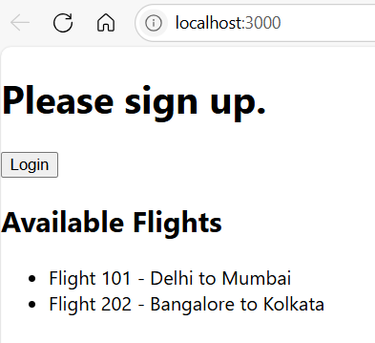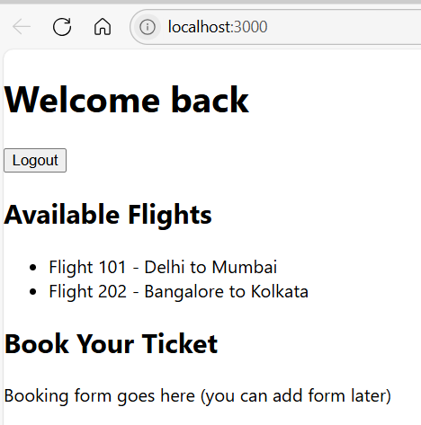

1. Handson-13:

App.js:

import './App.css';

import BookDetails from './components/BookDetails';

import BlogDetails from './components/BlogDetails';

import CourseDetails from './components/CourseDetails';

function App() {

  const books = [

    { id: 101, bname: 'Master React', price: 670 },

    { id: 102, bname: 'Deep Dive into Angular 11', price: 800 },

    { id: 103, bname: 'Mongo Essentials', price: 450 },

  ];

  const blogs = [

    { title: 'React Learning', author: 'Stephen Biz', body: 'Welcome to learning React!' },

    { title: 'Installation', author: 'Schwezdenier', body: 'You can install React from npm.' },

  ];

  const courses = [

    { name: 'Angular', date: '4/5/2021' },

    { name: 'React', date: '6/3/2021' },

  ];

  const showBooks = true;

  const showBlogs = true;

  const showCourses = true;

  return (

    <div className="App">

      <div className="container">

        {showCourses && (

          <div className="column mystyle1">

            <h1>Course Details</h1>

            <CourseDetails courses={courses} />

          </div>

        )}

        {showBooks ? (

          <div className="column st2">

            <h1>Book Details</h1>

            <BookDetails books={books} />

          </div>

        ) : null}

        {showBlogs && (

          <div className="column v1">

            <h1>Blog Details</h1>

            <BlogDetails blogs={blogs} />

          </div>

        )}

      </div>

    </div>

  );

}

export default App;

BookDetails.js:

function BookDetails({ books }) {

  return (

    <ul>

      {books.length > 0 ? (

        books.map((book) => (

          <div key={book.id}>

            <h3>{book.bname}</h3>

            <h4>{book.price}</h4>

          </div>

        ))

      ) : (

        <p>No books available</p>

      )}

    </ul>

  );

}

export default BookDetails;

BlogDetails.js:

function BlogDetails({ blogs }) {

  if (!blogs || blogs.length === 0) return <p>No blogs found</p>;

  return (

    <div>

      {blogs.map((b, i) => (

        <div key={i}>

          <h3>{b.title}</h3>

          <strong>{b.author}</strong>

          <p>{b.body}</p>

        </div>

      ))}

    </div>

  );

}

export default BlogDetails;

CourseDetails.js:

function CourseDetails({ courses }) {

  return (

    <>

      {courses.length ? (

        courses.map((course, index) => (

          <div key={index}>

            <h3>{course.name}</h3>

            <p>{course.date}</p>

          </div>

        ))

      ) : (

        <p>No course data available</p>

      )}

    </>

  );

}

export default CourseDetails;

**OUTPUT:**

