**Laveng: A Story of Transformation through Access to responsibly managed drinking Water service**

In the commune of Cavaillon, a rural community named Laveng has become a shining example of how sustained community engagement, responsible water management, and strategic partnerships can transform lives.

Before the intervention of HANWASH, the residents of Laveng faced major challenges accessing safe drinking water. The only available source was an unprotected spring located miles away, forcing households to endure long, arduous journeys for water that was neither treated nor responsibly managed. Sanitation practices were poor, with the community struggling to achieve Open Defecation Free (ODF) status, and there was no system in place for paying for or responsibly managing the water supply.

Recognizing the urgent needs of Laveng, HANWASH, through its Adopt-A-Well program, and in collaboration with its partner Haiti Outreach and the local authorities, inaugurated a new handpump well in Laveng on May 23, 2021. This well, made possible thanks to the generous support of donors Helene and John Vollmer, directly served 40 households — approximately 227 people — providing them with access to clean, nearby, and affordable water.

However, HANWASH's intervention went beyond the construction of the well. The organization through its partner Haiti Outreach implemented community engagement activities, training Laveng residents to adopt safe hygiene and sanitation practices, establish a payment system to ensure the financial sustainability of the well, and responsibly manage the new water source through the creation of a Water Point Committee (CPE).

These efforts quickly bore fruit. Laveng achieved Open Defecation Free (ODF) status, and households embraced a culture of paying for water service. Subscribers now contribute a modest fee of 125 Haitian Gourdes (approximately $0.95 USD) per month — a tariff carefully designed to remain affordable while supporting the operational needs of the system.

The success of the Laveng community caught the attention of Haiti’s national water regulator, DINEPA. In 2023, recognizing the community’s responsible management and steady revenue generation, DINEPA invested in upgrading the Laveng handpump into a solar-powered kiosk equipped with a reservoir, a chlorination system, and a complete solar electrical setup (including panels, batteries, inverter, and regulator).

Since its inauguration, the Laveng well has collected net savings of 71,438 Haitian Gourdes (about $545 USD) — a powerful testament to the community’s commitment to safeguarding its water resources.

Building on this momentum, the Laveng Water Point Committee introduced an innovative revenue-generating service: smartphone charging powered by their new solar system. Between January and March 2025 alone, the committee raised 4,035 Haitian Gourdes (approximately $33 USD) from this service — revenue equivalent to a month of subscription fees for 34 households. This additional income provides an important buffer, ensuring financial resilience even when some subscribers are unable to make timely payments.

The Laveng story is a powerful reminder that when communities are empowered with the right infrastructure, training, and support, they can not only sustain but grow their access to safe water and sanitation services.

HANWASH’s vision for a Haiti where every citizen enjoys safe, affordable, and sustainable water access is alive in Laveng — and thriving.

**Photos 1:** Thehandpump

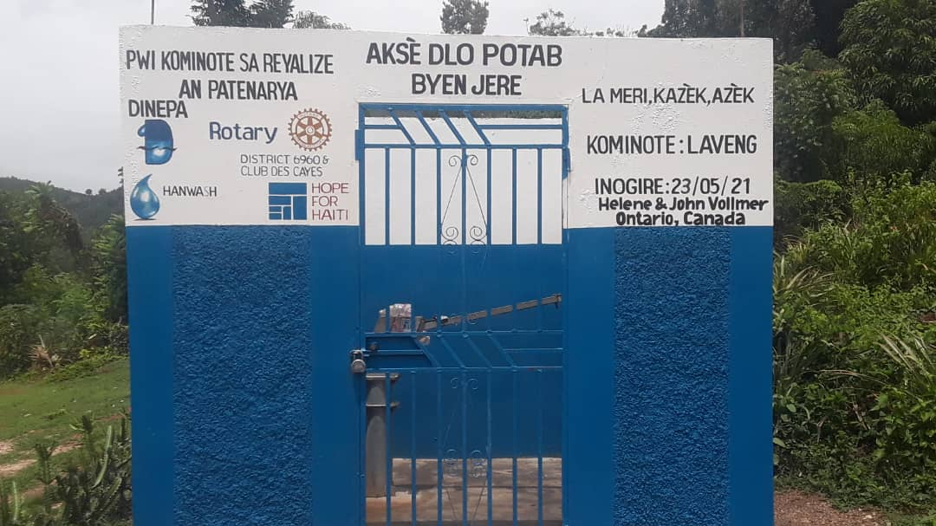

**Photos 2:** Children collecting water from the solar-powered kiosk

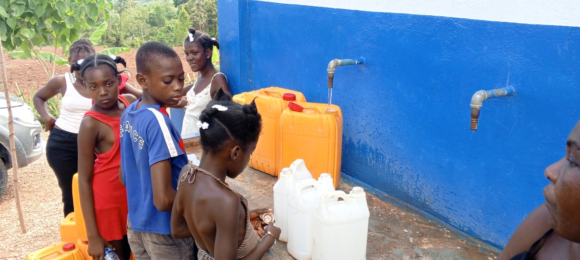

**Photo 3**: CPE members and partners in front of the solar-powered kiosk built by DINEPA

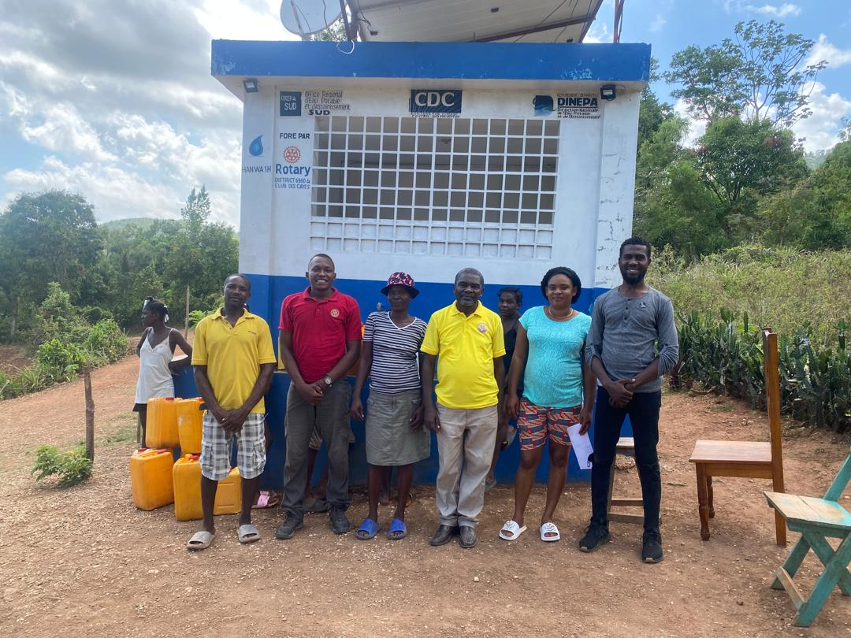

**Photo 4**: Meter of the Kiosk

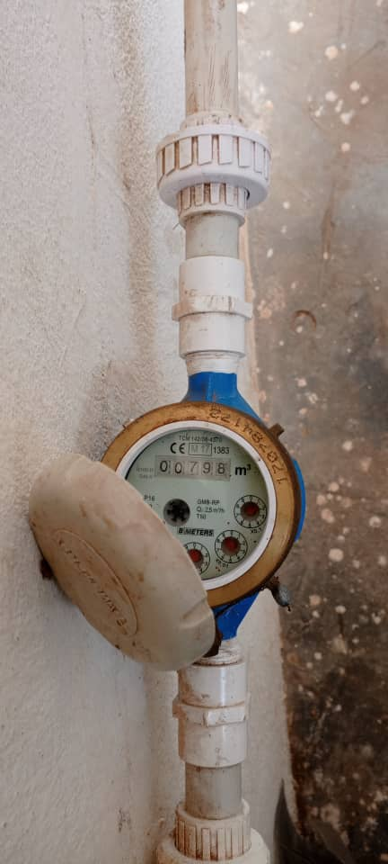

**Photo 5**: Phones recharging

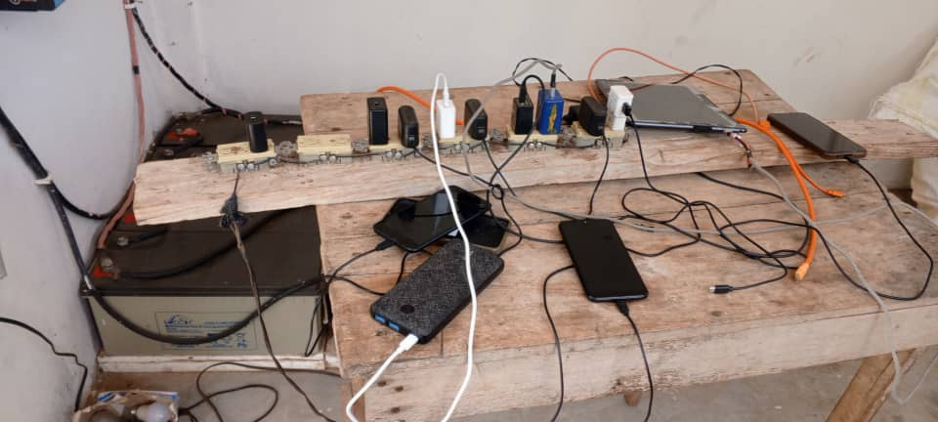

**Photo 6**: Batteries of the new solar powered kiosk

