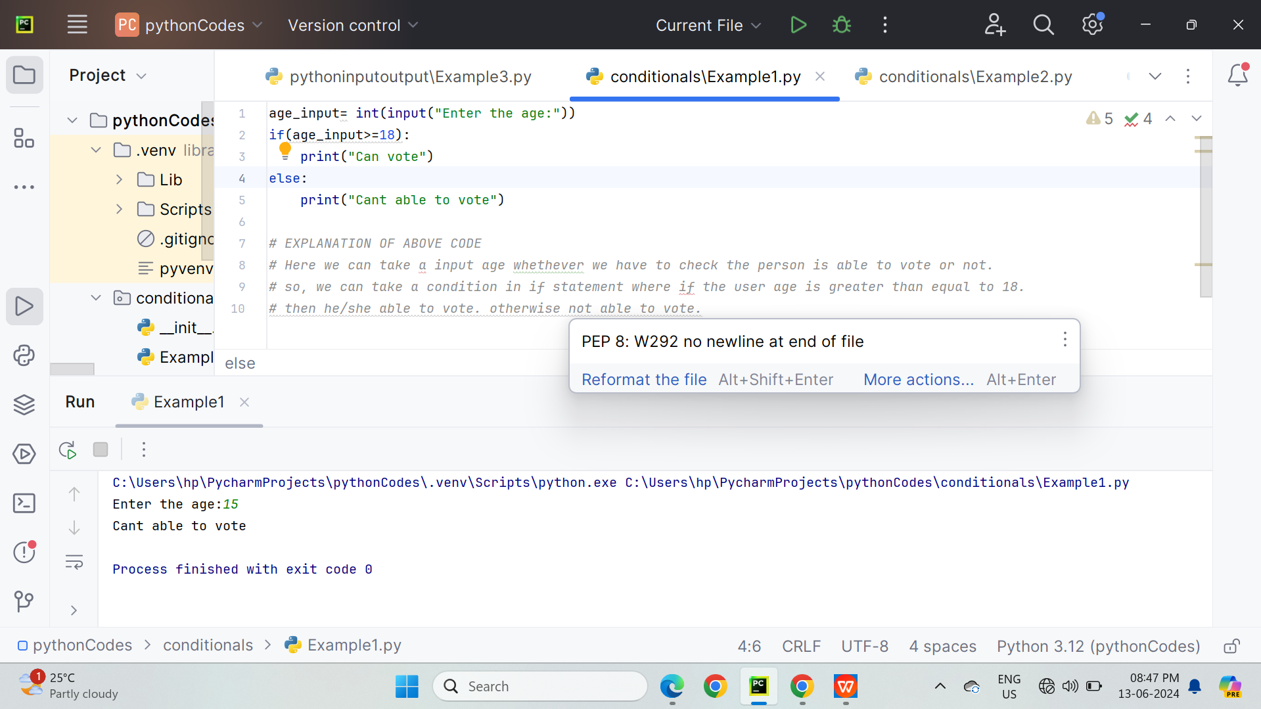

***# EXPLANATION OF ABOVE CODE  
# Here we can take a input age whethever we have to check the person is able to vote or not.  
# so, we can take a condition in if statement where if the user age is greater than equal to 18.  
# then he/she able to vote. otherwise not able to vote.***

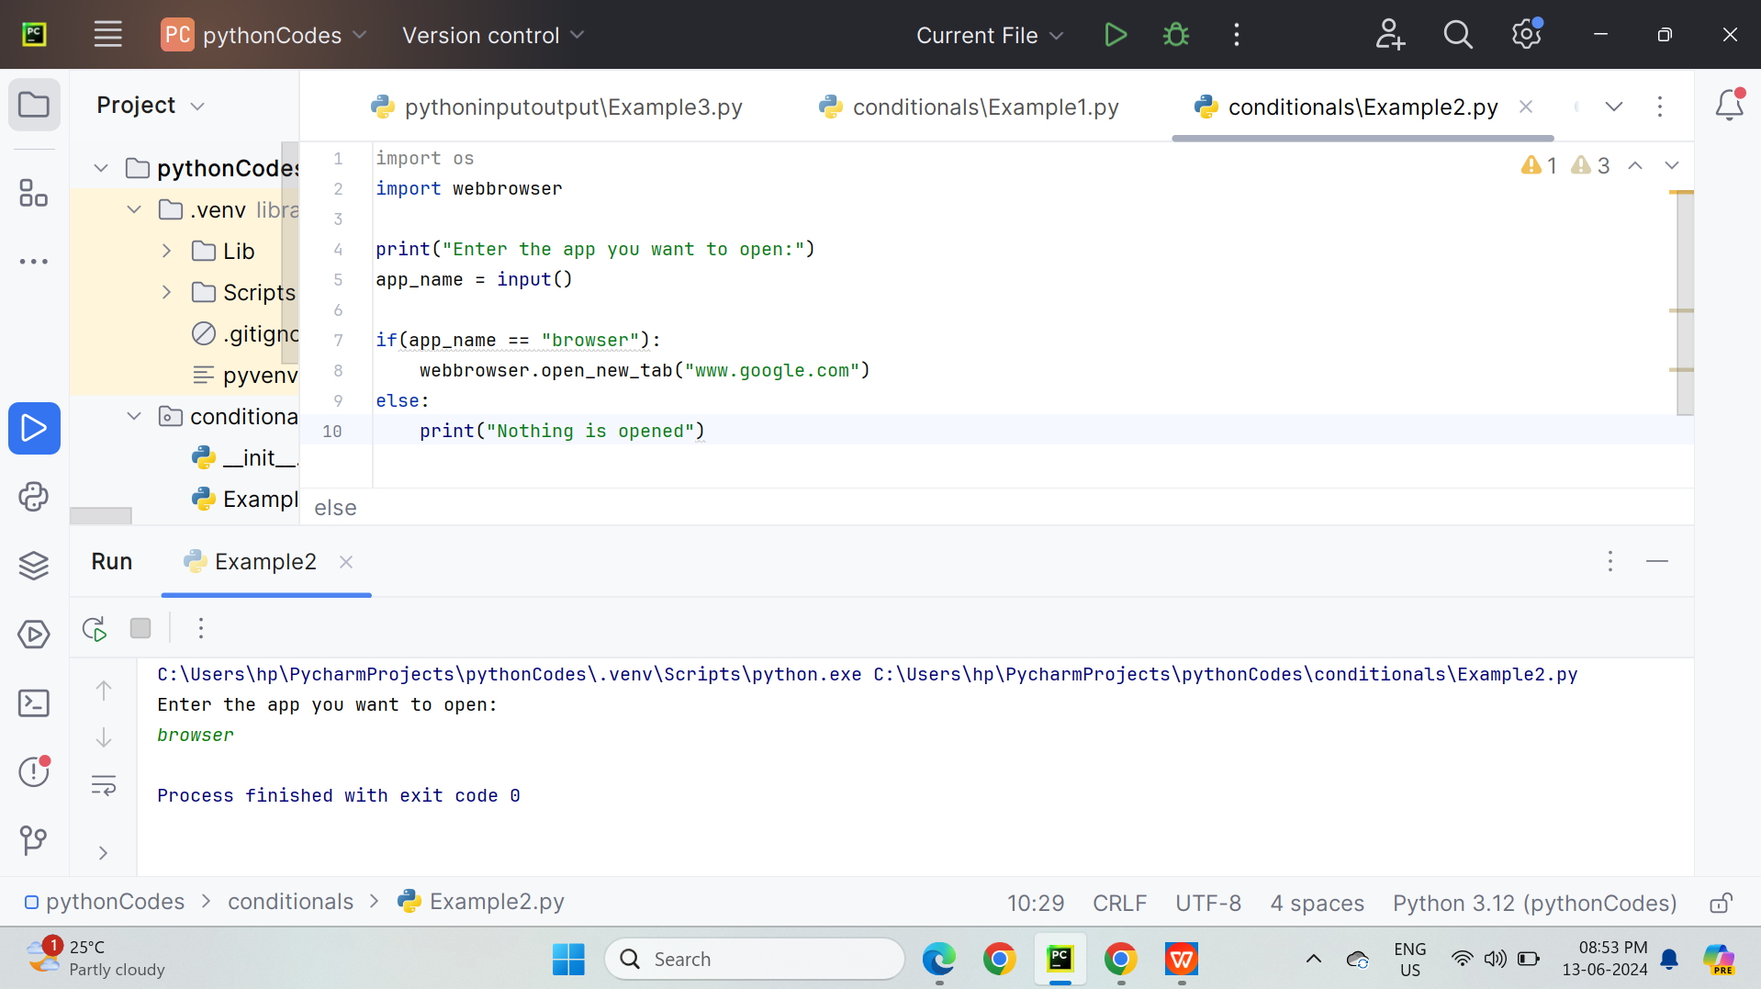



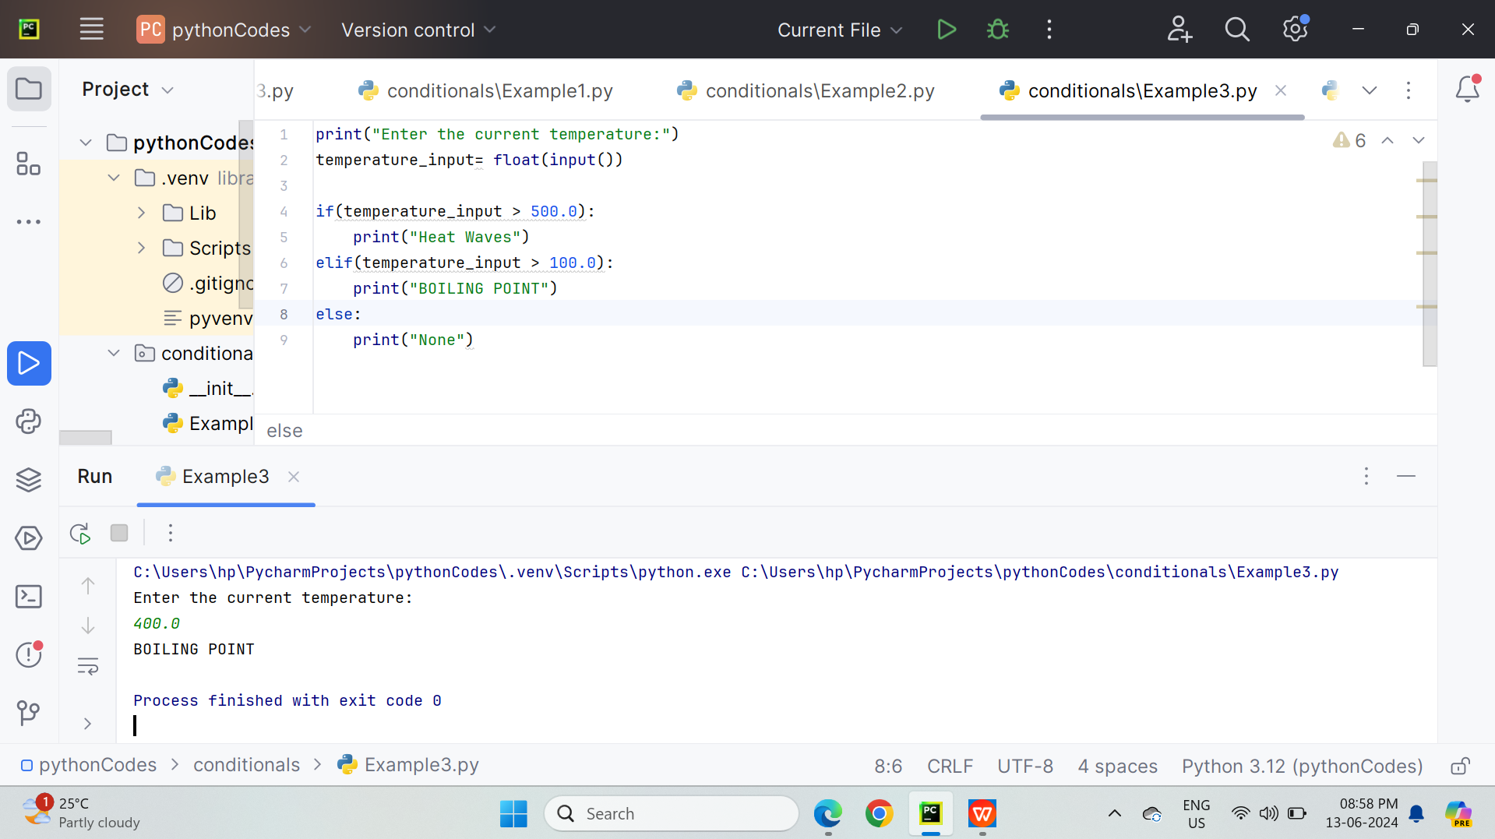

**ASSIGNMENT HOMEWORK:**

**TO CALCULATE BMI OF PERSON**

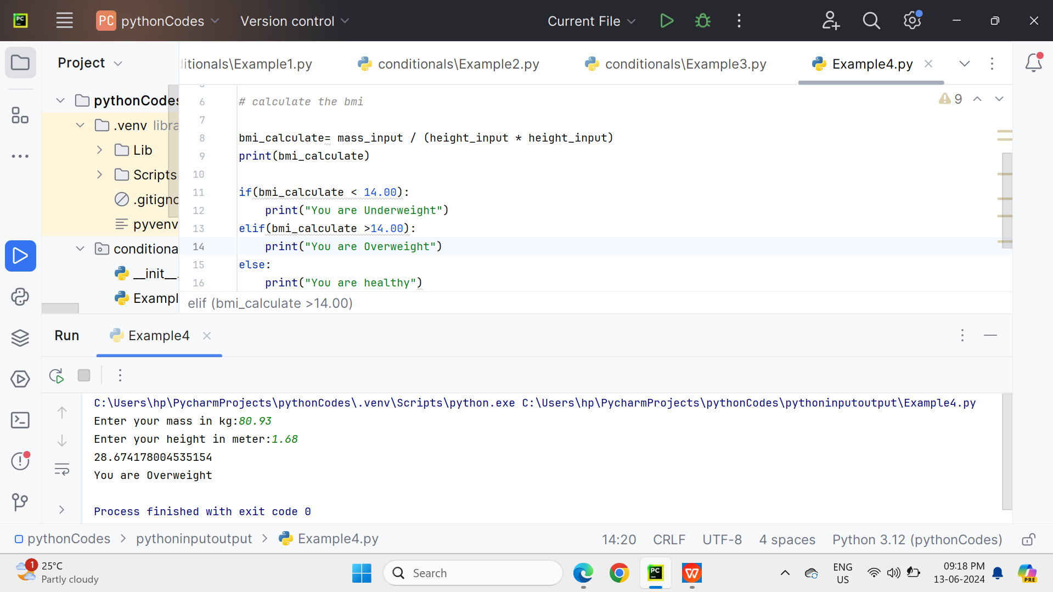

**Explanition about the conditional statements.**

The most common conditional statements in Python are if, elif, and else.

**if:** Checks if a condition is true. If it is, the indented block of code following it is executed.

**elif:** Stands for "else if" and provides an additional condition if the previous if condition was false.

**else:** Executes a block of code if none of the preceding conditions were true.