

School of Information Technology and Engineering

Senior Design Project I

Project title: Development of a system for medical image processing, labeling, and archiving.

**Understanding DICOM Image File and Processing**

Authors:

1. CS Rumiyya Alili
2. CS Minura Hajisoy
3. CS Narmina Mahmudova

Project supervisor: Dr. Jamaladdin Hasanov

Table of Contents

Introduction 3

What is a DICOM Image File? 4

Why cannot DICOM Files be Viewed Directly on a Personal Computer? 4

What are the parts of a DICOM File? 4

How to read the Header Information? 6

How to remove patient information from DICOM Images? 7

How to convert DICOM Images into other file formats? 7

Conclusion 8

# 

# **Introduction**

Nowadays, as all tools in radiology practice have digitized, as well as working with DICOM images. Image files that are compliant with part 10 of the DICOM standard are generally referred to as “DICOM format files” or simply “DICOM files” and are represented as “.dcm”. A DICOM file consists of a header and image data sets packed into a single file. The information within the header is organized as a constant and standardized series of tags. By extracting data from these tags one can access important information regarding the patient demographics, study parameters, etc. In the interest of patient confidentiality, all information that can be used to identify the patient should be removed before DICOM images are transmitted over a network for educational or other purposes. In addition to the DICOM format, the radiologist routinely encounters images of several file formats such as JPEG, TIFF, GIF, and PNG. Each format has its own unique advantages and disadvantages, which must be taken into consideration when images are archived, used in teaching files, or submitted for publication. Knowledge about these formats and their attributes, such as image resolution, image compression, and image metadata, helps the radiologist in optimizing the archival, organization, and display of images. This article aims to increase the awareness among radiologists regarding DICOM and other image file formats encountered in clinical practice. It also suggests several tips and tricks that can be used by the radiologist so that the digital potential of these images can be fully utilized for maximization of workflow in the radiology practice.

# **What is a DICOM Image File?**

The DICOM standard is useful for integrating all modern imaging equipments, accessories, networking servers, workstations, printers, and picture archiving and communication systems (PACS) that may have been installed by multiple manufacturers. Because of its ease of integration and continuous evolution this communication standard has over the years achieved a nearly universal level of acceptance among vendors of radiological equipment.

A DICOM image file is an outcome of the Digital Imaging and Communications in Medicine standard. Specifically, image files that are compliant with part 10 of the DICOM standard are generally referred to as “DICOM format files” or simply “DICOM files” and are represented as “.dcm.”.

# **Why cannot DICOM Files be Viewed Directly on a Personal Computer?**

There are several situations where DICOM files find their way into radiology practice. One common example of this is when information from a radiological study is exported into an offline medium such as a compact disk (CD) for easy transport or archival. Such a CD usually contains several DICOM image files as well as other files that are necessary for display of these images. Even though the specific folder architecture varies from vendor to vendor, the CDs usually contain an autorun file, a DICOM viewer, a DICOM directory (DICOMDIR), and a folder containing the DICOM images.

Inconveniently, in contrast to other image file formats such as JPEG or TIFF files, the individual DICOM files are not recognized by Windows® as image files. As a result, one is not able to view the contents of the image by simply double clicking on them.

To view these images on computers when a proprietary viewer is not supplied with the system, an additional software package called “DICOM browser” is needed, which will interpret the file information and display it as an image.

# **What are the parts of a DICOM File?**

DICOM differs from other image formats in that it groups information into data sets. A DICOM file consists of a header and image data sets, all packed into a single file.

The first few packets of information in a DICOM image file constitute the “header.” It stores demographic information about the patient, acquisition parameters for the imaging study, image dimensions, matrix size, color space, and a host of additional nonintensity information required by the computer to correctly display the image. The header is followed by a single attribute (7FE0) that contains all the pixel intensity data for the image. These data are stored as a long series of 0s and 1s, which can be reconstructed as the image by using the information from the header. This attribute may contain information regarding a single image, multiple frames of a study, or a cine loop, depending on the modality that has generated the image.

The header data information is encoded within the DICOM file so that it cannot be accidentally separated from the image data. If the header is separated from the image data, the computer will not know which imaging study has been done or to whom it belongs and it will not be able to display the image correctly, leading to a potential medicolegal situation.

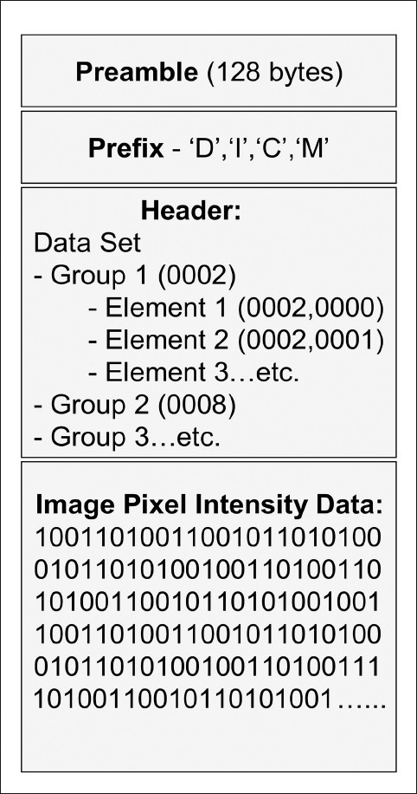

# **How to read the Header Information?**

The information within the header is organized as a constant and standardized series of tags. These tags are organized into groups of data elements. For example, the group “0010” contains patient information and is 92 bits in length. It contains the patient's name in the tag “0010–0010,” the patient's identification number in the tag “0010–0020,” birth date in the tag “0010–0030,” and so on. Similarly the group “0018” contains information regarding acquisition. It is 482 bits long and contains several elements that convey the MRI acquisition parameters. The group “0028” encodes image presentation and is responsible for display of the image on a monitor.

Analyzing the DICOM header may also give valuable information regarding the imaging study itself. For example, if a radiologist encounters a good-quality MRI image and would like to replicate the MRI pulse sequence on his MRI scanner, he can easily access all relevant parameters from the DICOM header.

There are several freely available software packages that can be used to extract information from the DICOM header. DicomWorks is a popular DICOM viewer that can view header information. Other examples of software that can be used to explore the contents of the header include ImageJ and XnView.

# **How to remove patient information from DICOM Images?**

The common tags that indicate the patient identity include the patient's name, age, sex, birth date, hospital identity number, ethnic group, occupation, referring physician, institution name, study date, and DICOM Unique Identifiers (UIDs). As described earlier, such demographic information of the patient and a host of other information about the imaging study is encoded within an image header. The data may or may not be displayed on the screen, but the information can be extracted from the header by anyone who has access to the DICOM file. Several educational resources using DICOM files are available for radiology students on the World Wide Web. Creating and accessing such electronic teaching files often involve transmission of DICOM data over the Internet. In the interest of patient confidentiality, all information identifying the patient should be removed from the DICOM header when a DICOM file is uploaded for such purposes.

Respecting the patient's privacy is important when images are used in presentations, teaching files, or publications. A simple and easy method of ensuring this is by converting and exporting the DICOM file into other image formats such as JPEG or TIFF. The header information is lost and patient identity cannot be obtained from the resultant image. Another method is “anonymization,” whereby all patient information is removed from the DICOM header. This is achieved by using software like DicomWorks, ImageJ, and FP Image. Specifically, all tags contained in groups “0008” (study information) and “0010” (patient information) of the DICOM header should be removed and replaced during anonymization.

# **How to convert DICOM Images into other file formats?**

Conversion of DICOM images into other formats is most often performed at a diagnostic workstation or at a Web client of a PACS system. Most of these systems have an “export” function that enables the operator to save the image displayed in the active window as a JPEG or TIFF file. While some applications permit export of a batch of DICOM images into other formats, most require repeated operations, converting one image at a time.

Even if the DICOM viewer lacks an image export function, users of the Windows® operating system can press the “Print Screen” key on the keyboard to capture the current monitor display and save by directly pasting it within a PowerPoint™ slide or by saving it as a file using an image editing software package. Also, the contents of an active window can be selectively captured by pressing “Print Screen” key along with the “Alt” key.

As has been noted earlier, the TIFF format should be preferred when creating a master copy from DICOM files. Though TIFF files have large file sizes, this format provides the highest image quality. Subsequently, the images can be saved in other formats such as JPEG in order to save on storage space. It should be remembered that while it is possible to convert a TIFF image into a low-quality JPEG image, it is not possible to regain the original detail from the JPEG image.

Outside the radiology environment, DICOM files can be exported to other image formats using stand-alone DICOM viewers. Several free stand-alone DICOM browsers (such as DicomWorks, ImageJn and MEDISP Viewer) available on the Internet are good examples of such software. An earlier article in this series has reviewed the capabilities and limitations of free DICOM browsers.

Several image management software packages that permit easy screen capture (such as IrfanView and XnView) are available for free download. For example, it is possible to activate a “capture/screenshot” function in IrfanView that automatically saves the monitor display as an image file when a specified hot key is pressed. The part of the display saved, the hot key, as well as the output file format can be flexibly specified by the user. IrfanView and XnView also have DICOM plug-ins that enable direct viewing of DICOM images. It is also possible to export a batch of DICOM images into other image formats, using the “batch processing” or “batch conversion” function in these software packages.

# **Conclusion**

This paper introduces the reader to a few basic concepts regarding digital image management. It also outlines a variety of ways in which radiologists can make the most of the “digital” nature of these images, using tools that are freely available on the World Wide Web. There are several other such software programs and techniques that can be similarly used by radiologists to optimize their practice. It is essential to try out a number of such programs before finding the one that best suits each purpose.

**Appendix**

1. Screenshot of the DICOM tags extracted from an MRI image by Dicomworks, a popular DICOM viewer software. Note the rich variety of information regarding the patient and the imaging study that can be visualized by analyzing the header

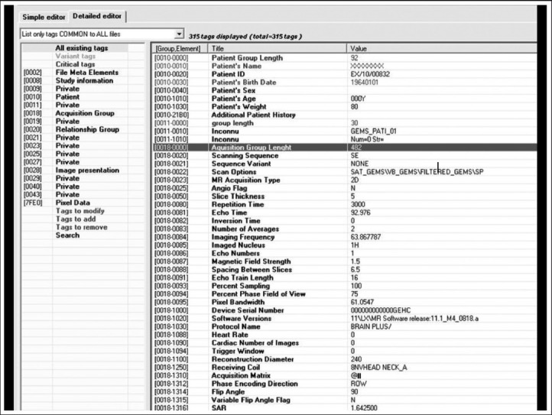

**References**

1. Varma, D. R. (2012). Managing DICOM images: Tips and tricks for the radiologist. *The Indian Journal of Radiology & Imaging*, *22*(1), 4-13. <https://doi.org/10.4103/0971-3026.95396>
2. DICOM. (2022, September 15). In *Wikipedia*. https://en.wikipedia.org/wiki/DICOM