**Submitter:** Elshan Naghizade **Date:** June 6, 2023

The ***“elshan_extract_lib.py”*** file aims to extract features from an image, and generate SQL statements to insert these extracted features into three database tables: `Main_tab_`, `Array_Tab_`, and `Feature_Tab_`. Additionally, it also includes a function to retrieve all file paths from a specified directory, including subdirectories to process dataset working directories all at once in future versions of this program.

* **“get_file_paths(directory)”** retrieves all file paths from the given directory and its subdirectories. It employs the built-in `os` module to traverse through the directory structure and append file paths to a list, which is returned at the end.
* **“extract_features(image_path)”** extracts image features using OpenCV and numpy. Here are the steps it follows:
  1. **Image Loading**: The function begins by loading an image from the given path, and converting it into a numpy array.
  2. **Image Attributes Extraction**: It then extracts the image attributes including height, width, and channels, and it also determines the file type.
  3. **Feature Extraction**: The function computes a color histogram, edge detection using Canny method, and corner detection using the Shi-Tomasi method. These features are stored as numpy arrays.

The function returns tuples containing the extracted information, which are to be used as values in the SQL insert statements. After the image features are extracted, they are used to generate SQL INSERT statements to insert the data into the `Main_tab_`, `Array_Tab_`, and `Feature_Tab_` tables.

Here is the Database schema:

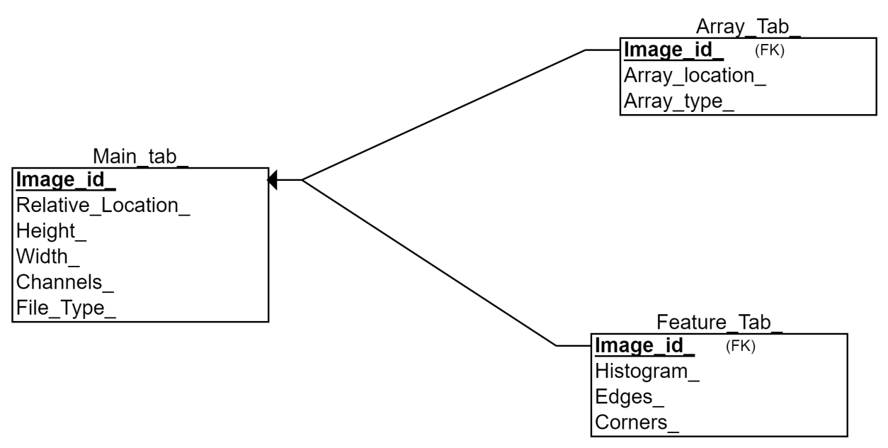

A unique identifier `num` is also included in each insert statement. The SQL statements are then written to a file named 'Inserts.sql', each statement on a new line.