**Name:** Tural Mehtiyev

**Project Title**: Scalability experiment of microservice architecture on an online bookstore application

**Date:** 26.06.2023

**Research Strategy:**

The research strategy will be based on a quantitative approach. Via experimental research, I am planning to collect data of application performance to conduct analysis on metrics such as response time, throughput, error rates, and resource utilization.

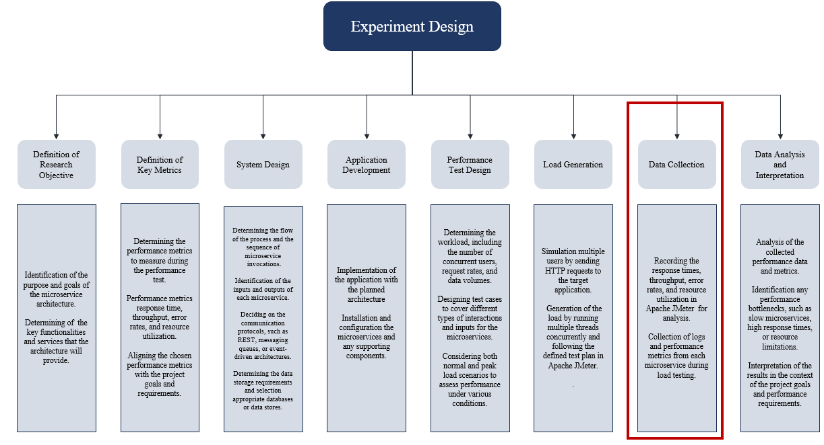

Since data collection and analysis are among the final stages of my experiment, I am currently focused on system design and application development. At this stage, data collection and analysis are not the primary focus. However, I have made progress in designing architecture and databases for microservices.

**Microservices for online bookstore application.**

Product Catalog Microservice:

* Responsible for managing the product inventory, details, and availability.
* Provides APIs for retrieving product information, searching for products, and updating inventory.

Shopping Cart Microservice:

* Handles the management of customer shopping carts.
* Provides APIs for adding items to the cart, removing items, and updating quantities.

Order Management Microservice:

* Manages the processing of customer orders.
* Handles order placement, order fulfillment, and order status updates.
* Provides APIs for creating new orders, retrieving order details, and updating order status.

**Draft Architecture**

**Entity Relationship Diagram and Schema for Microservice Databases**

Book Catalog Service:

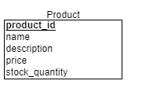

Shopping Cart Service:

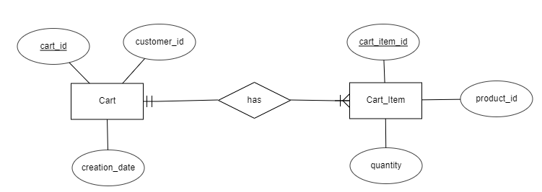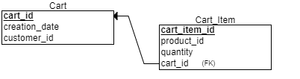

Book Order Management:

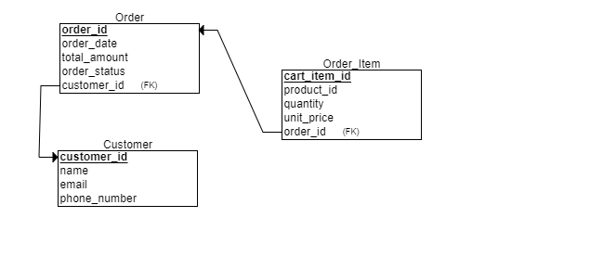

Regarding **Data Cleansing**, I am planning to implement the following strategies for the collected data from my experiment to ensure that unexpected errors in the load tests do not affect my results:

* Utilization of data cleansing techniques like data validation, filtering, and transformation of data types to ensure data accuracy and consistency.
* Review of the collected logs and metrics for data quality issues such as missing or inconsistent values, outliers, or duplicated entries due to.
* Application of data cleaning strategies specific to my experiment's objectives, such as removing incomplete or irrelevant data, handling outliers, and normalizing data formats.