# Assignment 1

## Task 1

1. 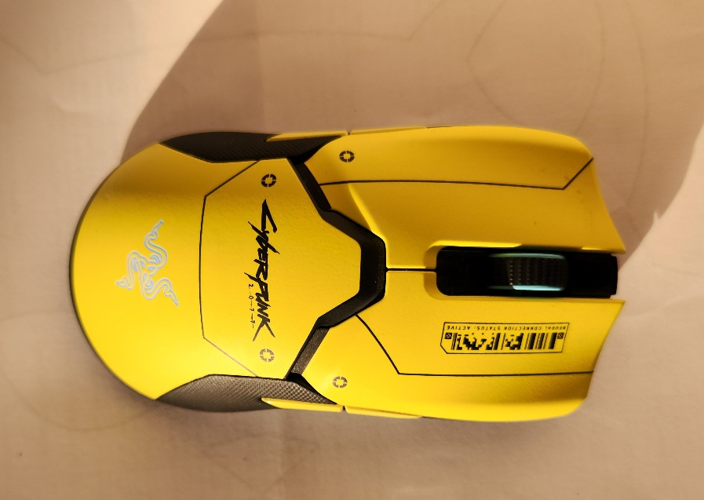

Image : Daylight at 10:00 AM

Image : Daylight at 14:00 PM

1. 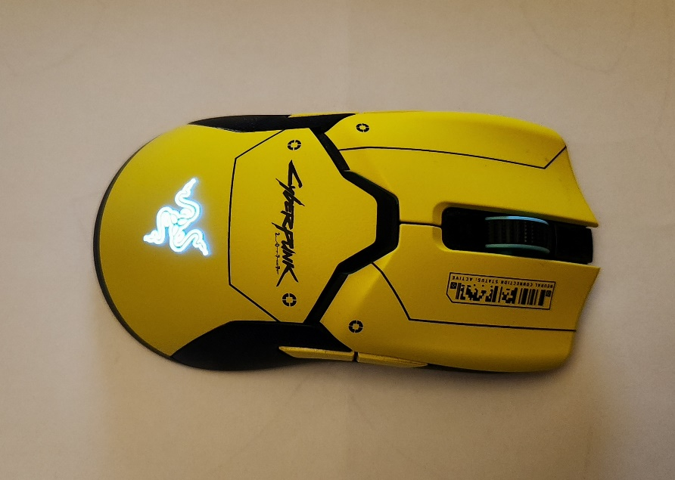

Image : Dim Fluorescent Light

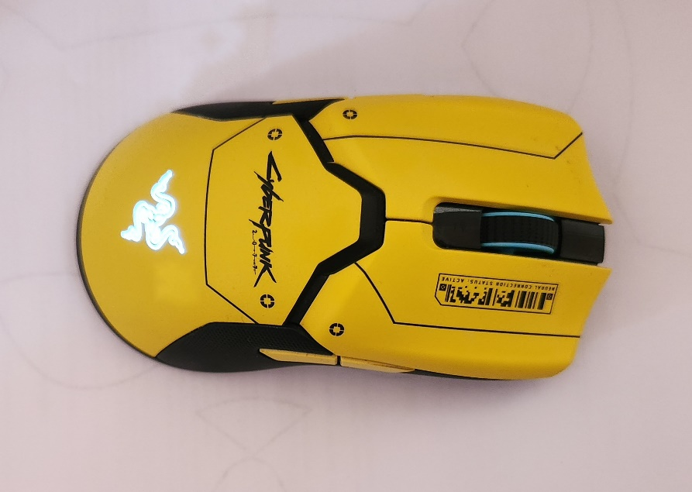

Image : Bright Fluorescent Light

## Task 2

I am using Samsung S22+ for capturing the images. Optics of this device features a triple-lens rear camera setup that includes a 50-megapixel primary sensor, a 12-megapixel ultra-wide sensor, and a 12-megapixel telephoto sensor. The lenses have a fixed aperture of f/1.8, f/2.2, and f/2.4 respectively, and support optical image stabilization (OIS). Moreover, it has several sensors that work together to capture high-quality photos. The primary sensor is a 50-megapixel ISOCELL GN2 sensor that features Dual Pixel Pro autofocus and is capable of capturing 4K videos at 60 frames per second (fps). The ultra-wide sensor is a 12-megapixel Sony IMX563 sensor with a 120-degree field of view, while the telephoto sensor is also a 12-megapixel sensor with 3x optical zoom and up to 30x digital zoom. When it comes to the resolution of images, there are wide range of resolutions, including up to 8K video recording at 24fps, 4K video recording at 60fps, and 1080p video recording at up to 240fps. Photos captured by the device can have resolutions of up to 8192 x 6144 pixels. The Samsung S22+ supports several encoding formats, including HEVC (H.265), H.264, and VP9.