ADA University

School of Information Technology and Engineering

Principles of Distributed Systems

**Assignment 2**

Processes and Asynchronous Messaging

Student: Mammadli Kanan

ID: 4685

Professor: Hasanov Jamaladdin

Baku, October 2023

**Table of Contents:**

1. **Docker Installation**
   1. Register on Docker
   2. Download Docker Installer
   3. Run Docker Installer
   4. Restart Device
   5. Installer Selection
2. **Docker Setup**
   1. Settings
   2. Data sharing
   3. Docker hub
   4. Run command
   5. Docker login
   6. Docker run
3. **Database Setup**
   1. Install IDE
   2. Connect to the database
   3. Configure the database
   4. Download drivers
   5. Create table
   6. Create user
   7. Finish
4. **Docker Installation**
   1. Enter the website [www.docker.com](http://www.docker.com) and proceed to create an account.
   2. Locate the application installer and download the docker installer for your system of choice, in my case it happens to be Windows.

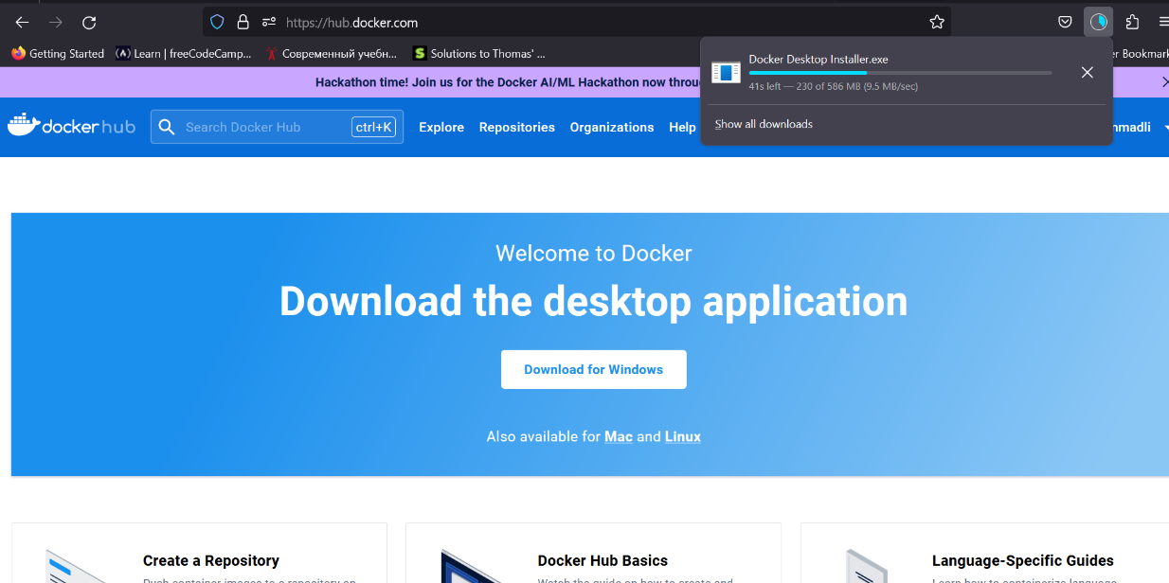

* 1. After the installation has finished, go ahead and run the Docker installer.

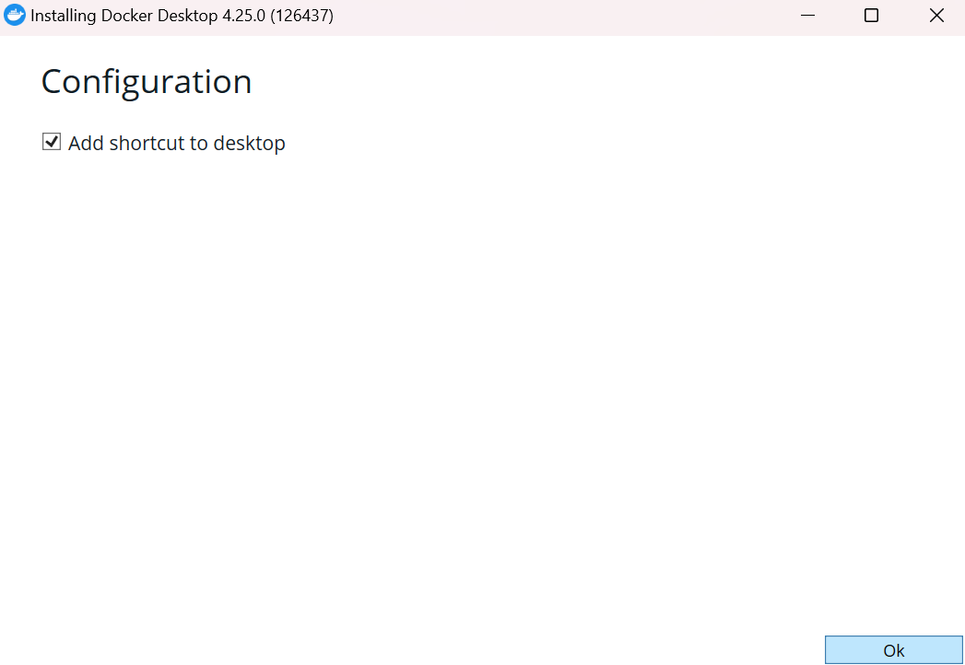

Let the installer run and unpack all the files without disruption, this will take a while, so it is advised to spend some time with your family and friends.

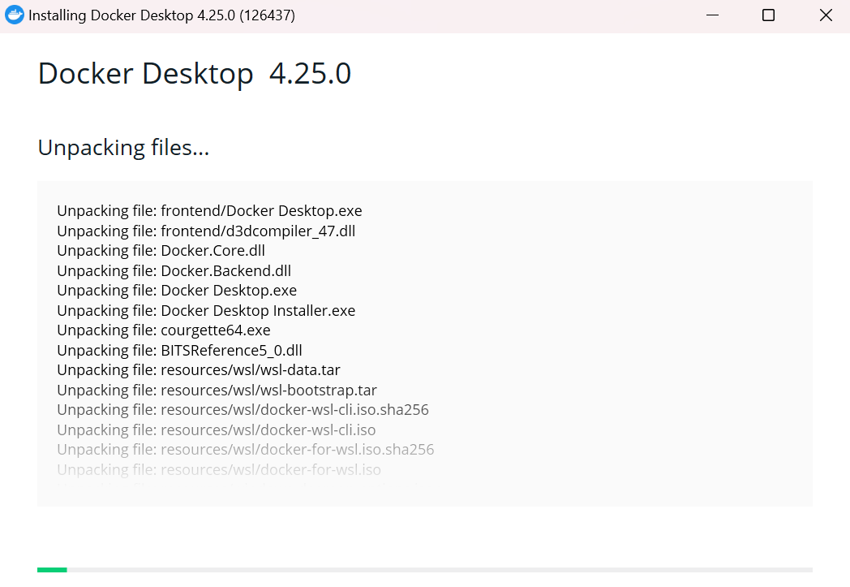

* 1. After the installation is finished, restart your device.

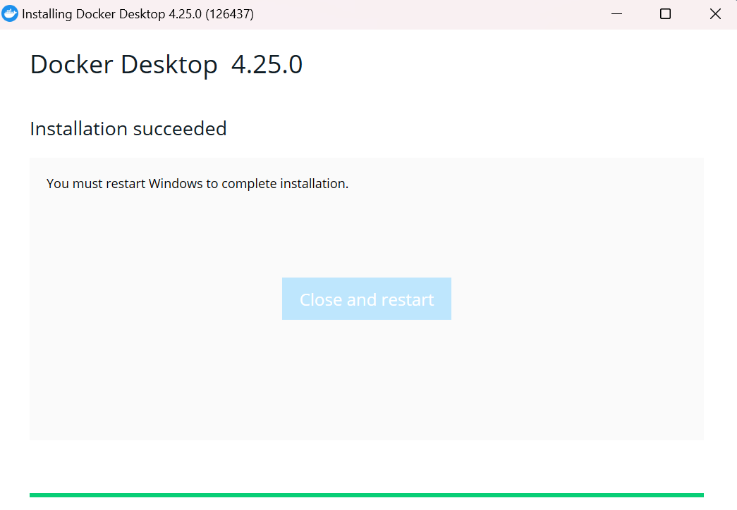

1. **Docker Setup**
   1. Open the Desktop Docker application and select recommended settings.

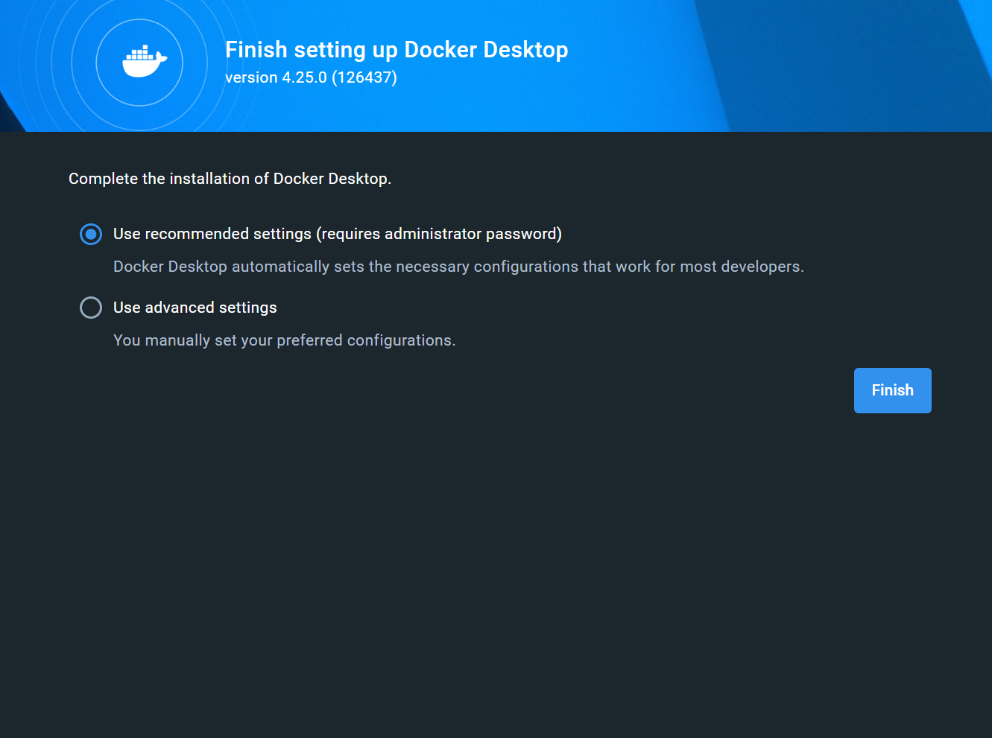

* 1. Give some data to the Docker team who releases freeware for students such as us, try to be honest.

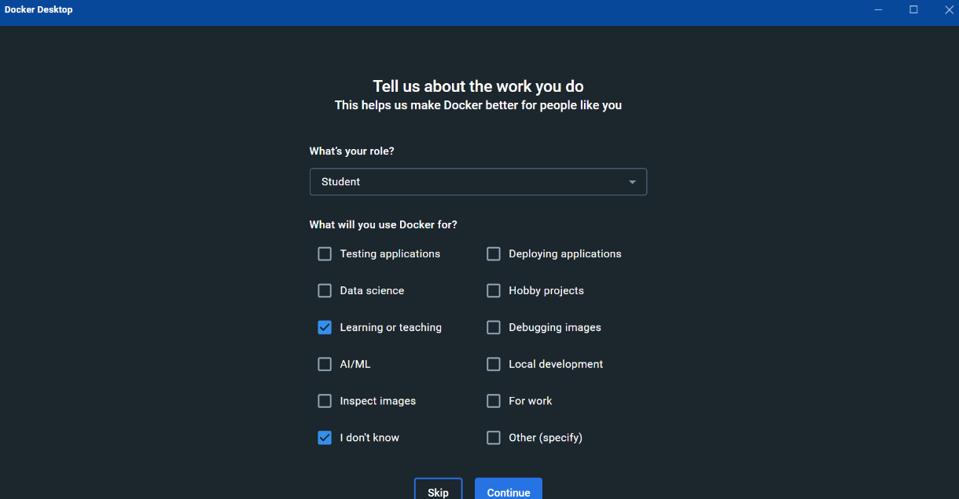

* 1. Open the hub.docker.com website and search for Postgres in the search bar.

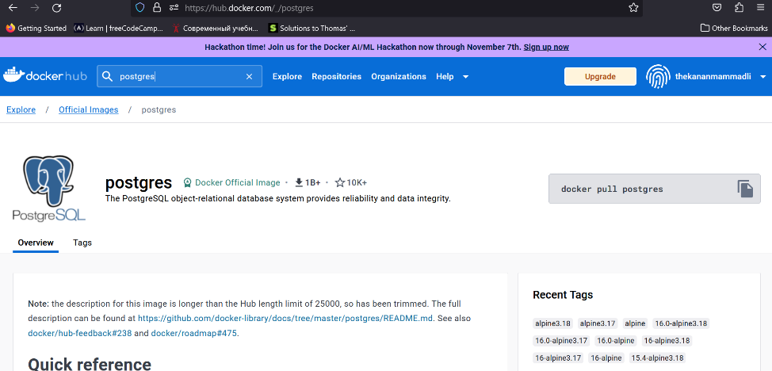

* 1. Scroll down until you find the docker run command and copy it, we will use it to run our docker with proper settings.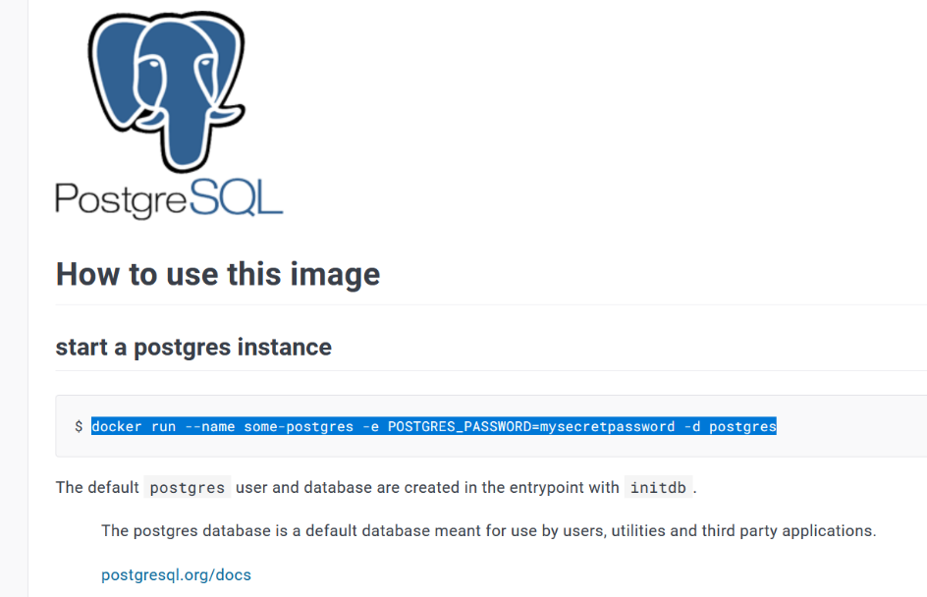
  2. Open command line in your device and type in docker login, it should automatically authenticate you.

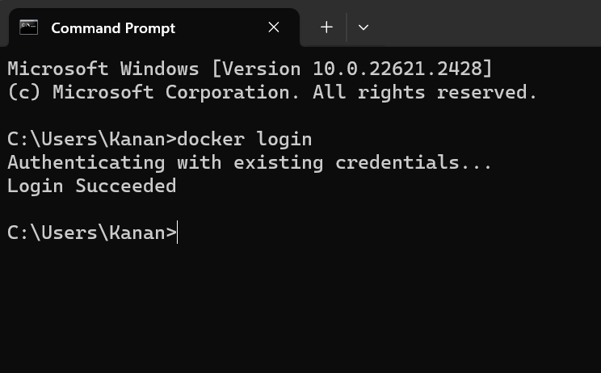

* 1. Paste in the docker run command we copied at figure **2.4.**, change the name and Postgres_Password to desired ones, also add -p 5432:5432 after the name, -p stands for port and the variable 5432 is the port we set for our Postgres. This will run our docker, check if it ran successfully with the docker ps command.

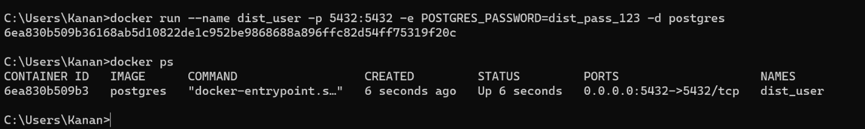

In case your wish to stop your docker, command to stop the docker is:

>docker stop *<dockername>*

In case Postgres is not installed, an installation guide will also be in the repository.

1. **Database Setup**
   1. Realize you do not have an IDE installed and install one. I chose DBeaver, register and install the application.

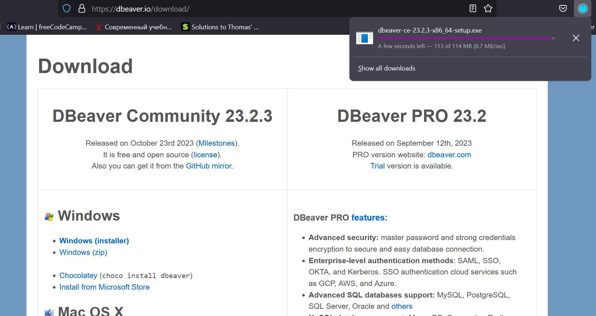

* 1. Open DBeaver or another IDE, click connect to a database, choose PostreSQL and click <next>.

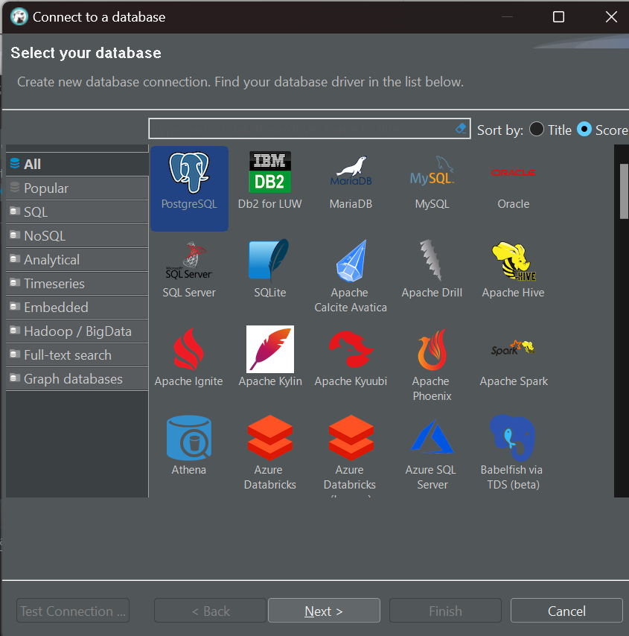

* 1. Setup our port, username and password we have for our PostgreSQL and our Docker. Click on Test Connection.

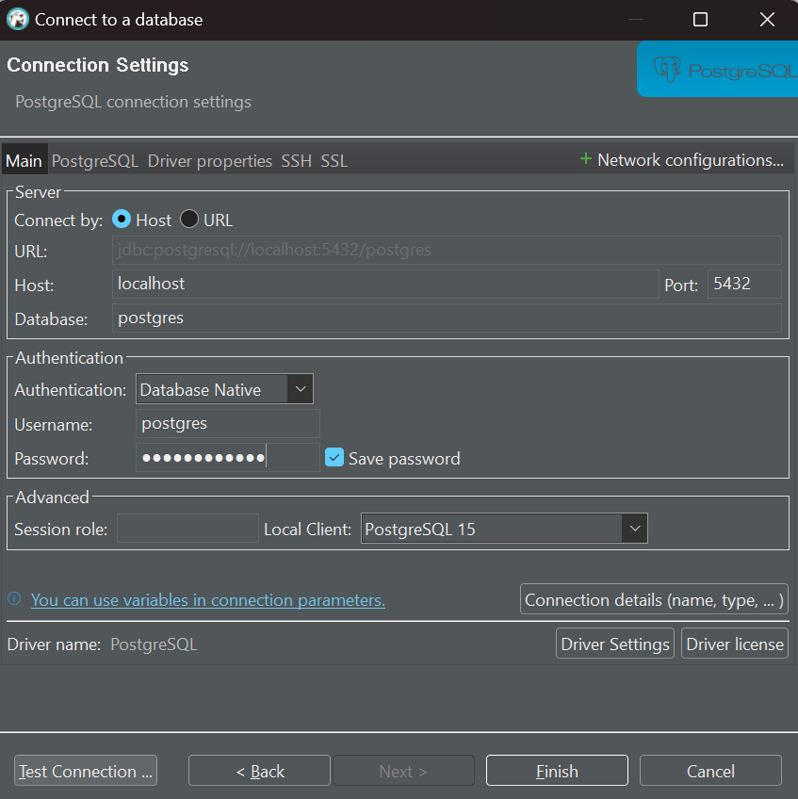

* 1. I have received this notification during the Test Connection, click Download to download all the necessary drivers. After this go back to figure **3.3.** and click Finish.

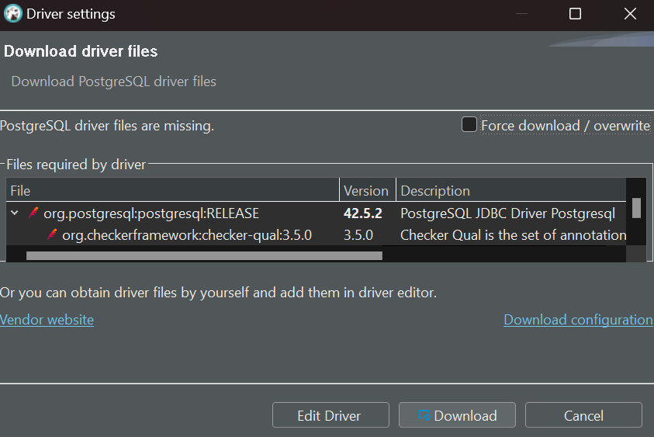

* 1. Create our Asynchronous Messages table.

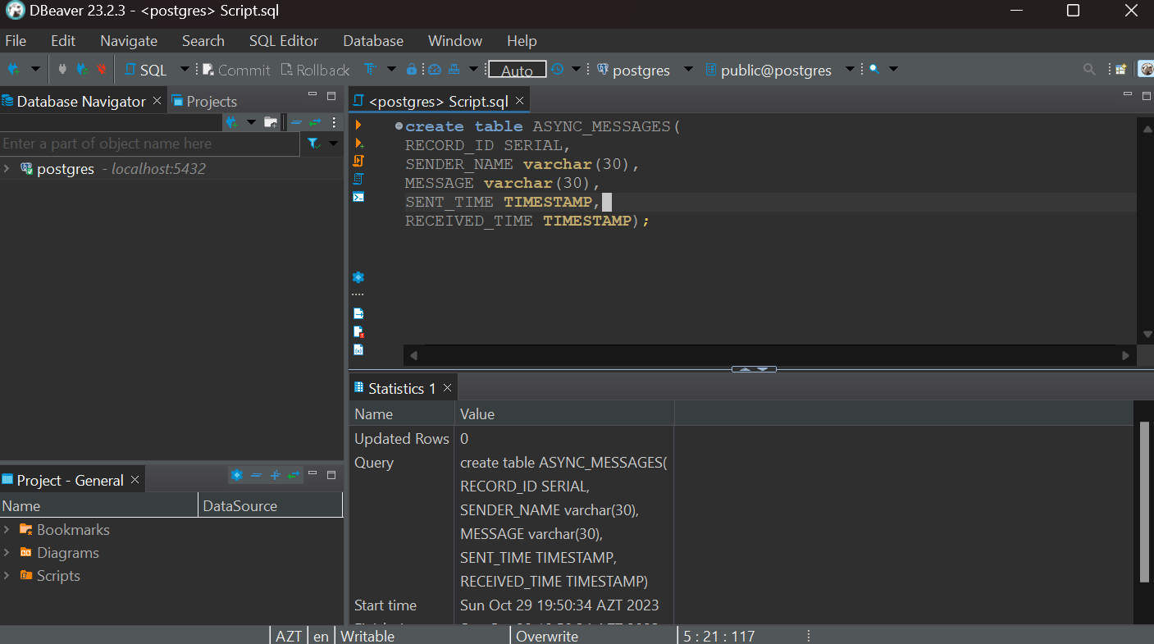

* 1. Create a user and grant the user ability to select, insert and update for the Asynchronous Messages table.

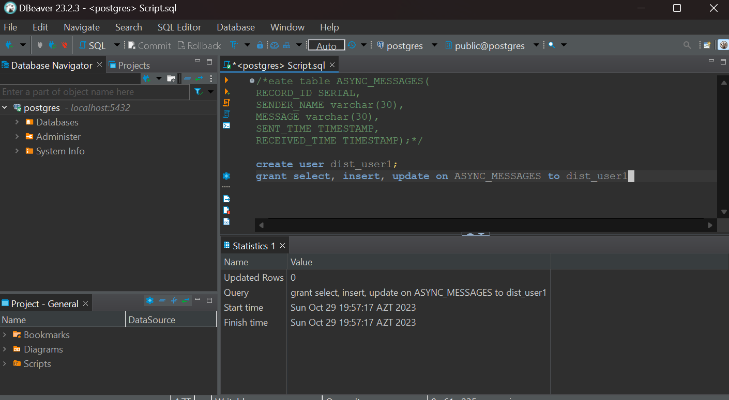

* 1. We are done and are free to call ourselves DB owners.