ADA University

School of Information Technology and Engineering

Principles of Distributed Systems

**Assignment 2**

PostgreSQL Installation

Student: Mammadli Kanan

ID: 4685

Professor: Hasanov Jamaladdin

Baku, October 2023

**Table of Contents:**

1. **PostgreSQL Installer File Download**
   1. Web Search
   2. PostgreSQL Website
   3. Operating System
   4. Hyperlink
   5. Installer Selection
   6. File Download
   7. File Opening
2. **PostgreSQL Installation**
   1. Setup
   2. Installation Directory
   3. Select Components
   4. Data Directory
   5. Password Selection
   6. Port Selection
   7. Advanced Options
   8. Pre-Installation Summary
   9. Ready to Install

**2.10.** Installing

**2.11.** Warning/Error

**2.12.** Finish Installation

1. **PostgreSQL Startup**
   1. App Location
   2. App Startup
   3. Password Input
   4. Finish
2. **PostgreSQL Installer File Download**
   1. Search Postgres/PostgreSQL installer on your browser or the google search engine.

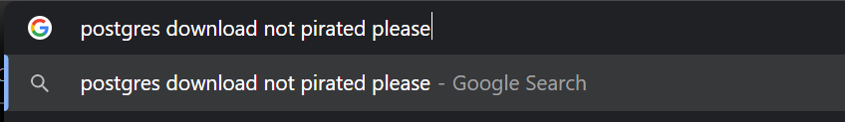

* 1. Locate the “Postgresql.org” website and click on the hyperlink to open the website.

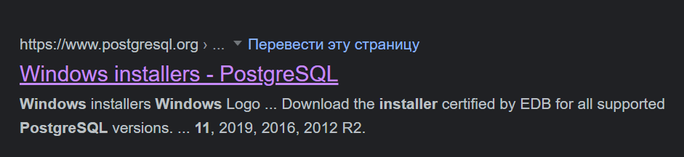

* 1. In the “Downloads” section of the website, locate the operating system that you use, in my case Windows, and click on the appropriate icon.

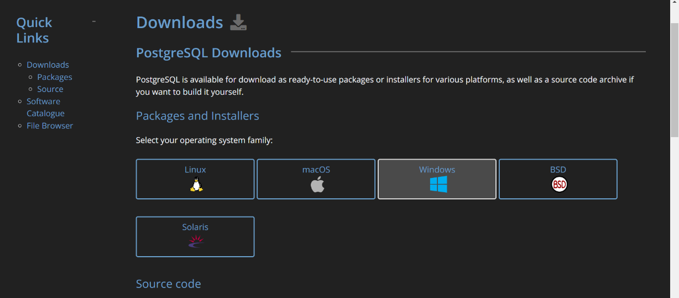

* 1. Click on “Download the installer” hyperlink.

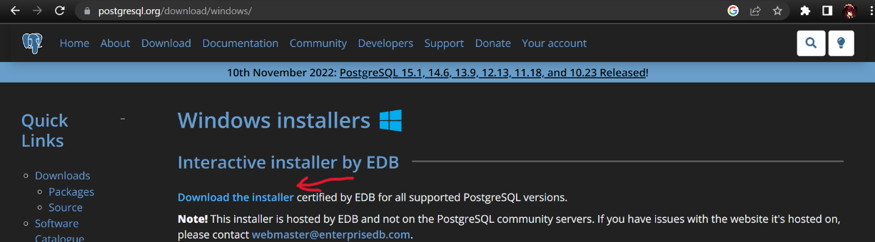

* 1. Locate an PostgreSQL installation version of your choice and your operating system, in my case I chose PostgreSQL version 15.1 for Windows x86-64. For older or weaker Windows machines, it is suggested to sue Windows x86-32 as it is a 32 bit version and is lighter on your system.

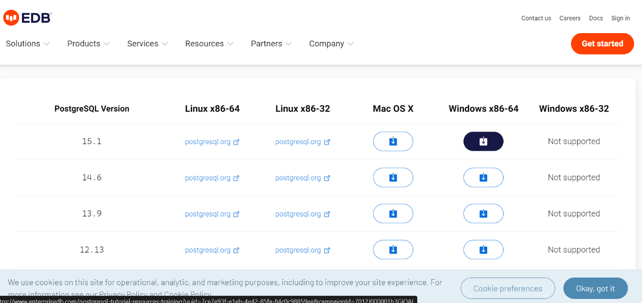

* 1. After you click on a download icon, you should be redirected, and file download should begin.

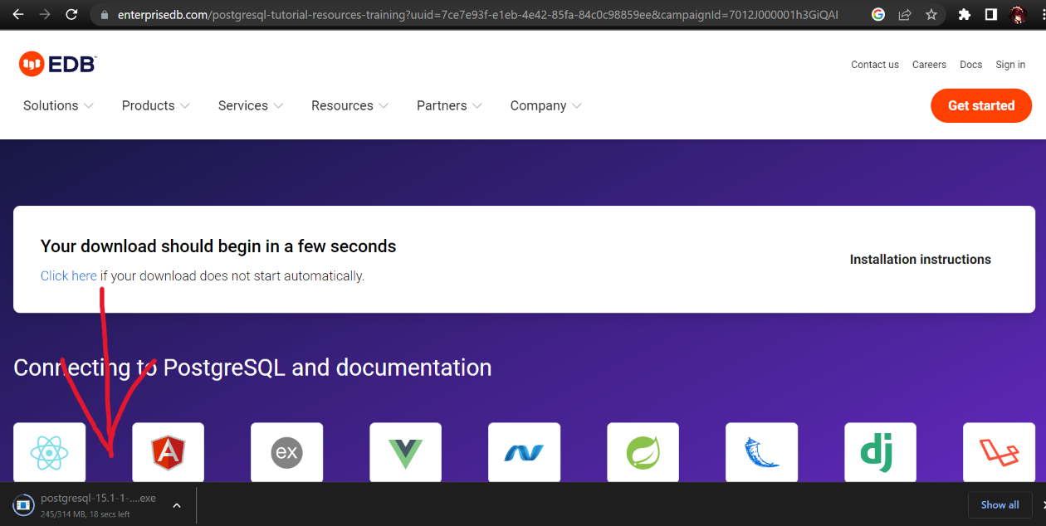

* 1. After the downloading process is finished, click on the downloaded file.

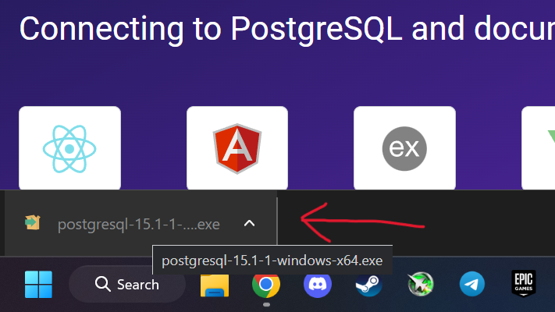

1. **PostgreSQL Installation**
   1. After opening the installer, you should be greeted by a setup screen, click on “next”.

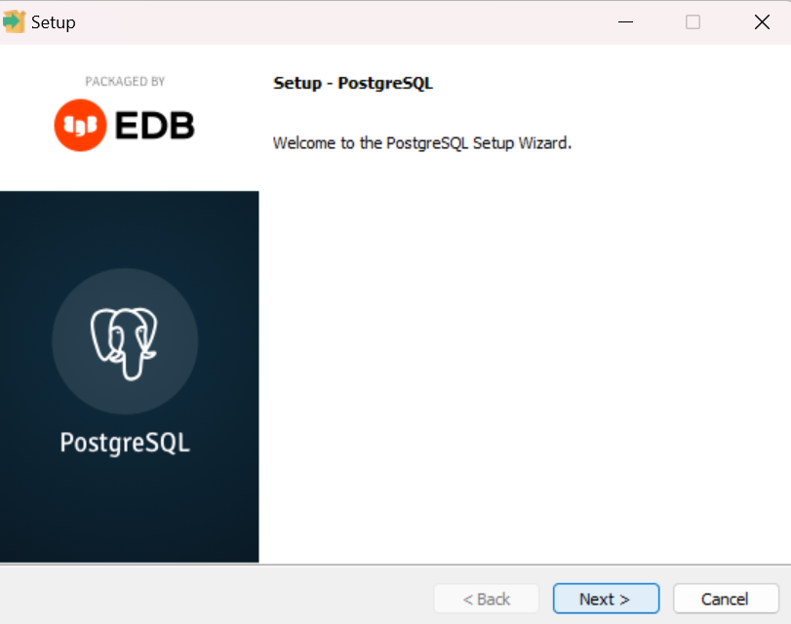

* 1. In the choice of installation directory, either specify a different location or leave it default as I have. Click “next”.

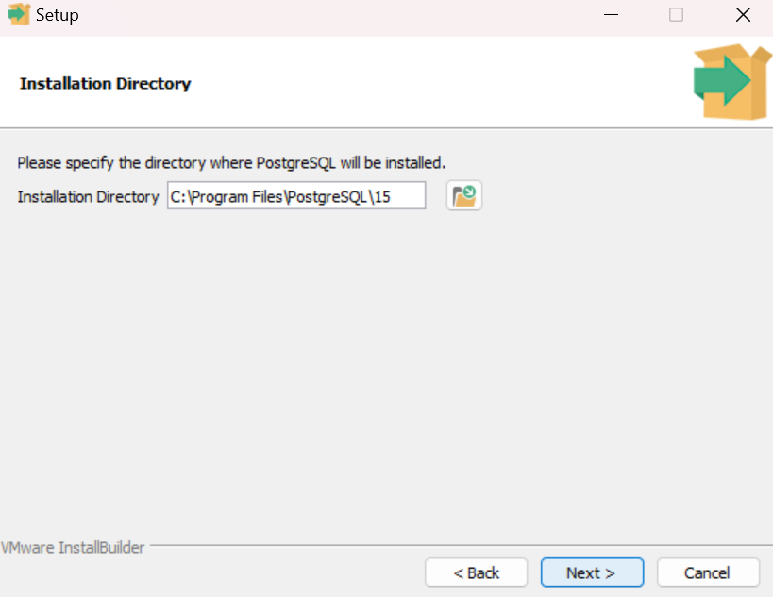

* 1. In selection of components, make sure to have all boxes checked out with blue checkmarks and click “next”.

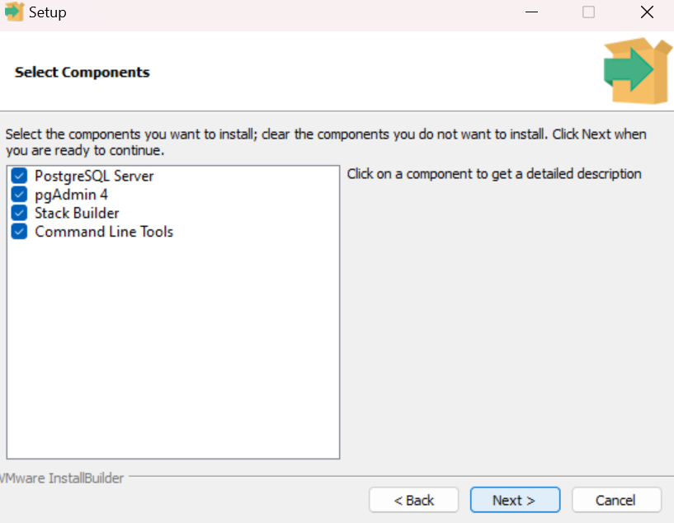

* 1. In “Data Directory” section, either specify a different location or leave it default as I have. Click “next”.

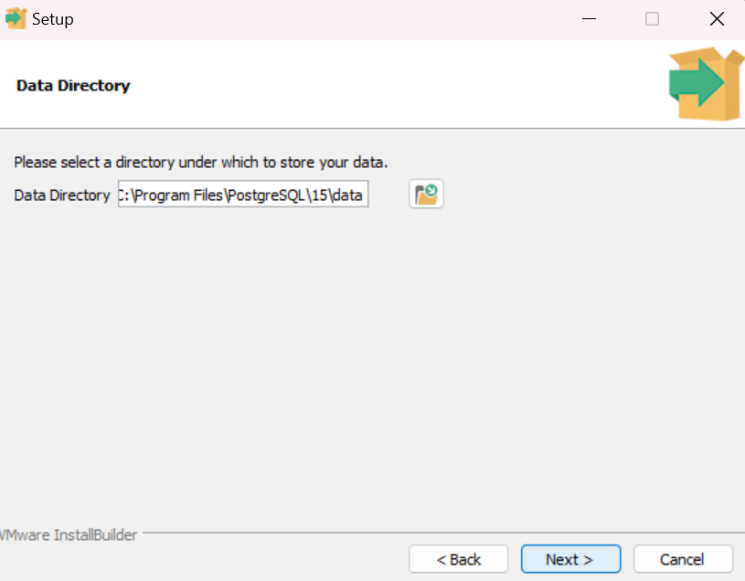

* 1. In the “Password” section, set up your password and click “next”.

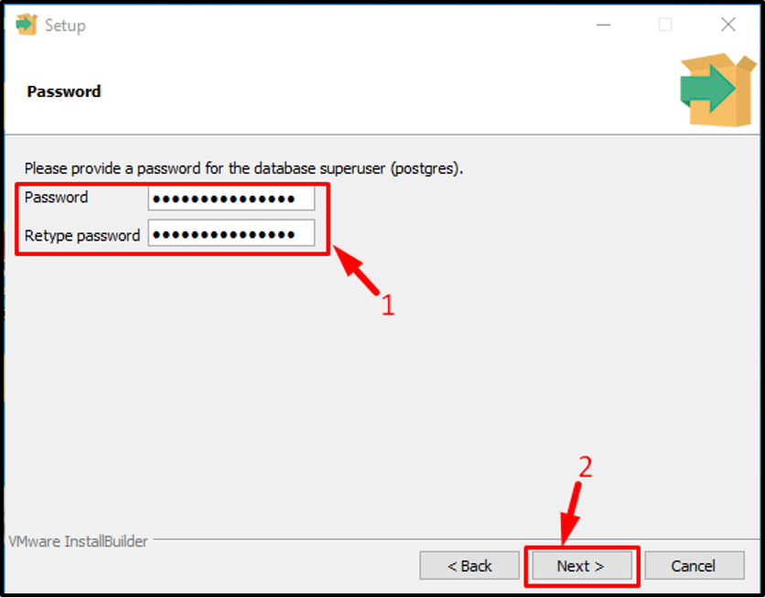

*image was pulled from the internet as I either forgot to take a screenshot or it failed in the password section*

* 1. In “Port” Section, either specify a different port or leave on default, which should be “5432”. Click “next”.

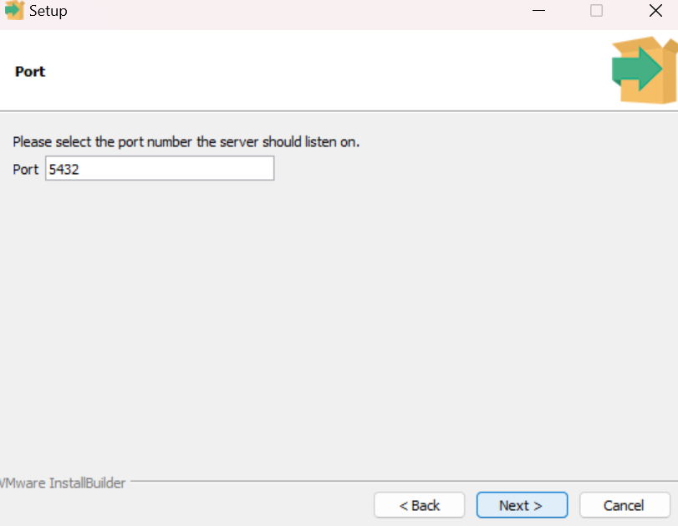

* 1. In “Advanced options” you will be offered to set up your locale, you could leave in blank, I have opted for Azerbaijani(Cyrillic) for some reason. Click “next”.

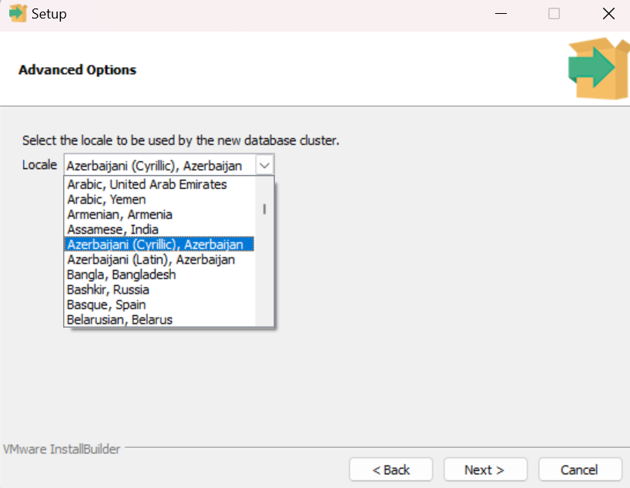

* 1. In “Pre-installation summary” section, verify your set up and click “next.

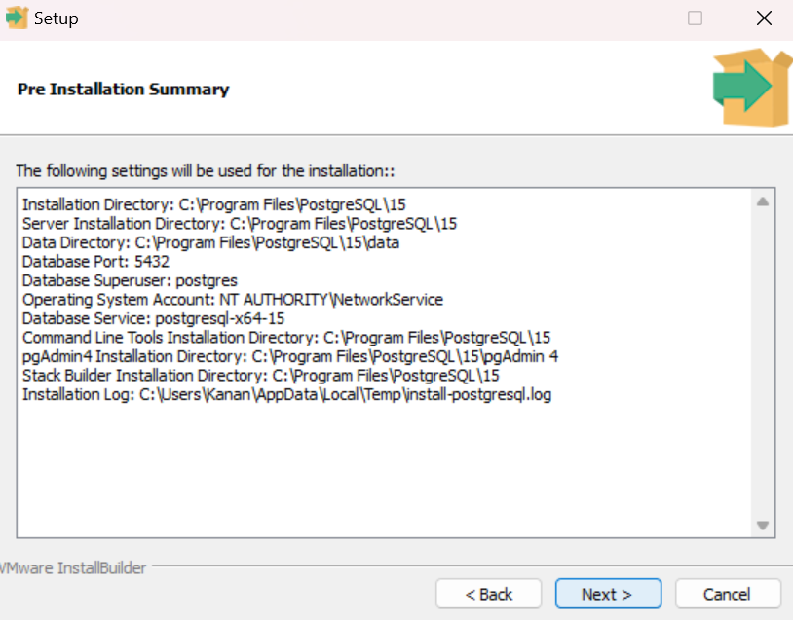

* 1. In “Ready to install” click “next” when you are ready to install.

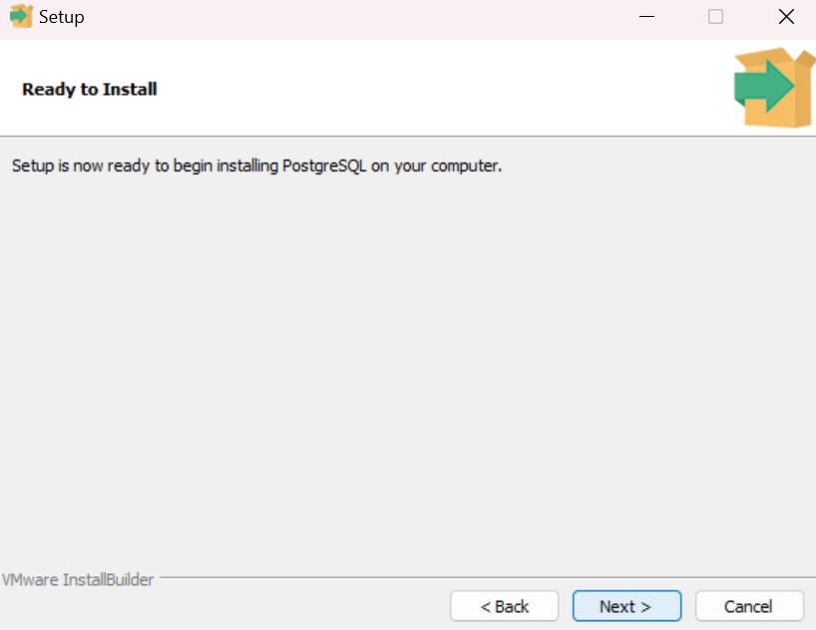

**2.10.** Let the installation process go on unimpeded, keep your device plugged in and running. Perfect time to go on and make yourself some tea in the meanwhile.

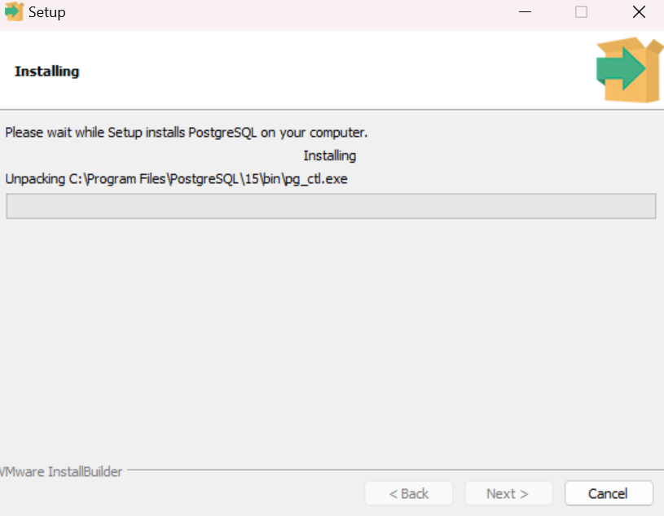

**2.11.** Crucial step. During the installation process you might receive a warning. You must channel all of your years of experience as an IT specialist, click “OK” and let the installation proceed as is.

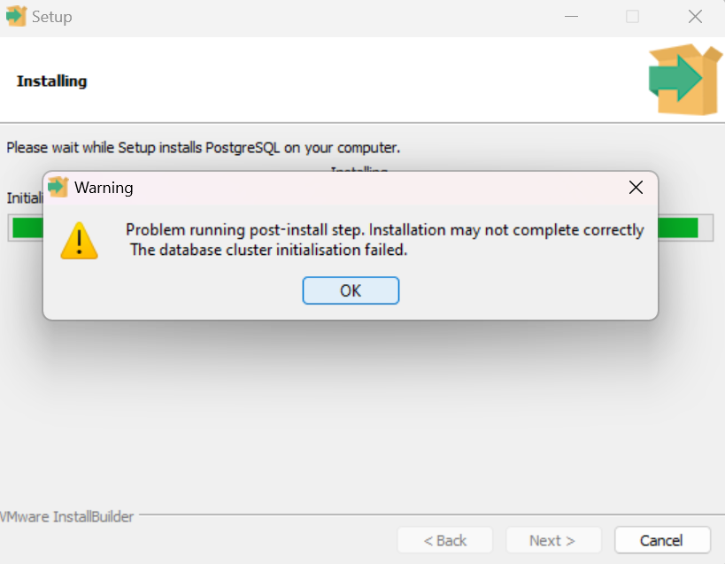

**2.12.** After the installation process is finished, click “Finish”.

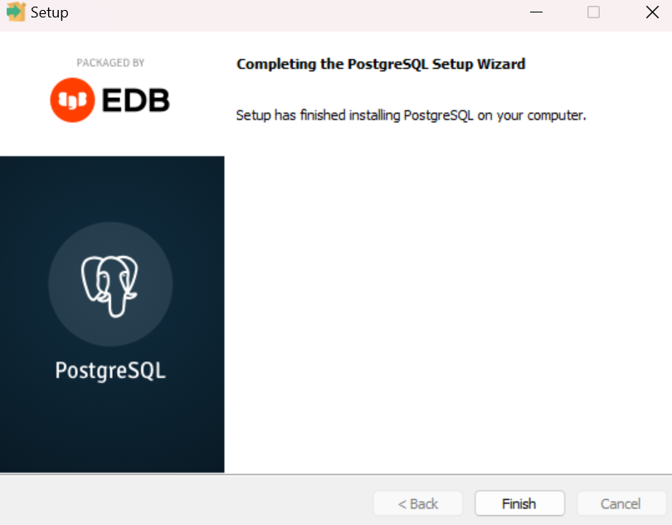

1. **PostgreSQL Startup**
   1. Search in your search bar for the “pgAdmin 4” app and click on it.

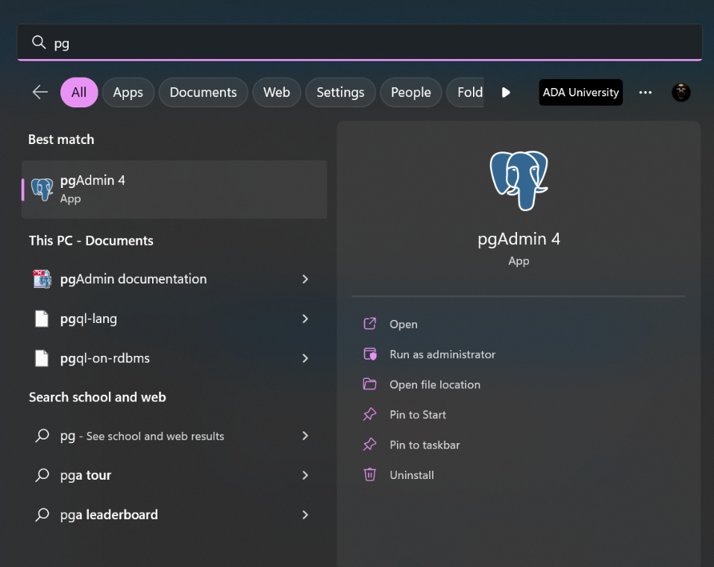

* 1. The app should begin starting up, let it start up without turning off your device.

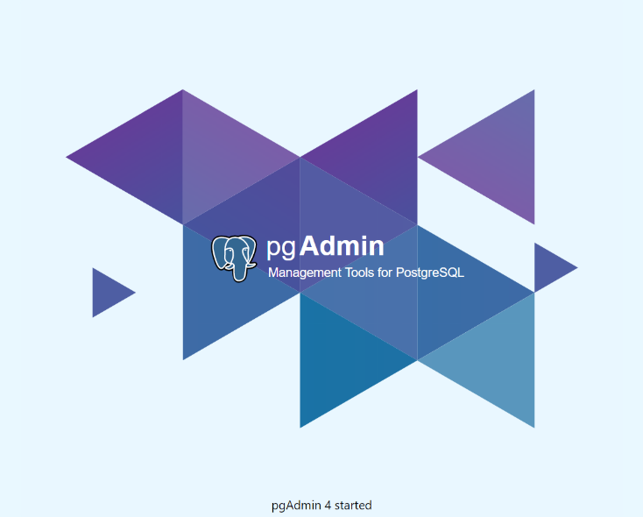

* 1. After the app starts up it will ask for your password that you set up during the installation process during the step **2.5.**, write it down and click “OK”

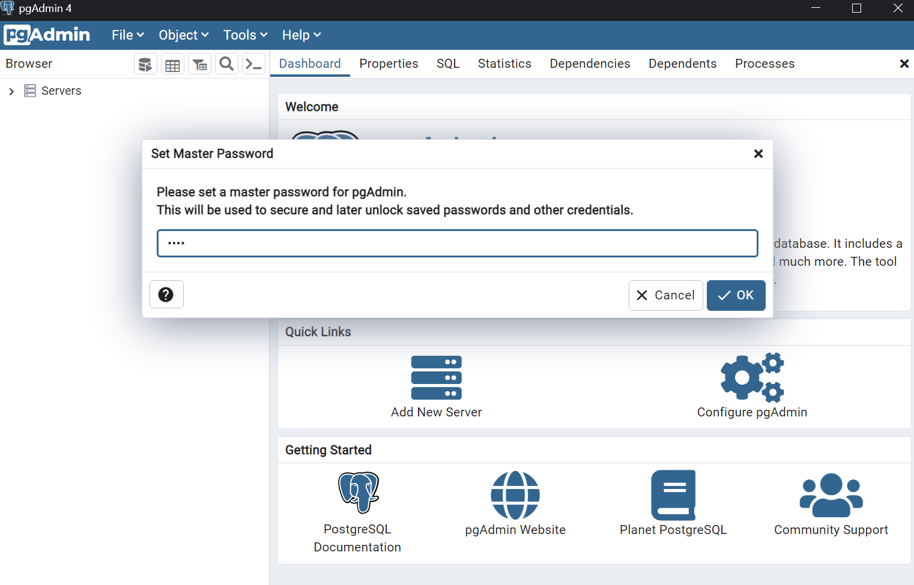

* 1. You are done and free to use the app.