**Notion link**

<https://www.notion.so/84765e38d3df483bb0e5f6f5791b5935?v=36b7e91153e3433abdc8272d38992416>

**GitHub link**

<https://github.com/ADA-SITE-CSCI-1202/team-project-team-1>   
  
**YouTube link**

**Team allocation**

|  |  |  |
| --- | --- | --- |
| Team Members | Contribution | Estimated % |
| Murad Orujov | Created admin and user view. Tested the code with Farhad and worked on bug fixes. Created UML diagram. | 25% |
| Farhad Rahimov | Created login and registration. Helped everyone to apply Java Swing. Started writing a report. Worked with Murad on fixing errors in the code and translated into Azerbaijani and helped earn bonus points. | 25% |
| Ibrahim Asgarov | Created filtering and sorting part. | 25% |
| Leyla Hasanzade | Created general and personal databases. Made adding books and reviews plausible. Continued writing report. Edited and posted YouTube video. | 25% |
|  |  |  |
|  |  |  |
|  |  |  |

**UML Diagram**

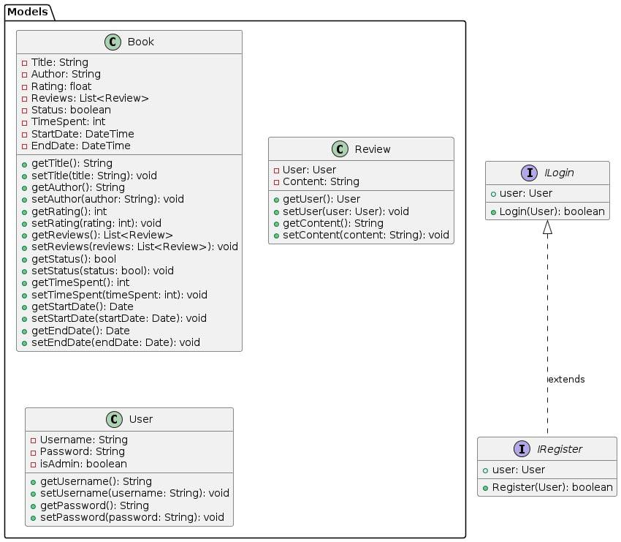

In Login System package’s IdandPassword.java class, we read Users.csv file and assign it to a hashmap. And with this class’ getLoginInfo() method, we can get that hashmap

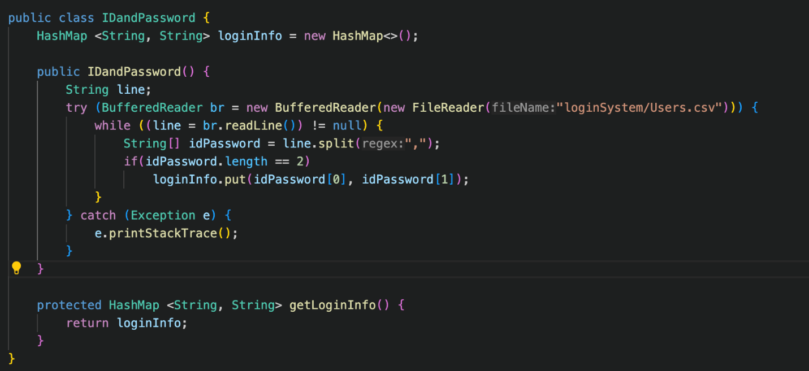

LoginPage.java’s constructor is triggered by this hashmap.

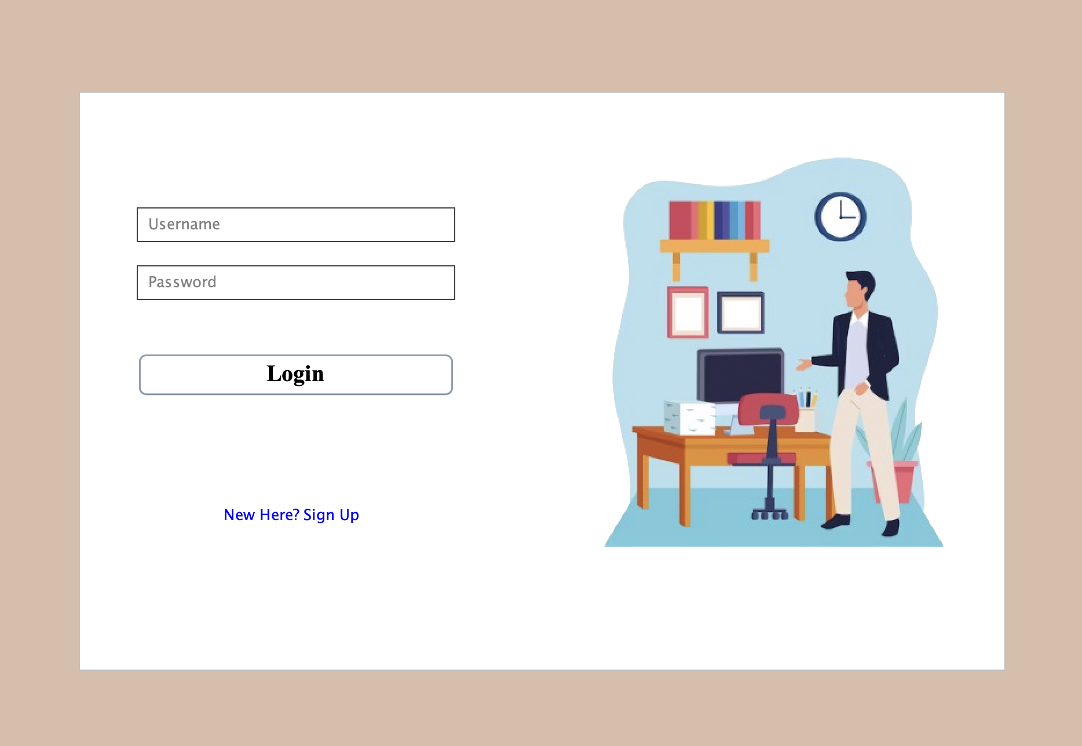

Whenever user input username and password, it is checked whether this username and password is in this hashmap. If yes, and if login and password equal to “admin”, then adminView is opened, else if they equal to user, userView is opened. If username is correct but password is wrong, program warns user that password is wrong. There are some exceptional(error) cases as well:

Nothing entered to the jTextField and JPasswordField: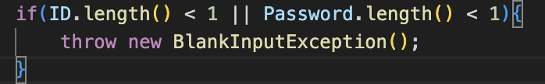

//it is a custom exception that we created

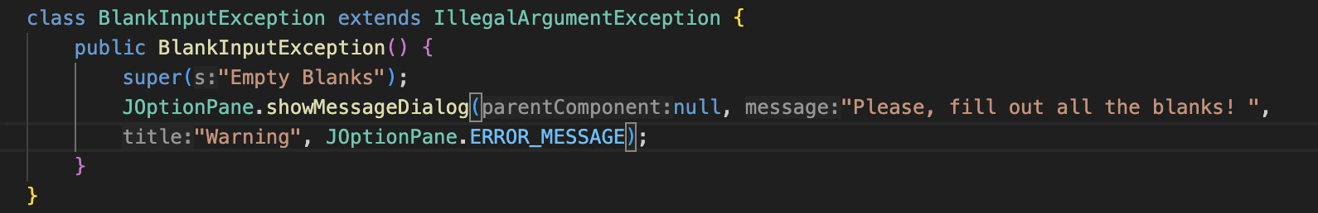

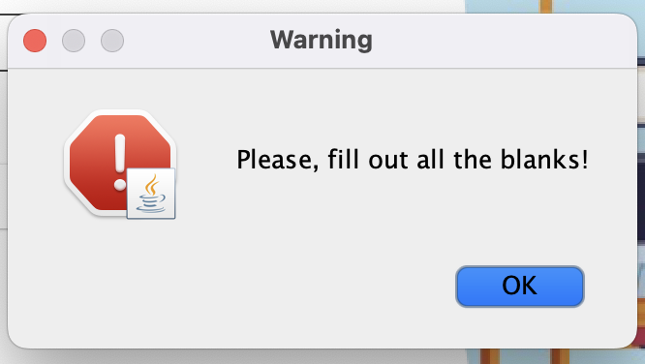

if the following clickable text is pressed the SignUp page opens.



User can achieve this page in another way as well. If the entered username does not exist, the following JOptionPane is opened:

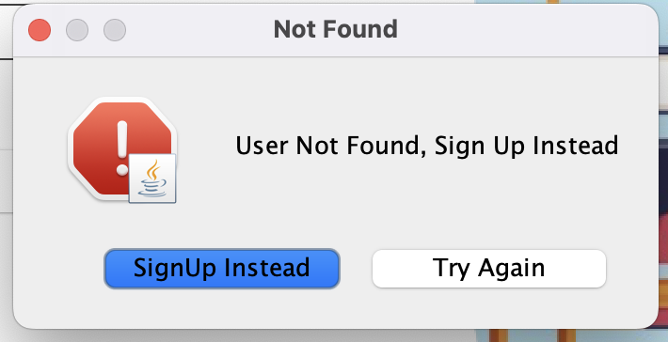

If Try Again is pressed user can try another login, but if SignUp Instead is pressed, SignUp page is opened:

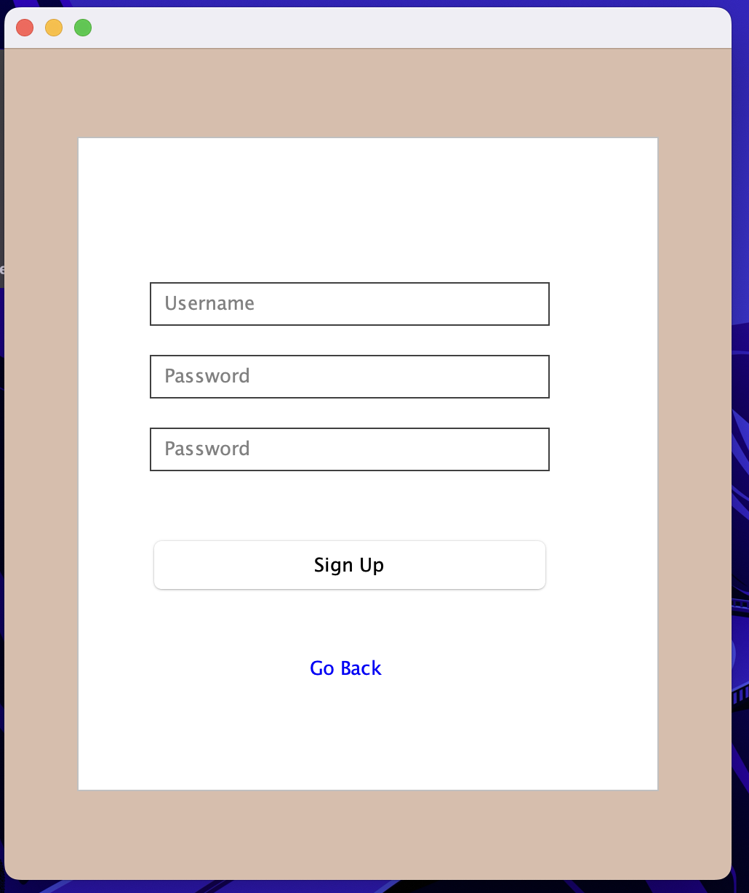

In this JFrame, user tries to sign new UserName and Password to the Database. But there are exceptional cases and some requirements:

* Username should be between 5 and 15 characters
* Password should contain at least 8 characters, including at least 1 Uppercase, 1 Lowercase letter, and 1 number
* The second and the first passwords should be the same
* The most import: Username should be new
* All the blanks should be entered

if any of them is not handled, then error and corresponding JOptionPanes appears. Each of them has custom classes extending an exception and initializing its JOptionPane.

for example:

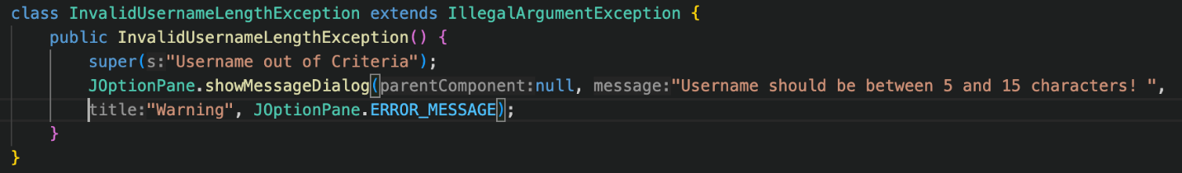

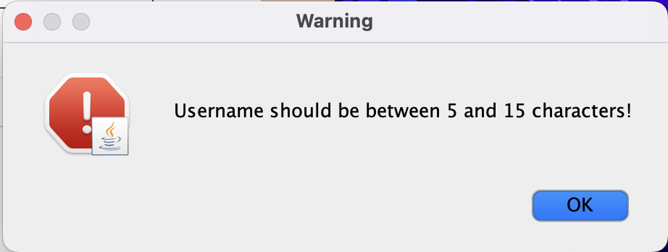

if a new user successfully signs up, then it is added to the csv and hashmap(yes, hashmap doesn’t read anything again, until the program is closed and opened again; how we achieved this? as hashmap’s name loginInfo is a reference to the real HashMap object, we pass the reference from loginPage to SignUp page when we initialize SignUp page).

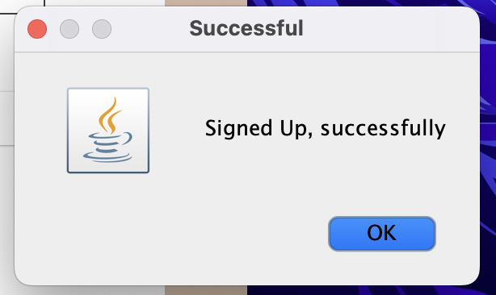

Now let’s lead to databases

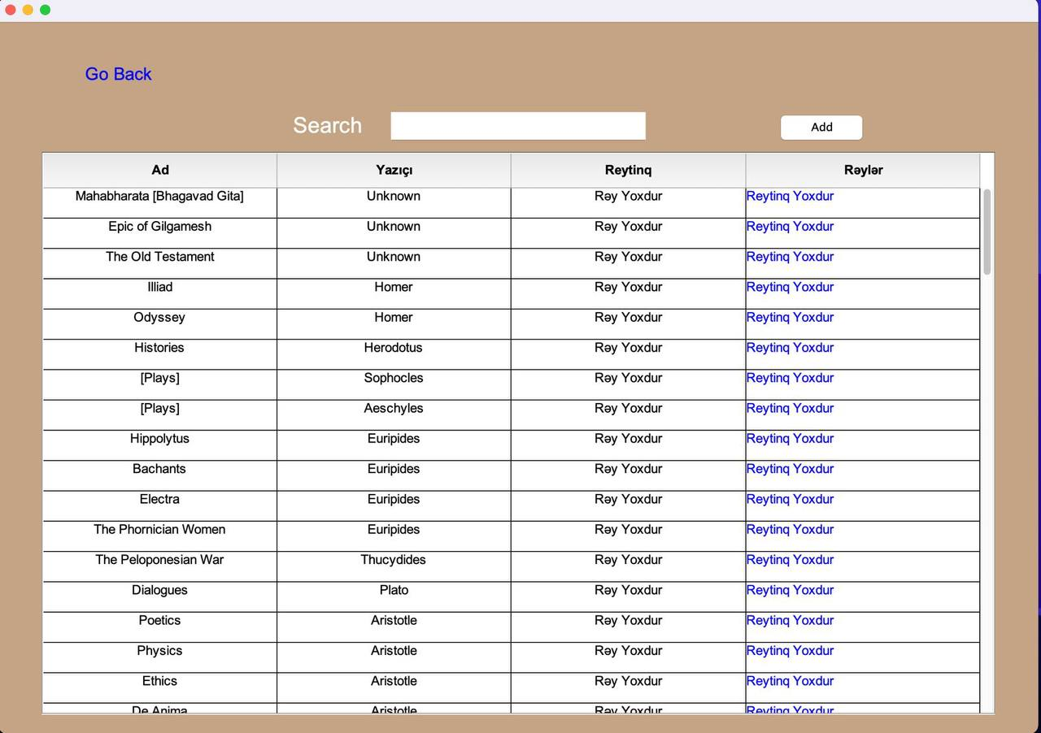

This database is general and it is used for user, as you can choose a row and add a review or rating. It includes filtering, sorting and searching methods; represents 4 rows(title, author, rating and review). “Search” button can be used to search by titles or author names. Here you can also add a review or rating yourself. “Go Back” button goes back to user view.

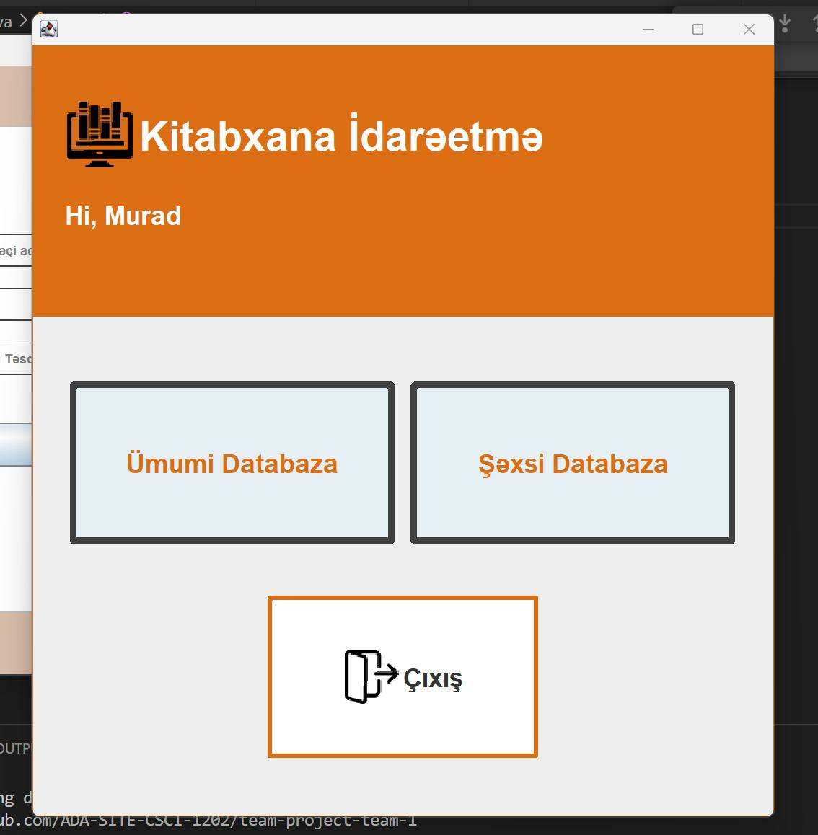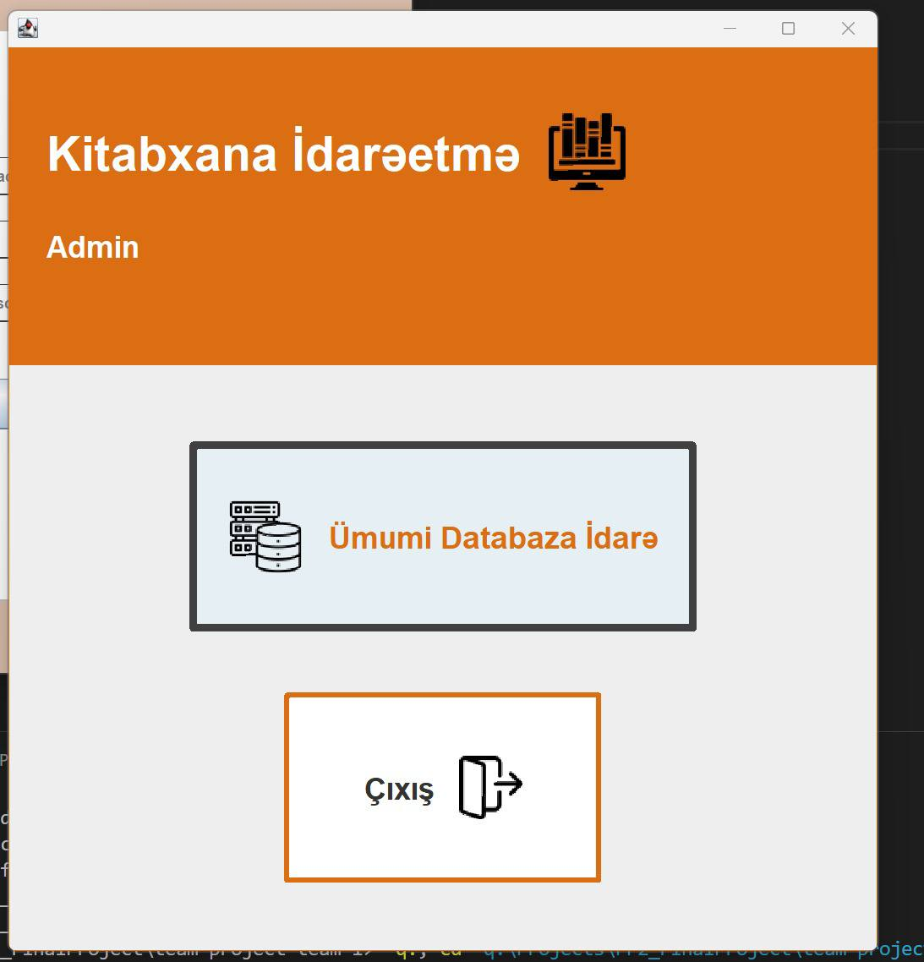

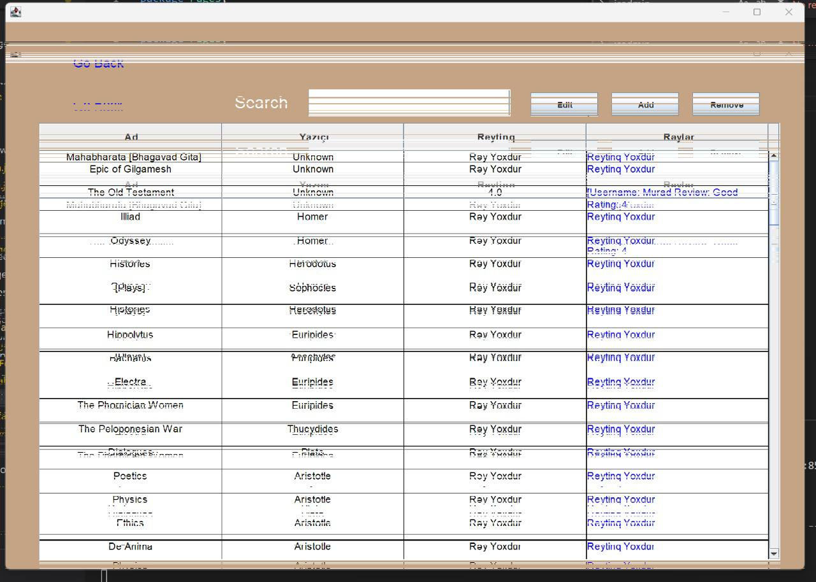

Finally Personal Database

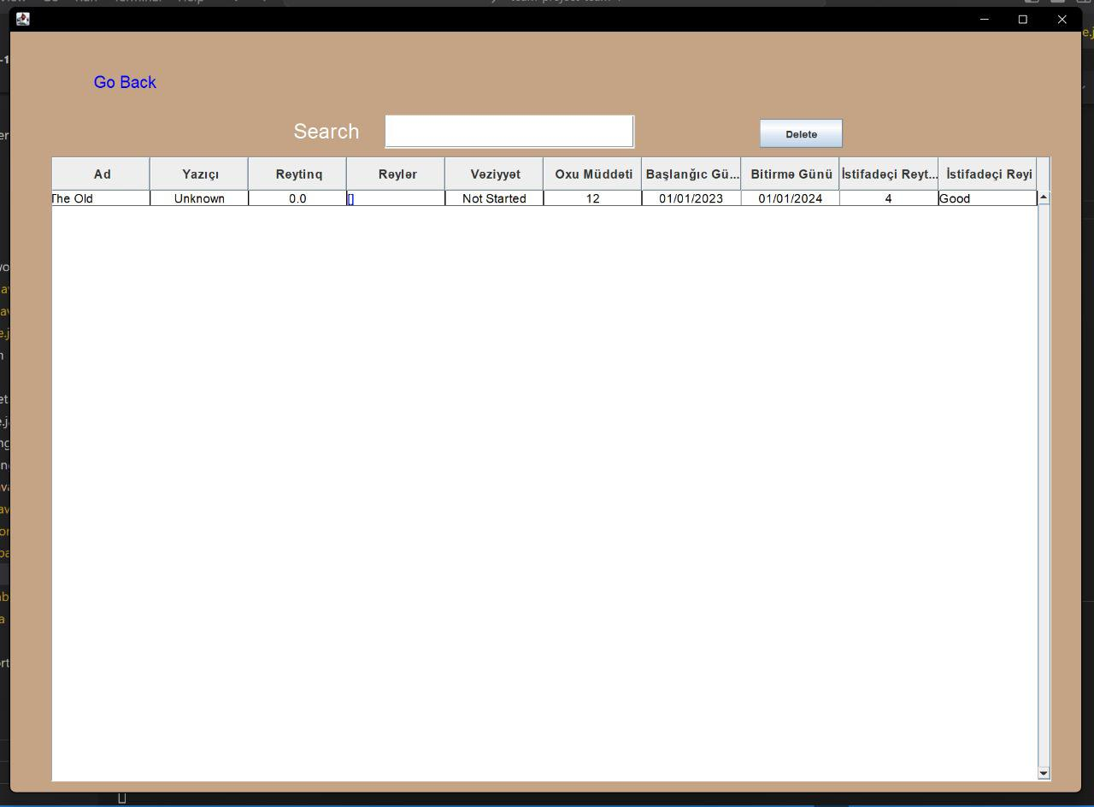

Unlike General database, it consists of 6 columns(Status, Time spent, start date, end date, user rating, and user review), however, the functions of filtering, sorting and searching are the same .