Qiz Qalasi Defense

No one is allowed to enter!

Design Document   
(Homework No.2)

Project team: Bakililar

Instructor: Dr. Araz Yusubov

Submitted in partial fulfillment of the requirements of the CSCI 4836: Game Development Fundamentals course project

|  |  |
| --- | --- |
| Version date | Version information |
| 21.10.18 | Initial draft |
| 21.10.18 | 2.0 |

|  |  |
| --- | --- |
| Other documents in the package | |
| File name | Brief description of the document |
| <File name> | <Description of the document> |
| <File name> | <Description of the document> |

|  |  |  |
| --- | --- | --- |
| Team member | Contribution to this homework (NOT the project) | Estimated % |
| Gunay Abbasova | Introduction, Global Game Elements | 25 % |
| Arsalan Iravani | User Interface, Game Architecture | 25 % |
| Seymur Ayvazov | Antagonistic Elements, Game Architecture | 25 % |
| Farhad Alishov | Player Elements, Global Game Elements | 25 % |

# Table of Contents

**Table of Contents** **2**

**Introduction** **3**

Game matrix 3

Game Flowchart 4

**Player Elements** **4**

Player Definition. 5

Player Properties 5

Player Rewards (Power-ups & Pick-ups) 6

**User Interface (UI)** **6**

Heads up Display (HUD) 6

**Antagonistic Elements** **6**

Antagonistic Definitions 6

Antagonistic Properties 6

Antagonistic List 6

Artificial Intelligence (AI) 7

**Global Game Elements** **8**

The Story 9

The Story Copy 9

Concept Art 10

Level Design 10

Level Copy 10

Audio & Sound F/X 10

**Game Architecture** **10**

Game Architecture Overview 10

Architecture Copy 11

How to Play Copy 11

# Introduction

This is part of the Game Design Document for a hypothetical project <Qiz Qalasi Defense Game> submitted for partial fulfillment of the requirements of the Game Development Fundamentals course in the School of Information Technologies and Engineering at ADA University, Baku, Azerbaijan.

Our video game which is called Qiz Qalasi Defense is about to maintain player’s area or properties from enemies by obstructing the entrance to tower. It is the primitive offline single player game that played with the mouse. The main objective of the game is to get much more money as possible as player can before the game ends. Player should do their best to protect their tower by killing the incoming enemies. By placing the protective towers, player will try to overthrow and shoot the enemies. The player should be able to locate defensive towers in particular zones. The player’s will have some steps to protect their tower and if the player win each steps, upcoming levels will become harder and enemies will become stronger. At the beginning of the level, enemies will show up in a location assigned for starting each level. Enemies will appear in every levels of the game. Each level will be more inflexible for the player. There will be only one type of enemy at the first level; nevertheless all the time when you reach the each level, the number of the enemy type and the amount of the incoming enemies will be increased. The period of level will be longer each level. Only some particular towers will be used in each level of the game. These enemies will go forward their target through a set path, also each level. At the end of the game player will win when the player survive from all enemies and eliminate all the incoming enemies from their territories.

## Game matrix

|  |  |  |
| --- | --- | --- |
|  | **Name** | **Description** |
| **1** | **Map** | The terrain map which includes birds eye view in which buildings and other elements of close territory of player will be seen. |
| **2** | **Player** | The important character in game which user will control each of their customized players |
| **3** | **Rockets** | Is used for killing the enemies |
| **4** | **Qiz Qalasi** | The Place where we should protect |

## Game Flowchart

The below is general game flowchart:

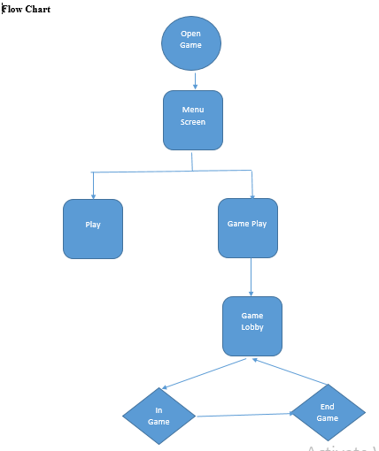

# Player Elements

Basically we assume that main benefit to player to succeed to next levels will be his quickness and tactical use of weapons. The player will be provided with not improved and not powerful assets to keep 07 cars or tractors out of Qiz Qalasi however to make the game interesting and doable for player we give little power to 07 cars in beginning of the game. This selection of power share between enemies and player will ensure that after a small amount of time player will master some skills. To provide benefit to player 07 cars are provided with little speed of moving as well as they are given little health. As few assets are thrown on enemies they will be removed from screen which will give 1 point to player for destroying one enemy. Player is expected to have time to look at his weapons and power for further attacks. It will happen if player will demonstrate good game and destroy enemies quickly before other 07 cars to Qiz Qalasi. There will be little time that no enemies will be on screen and player will be provided with time assumedly to substitute his weapon with more powerful ones. This benefit will be given at high levels of game when player will score points and get new assets for use. In first level player will have 30 stones to destroy 20 “07 cars or tractors”. Player is given a name of Bakili Qaqash who defenses his city and Qiz Qalasi from enemies such as 07 cars or tractors.

The game will be offline single player game. It will not have a special requirement of internet connection.

## 

## Player Definition.

Below is a suggested list of player definitions:

• Default (Status): Player will be given basic abilities in the first level. He will have stones to throw on enemies. After he throws the stone and until it beats enemies he can not throw other stone. This selection of player ability is for demonstrating the increase in power of player as he will throw assets at quicker manner in higher levels of the game.

• Actions: Player can basically succeed with killing enemies and not do anything giving Qiz Qalasi to Arabian guys. He can make selection of weapons to use. Player can give time to enemies to come near Qiz Qalasi. This ability will make it easy for player to beat enemies accurately however player can throw assets from a long distance where it will be difficult to kill them. Tactical skill of player will help him to select good distance to beat enemies. Player can move further, back left as well as right.

• Information (Status): Player knows that the game is offline single player game. With no internet connection he can play an interesting game.

• Default Properties: Before game screen is opened there will be START, EXIT and ABOUT writings. With entering START the game will be opened with basic abilities given to player in the beginning.

• Winning: For the first level it will be easy to succeed. To win player should destroy 20 07 cars with 30 stones where one enemy will be destroyed with one accurate beat in the first level. In the next levels condition to succeed will be written before screen for the next level is opened.

• Losing: Player should read condition to succeed which is written before beginning of the level. For the first level if he uses provided assets before destroying shown number of enemies he will lose however he can restart from the level where he lose.

>

## Player Properties

• Health

Player will have a not strong health when he starts the first level. This will be demonstrated with throwing power of player. When he throws stone to enemies which are in long distance the stone will fall and not kill enemy. For this player should wait for enemy to come near Qiz Qalasi. In higher levels when player will be provided with stones, arrows and cannons he will throw stones to long distances. He will have good health in higher levels however enemies will be more powerful as they will not be killed with one accurate beat of stone.

• Weapons

Player will have weapons such as stones, arrows, cannons as well as firing trees. For tactical use of weapons player is expected to use arrows to destroy enemies faster. When driving cars such as 07, Mercedes or Prado player is expected to use cannons and throw firing trees on enemies.

• Actions

Player can move further, back, left and right to beat enemies. As his health will get better he will go up to high stones near Qiz Qalasi and throw arrows from there. This will make it easy to destroy more powerful enemies.

## Player Rewards (Power-ups & Pick-ups)

In the first level player will have basic health and weapon. As he succeeds opening the second level his power will increase however no new weapon will be introduced. He will have power to throw stones to longer distances. After third level player will get improved weapons.

# User Interface (UI)

## Heads up Display (HUD)

1. There will be a label indicating a wave that player is currently on
2. Money earned during eliminating enemies
3. Shop to buy different weapons, under each weapon will be its cost

# Antagonistic Elements

* Lada Riva so called “07”
* Tractors

## Antagonistic Definitions

Antagonistic elements are elements that are aimed at reaching and destroying the Maiden Tower.

## Antagonistic Properties

* Damage the player’s defense weapons and equipment (Turrets, Missile Launchers, Laser Beamers)
* Reach the Maiden Tower and collapse it

## Antagonistic List

**Lada Riva**

The car goes on the way to the Maiden Tower, makes the manoeuvres that damage the defense buildings and structures. The higher speed means the higher damage rate. Lada Riva objects are less viable than “arabs”.

**TRACTORS**

Tractors usually go in couple of groups and throw the gold bars and coins on the defense structures. To be precise, gold bars have stronger damage rate than the coins. In addition, tractors are considered to the most viable characters in the game meaning that they need more hits to be destroyed.

## Artificial Intelligence (AI)

The game actually is an offline single-player game which includes several levels.

The game takes place on the map board which consists of the “firm squares” where the player may build his defense structures, and from the ground, some kind of pathway through which the player’s opponents go.

So called “wave spawner” (the start point where the enemies come from) generates enemies. Enemies usually come in groups while “07”s may come alone. Level by level the health rate of both of the characters gets raisen, therefore, both enemies need more shoots to be destroyed.

if the player has not come into contact with the opponents objects, they simply move towards the target place (the Maiden Tower, i.e. ending point on the pathway). if enemies objects face the player (Turrets, Missiles etc.), along with moving it damages the state of defense structures. If enemies reach the target place (the Maiden Tower), they start shooting until it gets collapsed. if it is, then the player faces “game over”.

***Lada Riva “07”***

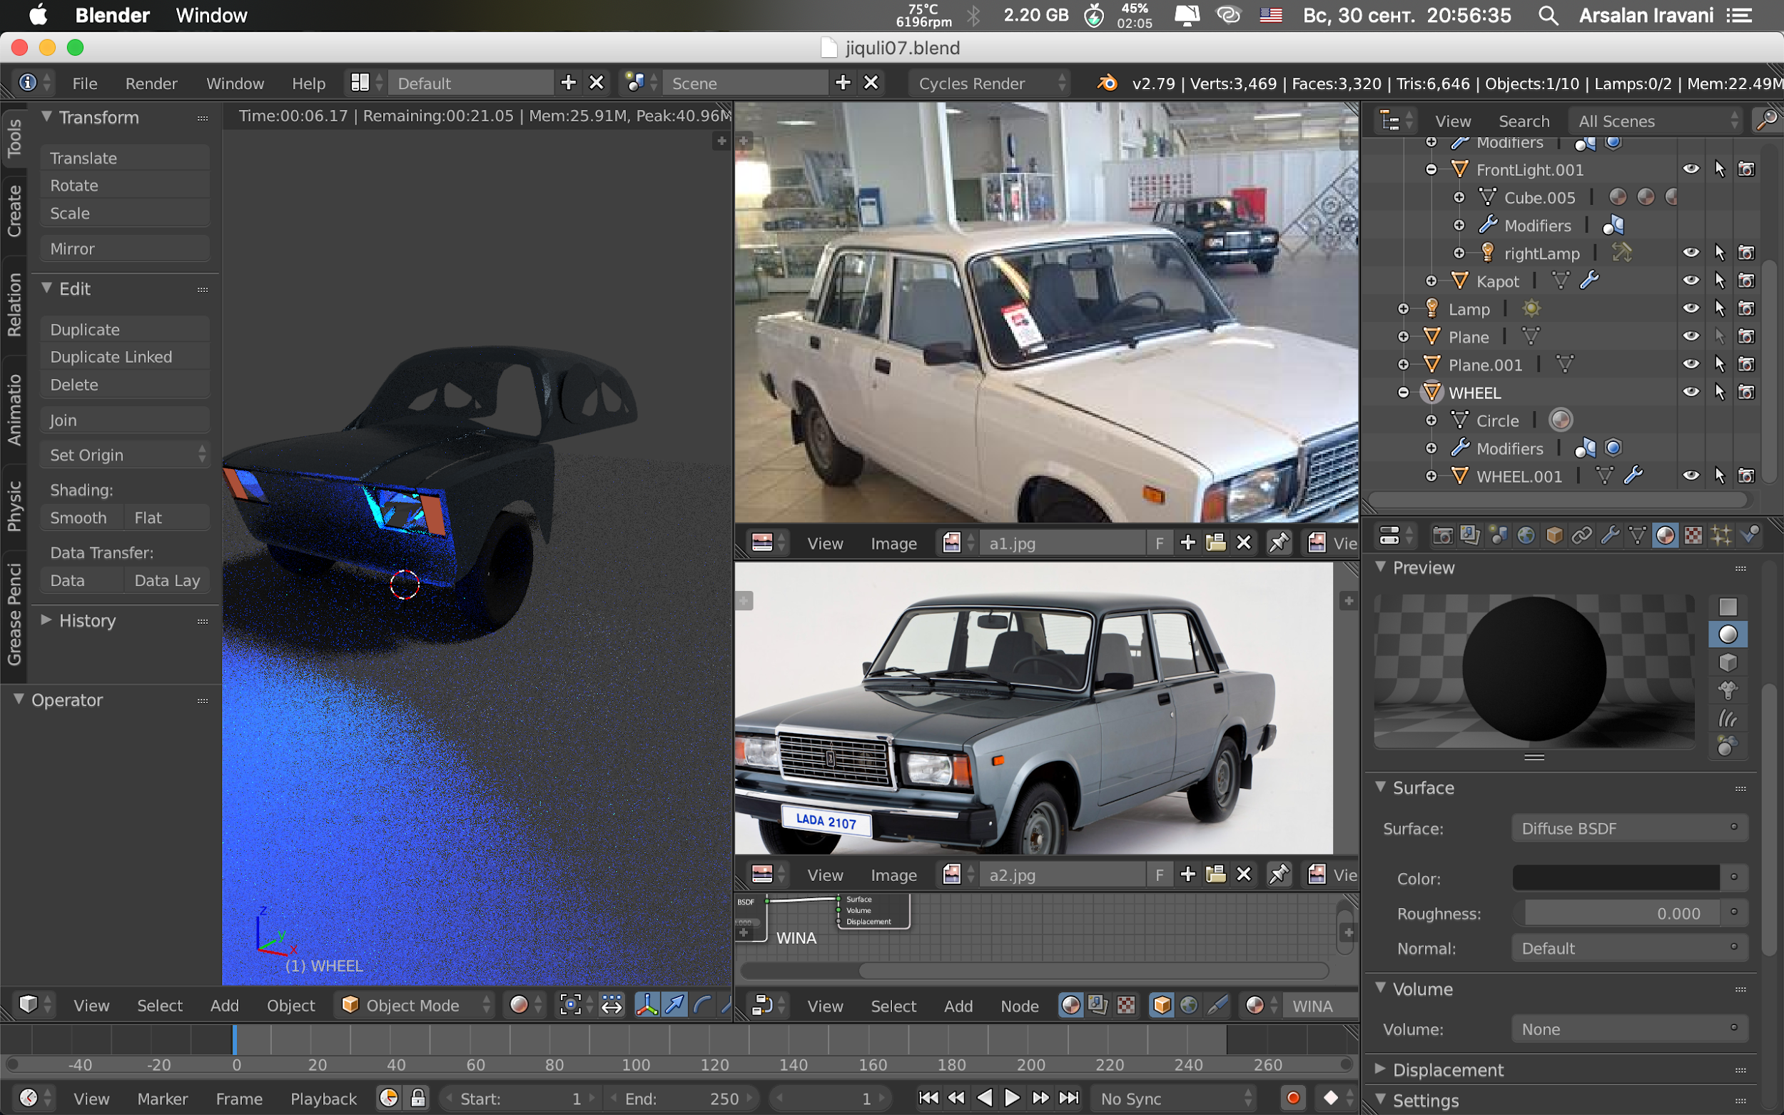

The following enemy object has been developed from scratch in Blender (3d Graphics Software) by our teammate Arsalan Iravani. In the game, cars will have different colors. In addition, level by level the viability and speed will increase.

# Global Game Elements

In Qiz Qalasi Defense game, map will be limited to Baku including some buildings, weapons, Qiz Qalasi, Flame Towers. All the objects that we used in the game is similar to the real world objects. Our game is based on 3D PC game and no need for any static background. We will try to make our environment more realistic as possible as and will put some realistic object to our game. Trees, gazoon, flag square, bushes will be added, and each will have its corresponding sound effect. We will have also some castle that to protect our area from the enemies. Level would have different sightseeing of Baku and national musics as a background. We will try to create interesting level that will attract our players.

The below is the 3D design of Flame Towers drawn by Blender that will be used in our game.

--

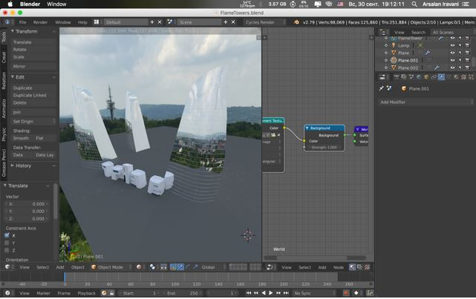

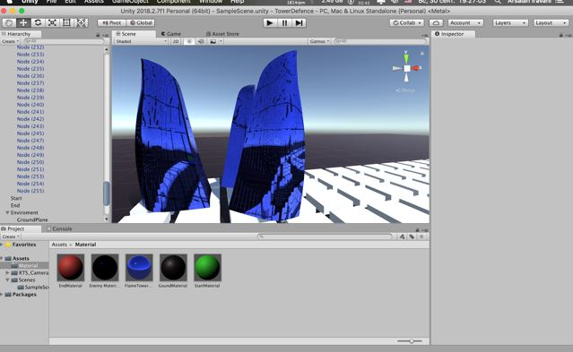

Maiden Tower, crucial object which is supposed to be defended from the enemies.

--

## The Story

Basically Tower Defense games have similar goals of defending a point with building structures to stave off the enemies. In our Tower Defense game Baku boys will do everything to stave off the Arabian guys from Baku. Baku guys will be placed on top a high tower throwing different types of assets on 07 cars or tractors to destroy them. Each eliminated enemy results in gained scores and these scores will be used by the player to buy more towers, or upgrade current assets. The tractors will be coming on different types. As player goes to higher levels many elements of game will change. We have two types of defender. First one is “Bakili” who has typical rounded black hat, pants and shirt, and also he has shoes with long base, and final obligatory attribute of his image is rosary. The second one is military guns, which have a greater impact efficiency, and deprive lifes from enemies much faster. Player can earn money from defeating enemies and successfully passing a wave. Each enemy has different number of coins. Whenever player gathers enough number of coins he can purchase new weapons, cannons, and guns, as well as upgrade existing weapons to much more powerful ones. At the end player loses if number of enemies exceed a limit defined beforehand. Player wins if he can manage to resist all enemies and defeat a boss.

## Level Design

In the first level Qiz Qalasi will be placed in the center of screen. To the right end of screen sea will be demonstrated. This will be same for all levels however view of buildings will change substantially from level to level. In the first level basic city road will be demonstrated. After player succeeds with opening higher levels the city will be as Baku city. It will be more like Baku city in higher levels as new buildings will be added.

## Level Copy

Our main characters are tractors and 07 cars, have their personal background which also externalized to the game as a characterization that personalize players as a speed or resistance in particular field.

## Audio & Sound F/X

**Stone beated**

When stone beats enemies it will create special sound.

**07 car sound**

When driving 07 car in the second level this sound will be played.

**Mercedes sound**

When driving Mercedes car in the second level this sound will be played.

**Prado sound**

When driving Prado car in the second level this sound will be played.

**Enemy speaking**

When player loses enemies will speak.

**Player speaking**

When player will succeed to next level he will speak.

# Game Architecture

## 

## Game Architecture Overview

