Qiz Qalasi Defence

Technical Document   
(Homework No.3)

Project team: Bakililar

Instructor: Dr. Araz Yusubov

Submitted in partial fulfillment of the requirements of the CSCI 4836: Game Development Fundamentals course project

|  |  |
| --- | --- |
| Version date | Version information |
| 09.11.2019 | Initial draft |
| 18.11.2019 | 3.0 |

|  |  |
| --- | --- |
| Other documents in the package | |
| File name | Brief description of the document |
| <File name> | <Description of the document> |
| <File name> | <Description of the document> |

|  |  |  |
| --- | --- | --- |
| Team member | Contribution to this homework (NOT the project) | Estimated % |
| Gunay Abbasova |  | 25% |
| Arsalan Iravani |  | 25 % |
| Seymur Ayvazov | Visual Content, Class Diagram | 25% |
| Farhad Alishov |  | 25% |

# **Table of Contents**

**Table of Contents** **2**

**Introduction** **2**

System Requirements 3

Concerns and Alternatives 3

Resources 3

**Visual Content** **3**

**Audio Content** **5**

**Programming Content** **5**

Code Structure 6

# **Introduction**

The name of the game which is designed by “Bakililar” team is called “Qiz Qalasi Defense”. This game is non-violent, single player, which take place in Baku, Azerbaijan.

First of all tower defense game is the most popular game according to its game types of the history and therefore we are planning to create this type of game with the same genre. We will try to make offline single player game that every user will play with great pleasure. Player knows that the game is offline single player game with no internet connection. Before game screen is opened there will be START, EXIT and ABOUT writings. With entering START the game will be opened with basic abilities given to player in the beginning. Our game is based on 3D PC game and no need for any static background. We will try to make our environment more realistic as possible as and will put some realistic object to our game. Our team also make the 3D design of Flame Towers drawn by Blender that will be used in our game. Enemy objects has been developed from scratch in Blender (3d Graphics Software) by our teammate Arsalan Iravani. In the game, cars will have different colors. Maiden Tower, crucial object which is supposed to be defended from the enemies. In addition, level by level the viability and speed will increase. We try to develop and improve the process of objects in better way. According to the architectural complexity of our objects such as Maiden tower, Flame Tower and etc, our team gives efforts both to make it on time and design photorealistic architectural model of the architectures which can be implemented in real time. Our game is offline single player game and will not be any level difficulty. In the first level, Qiz Qalasi will be placed in the center of screen. To the right end of the screen sea will be demonstrated. This will be same for all levels however view of buildings will change substantially from level to level. In the first level, basic city road will be demonstrated. After player succeeds with opening higher levels the city will be as Baku city. It will be more like Baku city in higher levels as new buildings will be added. In 3D games map plays special role for the users that can easily navigate on the territory and do not get lost. Here the map of the “Qiz Qalasi” was designed by our “Bakililar” team:

GAME MATRIX

|  |  |
| --- | --- |
| NAME | DESCRIPTION |
| Map | The territory map which includes birds eye view in which architectures and other objects of close terrain of player will be seen. |
| Player | The important character in game which user will control each of their customized players |
| Rocket | Is used to make the enemies down |
| Qiz Qalasi | The Place where we should protect |
| Tree | An element which is not related with users but will be added to make more realistic look |

**Game Flowchart**

The below is general game flowchart:

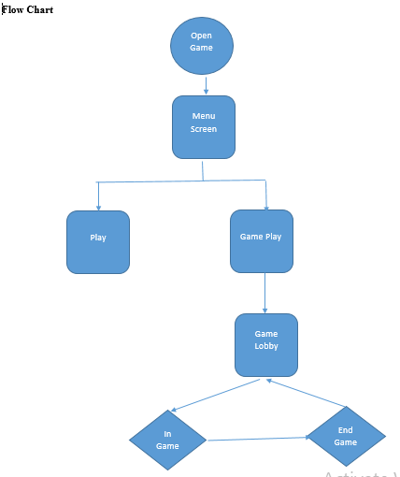

## **System Requirements**

Minimum Hardware Requirements:

800 Mhz Intel Pentium III or 800 Mhz AMD Athlon or 1,2 Ghz Intel Celeron or 1,2 Ghz AMD Duron processor

128 MB of RAM

32 MB video card with DirectX 9.0 compatible drivers ("GeForce" or better)

8X speed CD/DVD drive

Sound Card with DirectX 9.0 compatible drivers

915 MB of free hard disk space (+ 635 MB if video card does NOT support DirectX Texture Compression)

Windows 98, 98 SE, ME, 2000, XP or Vista

DirectX 9.0 or higher

Keyboard and Mouse

Recommended Hardware Requirements:

Intel Pentium IV or AMD Athlon XP processor or higher

256(+) MB of RAM

64(+) MB video kcard with DirectX 9.0 compatible drivers ("GeForce 3"/"Radeon 8500" or better with DirectX Texture Compression support)

16 speed CD/DVD drive

DirectX 9.0 compatible sound card with surround sound

1.55 GB of free hard disk space (+635 MB if video card does NOT support DirectX Texture Compression)

Windows 98, 98 SE, ME, 2000, XP or Vista

DirectX 9.0 or higher

Gamepad (USB or Joystick Port)

Keyboard and Mouse

## Concerns and Alternatives

Our team had major difficulties in creating 3D Models of objects which are displayed of game screen. To provide realistic view of game objects such as Qiz Qalasi, guns, bombs, different trees as well as enemies we collected images on which we started designing. Having not extended modelling knowledge we were not succeeding in creating objects as we wanted in the beginning. When we learned designing and improved developed objects the game was more interesting to play. Major concern in development of 3D Models is details of objects. Software that is used to design game objects provide basic set of lines, points, geometric data and colors however to create interesting game developers are required to have attention to details. Creating fully provided game object with all details for one time without further changes is not easy. In alternative our team uses technique of continuous development where we add new details to created objects lots of time. Other concern was that objects we created did not look well in colors. We were assigning colors separately for details however objects did not have specularity. In alternative we used specular map of modelling software to add shininess to colors. This technique gives strong level of variation in colors.

## Resources

For development of game codes and scripts we use Unity development tool. Specialization of Unity in C programming language goals to collect beginner programmers to code in Unity.

We use Blender to create 3D Models which are present in game. Objects developed in this software can be used in any third-party game engine. Blender has a number of tools that performs tasks in little time. With help of modifiers designer can assign many effects to object automatically. This tool does not affect geometry of object.

# **Visual Content**

* **Player Elements**
  + Type of States (Alive, Dead)
  + Amount Animation Frames 60 Hz
* **Heads Up Display (HUD)**

Heads Up Display shows the Defense Equipment together with their prices in AZN currency. To the left of the Defense Equipment Board, the amount of money that the user has, is shown. To the right of the mentioned board, the Timer actually demonstrates the time interval for the next wave of opponents to come out and appear on the game board.

The Equipment Board at the same time plays the role of SHOP. By clicking it is possible to make a purchase, the only condition is having enough money to buy.

In the above of game board, there is an indicator of lives that the Player has.



* + States ?

* + Type Icons

There are icons of weapons, which player can buy from shop for a certain amount of money.

* + Font Type: Helvetica-Neue
* **Antagonistic Elements**
  + Type of States

Default, Damage(when cannons are shooting an enemy they start to slow down), Destroyed (if their health reaches 0, they are destroyed). Each of the antagonistic elements has health bar above which indicates the health state. It is at first has the green color, but after hits the green color gets subtracted which indicates the damage, and after reaching the minimum value, the antagonistic element gets collapsed.



* + Amount Animation Frames minimum criteria of 60 FPS is recommended.

60 frames per second

* **Global Elements**
  + Background/Texture/Tiles: Static Color

We use terrain in our game where there is a path road through which enemies move on and all the rest area represents the city with buildings and places where the user may put the defense equipment. Flame Towers, The Maiden Towers, urban constructions are examples of buildings.

The Flame Towers

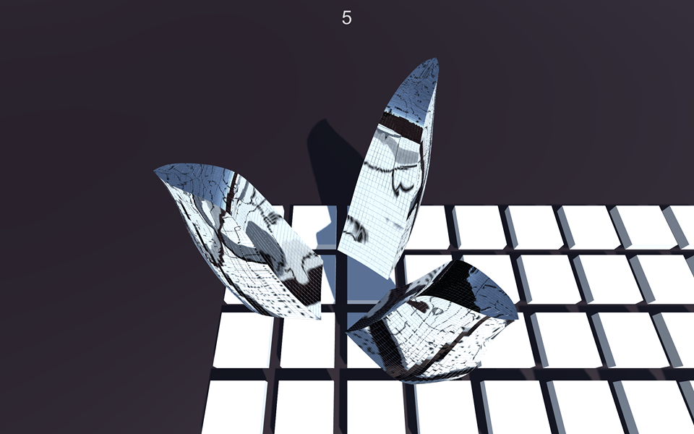

Urban Construction

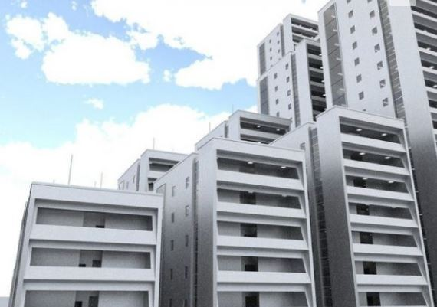

The Building from where antagonistic elements will

* + Font Type: Helvetica-Neue

The player will see the game board on top. The game board is a square area.

# **Audio Content**

* Player Elements

Establishment Sound:

This sound is played whenever player clicks to a empty spot and confirm building a tower.

UI sounds:

Mouse click to a tower or an enemy sound.

* Antagonistic Elements
  + Movement sound:

While opponents move they will emit driving sound.

* + Defeat sound:

When enemy is died this sound is played.

* Global Elements
  + Background Music:

Music will start as soon as game starts. It will be silent in order to not distract player from gameplay.

# **Programming Content**

* Player Elements
  + Buy a Tower
    - User can buy a tower from a shop if he has enough money to do so.
  + Upgrade a Tower
    - User can upgrade a tower to improve its properties
  + Sell a Tower
* Menus
  + Play
  + Quit

# Class Diagram

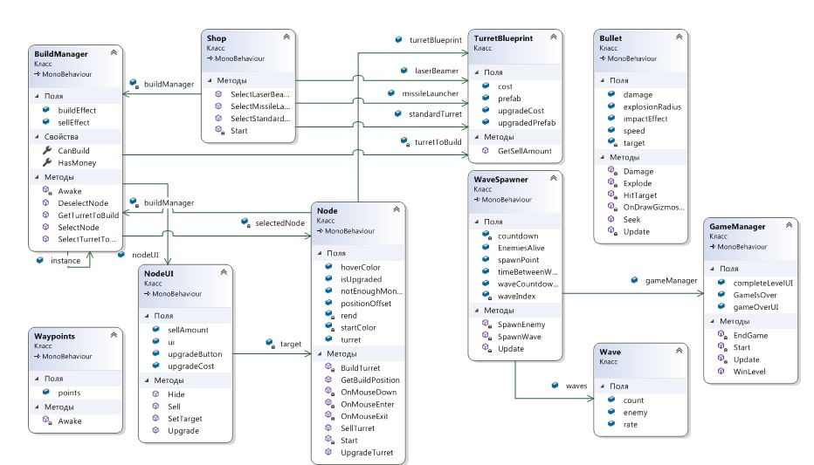

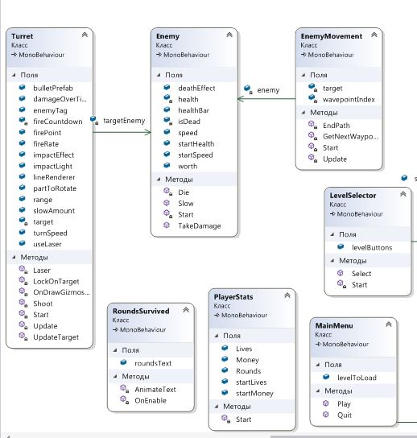

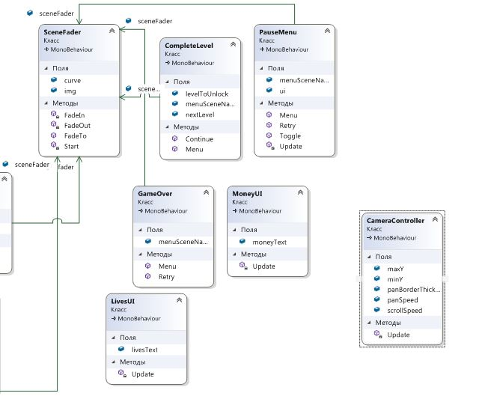

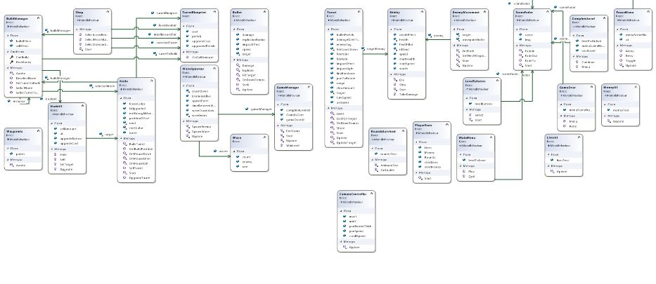

Interaction Matrices...