<Game project name>

<Game catch phrase>

Technical Document   
(Homework No.3)

Project team: <Team Name>

Instructor: Dr. Araz Yusubov

Submitted in partial fulfillment of the requirements of the CSCI 4836: Game Development Fundamentals course project

|  |  |
| --- | --- |
| Version date | Version information |
| <Date> | Initial draft |
| <Date> | <Version description> |

|  |  |
| --- | --- |
| Other documents in the package | |
| File name | Brief description of the document |
| <File name> | <Description of the document> |
| <File name> | <Description of the document> |

|  |  |  |
| --- | --- | --- |
| Team member | Contribution to this homework (NOT the project) | Estimated % |
| <Student Name 1> | <Description of the work contributed> | <X>% |
| <Student Name 2> |  |  |
| <Student Name 3> |  |  |
| <Student Name 4> |  |  |

# Table of Contents

<Automatically generate here using Microsoft® Word menu References🡪Table of Contents>

# Introduction

This is part of the Game Design Document for a hypothetical project Race in Baku F1 Circuit

submitted for partial fulfillment of the requirements of the Game Development Fundamentals course in the School of Information Technologies and Engineering at ADA University, Baku, Azerbaijan.

 The game which is planned to be made by GameOPS team is “Race in Baku F1”. This game is single player, competitive, non-violent, extremely exciting and take place in Baku, Azerbaijan. Regarding to genre of the game, sport is one of the most popular and loved game types in the history and therefore we are choosing to create game with the same genre.  The mode of the game will be single player, and users will be enabled to play with computer players in order to get an memorable experience. The game is given a cityscape look to give a player more realistic impression. The territory will be based on three-dimensional model of real-world location of the circuit, which is in Baku. In addition, our three-D models include central streets of Baku, modern buildings and old towers of the city. Players will feel excited in Baku F1 Circuit and try to compete against opponents until the finish line. The theme of our game is to compete with the other opponents that are controlled by computer in a racing tournament, the player’s goal is to reach to the destination as soon as possible while trying to avoid bumping to other cars or road objects, which slows down speed of the car.Lastly, it worth mentioning that the genre of the game is somewhat cloned, however the game is in Baku street which makes it unique.

Furthermore, our team has created 3D models of Baku  where race will happen . Players will feel stuck in curved road of city and it makes game more interesting and entertaining. We are trying to make our model more realistic and similar to real race happened in our city.  The underlying motive for us to locate national architecture of Azerbaijan on the street make people who live in abroad feel nostalgic while playing game. Below, 3D models of the city shall be demonstrated:

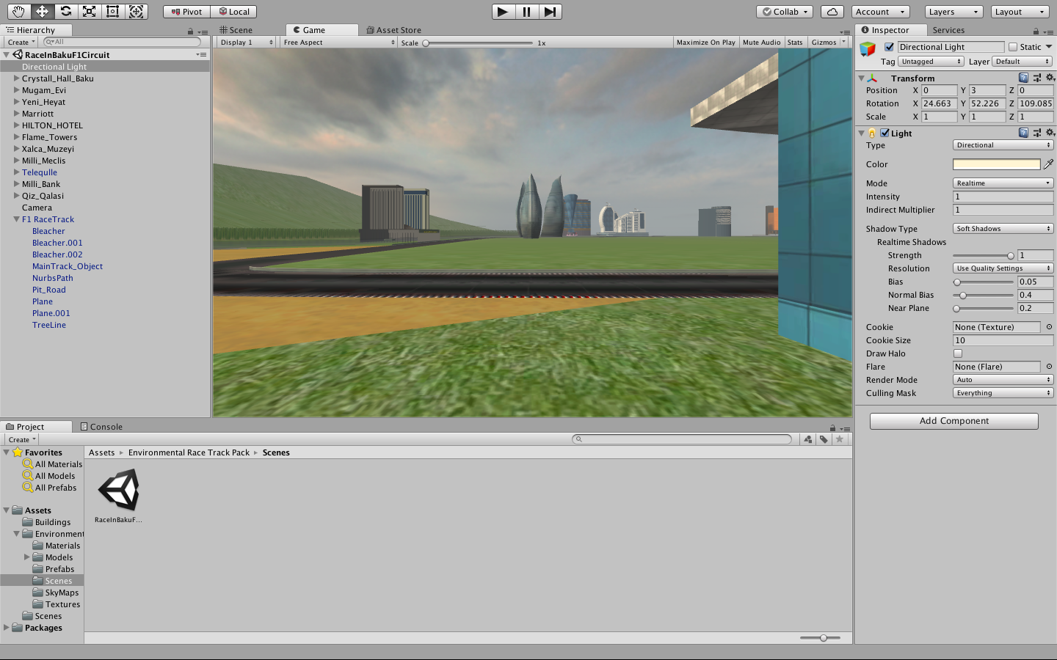

**Image 1.1 Road area**

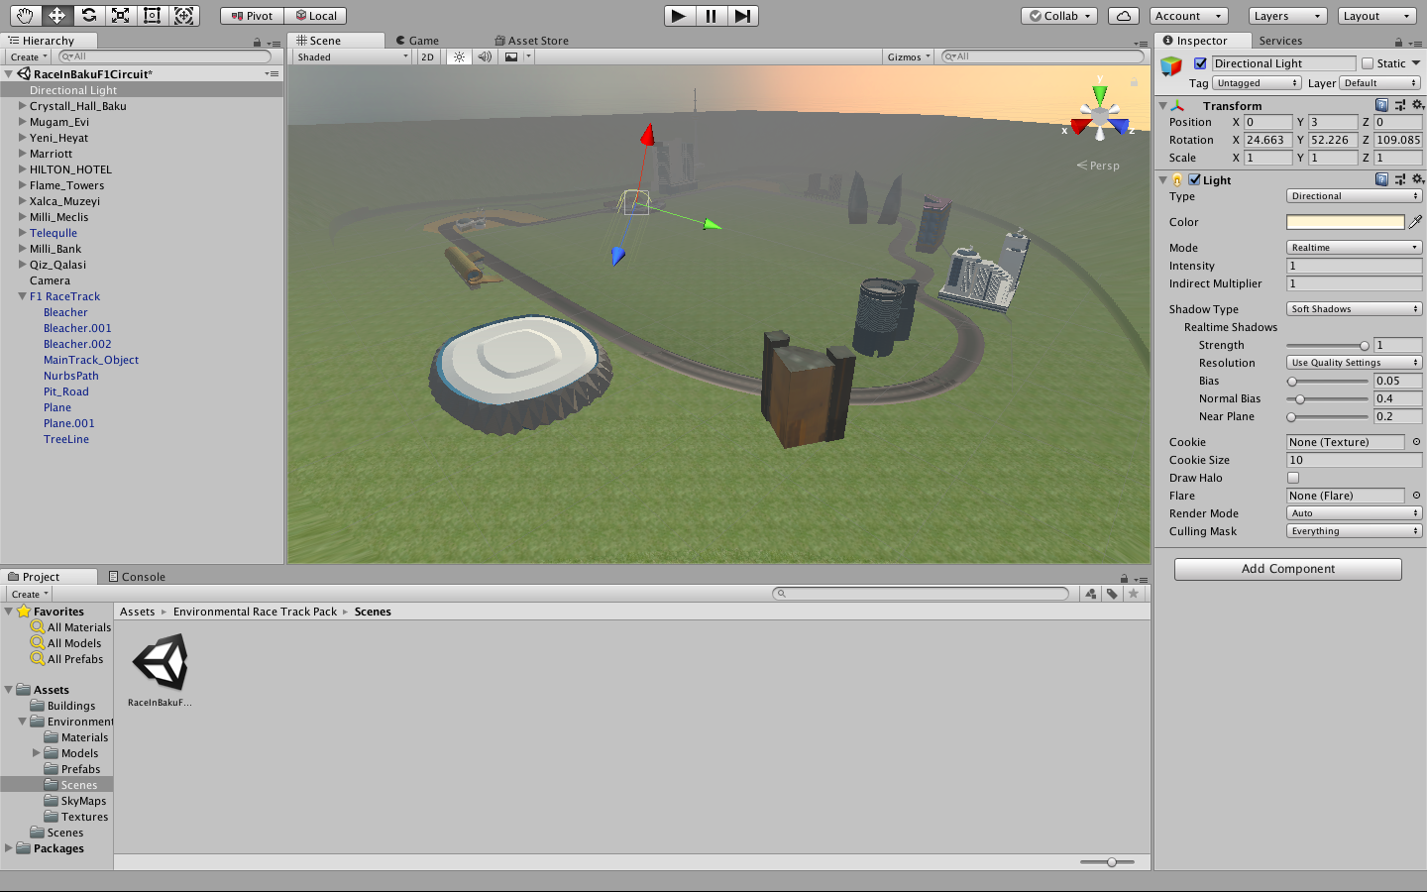

**Image 1.2 City view from sky**

Development and improvement process of model still continue. As it can be seen below model is combination of modern and national architecture of Azerbaijan.

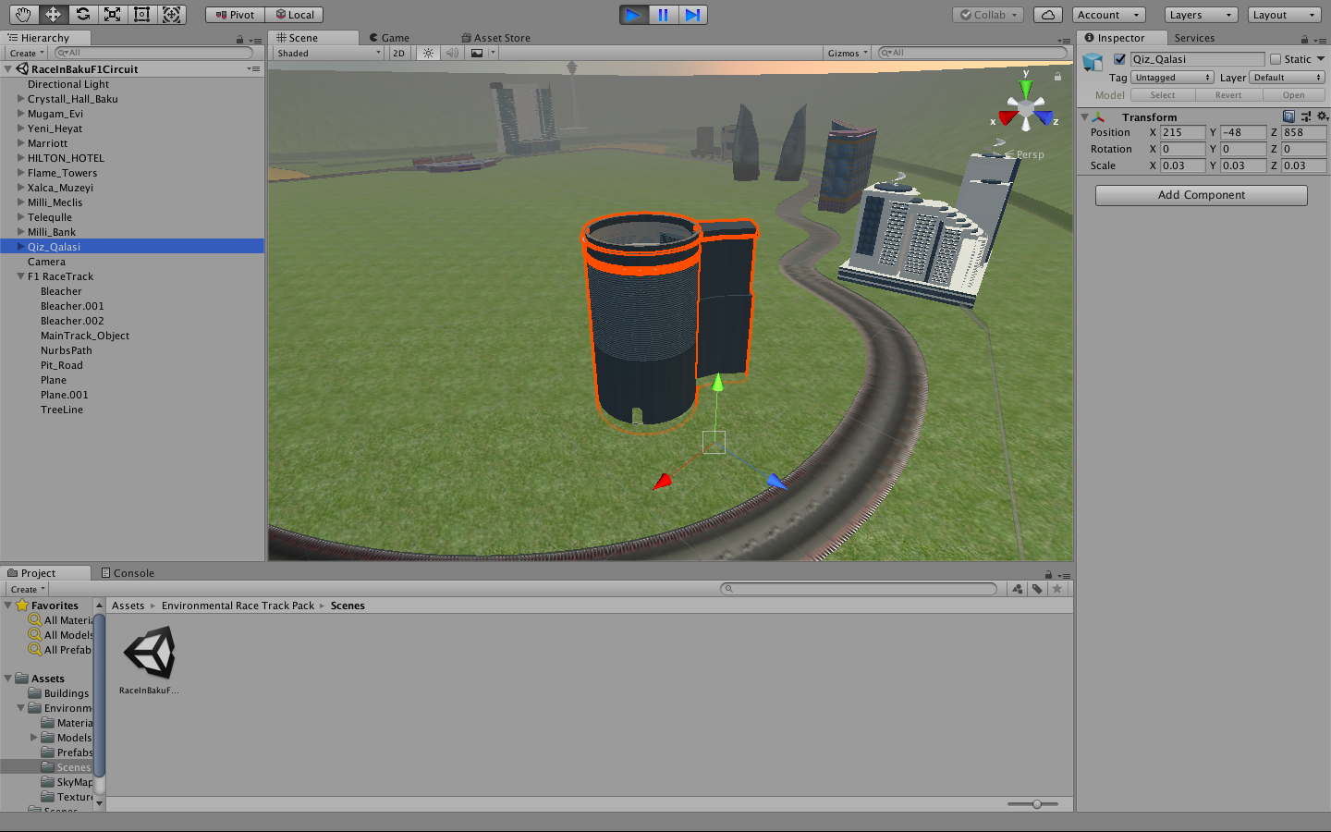

**Image 1.3 Maiden's Tower**

Main menu will be displayed when player start game , which consist of Start Game, Settings, Controls, Quit Game, Story. Example game menu will be same as below mentioned. When player click the start game each time, player can choose three levels of game and unlocked cars to start new game. On settings mode, Player can modify audio, video, display on this screen. Further improvements shall be added as project growth.

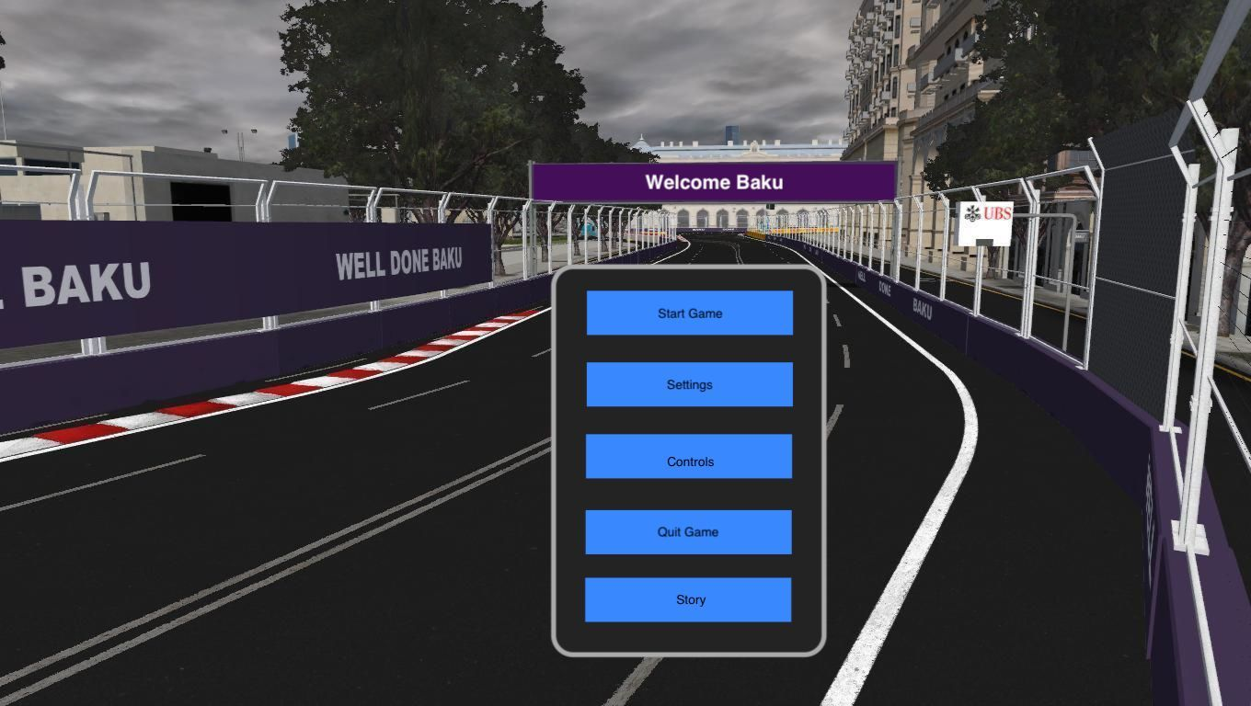

**Image 1.4 Menu Screen**

**Game Flow-Chart**

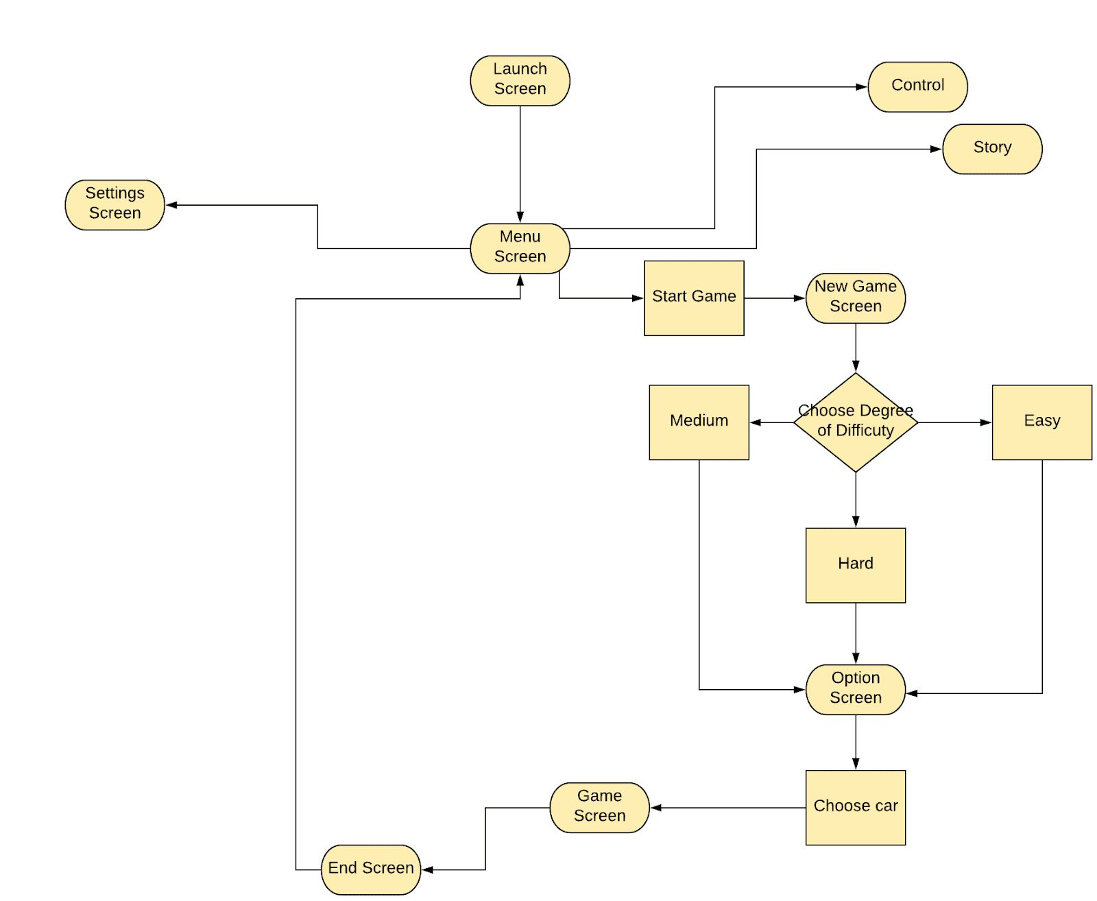

## System Requirements

When user purchases or install  game they have to make sure their computer support system requirements of game.Our game going to be PC oriented. Below are system requirements for game:

Minimum Requirements:

CPU:Intel i3-4170 @ 3.7Ghz / AMD FX 6300 or equivalent

RAM: 4GB RAM

HDD: 15 GB HD space

GPU:NVidia  GeForce GTX 650TI / GT 740 or AMD  Radeon R7 250x

DirectX: Version 11.0

Sound Card: DirectX Compatible

Operating System: Windows 7 64-Bit or later

Recommended Requirements:

CPU: Intel i7-6700k@ 4.0 GHz/AMD FX 9590  or equivalent

RAM: 16GB RAM

HDD: 25 GB HD space

GPU: NVidia GeForce  GTX 1080 or AMD Radeon RX 480

DirectX: Version 11.0

Sound Card: DirectX Compatible

Operating System: Windows 10 64 Bit

## Concerns and Alternatives

As in every software product there can be some bug in the initial version of game.Our main concerns is to fix bugs till the certain deadline for each phase of game .Therefore,firstly alpha and beta versions of game will be released .Before launching  game, main four testing techniques will be tested such as combinatorial testing, clean room testing, functionality testing and compatibility testing.Alternative solution for finding and fixing bug is that users or developers could report any bug  as they observed. This will provide nice and interesting collaborations within developers and users.

## Resources

Two main and heavily used tools for development and improvement of our game are Blender and Unity. Blender is being used to build up city roads and improve architectures of our model.After the model is ready it will be added to Unity for development of game.In the project documentation,appropriate credit will be given to softwares or assets used during all phase of game development.

# Visual Content

<This is a section that lists technical requirements from those in concerned with the visual aspects of the game. All objects should be listed with their generic names.

* General
  + File Size Restrictions
  + File Format Type
  + File Quality Type
  + Visual Scale
* Player Elements
  + Type of States (Default, Damage, Destroyed, ect.)
  + Amount Animation Frames
* Heads Up Display (HUD)
  + Type Icons
  + States
  + Font Type
* Antagonistic Elements
  + Type of States (Default, Damage, Destroyed, ect.)
  + Amount Animation Frames
* Global Elements
  + Background/Texture/Tiles
  + Font Type

>

# Audio Content

<This is the section for organizing the audio content. It is very important to communicate with the audio designer before and while the audio content is being developed.

* General
  + File Size Restrictions
  + File Format Type
  + File Quality Type
* Player Elements
  + Type of Sound f/x
  + Device Vibration
* Antagonistic Elements
  + Type of Sound f/x
  + Device Vibration
* Global Elements
  + Ambient Music
* Splash Screens
  + Ambient Music
* Menus
  + Type of Sound f/x

>

# Programming Content

< The programming content section should help permit good collaboration with the programmer. The objective of this section (and task) is to try to organize and modulate as much as possible.

* General
  + Requirements
  + File Size Restrictions
  + File Format Type
  + Specify Coding Conventions
  + Language/Device Restrictions
  + Screen Type (Small, Medium, Large)
* Player Elements
  + Type of Event
* Antagonistic Elements
  + Type of Event
* Global Elements
  + Type of Event
* Splash Screens
  + Type of Event
* Menus
  + Type of Event
  + Type of Options

>

## Code Structure

<This is where an overview of how objects/functions/data interact, a list of what specified functions/routines do and a list of what order modules will be written.

**Bonus:** Get extra **10%** points for including Interaction Matrices[1] and/or Class Diagrams.>

# References

<Insert here any document referred to in the document. An example might be articles or Web sites that you consulted during the literature search. This is not just a list of used materials, so do not forget to clearly MARK the exact points(s) of reference in the main text.>

1. Interaction matrix is a spreadsheet listing game objects on sides, and interactions that can occur between them during the game at intersections of rows and columns.