Race in Baku F1 Circuit

“A RACE ISN’T WON UNTIL IT’S OVER”

Concept Document
(Homework No.1)

Project team: Game OPS
Instructor: Dr. Araz Yusubov

Submitted in partial fulfillment of the requirements of the CSCI 4836: Game Development Fundamentals course project

Version date | Version information
22.09.2018 | Initial draft
29.09.2018 | Final Draft

Team member | Contribution to this homework | Estimated %
Elvin Ahmadov | Game Atmosphere and Selling Features | 25%
Musadig Aliyev | Game Analysis and Game Play | 25%
Kanan Alizada | Introduction and Game Analysis | 25%
Habil Gadirli | Key Features and Game Atmosphere | 25%

Table of Contents
1. Introduction……………………………………….………….………………………...….. 3
2. Game Analysis…………………………………………..………………….…………..….. 4
3. Game Atmosphere……………………………………………….………..…………..….... 6
4. Game Play………………………………………………………………………....…..…… 8
5. Key Features…………………………………………………………………………….…..9
6. Selling Features………………………..……………………………………….…….....…10
7. References………………………………………………………….……………….………11

1. Introduction
The game that will be made by GameOPS team is “Race in Baku F1 Circuit”. This is single player, competitive, non-violent and extremely exciting game which takes place in Baku, Azerbaijan. “Race in Baku F1 Circuit” incorporates Baku`s F1 circuit and various rare and extraordinary cars in itself. Sport genre is one of the most popular and loved game types in the history of gaming among all genres, and therefore we have chosen to create game with this genre. The game mode will be single player, and users will be enabled to play with computer players in order to live an unforgettable experience. The game is given a cityscape look to give a player more realistic impression. The territory will be based on three-dimensional model of real-world location of the circuit, which is in Baku, Azerbaijan. Furthermore, our 3D models include central streets of Baku, modern buildings and old towers of the city. The map also includes some buildings that are not yet completed but are still in process. Players will feel excited in Baku F1 Circuit and try to compete against opponents until the finish line. The theme of our game is to compete with the other opponents that are controlled by computer in a racing tournament, the player’s goal is to reach to the destination as soon as possible while trying to avoid bumping to other cars or road objects, which slows down speed of the car. Lastly, it worth mentioning that the genre of the game is somewhat cloned, however the game is in Baku street which makes it unique.

2. Game Analysis
Game Description

The game combines three different genres – role-play, simulator and sport. This feature makes our game unique and the most interesting factors from each genre will be included. Players are expected to reach to the finish line as fast as possible in order to earn money, which will be used to unlock other cars. The major elements of the game are acceleration, break, score and speeding. As it was mentioned, game is based on concept of racing and main goal is to overcome every one of opponents to reach to the finish line first. The theme is based on the real F1 circuit of Azerbaijan. The game is styled as real, and main effort will be to make the game circuit closer to the reality as possible. The game sequence will be linear, the player will unlock more cars after each victory by obtaining points. The maximum number of the players that are allowed in a game will be 10.

Game Reference
“Race in Baku F1 Circuit” is a racing game that combine fantastic cars, reflections, lighting and environment. The game will give players keep feeling of thrilling and emotion of satisfaction with overcoming opponents. Like most racing games, the game’s main idea is to give players unforgettable, excited moments while racing with hard opponents.

Definitions

There are several words, which might cause difficulties for understanding exact meaning so we create this table to help you.

Term | Definition
Computer Player | Opponent player controlled by computer using Artificial Intelligence algorithms.
Theme | Mechanics and components are related to game topic.
Clone | A game that is similar in design to another game in its genre
Occlusion Culling | A feature that disables rendering of objects when the camera does not currently see them because they are obscured (occluded) by other objects.
FPS(Frame Per Second) | A measurement for how many unique consecutive images can be rendered in a second.

3. Game Atmosphere

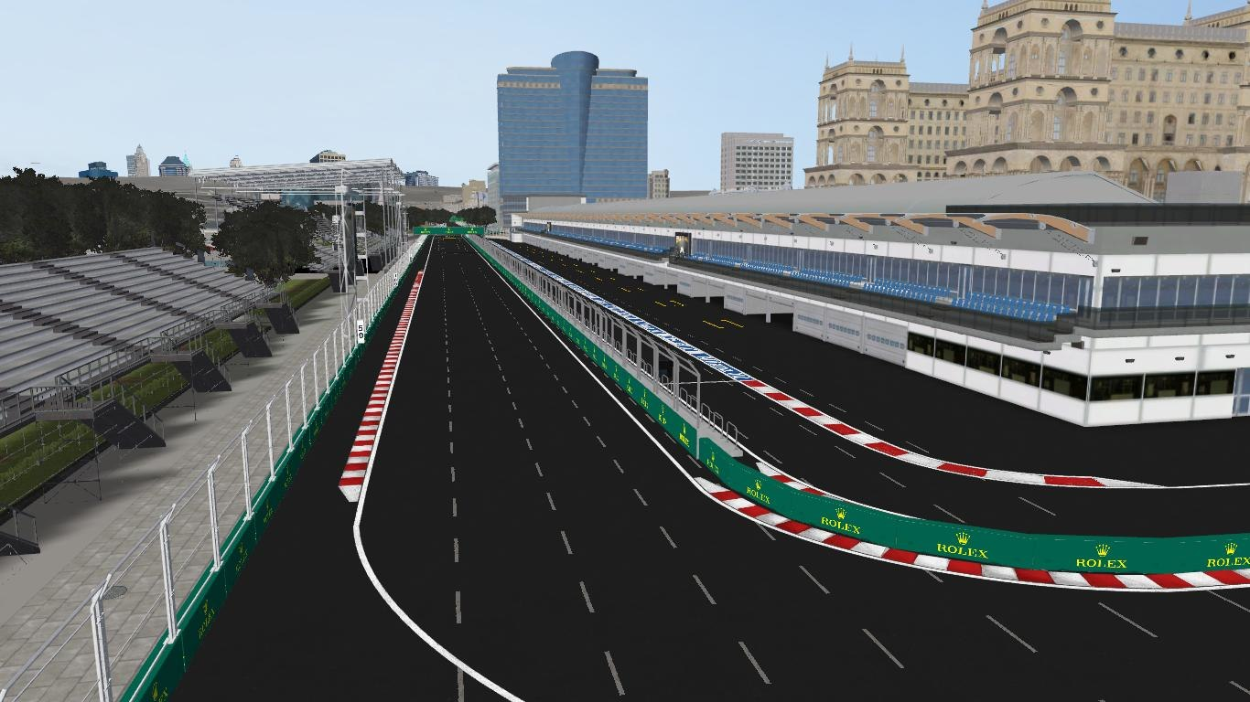
The highlighting point of this game is to exhibit center of Baku streets and historic architectural monuments. This includes Maiden Tower, House of Government, Hilton Baku, Absheron hotel, Walled Old City, Philharmonic Hall, etc. (Image 3.1)
3.1 Screenshot from game

As it mentioned before rare and extraordinary car models with high quality are intended to be used in this game.
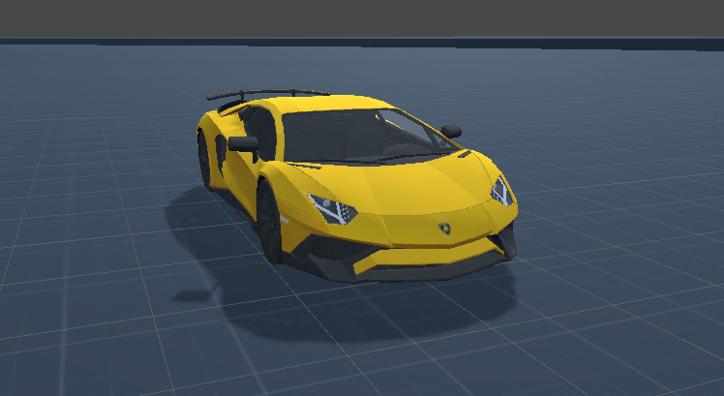
3.2 Car model used in the game

From image 3.1 it can be seen that sunny weather has been chosen for this game with the aim of giving players warm impression. Besides car sounds there will be city sound which will make the game more realistic.

4. Game Play
During the game, the player control one of the cars to compete with other opponent computer players. The player uses keyboard to manage the car to turn left or right, move back and forward, to hit a break or accelerate. In the beginning of the game, there will not be any difficulty levels but when players pass levels, it will change to difficult ones. Game mode is similar to “NASCAR” in which cars compete to win the race. Synopsis of game is players have to win every race in order to earn cash and points to unlock cars and levels, «A RACE ISN’T WON UNTIL IT’S OVER”. In the game, options are provided to players to choose a car to start a race.
Fundamental objective of this game, compete and to be the winner at the end of the race. To be so, you have to be fast to overcome your opponents. It may seem easy to play in lower level; however, as your level gets complicated, it becomes to be quite difficult to win the game. As players win games they will earn points and money so, points will open levels, as you, reach higher-level cars will be unlocked but in order to buy cars you should have enough money. When a player starts to play the game, road of the game and turning points seems uncertain but as player play, more they become familiar with the circuit. When cars crash they will not damage each other, game will finish after all cars reach to finish line.
As it becomes more competitive already, losing even will get you more motivated and eagering to play more. When you reach last levels, all cars will be unlocked and the game will finish. Winner of the game will have expensive, faster car to compete again in difficult levels. To sum all this up, the core point is having fun and spending enjoyable and exciting time.
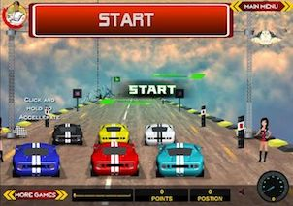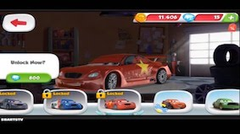
4.1 Start, Unlock car, Finish windows of game

Image 4.1 demonstrates similar prototype of our game.

5. Key Features

The game possesses multiple levels in which each level can be reached by gradually accumulating points by completing race in one of the top 3 places. Each level requires different amount of points in order to be reached. The purpose of reaching next level is to unlock a new car. As level increases car with better features will be unlocked.
Unlocking a car does not mean that a player can choose this car for a race because “Race in Baku F1 Circuit” will require player to obtain enough amount of money in order to buy a car.
So, if a player wants to buy a certain car he/she needs to first reach to the particular level which unlocks the car and after that if he/she does not have enough cash then he/she has to finish some races in top 3 in order to obtain more money and buy the car.
A player can race against minimum 5 and maximum 10 opponents. It is chosen to be minimum of 5 opponents otherwise it would be meaningless because, only top 3 places are awarded with points and cash.
Each race will have its own difficulty and it depends on the level of the player. As level increases, the difficulty of a race will increase too. Nevertheless, there will be a balance between the difficulty of a race and the skills the player has in order to not to frustrate a player. In this game`s context, skills means owning a car with better performance.
The game does not have a time limit; a player can play in a particular race until it is over. However there will be a record of fastest race of a player and if a player breaks this record he/she will earn extra money for that. Moreover, amount of money for breaking the record will be much more than the amount of money, which can be obtained from winning a race. This strategy has been chosen in order to make the game more competitive and engaging.
There will be various types of sounds in the game in order to simulate street race more precisely. Cars will have sounds for accelerating, engine, and horn. When a race starts, there will be sound for a countdown also. In the menu, part of the game there will be some amount of energetic songs in order to make this part of the game more engaging.
“Race in Baku F1 Circuit” is intended to be a 3D game with high quality map and car models. With the help of some optimization techniques such as “Occlusion Culling”, the game will be playable at normal FPS on medium level computers.

6. Selling Features

Principally our team will use some copyrightable materials regarding models. At first, this game can be seen as the simple racing game, however; there exist several key points which make “Race in Baku F1 Circuit” unique. Exclusive side of our game is to demonstrate Baku center streets and historical constructions. Another unique aspect of our game “Race in Baku F1 Circuit” is that besides some Formula 1 cars, it possesses also various types of cars, which can be chosen by a player.
The triggering points for us to choose Baku center streets and architectures, to take attention of native and foreign people to represent Azerbaijan`s historical places which locates in the center of Baku. Obviously, these features will be helpful to our game in order to be well known in the video game industry. Respect to Race in Baku F1 Circuit, our goal to hit the ground not only in Azerbaijan Game sector, but also all over the world.

7. References
- https://ada.blackboard.com/bbcswebdav/pid-22964-dt-content-rid-204158_1/courses/10130.201810/Week-2-Zombie-Toys-Game-Design-Document.pdf

- https://en.wikipedia.org/wiki/Game_classification
- http://www.cs.columbia.edu/~sedwards/classes/2015/4840/reports/racing.pdf
- http://www.cse.chalmers.se/~uffe/bachelor/kandidatarbetestartpaket/3D%20Racing%20Car%20Game%20-%20Project%20Lloyd.pdf
- https://en.wikipedia.org/wiki/Game_mechanics
- https://en.wikipedia.org/wiki/List_of_video_game_genresa

