<Liberation of Garabagh>

<Ya Qarabağ, ya ölüm!>

Design Document   
(Homework No.2)

Project team: Gamers

Instructor: Dr. Araz Yusubov

Submitted in partial fulfillment of the requirements of the CSCI 4836: Game Development Fundamentals course project

|  |  |
| --- | --- |
| Version date | Version information |
| 17.10.2018 | Initial draft |
| 21.10.2018 | Final version |

|  |  |  |
| --- | --- | --- |
| Team member | Contribution to this homework (NOT the project) | Estimated % |
| <Nezir Yunuszada> | 1,4,5 | <25>% |
| <Arzu Mammadova> | 2,3 | <25>% |
| <Zohrab Musayev > | 1,4,5 | <25>% |
| <Semed Semedzade> | 6 | <25>% |

# Table of Contents

Contents

[Table of Contents 2](#_Toc527198360)

[1. Introduction 3](#_Toc527198361)

[Game matrix 3](#_Toc527198362)

[Game Flow Chart 5](#_Toc527198363)

[2. Player Elements 6](#_Toc527198364)

[Player Definition 6](#_Toc527198365)

[Player Properties 6](#_Toc527198366)

[Player Rewards (Power-ups & Pick-ups) 7](#_Toc527198367)

[3. User Interface (UI) 7](#_Toc527198369)

[Heads up Display (HUD) 8](#_Toc527198370)

[Player View 9](#_Toc527198371)

[4. Antagonistic Elements 10](#_Toc527198372)

[Antagonistic Definitions 10](#_Toc527198373)

[Antagonistic Properties 11](#_Toc527198374)

[Antagonistic List 11](#_Toc527198375)

[Artificial Intelligence (AI) 11](#_Toc527198376)

[5. Global Game Elements 11](#_Toc527198377)

[The Story 11](#_Toc527198378)

[The Story Copy 12](#_Toc527198379)

[Concept Art 12](#_Toc527198380)

[Level Design 12](#_Toc527198381)

[Level Copy 12](#_Toc527198382)

[Audio & Sound F/X 13](#_Toc527198383)

[6. Game Architecture 13](#_Toc527198385)

[Game Architecture Overview 13](#_Toc527198386)

[Architecture Copy 14](#_Toc527198387)

[How to Play Copy 14](#_Toc527198388)

[7. References 15](#_Toc527198389)

# Introduction

<Bonus: In addition to our first homework, we have added some new special features in order to increase the enthusiasm of the game. First of all, now, the player’s tank has additional ability to destroy enemy tanks besides fire shooting. It includes mine releasing specialty to the certain location of the ground. After revising the first homework, we have decided that it is too difficult to achieve the goal without extrinsic help. Secondly, for the limiting the player’s action we have added “fuel” property that goes down throughout the game. Furthermore, we have changed the concept of the main menu. We come to this decision to add “Tank Shop” which will allow the player to choose the tank model he or she wants. Taking all into consideration, we made these adjustments to keep the flow. >

* Menu

In menu section, we will demonstrate essential parts of the game. These include Start Game, Options, Tank Shop, Exit Game. As you might know, Start game button maintains the beginning of each new game. Additionally, we added “Tank Shop” button which will be the new feature for our game. By clicking it, the player will be able to see available list of tanks. In order to sustain the enthusiasm of the game, available list of tanks will differ from each other by “damage power” and speed. Furthermore, there is an “Options” button which the player can manage some game properties (Background sound, Graphical adjustments, Screen resolution). At the end, it is obvious that by clicking the “Exit Game” button the player will terminate the game.

* Synopsis

You entered Garabagh on the tank and surrounded by Armenian forces. No way to return back. You have to destroy them in order to forge ahead to rescue “Shusha fortress”. You have all medical support which will help you on this purpose.

* Game Play

In Game Play section, we should mention how the player interact with a game under the framework of the game rules. In our game, the player must destroy all enemy tanks in order to finish the level. Afterwards, the player will continues to the next levels. At the end, the player will reach his/her goal by completing 3 levels in total. On this purpose, there will be some extrinsic motivation that will help to boost the health of the main character.

* Player Control

For controlling the tank, the player will use arrow keys on keyboard; Left “🡨”, Right “🡪”, “Up” and “Down” for moving forward and back. “W” and “S” maintain the same purpose as “Up” and “Down”. “A” and “S” keys will have the alternative function for “Left” and “Right” keys. In addition, “Space Bar” key will be used for shooting Armenian tanks. In our game, we decided to add a new feature which provides the tank with a function of releasing mines. In order to realize it, the player should click the “Shift” button.

* Game Over (Winning & Losing)

Player must complete appropriately each three levels for winning the game. For winning the game, player must reach the “Shusha” fortress but before that, he or she must ensure that there are not any enemy tanks acting in fight zone. For losing, Azerbaijani tank must be destroyed by enemy tanks and health indicator must down to “0”.

>

## Game matrix

< The game matrix is a spreadsheet containing the generic names of the player and antagonistic elements and their game properties. This should allow an easy cross reference for any elements in the game that have numerical or other descriptive values associated with their name.>

|  |  |  |  |  |  |  |
| --- | --- | --- | --- | --- | --- | --- |
| Game elements | RB | Collider | Physics | Texture | Mine Putting | Health Boost |
| Azerbaijani Tank | + | + | + | + | + | + |
| Armenian Tank | + | + | + | + |  | - |
| Shusha Fortress | + | + | - | + |  | - |
| Health Boost | + | + | + | - | - | N/A |

Game elements will include “Rigid Body”, “Collider” and “Physics”. Shusha fortress should have the collider because when Azerbaijani tank approach to the fortress, it means we win the game. We will have “OnCollisionEnter” the function which will detect that Azerbaijani tank has already reached to fortress or not. In order to differentiate the tanks, we will have the textures which will cover enemy tanks with Armenian flag.

## Game Flow Chart

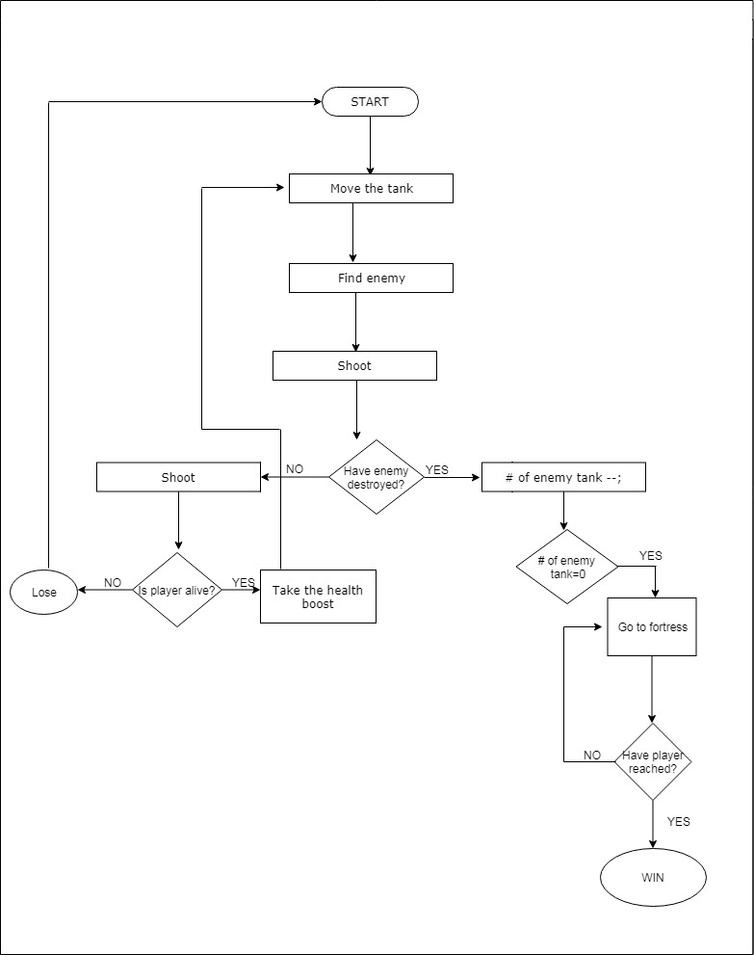

# Player Elements

## Player Definition

* **Default (Status):** At the beginning of the game the player has a 100% of health and 20 bullets for shooting as a default.
* **Actions**: The player starts the game by choosing the appropriate tank and can move it either to the left/right or forward/backward and then, he/she can make shots and after, if he/she needs any bullets for his tank there will be an option to gain them during the game.
* **Information (Status)**: During the game, the user will be able to see some details about his/her current state including **Health**, **Bullets,** and a **Pause** button will be shown on the right side of the screen. The detailed information is given in the Heads Up Display part below.
* **Default Properties**: The player begins the game with a simple tank appearing on the screen while having 100% of health and 20 bullets available for shots.
* **Winning**: After passing each level, the winning screen will appear and notify you about the conclusion of the stage and the next stage as well. To conclude the game, Azerbaijani tank should approach the fortress, after which our flag will be raised, and background music will be changed meaning that you came to the last part. After all of this, there will be an alert saying that “you successfully completed the mission”.
* **Loosing**: If your tank is in a terribly damaged condition, and the health indicator displays that your health percentage is zero, the losing screen will be shown together with the appropriate audio sounds on the background.

## Player Properties

**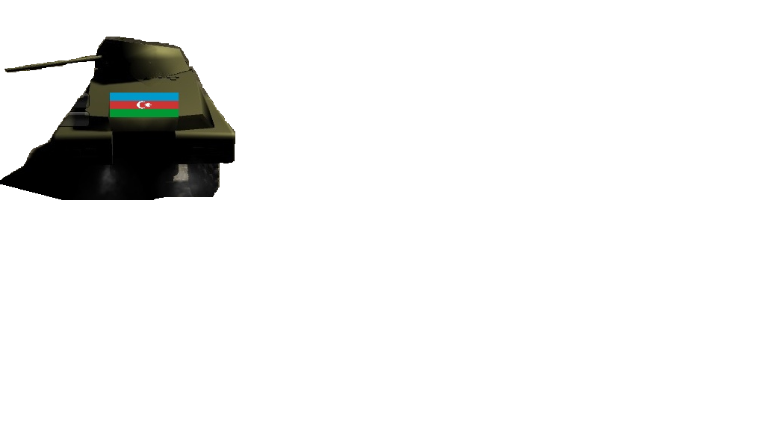**

**Player character:**

Player will utilize the tank which belongs to Azerbaijani army.

**Player Metrics:**

**Max health:**100%;

**Attack damage:** 20 %;

**Speed:** N/A

**Unique features:** Player will be able to use “health boost” up to 3 chances.

* **Health** – The player will have a 100% of the health at the beginning of the game and it can be damaged/decreased by an enemy’s tank shot. Health is one of the considerable aspects for the player to be alive and continue the game.
* **Weapons** – The only weapon in the game is just tank itself which has some bullets to make shots/fire.
* **Actions** – Actions include passing the levels by going forward and destroying the enemy’s tanks. All of these can be done using arrow buttons to move the tank and a space button to make a shot. Also, a mouse/touchpad can be used to move the tank’s head(pivot).

## Player Rewards (Power-ups & Pick-ups)

The player can increase/replenish his health condition by collecting some health-related points and bring it up to the maximum possible value. Another various pick-up part is related to the bullets of the tank. So, while playing the game to make it possible to go forward and destroy more tanks, the player should collect bullets which will appear somewhere on the screen and they will be automatically added to the number of current bullets.

# User Interface (UI)

One of the important factors to succeed in a game development is to have a well-designed User Interface. So, to make it easy for a new player to interact with the game, we chose the best and simple ways. Firstly, welcoming page will be displayed when the user starts the game. It will consist of the game’s name followed by the **main menu** which will have some parts like **new game**, **resume the game**, **quit** the game and its **settings/options**. The settings part will contain some options to choose the desired tank from the list. After starting the game, to move the Tank a user must use the arrows **(left, right, straight, back)**. Secondly, to have a fire shot from the tank’s pivot **space button** should be used. Then, **touchpad or mouse rotating** should be used to rotate the head of the tank around the screen.

Additionally, we will have 2 types of view related to camera control, where the first one will have the larger view from the back side of the tank where you will have an opportunity to completely see the player which is Azerbaijani tank in our case. The second one will utilize the view from the tank’s pivot.

Buttons to move 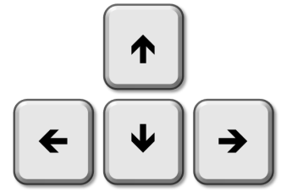

A button to fire 

For rotation 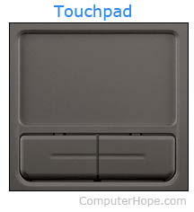

**Types of view:**

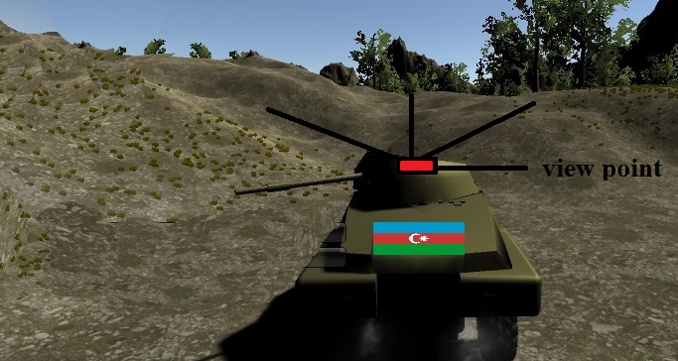

The whole picture describes the first view which is the larger one from the back side of a tank as you can see on the picture. As noted with a red color on the picture, the second one stands for the view from the tank’s pivot.

## Heads up Display (HUD)

During the game, the user will have an opportunity to see some details about his/her current state including **Health** and **Bullets**. Also, **Pause** button will appear on the screen to make a pause or to go to the Menu bar.

* **Health** - it will show the health percentage of a player which is 100% as a default in the beginning of the game
* **Bullets** – as the player will have a limited number of bullets for a shot, we will have the remaining part shown on the screen
* **Pause** – this stands for pausing the game or making any changes to the game by choosing continue, new game or quit the game buttons.

|  |
| --- |
| 100 % pause-512  20 bullets    tanque_xd_by_cartoont0ny-d8jtn64 |

## Player View

Here is the screen shot of the player view that we have for now. Precisely, the camera is in 3D format and it follows the player which is the tank in our case.

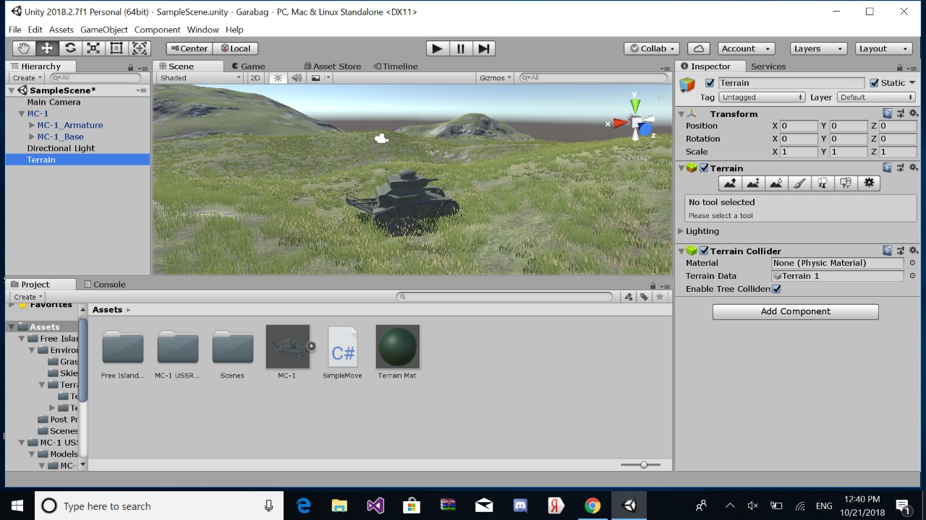

# Antagonistic Elements

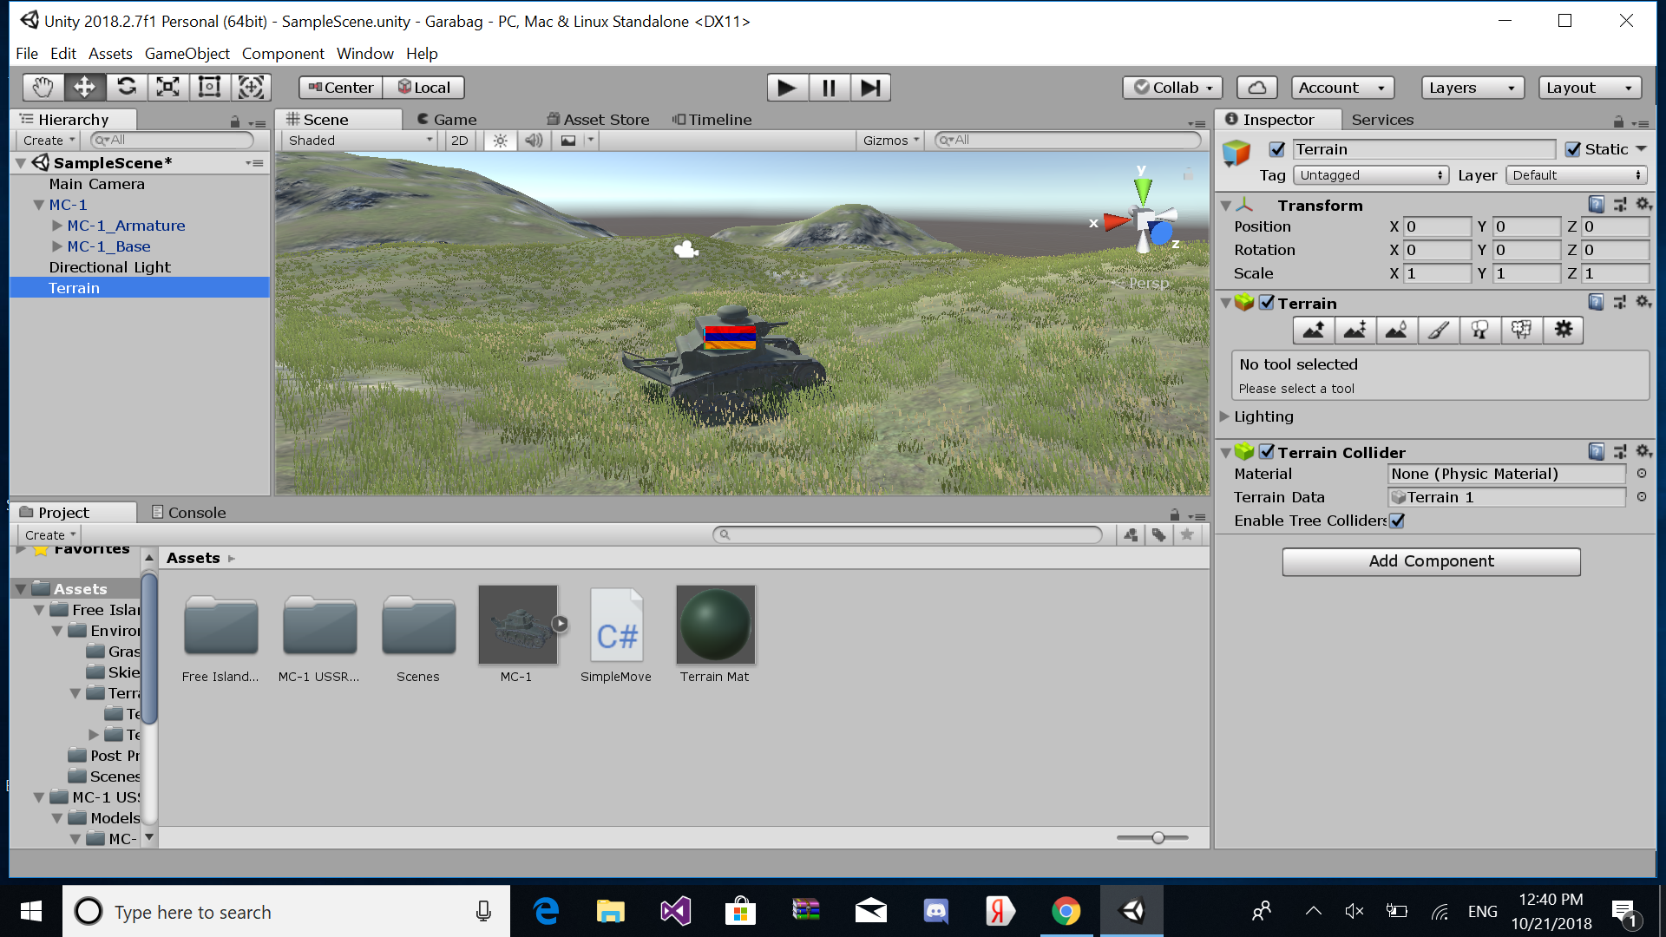

Generic Name: Enemy Tank, Prohibited area.

Game Name: Armenian Tank, Neutral zone.

**Enemy Character:**

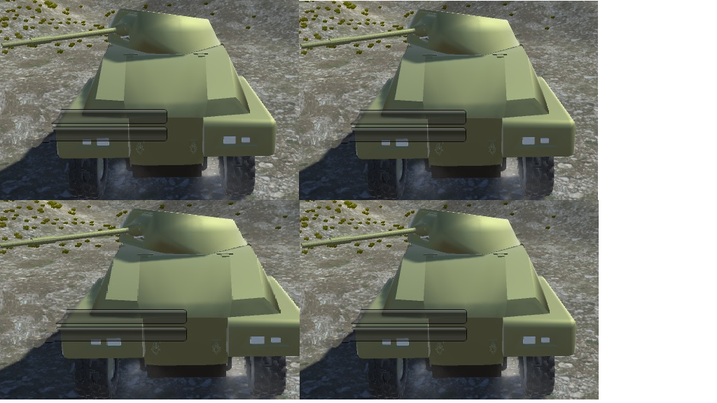

Enemy character is the tank which belongs to Armenian forces.

**Metrics:**

**Max health:**100%;

**Attack damage:** 20 %;

**Speed:** N/A

**State:**

Alive: while our player is alive then Armenian tanks will move toward the player.

Destroyed: When player exterminate them with fire shot down to 0 percent health, they will not be able to move further.

## Antagonistic Definitions

The word “antagonistic” means that which game objects are enemies to our main character. In our game, our main character is Azerbaijani tank and antagonistic objects are Armenian tanks.

## Antagonistic Properties

Since our game concept is a little bit narrow. Therefore, there are only 2 antagonistic elements in our game.

## Antagonistic List

|  |  |
| --- | --- |
| Name of antagonistic object | Description |
| 1. Armenian tanks | These tanks are the main obstacles which |
| 1. Prohibited Areas | There will be some prohibited areas that when the main character enter, health of the tank goes down. |

## Artificial Intelligence (AI)

Armenian tanks – The main obstacle for our player.

Normal State: If enemy tanks have not come across with Azerbaijani tank, they will continue to search the Azerbaijani tank randomly.

Detection State: After seeing the Azerbaijani tank, enemies will know the exact location of the player, so that they will act toward this location. So each of the enemy tanks will trace the location from different path. Consequently, they will detect the player location.

Reaction: After detecting the location of Azerbaijani tank, Armenian tank will start to shoot.

End State: If shooting from Armenian tanks hits the target, health of our tank will decrease.  
If not, the game will continue.

# Global Game Elements

Our game is based on 3D. We will use 2 main camera views. Main one will follow the player’s tank from behind. Another camera will provide the view from tank’s head. Neutral objects in our game comprise of landscape objects such as mountain, stones, grass and fortress. Although fortress as a close connection to the underlying objective of the game, it does not interfere player’s action.

## The Story

Our game is the virtual reflection of our army’s superior forces in order to liberate occupied lands of Azerbaijan Repubic. A single Tank that belongs to Azerbaijan Army crosses the border with Nagorno Karabakh and enters the historical Azerbaijan lands. Armenian tanks will be the main impediment for our tank to destroy. Enemy tanks inhibit our tank to reach its main objective. At the end, it reaches Susa fortress and liberate the lands by devastating the enemy tanks.

## The Story Copy

The main objective of the game is Azerbaijani tank fight with Armenian forces and after eliminating the obstacles, achieve its main purpose. After destroying all enemy tanks, declare its win by liberating “Shusha” fortress. For accomplishing its underlying mission, the tank will face the increasing number of Armenian tanks.

## Concept Art

The game will start with MC-1 tank as a default. Here is the representation of our tank. Moreover, in the “Tank Shop” section, there will be other kind of tanks which will be available for the player to choose. Azerbaijan flag will be our texture for the main tank character.

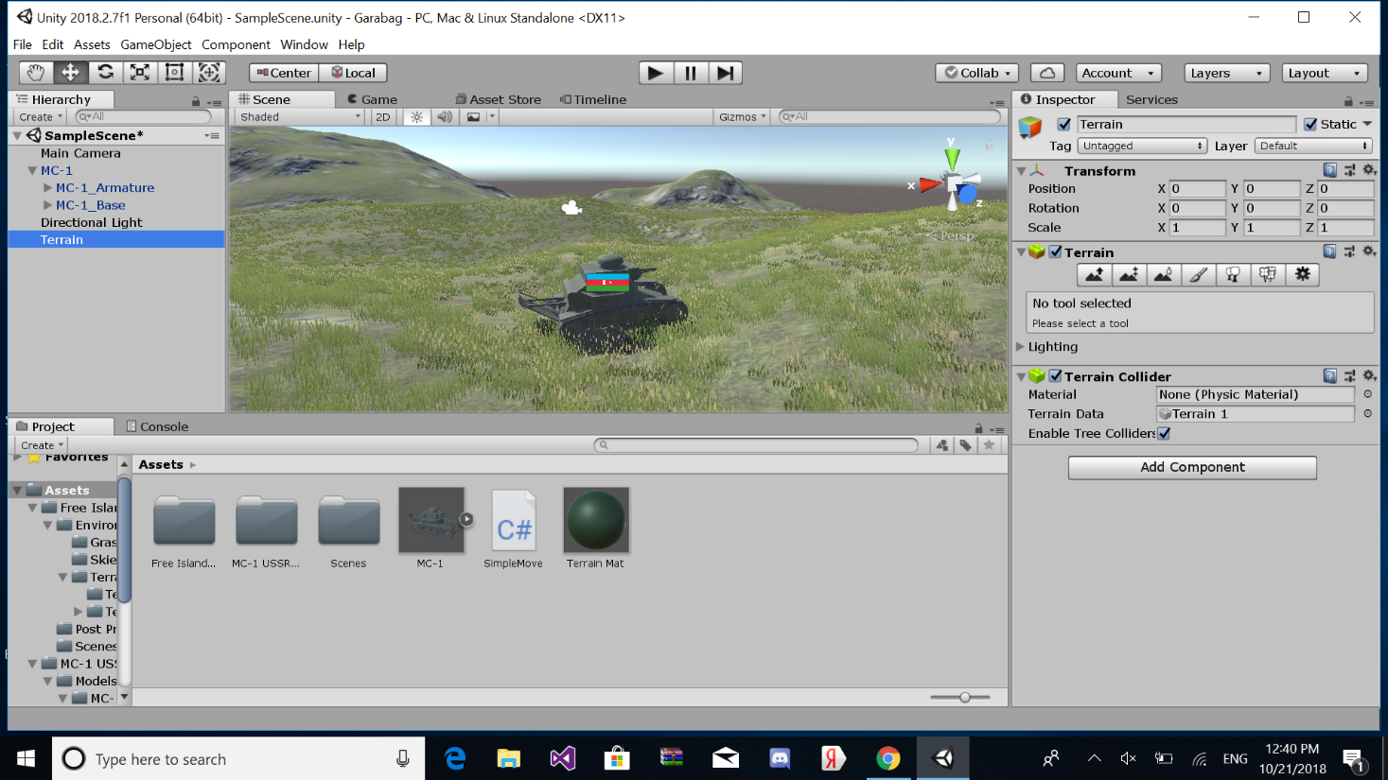

## Level Design

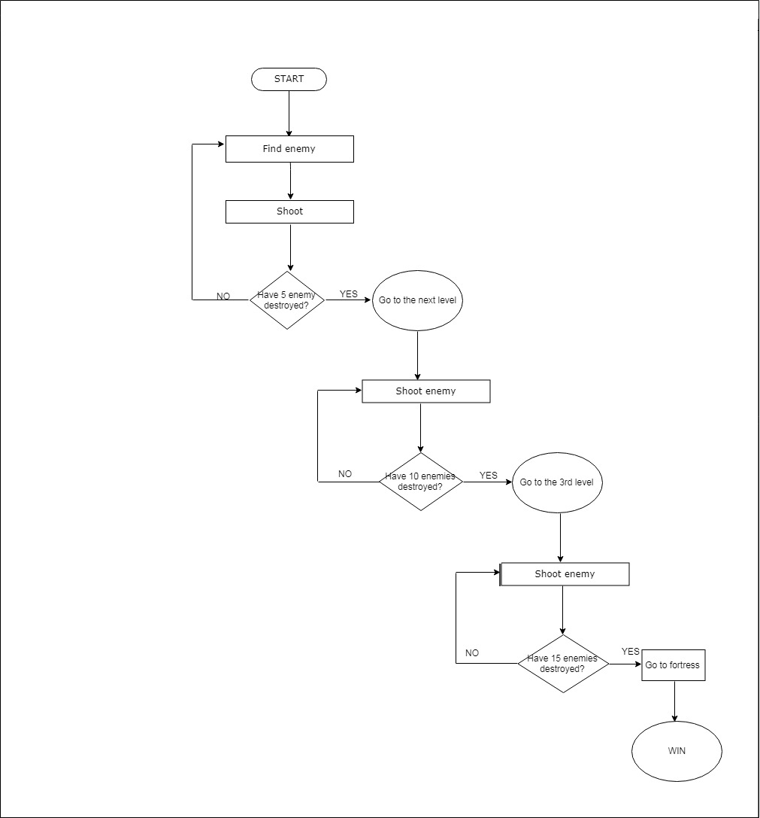

## Level Copy

In each new level, we have 5 more enemy tanks. So it means that, complexity will be increased in order to maintain the flow point of the game. Passing to the next level will bring the full fuel and full health to the main character.

## Audio & Sound F/X

Game audio specification is very significant in order to build the realistic emotions between player and game itself. So, we have tried to add some creative sounds too.

Main audio specification includes:

|  |  |  |
| --- | --- | --- |
| Name | Type | Description |
| Main\_background\_music | Background | It is the underlying background music which will play during the entire game and make the player feels in the appropriate atmosphere. |
| Win\_sound | Background | After successfully completing each stage, background music will be sounded to aware the player |
| Lose\_sound | Background | To let the player know the status of the game, after losing audio will be heard along with the losing screen. |
| End\_music | Background | “Azərbaycan güclü dövlətdir, Azərbaycanın güclü ordusu var!” When the tank complee all stages and reach the fortress this music will be played. |
| Fire\_shot\_audio | FX | The sound which will appear once the tanks fire |
| Move\_audio | FX | It is the sound of tank engine when it moves |
| Crash\_sound | FX | When the tanks crashes, this audio specification will be played to maintain the reality |
| Brake\_audio | FX | It will be sounded when player uses brake to stop the tank |

# Game Architecture

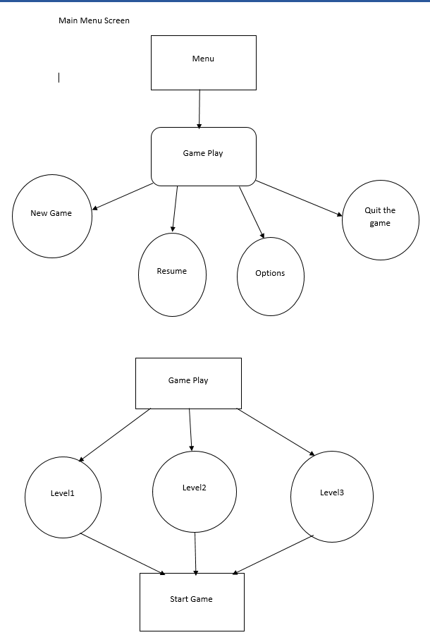

GAME PLAYSSS

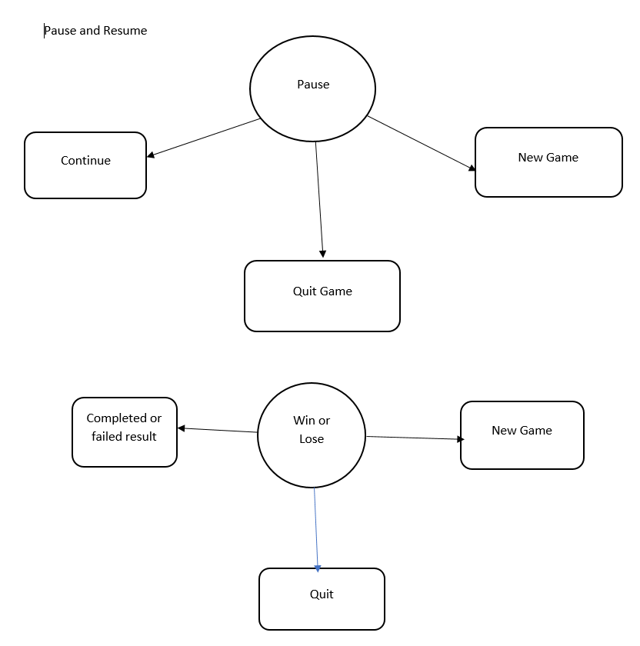

END SCREEN

## Game Architecture Overview

## The format of the game is quite simple. There will be some properties including Health, Bullets on the left bottom side and a Pause on the right bottom side of the screen. In the beginning, the player will see “play” button, he will click it and start the game. The player can use arrows for the moving as well as “W”, “S”, “A”, “D” buttons to move forward, backward, left, right accordingly. Moreover, a space button will be used to make a fire. After the player destroys more than 5 enemy’s tanks, he will move to the next level and after that the number of tanks to be destroyed to pass the level will increase. Another point is that there will be three chances to boost up health in the entire game. For the last level, the goal is to destroy 15 tanks and reach the “Shusha Fortress”.

## Architecture Copy

To begin the game the player clicks the “play” button. For the moving the player can use arrows (left, right, forward, backward) and “W”, “S”, “A”, “D” buttons accordingly. There will be 3 levels. In the first level, there will be 5 enemy tanks and their number will be doubled in the next level. In the final level, there will be 15 tanks. At the end, after the desired number of the enemy tanks will be destroyed, there will appear Azerbaijani flag together with some music on the background and the game will be considered successfully done

## How to Play Copy

Before starting the game, the player will see “play” button, by clicking it he will start the game. The player can use arrows for the moving as well as “W”, “S”, “A”, “D” buttons to move forward, backward, left, right accordingly. Moreover, a space button stands for making a fire. Whenever the player fires the enemy tanks, he will increase his score. After reaching Shusha Fortress, Azerbaijani flag will be raised, and background music will be changed meaning that you came to the last part. After all of this, there will be an alert saying that “you successfully completed the mission”.

# References

1. Jeremy Gibson Bond Foreword by Richard Lemarchand, From Concept To Playable Game With Unity and C# (2nd Edition)
2. <https://www.edrawsoft.com/flowchart-symbols.php>
3. https://www.conceptdraw.com/examples/processing-box-used-in-flowchart