<Game project name>
<Game catch phrase>

Design Document
(Homework No.2)

Project team: <Team Name>
Instructor: Dr. Araz Yusubov

Submitted in partial fulfillment of the requirements of the CSCI 4836: Game Development Fundamentals course project

Version date | Version information
<Date> | Initial draft
<Date> | <Version description>

Other documents in the package
File name | Brief description of the document
<File name> | <Description of the document>
<File name> | <Description of the document>

Team member | Contribution to this homework (NOT the project) | Estimated %
<Student Name 1> | <Description of the work contributed> | <X>%
<Student Name 2>
<Student Name 3>
<Student Name 4>

Table of Contents
<Automatically generate here using Microsoft® Word menu References→Table of Contents>

<This document describes how game objects behave, controlled and properties they have. This is often referred to as the “mechanics” of the game. This documentation is primarily concerned with the game itself. This part of the document is meant to be modular, meaning that you could have several different Design documents attached to the Concept Document.>

Introduction
This is part of the Game Design Document for a hypothetical project <Game Project Name> submitted for partial fulfillment of the requirements of the Game Development Fundamentals course in the School of Information Technologies and Engineering at ADA University, Baku, Azerbaijan.

<This document must be submitted in original Microsoft© Word format.

DELETE each and every instructional paragraph between < and > everywhere in the document and REPLACE ALL of them with your text. Keep the main numbered sections, but feel free to add sub-sections if needed. All consequent homework assignments will be based on this document, so give it enough thought.>

< While doing further planning and getting better understanding of the project you may need to make changes in the HOMEWORK 1 content, such as additions/modifications to the Game Play or to Definitions. In this case edits in the Homework 1 content should be visible by turning the TRACK CHANGES option on through Review→Track Changes menu. Remember that the version information on the title page should be updated.

Bonus: Get extra 5% points for revising and SUBSTANTIALLY improving the Homework 1 content.

All Microsoft© Word documents should be submitted as separate files. Any additional files of other types e.g. diagram and charts will usually be inserted to this document as embedded images, but the source files e.g. Photoshop .psd files should also be submitted. In this case (of having multiple non-Word files) all of them should be submitted as part of a SINGLE .zip archive file.>

< In this section, the definition of the game-play is established. Definitions should include how a player wins, loses, transitions between levels, and the main focus of the game-play. Issues that should be addressed here are:
- Menu
- Synopsis
- Game Play
- Player Control
- Game Over (Winning & Losing)
>

Game matrix
< The game matrix is a spreadsheet containing the generic names of the player and antagonistic elements and their game properties. This should allow an easy cross reference for any elements in the game that have numerical or other descriptive values associated with their name.>

Game Flow Chart
<The game flow chart provides a visual of how the different game elements and their properties interact. Game flow charts should represent Objects, Properties and Actions that are present in the game. Flow chart objects, properties and actions should have a number reference to where they exist within the game mechanics document.>

Player Elements
<The player elements section lists all the elements that are directly related to the player or serve to benefit of the player. Devise two sets of names for player elements. One set is a generic name (or code) and the other is its game name. Describe the terminology that you use to describe the player’s properties.
This is a good place to interact with a graphic designer to ensure the game graphics match the game names. Graphics that will be seen during game play should be exhibited here. Multi-player issues should also be mentioned here.>

Player Definition
<Use the player definition section to make quick descriptions that define the player.
Below is a suggested list of player definitions:
- Default (Status): What are the default settings for the player at the beginning of the game or level?
- Actions: What can the player do?
- Information (Status): What information about the game is available for the player?
- Default Properties: How does the player begin the game?
- Winning: How can the player win?
- Loosing: How does the player lose?
>

Player Properties
<Make a list within the player properties section that defines the properties for each player. Player properties can be affected by player’s action or interaction with other game elements. Define the properties and how they affect the player’s current game. A suggested list of player definitions may include:
- Health
- Weapons
- Actions
- Etc.
Each property should mention a feedback as a result of the property changing.>

Player Rewards (Power-ups & Pick-ups)
<Within the player rewards section, make a list of all objects that affect the player in a positive way (i.e. health replenished). Define these objects by describing what affect they cause and how the player can use the object.>

User Interface (UI)
< This is where a description of the user’s control of the game can be placed. It is also recommended to think about which buttons on a device would be best suited for the game. Consider what the worst layout is, then ask yourself if your UI is it still playable?
A visual representation can be added, where we relate the physical controls to the actions in the game. When designing the UI, it may be valuable to research quality control and user interface (UI) design information.>

Heads up Display (HUD)
<The HUD section is where a description of any graphics that will represent information during game play should be described. A visual representation (mock-up screenshot) here would be useful. This is another good place to seek the advice or collaboration of a graphic designer.>

Player View
<A screen shot is very necessary in the player view section. It is also beneficial to include a definition of how the camera moves for the player. Finally, a (mock-up) overview of the level relative to the screen size will help create a perspective of a levels size compared to what is actually seen.

Antagonistic Elements
<This is where a list of antagonistic (i.e. enemies, opponent) objects should be listed with graphics and written description. Describe the terminology that you used to describe antagonistic properties. Devise two sets of names for player elements. One set is a generic name (or code) and the other is its game name. This is another good place to collaborate with a graphic designer to ensure the game graphics match the game titles, names, and descriptors. >

Antagonistic Definitions
<This where a description goes of what makes an antagonistic element.>

Antagonistic Properties
<This is a list of properties that antagonistic elements have in common.

Antagonistic List
<This is where a list of all the antagonistic elements goes.>

Artificial Intelligence (AI)
<This is where visuals and written description(s) of the antagonistic element’s behaviors. These should be labeled in such a way that they can be used in level design without having to describe them again. Devise generic names for repetitive behaviors. This is how an AI action could be deconstructed:
- Normal State: What is the object doing if it has not come in contact with the player?
- Detection State: What does it take for this object to detect the player?
- Reaction State: What does the object do as an action after passing the reaction state?
- End State: What happens to the object after player has reacted correctly or incorrectly to object?
>

Global Game Elements
Our game is based on 3D. We will use 2 main camera views. Main one will follow the player’s tank from behind. Another camera will provide the view from tank’s head. Neutral objects in our game comprise of landscape objects such as mountain, stones, grass and fortress. Although fortress as a close connection to the underlying objective of the game, it does not interfere player’s action.

The Story
Our game is the virtual reflection of our army’s superior forces in order to liberate occupied lands of Azerbaijan Repubic. A single Tank that belongs to Azerbaijan Army crosses the border with Nagorno Karabakh and enters the historical Azerbaijan lands. Armenian tanks will be the main impediment for our tank to destroy. Enemy tanks inhibit our tank to reach its main objective. At the end, it reaches Susa fortress and liberate the lands by devastating the enemy tanks.

The Story Copy
The main objective of the game is Azerbaijani tank fight with Armenian forces and after eliminating the obstacles, achieve its main purpose. After destroying all enemy tanks, declare its win by liberating “Shusha” fortress. For accomplishing its underlying mission, the tank will face the increasing number of Armenian tanks.

Concept Art
The game will start with MC-1 tank as a default. Here is the representation of our tank. Moreover, in the “Tank Shop” section, there will be other kind of tanks which will be available for the player to choose. Azerbaijan flag will be our texture for the main tank character.

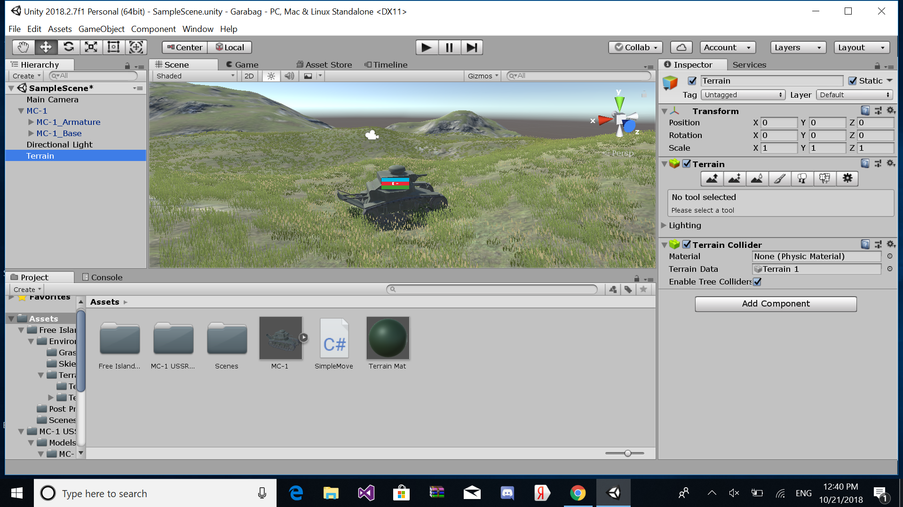

Level Design
<This is where information pertaining to level design and visuals of the level design goes. Level design can best be shown as a flow chart. Use generic names to create level design.>

Level Copy
In each new level, we have 5 more enemy tanks. So it means that, complexity will be increased in order to maintain the flow point of the game. Passing to the next level will bring the full fuel and full health to the main character.

Audio & Sound F/X
Game audio specification is very significant in order to build the realistic emotions between player and game itself. So, we have tried to add some creative sounds too.
Main audio specification includes:
Name | Type | Description
Main_background_music | Background | It is the underlying background music which will play during the entire game and make the player feels in the appropriate atmosphere.
Win_sound | Background | After successfully completing each stage, background music will be sounded to aware the player
Lose_sound | Background | To let the player know the status of the game, after losing audio will be heard along with the losing screen.
End_music | Background | “Azərbaycan güclü dövlətdir, Azərbaycanın güclü ordusu var!” When the tank complee all stages and reach the fortress this music will be played.
Fire_shot_audio | FX | The sound which will appear once the tanks fire
Move_audio | FX | It is the sound of tank engine when it moves
Crash_sound | FX | When the tanks crashes, this audio specification will be played to maintain the reality
Brake_audio | FX | It will be sounded when player uses brake to stop the tank

<This is where game audio and Sound F/X should be listed, first with generic names and then described. This section also includes deciding if you will use a device’s vibration ring mode.>

Game Architecture
<The game architecture section is best produced using a flow chart to represent the overall game. Be sure to identify (i.e. name, number) each screen.
- Title Screen
- Option Screens
- Game Modes
- End Screens
>

Game Architecture Overview
<The splash screens or video clips need to be in accordance to game story and style. If cut scenes use video then story boards should be created.
Menus should be designed with the most important options easily accessible. Be aware how many clicks it takes to accomplish a task. The game Instructions should be written so that the player understands how to play the game. Mock-ups should be made so that the game programmers get the correct layout of the menu. It is a good idea to mention and describe the high score screen in this section.>

Architecture Copy
<All text from the game can be compiled here. Review the Game Architecture Overview section.>

How to Play Copy
<This section will organize the game copy. The game copy includes information for the player, clearly describing how to play the game.>

References
<Insert here any document referred to in the document. An example might be articles or Web sites that you consulted during the literature search. This is not just a list of used materials, so do not forget to clearly MARK the exact points(s) of reference in the main text.>

This template is based on the Unity Curricular Framework ©May 2015 Unity3d.

