Malikmamed
Kill the betrayers!

Technical Document
(Homework No.3)

Project team: HahaSoEasy
Instructor: Dr. Araz Yusubov

Submitted in partial fulfillment of the requirements of the CSCI 4836: Game Development Fundamentals course project

Version date | Version information
9.11.2018 | Initial draft
18.11.2018 | Final draft

Other documents in the package
HW3.doc | Technical document of Malikmamed game

Team member | Contribution to this homework (NOT the project) | Estimated %
Fidan Sadirli | Introduction, Audio Aspect | 30%
Selin Hebipoghlu | Visual Content, Programming Content | 30%
Narmin Salahli | Audio Content | 20%
Chingiz Huseynzade | Programming Content | 20%

Table of Contents
1. Introduction 2
System Requirements 3
Concerns and Alternatives 3
Resources 3
2. Visual Content 3
3. Audio Content 6
4. Programming Content 7
Code Structure 9
5. References 9

Introduction
This is part of the Game Design Document for a hypothetical project Malikmamed submitted for partial fulfillment of the requirements of the Game Development Fundamentals course in the School of Information Technologies and Engineering at ADA University, Baku, Azerbaijan.

Malikmamed is a 2D side-scroller adventure game that is inspired by Azerbaijani fairytale Malikmamed and carries the main storyline and motives of it and the game will be made in Unity. The game has three classifications such as Visual, Programming, and Audio aspects.

- Visual Aspect:
  - Main player character and antagonist elements in visualization and their animated states
  - Type icons, background images and obstacles

- Programming Aspect:
  - Developing game in Unity and Microsoft Visual Studio
  - Programming functions in details

- Audio Aspect:
  - Type of sound of player and antagonistic elements
  - Type of sound of splash screens and menus
  - Device vibration

System Requirements

The game - Malikmamed will be available in both computer and smartphones.
System Requirements for PC Users:
- OS: Windows 7 or higher updates (32 or 64 bit)
- Processor: 2 ghz Intel Core i3 or equivalent
- Memory: 1 GB RAM
- Graphics: any types of graphic card
- Hard Drive: 100 MB free space
System Requirements for Smartphone users:
- OS: Android
- Processor: Android 5.0+
- Memory: 1 GB RAM
- Graphics: any types of graphic card
- Hard Drive: 100 MB free space

Concerns and Alternatives
While developing the game there can be some problems to solve. Such as:
- Errors and bugs while coding
- Testing the game

Resources
The following applications are using in the development of this game:
- Unity - for building and developing the game
- Adobe Photoshop and Illustrator - creating character and editing scenes
- Microsoft Visual Studio - coding part

Visual Content
This part of the document is dedicated to visual requirements of Malikmamed game and comprises the following sections: General, Player Elements, Heads up Display, Antagonistic Elements, Global Elements.
- General
  - File Size Restrictions: The game is expected to have approximately 50~100 MB of file size. Components with the biggest file size are background scenes size of which are between 0.5 MB and 1.1 MB. Design elements like trees, bushes, stones,apples,stars, elements of architecture are rather insignificant in size and most of them can be represented in 2 digit KB values. The player character- Malikmamed is 121 KB in size, whereas some of antagonist characters are bigger in size e.g. Giant character with 800 KB.
  - File Format Type: All images are in PNG (Portable Network Graphic) file format.
  - File Quality Type: PNG-24 will allow to render images with millions of colors, which in turn makes the quality of image high.
  - Visual Scale: Visual Scale Design proves to be important factor when porting games across different screen sizes. Since the game will be distributed in both PC and mobile(Android platform) versions, there will be differences that can be attributed to input modality and screen size. HUD is expected to be different for PC and mobile. On PC icons of settings elements like volume, language, hints will be displayed separately on top of the screen next to each other, whereas in mobile version they will be placed inside the Menu element on the upper left corner. Moreover, in mobile version, left,up and right buttons, as well as “Attack” command will be displayed on the screen.
- Player Elements
  - Type of States : Player element-Malikmamed will have 3 states :Default, Super and Destroyed. Whenever Malikmamed jumps over white sheep he becomes super- Malikmamed as in analogous Super-Mario game. When scores of Malikmamed hits minus, he enters Destroyed state and the game stops. In all other cases Malikmamed is in Default state.
  - Amount Animation Frames: It will be animated at 12 frames per second(fps).
- Heads Up Display (HUD)
- Type Icons: Type icons for the game are score icon with apple on the side which shows current score of the player on upper right corner of the screen; main menu icon, hints and volume which are displayed side by side on upper left corner of the screen.

  - States: In the splash page of the game an image with all of the characters of Malikmamed game and with writing “Malikmamed” will appear. Another state would be main menu with buttons like start a new game, resume, instructions, privacy policy and exit buttons.
  - Font Type: Rosewood std. with font size of 48 will be used.
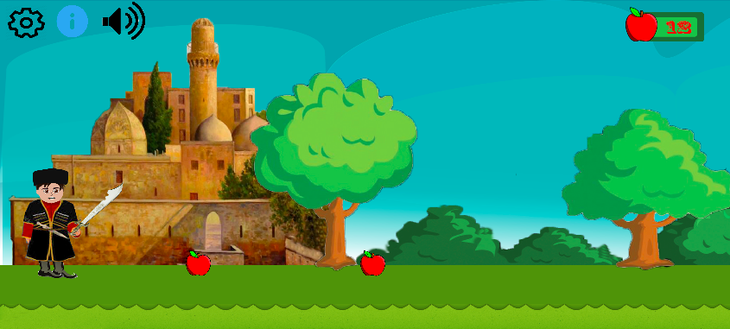
- Antagonistic Elements
  - Type of States : Antagonistic elements will have Default, Damaged and Destroyed states. All antagonistic elements will have limit of 5 damages. Whenever player manages to damage the antagonists for 5 times it enter to Destroyed state and disappears from scene.
  - Amount Animation Frames: As player elements, antagonistic elements will be animated 12 frames per second.
- Global Elements
  - Background/Texture/Tiles: Since there are 3 rounds in the game, background will be different in each of them. In the first round background is sky and forest with different shapes of trees and bushes, also at some places Azerbaijani architecture like Shirvanshahs palace, Ateshgah temple, Mardakan Castle etc. The tile is green plain. The second round occurs in underworld and background is expected to be dark, scary and imitating hell. Tile is ground. In the last round Malikmamed is again in normal world, however background is desert-like.
  - Font Type : Times New Roman is used for global elements.
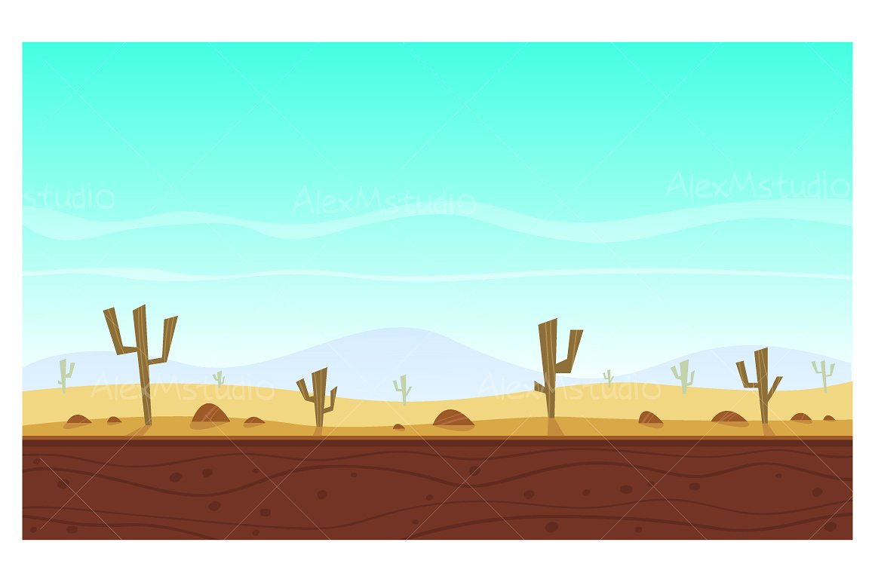
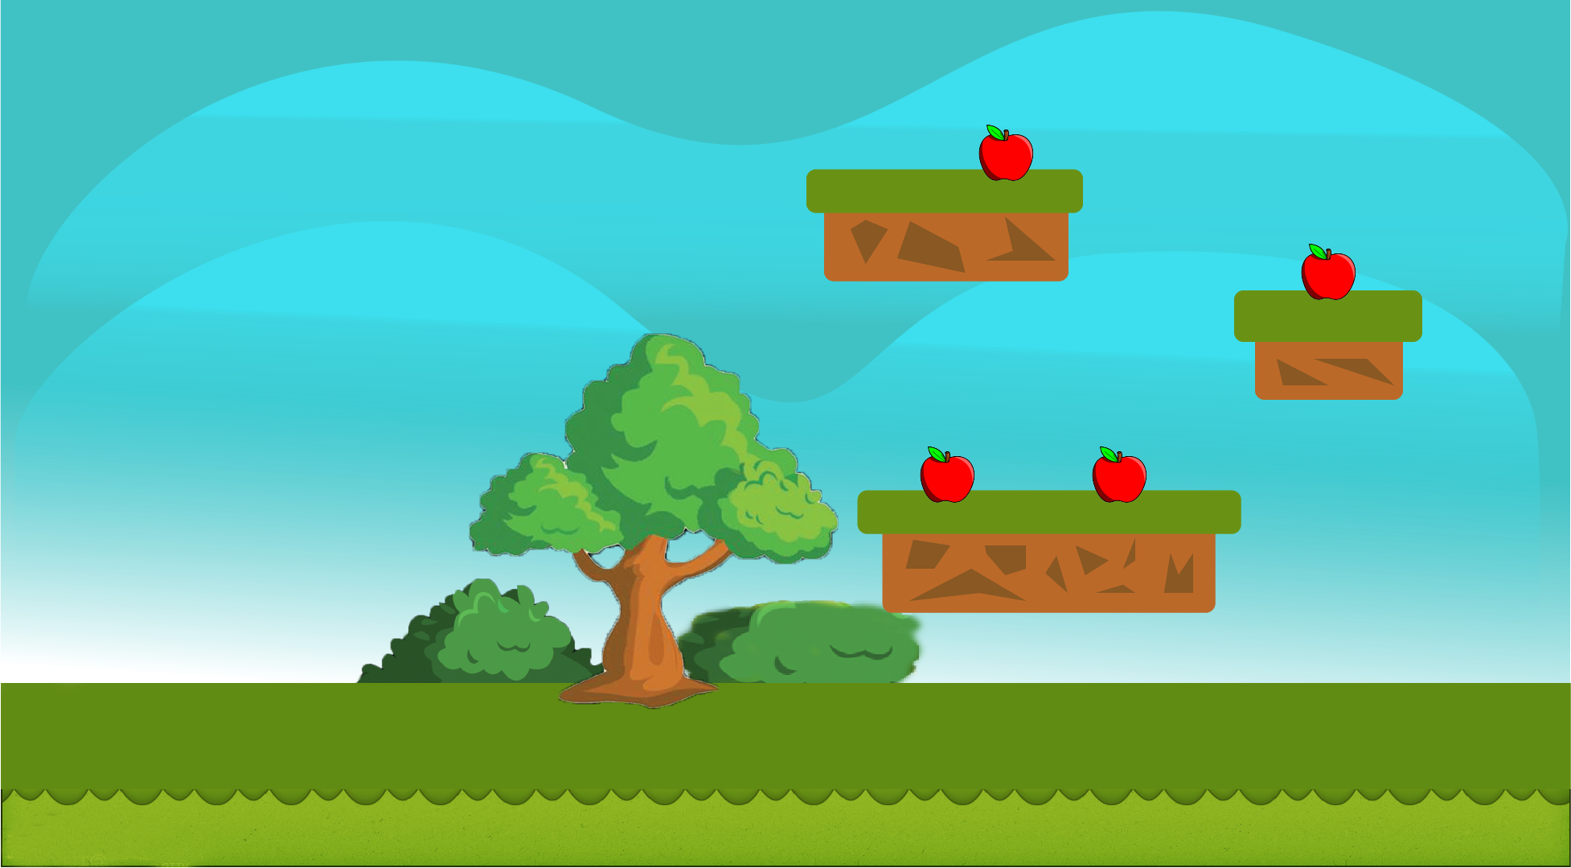

Audio Content
The following sections are used for organizing the audio content:
- General
  - File size restriction: max size will be 50 MBs
  - File Format Type: There will be mp3 file format for background music and wav for system sounds.
  - File Quality Type: Stereo
- Player Elements
  - Type of Sound f/x: There will be sound when Malikmamed uses his sword, picks up apples, touches obstacles and when Malikmamed jumps over the white sheep, he becomes SuperMalikmamed and there also will be a sound. At the third round Phoenix appears and helps Malikmamed, and there will be a sound which imitates their flights.
  - Device Vibration: While Malikmamed’s life is decreasing there will be vibration and it will only be available when player plays the game on the mobile phone.
- Antagonistic Elements
  - Type of Sound f/x: There will be sounds like roar when Giant appears, bleat when black sheep appear
  - Device Vibration: While Giant’s life is decreasing there will be vibration and it will only be available when player plays the game on the mobile phone.
- Global Elements
  - Ambient music: There will be some pieces of music from Koroghlu opera
- Splash Screens
  - Ambient Music: There will be a piece of music from Soltan Hajibeyli Karvan symphony
- Menus
  - Type of Sound f/x: There will be a piece of music from Soltan Hajibeyli Karvan symphony

Programming Content
This part is used to explain system requirements, file size and programming functions of the game.
General
  - Requirements:
Operating Systems which our game will be based are Windows and Android. Android versions higher than Lollipop should be able to support it. Processors starting from Intelcore i3 and of higher quality are all suitable. It is a simple 2D game with no complicated graphics, so any graphic card fits it. 1 GB of RAM should be enough for both Windows and Android.
  - File Size Restrictions: The game is expected to occupy Hard Disk Space of 50MB-100MB.
  - File Format Type: Programming will be done entirely in C# .
  - Language/Device Restrictions: Not dedicated for IOS systems and Mac users. The main menu, hints and speeches of characters will be only in English.
  - Screen Type : This game is intended for large(1024 px -2560 px) and small screen sizes(<425 px). Screen resolution will be adjusted to fit specific screen size.
- Player Elements
  - HitStone()- this function determines if Malikmamed collides with stone and if it happens score which is shown on upper right corner is decreased by 3 points.
  - Movement()- is used to move Malikmamed based on the key which is hold down. This function is used to change the velocity of the rigidbody which in our case is Body of Malikmamed. Velocity is equal to speed multiplied by getAxis() method.For instance, if getAxis(“Horizontal”) is positive value, it means that user presses right button and it moves Malikmamed right. This method also enables jumping for Malikmamed.
  - PutSword()-Whenever user presses “A” button, sword of Malikmamed is moved to right or left depending on the direction that Malikmamed’s face is directed. It will be accompanied with some sound imitating sword.
  - HitWSheep()- As Malikmamed jumps onto white sheep his changes his state from Default to Super and grows in size.
  - HitBSheep()- AS malikmamed jumps onto black sheep his score game is over if the state is Default, if the State is Super it changes to Default state.
- Antagonistic Elements
  - DamageGiant()- As Malikmamed attacks Giant with sword Giant loses one of his life. He has in total 5 of them, however it is not displayed on screen. Each attack results with drop of blood from Giant.
  - DisappearGiant()- As the Giant enters Destroyed state, he disappears from screen.

- Global Elements
OnTrigger2D() event is added as a component to apples and it makes possible for Malikmamed to collect them. Simply it makes collision detection and as Malikmamed collides with apples, they disappear.
SheepDisappear() event is used for sheeps to disappear slowly by falling down from screen whenever Malikmamed touches them from upwards which means when Malikmamed jumps to them.
- Splash Screens
  - Fadein and FadeOut methods, as the user presses start game button, Splash screen should fade out. As in HUD player presses Options icon, it fades in.
- Menus
  - Type of Event: Click() event will be used to display specific screen based on option pressed.
  - Type of Options: Types of Options are Start Game, Resume,Hints, Instructions,Volume, Exit.
Volume option will also appear as a menu with two puncts: Music volume and SFX volume. SFX volume is used for changing the volume of special effects. Volumes will be adjusted using slider.

Code Structure
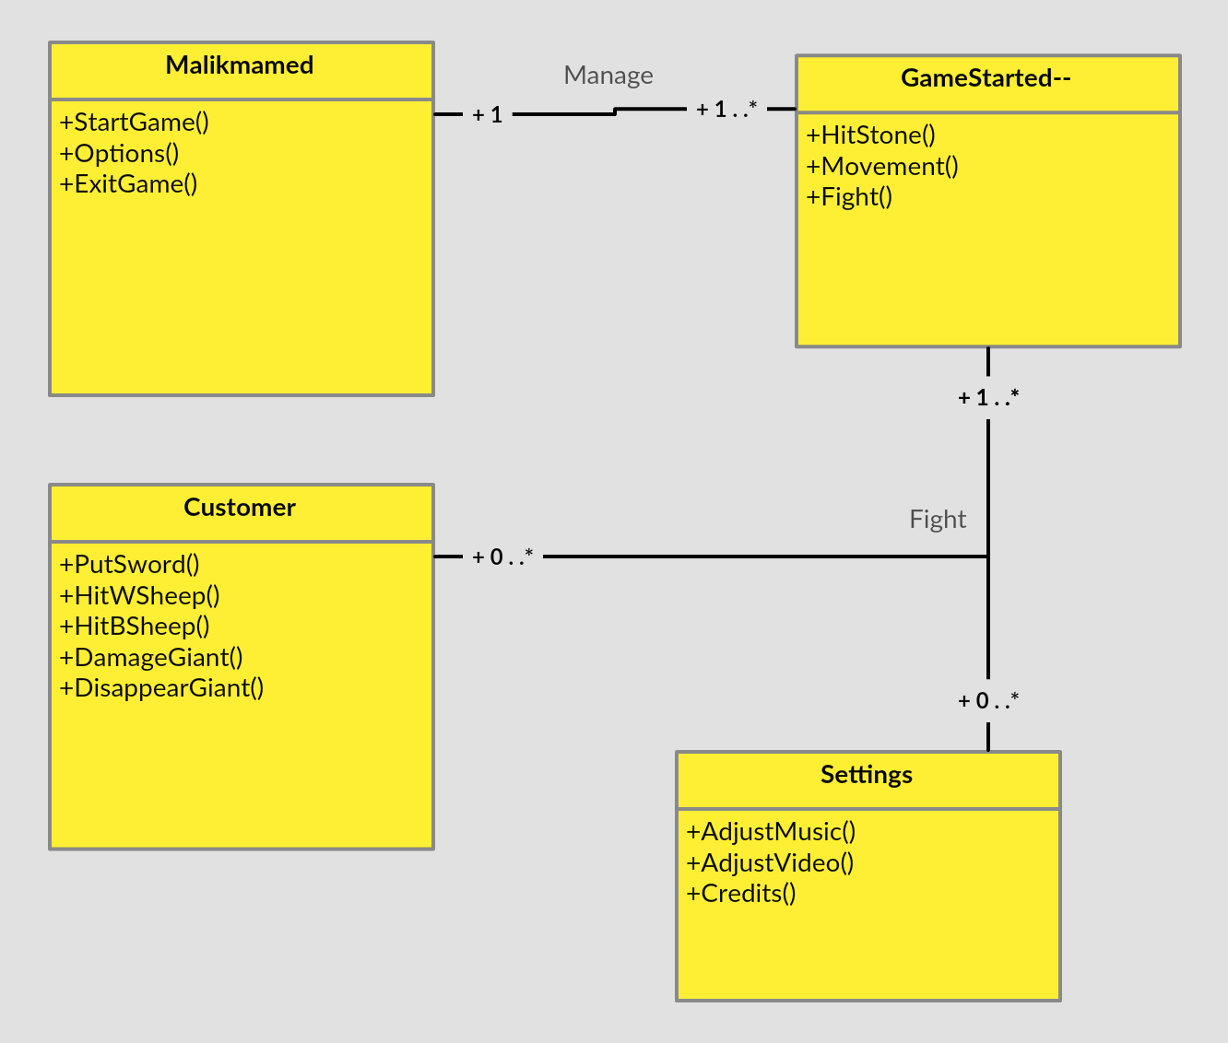

References
https://unity3d.com/- This link was used to understand different methods that exit in Unity
https://www.digipen.edu/fileadmin/website_data/gallery/game_websites/NarbacularDrop/documents/narbacular_drop_technical_design_document.pdf -This link was used to understand system requirements, file format types, visual scale design.

