Malikmamed
Kill the betrayers!

Design Document
(Homework No.2)

Project team: HahaSoEasy
Instructor: Dr. Araz Yusubov

Submitted in partial fulfillment of the requirements of the CSCI 4836: Game Development Fundamentals course project

Version date | Version information
14.10.18 | Initial draft
21.10.18 | Final draft

Other documents in the package
File name | Brief description of the document
<File name> | <Description of the document>
<File name> | <Description of the document>

Team member | Contribution to this homework (NOT the project) | Estimated %
Fidan Sadirli | Introduction, Player Elements | 25%
Selin Hebipoghlu | Player Elements, Antagonistic Elements | 25%
Chingiz Huseynzada | User Interface, Global Game Elements | 25%
Narmin Salahli | Global Game Elements, Game Architecture | 25%

Table of Contents
Table of Contents…………………………………………………………………………………… 2
1.Introduction………………………………………………………………………………………. 3
Game Matrix…………………………………………………………….............................. 4
Game Flow Chart ………………………………………………………............................. 4
2.Player Elements………………………………………………………………............................... 4
Player Definition…………………………………………………………………………… 4
Player Properties…………………………………………………………………………... 5
Player Rewards…………………………………………………………………………….. 5
3.User Interface……………………………………………………………………………………. 6
Heads up Display…………………………………………………………………………...6
Player View……………………………………………………………………………….... 6
4.Antagonistic Elements…………………………………………………………………………....7
Antagonistic Definitions…………………………………………………………………… 7
Antagonistic Properties…………………………………………………………………….7
Antagonistic List…………………………………………………………………………… 8
5. Global Game Elements…………………………………………………………………………..8
The Story…………………………………………………………………………………… 8
The Story Copy…………………………………………………………………………….9
Concept Art………………………………………………………………………………… 9
Level Design……………………………………………………………………………….. 9
Level Copy………………………………………………………………………………….9
Audio & Sound……………………………………………………………………………. 9
6.Game Architecture………………………………………………………………………………. 9
Game Architecture Overview……………………………………………………………. 10
Architecture Copy………………………………………………………………………10
How to Play Copy………………………………………………………………………….10
7.References………………………………………………………………………………………..10

Introduction

This is part of the Game Design Document for a hypothetical project Malikmamed submitted for partial fulfillment of the requirements of the Game Development Fundamentals course in the School of Information Technologies and Engineering at ADA University, Baku, Azerbaijan.

Malikmamed is a 2D side-scroller adventure game that is inspired by Azerbaijani fairytale Malikmamed and carries the main storyline and motives of it. The objective of the game is to navigate the player’s character through different environments - apple tree yard, underworld, dark world and to kill antagonists of the game- Giants and betraying brothers of the main character.
The genre of the game is action-adventure . The central character - Malikmamed is the only protagonist of the game and there are no alternatives to him. Player type is single player. Technical form is 2D. Player has the ability to jump, slide, collect the objects and fight with sword. If he hits an obstacle, the game ends unsuccessfully. Different objects act as an obstacle-black sheep, dragon fire, stones.
Since the story of the character is based on tale, we expect our major audience to be children and teenagers, regardless of their gender. Malikmamed is a sample of Azerbaijani oral literature and is included in 5th class literature books of Azerbaijani public schools. Developing such a game may attract the attentions of school time children or even the ones younger since it is one the most famous fairy tales. Notwithstanding our expectations, there are no age or interest restrictions and can be played by anyone. Due to the lack of design experience, our design intention is to make it cloned. We intend to use audio description along with summary scenes to give some insights from the original story of Malikmamed.
The game is supposed to be comprised three parts. Our gameplay is as follows: In the first part the event takes place in apple tree yard. The environmental theme there has trees in the background , however apples are on the ground. Malikmamed collects apples which in turn accumulates as points on the upper left corner of screen. However, if the suddenly appearing Giant hurts him, he starts to lose points. If the point happens to be negative at some point, game is over, the player will lose. If Malikmamed successfully encounters all obstacles he reaches a well at which the second stage of the game starts. In the second round, the environment is underworld. Malikmamed should reach the capsule which contains the soul of the Giant. As soon as he finds and breaks it, the Giant dies. Obstacles here are black sheep, dragon which breathes fire etc. Jumping on to white sheep, on the other hand, gives Malikmamed points. The third part happens to be in dark world , which is solely boss fight. Malikmamed sits on Phoenix and flies. On his way Phoenix gathers water capsules and meat which stands on the way. Malikmamed fights his two brothers and should kill them with his sword. Brothers are flying on dragon. At the end of the game, in case of success Malikmamed meets his father and fiancée, and the player will win. In the opening of the game, users will see a ‘Play’ and ‘About the game’ buttons. By clicking the ‘About the game’ button gamers will be able to read instructions and by which keys they are going to control as well as brief information about Malikmamed’s background and mission in the game. And in the menu section, there will be options for choosing the level, how to play, resume, play, replay, sounds, and exit tabs.

Game matrix
The generic name of the player is Malikmamed, which the story of the character is based on a fairytale. Malikmamed collects apples through the game and fights with his main antagonistic element - Giant. The Giant will appear at the end of the first stage. And Malikmamed should fight and kill the Giant for reaching the second stage of the game. At the second stage Malikmamed’s antagonistic elements are his two brothers. In this stage, he should kill them to win the game.

Game Flow Chart
In the game, there will be some different elements which is the obstacles for Malikmamed, such as black sheep, dragon which breathes fire. Malikmamed should overcome them to be successful. On the other hand, there will be white sheeps, which Malikmamed will earn point by jumping in to them.

Player Elements
The sole player of the game is Malikmamed which in the boss fight stage of the game is accompanied by Phoenix. He will be visualized as a young , slim , brunette boy in warrior garments (armor and sword) . Moreover , he has quiver on his back to collect apples. User at the beginning scene of the game will have a chance to know brief history of him and his brothers going to apple yard to fulfill the desire of their father. User will have impression of him as a brave and initiative personality.

Player Definition
Malikmamed could jump, slide down, move to right and left and attack with his sword. Exclusively in the boss fight he is passive and he manipulates the power of the Phoenix. He does not automatically move to the right as in original SuperMario game. Player may press two buttons so that not to just jump vertically but with angle. Player may attack his enemies by holding his sword and escape from attacks either by jumping or sliding down depending on the direction of the attack. He collects the apples which are on his way or may jump to get apples which are on platforms above the floor. As soon as he collected his first apple quiver on his back seems full. He uses his sword in the fight to Giant and when he injures him it results with bleeding but no death, in order for Giant to die, he should finish second level. If he jumps on white sheep it brings extra 3 points to him, whereas crossing black sheep loses him 3 points.
The player may win the game by completing all three levels. If the game is won the user should expect Malikmamed`s betrothal and his meeting with his father again.
Losing the game may happen from the points becoming negative. Each eaten apple or white sheep brings points while successfully ending attacks from the side of enemies decreases the points by 3. In the boss fight three arrows that brothers are throwing result with losing the game.

Player Properties
Phoenix is a mythological creature that can be faced in different cultures, as well as in Azerbaijani oral literature. In this game Phoenix acts as accompaniment of Malikmamed in boss fight part. Phoenix collects meet and water on his way. On the contrary of other levels there Malikmamed moves both vertically and horizontally, since Phoenix is flying. Phoenix will be visualized as red-orange colored bird and will Malikmamed will defend himself using fire of Phoenix. Fire will be directed at brothers using ‘F’ button.
Malikmamed also will have passive friends or proponents like his father and his bride who actually does not act in the gameplay, but appear at scenes of the games stroyline. Theft of his brides makes him revenge his brothers in the boss fight stage of game.Only weapon of him is his sword, jumping and sliding down act as defense mechanism for him.

Player Rewards (Power-ups & Pick-ups)
- collecting apples
- collecting meat and water for Phoenix
- attacking the Giant
- breaking the life capsule of the Giant

User Interface (UI)
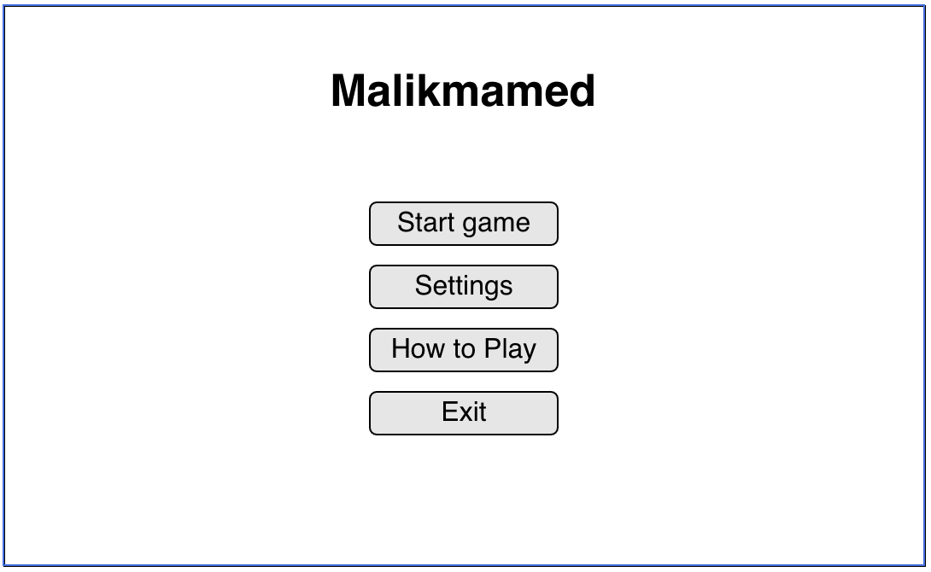

Interface of game is going to consist from title, background parallax image, and most importantly menu with 4 buttons.

Heads up Display (HUD)
User will be able to pause the game by clicking “P” key on the keyboard. After this actions there will buttons like main menu with background of action.

Top right of the screen will show the score of the player. On the bottom of the “score” there is going to text which shows level of user in the game. Top left will show the information how to pause the game which is simply by clicking the “P” key.

Player View
Player view is going to look similar to what famous “Super Mario” is like.
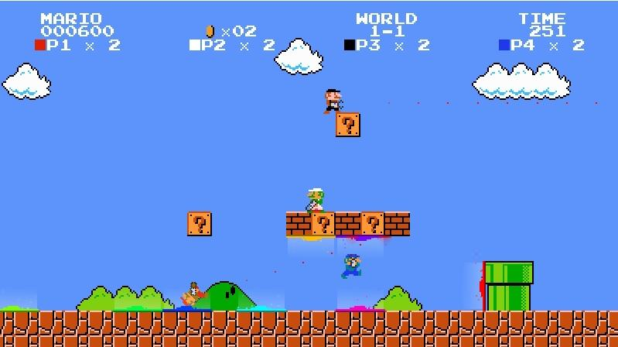
It is 2D with character of Malikmamed.

Antagonistic Elements

Antagonistic Definitions
Antagonist elements will be different in each three stages of the game. These all are the characters that are inspired by original story of the fairytale: giants, black sheep, brothers, dragon. Being injured by the antagonist elements will result with losing points and as soon as the points are less than 0, with losing the game. Some of the enemies of Malikmamed will counteract by attacking him, whereas some will passively affect the performance.

Antagonistic Properties
Any counterattack by antagonist elements will result with losing 3 points from overall score. All characters except black sheep will revenge Malikmamed by specific power. Dragon have the ability to breath fire, the Giant has the ability to punch and brothers are fighting with sword just as Malikmamed does. While touching white sheep result with gaining 3 points, black sheep will result with losing 3 points. To sum up, all antagonists are barriers to continue the game and are conducive for losing .

Antagonistic List
Giant: Giant is a fantastic creature which is commonly encountered in many national tales of Azerbaijan. It will be visualized as green , tall and muscular creature with angry face and will be as twice as big as Malimamed so that punches of him will aim directly to the head of Malikmamed. It is present in first and second stages of the game. The player should defense himself/herself from Giant by attacking him with sword, however, sword injuries are not contributing to defeating the Giant. If the user successfully accomplishes second stage of the game and finds capsule that contains the soul of Giant , it will result with automatic death of him.
Dragon: A character that resembles a dinosaur and has the ability to breath fire. Appears in the second level and counteract to the main character by fire. Malikmamed should slide down in order to escape it, nonetheless can not rebel him. Dragon appears suddenly from the right side of the screen and after breathing his fire immediately disappears.
Brothers: Though neutral in the introductory scene of the game, after betraying Malikmamed by stealing his bride, they become negative characters. In the final boss fight level of the game, two of them act as unified character and attack Malikmamed who sits on the Phoenix by throwing arrows to him. User should move Phoenix up and down depending on the final destination of the arrows. Simultaneously, Malikmamed should direct the fire of Phoenix to the brothers in order to weaken. If Malikmamed survives till the end of the game , brothers are dying defeated.
Black sheep: Passive antagonists of the game, no attacks are expected from them, nevertheless crossing them results with losing points. They may be escaped by jumping over them. At the end of second level, even though user successfully reached the end of level, black sheep comes and carries Malikmamed to dark world at which point third part of the game starts.

Global Game Elements
This game is going to be 2D like “Super Mario”. Camera will move accordingly as the user moves the Malikmamed. Background will be static and there will be objects that user should either ignore by jumping or kill with the sword.

The Story
The story of the game comes from the Azerbaijani oral literature. In fairy tale, Malikmamed collects meats, water capsules, fights with the Giant and etc.

The Story Copy
In our game, in the first stage of the game Malikmamed collects the apples through the game for gaining the points. At the end of the first stage, the player fights the Giant. After overcoming the obstacles, he/she passes the second stage. In the second stage, the player collects water capsules and meats. At the end of the second stage, he/she finds a capsule which is the soul of the Giant. The player should break it, and passes the third stage. At the end of the third stage, he/she should kill Malikmamed’s two brothers and win the game.

Concept Art
Sketches that are used for the concept can go into this section as visual reference. In the case of a brand, certain creative restrictions should be noted here. This is a good place to collaborate with a graphic designer to ensure game graphics match game names.

Level Design
This is where information pertaining to level design and visuals of the level design goes. Level design can best be shown as a flow chart. Use generic names to create level design.

Level Copy
This is where the script for in game characters or story information during the cut scenes would be placed.

Audio & Sound F/X
There will be multiple audios and sound effects in this game. The main theme, game music, jumping, swinging sword, and killing enemies sounds. In future we could add some dialogs to this game, while boss fights.

Game Architecture
The game architecture section is best produced using a flow chart to represent the overall game. In the game, there will be:
- Title Screen
- Option Screen
- Game Modes
- End Screen

Game Architecture Overview
The architecture of the game is simple. There will be several properties such as Life, Score, and Pause buttons. Before starting the game the player will see “play” button, and he/she will click it, and Malikmamed’s adventure will starts. At the end of the first stage Malikmamed should overcome the obstacles to pass the second stage of the game. The second stage of the game, Malikmamed should find the capsule, which the soul of the Giant is in it, and should break it to kill the Giant, and pass the third stage. The main goal of the game is seeing Malikmamed’s meeting with his father and fiancee, which it happens at the end of the third stage. To do it, Malikmamed should kill his two brothers at the end of the third stage.

Architecture Copy
The game will start by clicking “Start game” button. For the moving forward “D” button, backward “A” button, for jumping “W’ button, and down “S” button will be used. At the end of the first to overcome the obstacles, the second stage is to kill the Giant and at the end of the third stage to kill his two brothers Malikmamed can use his sword by clicking “space” button. At the end of the story, if the player will win, Malikmamed will meet his father and fiancee in case of success.

How to Play Copy
Before starting the game, there will be “Start game” button, which the game begins with clicking this button. Moreover, there will be “How to play” button, which the player will see the description about the game and which buttons he/she will use through the game for acting. While playing the game, the player will use “D”, “A”, “W”, “S”, and space buttons. After winning the game, there will be a message like “YOU WIN!” and Malikmamed will meet his father and fiancee.

References
Rabin, S. (2009). Introduction to game development. Retrieved from http://ebookcentral.proquest.com
Created from adaaz on 2018-09-29 20:46:40.
https://az.wikisource.org/wiki/M%C9%99likm%C9%99mm%C9%99d_na%C4%9F%C4%B1l%C4%B1

