Frozen Summer: Oghuz Edition
Finish them! If you can…

Technical Document
(Homework No.3)

Project team: Rush B
Instructor: Dr. Araz Yusubov

Submitted in partial fulfillment of the requirements of the CSCI 4836: Game Development Fundamentals course project

Version date | Version information
11/17/18 | Initial draft
12/17/18 | Final Draft

Other documents in the package
File name | Brief description of the document
<File name> | <Description of the document>
<File name> | <Description of the document>

Team member | Contribution to this homework (NOT the project) | Estimated %
Davud Ismayilov | Visual Content, Programming Content | 25%
Sabuhi Yusifzada | Introduction, Visual Content | 25%
Kamran Ahmadzada | Programming Content, Audio Content | 25%
Nurana Mahmudzada | Audio content | 25%

Table of contents
Table of Contents 2
1. Introduction 2
System Requirements 2
Concerns and Alternatives 3
Resources 3
2. Visual Content 3
3. Audio Content 4
4. Programming Content 4
Code Structure 4
5. References 5

Introduction

This is part of the Game Design Document for a hypothetical project Frozen Summer submitted for partial fulfillment of the requirements of the Game Development Fundamentals course in the School of Information Technologies and Engineering at ADA University, Baku, Azerbaijan.

We are planning to create a snow themed game which is taking place at ADA University. [1] Since, shooter gaming is the most popular genre among the video game players, we decided to choose this genre. Users of our game are going to fight against the bots via shooting snowballs to them. Main players will have different abilities based on their roles. Our game will have gloomy atmosphere in order to catch the player’s more attention. In our map 3D models such as buildings of ADA University, Flame towers of Azerbaijan will be included. Our players have to defeat each “snowman” to access new levels. This game basically is going to be “nationalized” version of the Snow Craft.
As mentioned before our game is going to have post-apocalyptic atmosphere and we are planning to reach that kind of atmosphere by using gloomy sky in the game and dark colors. In our game, during the given time main player has to survive from snowmen in order to gain access to the new level. After the each level difficulty is increasing by changing speed and power of snowmen to the higher. TPS (Third Person Shooter) is going to be used in our game which it enables the player to see main character on screen. nsead of seeing the games through the main character’s eyes, you see the main character moving and shooting in the game [2].

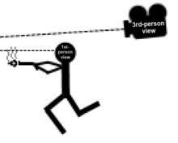

3rd Person View

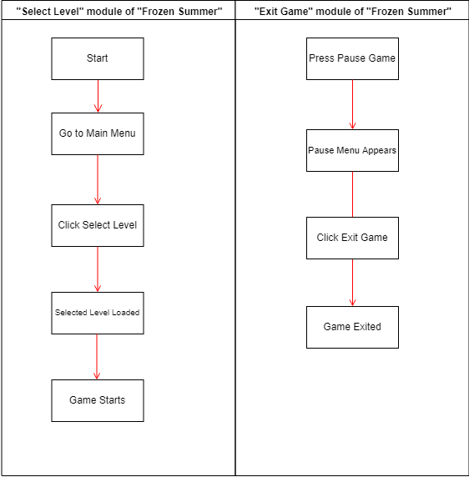
“Frozen Summer” activity modules
“F

Game Flow Chart
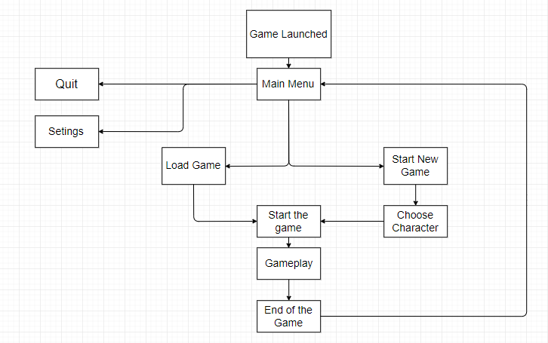

System Requirements

The game is intended to be played in the Windows OS, because currently Windows OS has 88 percent market share dominance [2]. In future we may build the game for for and Xbox One users. More detailed requirements could be find in the down list.

MINIMUM:
OS: Microsoft Windows 7
Processor: 2 GHz Dual Core Intel Core i3
Memory: 4 GB RAM
Graphics: NVIDIA GeForce 220 / ATI Radeon HD 3870 or better
DirectX: Version 9
Network: Broadband Internet connection
Storage: 4 GB available space

RECOMMENDED:
OS: Microsoft Windows 10
Processor: Intel Core i5 2400 @ 2.8 GHz or AMD FX 4100
Memory: 8 GB RAM
Graphics: NVIDIA GeForce GTX 650 / AMD Radeon HD 7870 or better
DirectX: Version 11
Network: Broadband Internet connection
Storage: 6 GB available space

Concerns and Alternatives

We will have DirectX 9 and 11 for an option but DirectX 11 may cause some problems for some players’ PCsS, becuse most of the graphic cards are not fully supported Vsion 11. That’s wWhy wehave 2 option because DirectX x9 is uing CPU mostly for gaming Example Oo) andDirecX 11 is based on PU mostly. After improving of GPU-es evelopers includig uUs aded this feature to our game. Users will have option to change DirectX 9 if they have any problem with
DirectX 11.

Resources

Blender (for map and character creation)
Mixamo (For adding motion)
Unity 3d (as a main game engine)
Fuse (for Character movement creation).
Microsoft visual Studio Code (to work with C#)

Visual Content
- General
  - File Size Restrictions
File size of our game’s visual content is not exactly decided yet, but we are expecting it not to exceed more than 1GB. Because larger files can negatively affect the gameplay and decrease availability for people who has low performance PC. We will do our best to increase efficiency and to decrease general system requirement in order to increase high availability across all PC users.
  - File Format Type
Various file types are going to be used in our game. [2] For text based file types: .xml, .txt, .ini. For image types: .png, jpg, .bmp. For audio: mp3, wma, wav. Other file versions are subject to be added in the developing phases.
  - File Quality Type
For the MVP version of the game only low level of graphical contents are expected; however, in the future versions in all important places as high as possible visual files will be used. In this case the quality of the documents will be prioritized, it means only in more important contents player will feel the high quality, which will help us to create less consuming gaming experience for all users.
  - Visual Scale
In the game all objects(in this case all visible things) has their scales, and in most of the cases our developers will try to make them more pixel independent, which means they all can be seen in same proportions for all computers.
- Player Elements
  - Type of States (Default, Damage, Destroyed, ect.)
In the game as it is previously mentioned there 3 states for our player in the game:
Default – in this state player will have just a normal “coldmeter” scale, and player can stay in this state as long as not takes any snowball from enemies.
Reduced coldmeter scale - If player got hit by snowball character will feel colder and will be vulnerable for future attacks.
Frozen – in this state the game will be finished for the player because the character will be frozen at that moment.
  - Amount Animation Frames
For the MVP the game is expected to have 30 to 60 FPS and it will not be changed during the play time, but in the next future versions players will be able to change it in the settings.
- Heads Up Display (HUD)
  - Type Icons
In our newly developed games all states of the game will be visible in the screen to make the players more aware of the game and somehow help them, and they will be able to see the cold meter bar and the time of the round and so called stamina, which shows the level of coldness of player.
  - States
All states of the game will be on the screen, and it is expected to change in the next versions of the game as it’s visuals going to be developed after MVP.
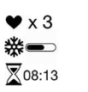
- Antagonistic Elements
  - Type of States (Default, Damage, Destroyed, ect.)
States will be more or less same for the antagonistic elements, but the reduced part will be deducted from them because they will be frozen from the first shot and the states will be as these:
Default – in this state player will have just a normal “coldmeter” scale, and player can stay in this state as long as not takes any snowball from enemies.
Frozen – in this state the game will be finished for the player because the character will be frozen at that moment.
  - Amount Animation Frames
The amount of animations for them will be exactly same with normal players, and they will be visible in same level with us.
- Global Elements
  - Background/Texture/Tiles
The game will be in the somehow “horrifying” type, it means in the game player always will wait for the possible attack of the enemies. Moreover, game will be played in winter like weather; therefore, weather always snowing in the game. Thus, all places will be snow.
  - Font Type
Showcard Gothic will be the main font of the game.

Audio Content
We are going to use various sound effects in order to increase a user engagement with our game.
- General
  - File Size Restrictions: It is impossible to say exact file size restriction for audio files in our game but we are not expecting to get over 50MB for general audio content, 3MB for
  - File Format Type: Most of the time we will use MP3 and WAV audio file format.
  - File Quality Type: Between 128 kbps and– 30 kbps for high quality audio experience is planned.
- Player Elements
  - Type of Sound – Walking on the snow sound, throwing the ball sound, hitting the target sound m
  - Device Vibration – Since our game is going to be PC game, so, we are not intending to put vibration feature.
- Antagonistic Elements
  - Type of Sound f/x

  - Device Vibration: No device vibration feature will be used because of the fact which mentioned above.
- Global Elements
  - Ambient Music
- Splash Screens
  - Ambient Music – Since we are not going to use splash screen feature, music will not be used.
- Menus
  - Psychedelic music genre is going to be used

Programming Content
In Unity for giving some action or psych to the game we need scripts. Scripts can be written in C# JavaScript or B. We are using C# in our project. In order to write and edit code inside a script we need additional environment. As editor we are using Microsoft Visual Studio Code.

- General
  - Requirements
In Unity for giving some action or physicssto the game we need sScrips. Scripts can be written in C# JavaScript or B. We are using C# in our project. In order to Write and edit code inside Script we need additional environment. As editor we are using Microsoft Visual Studio Code.

  - File Size Restrictions
There is not any file size restriction because we are using lots of scripts and it is not that long in order to need any kind of restriction.

  - File Format Type
Our Scripts Stored as C# file.

  - Specify Coding Conventions [3]
● Write only one statement per line.
● Write only one declaration per line.
● If continuation lines are not indented automatically, indent them one tab stop (four spaces).
● Add at least one blank line between method definitions and property definitions.
● Use parentheses to make clauses in an expression apparent, as shown in the following code.
● Place the comment on a separate line, not at the end of a line of code.
● Begin comment text with an uppercase letter.
● End comment text with a period.
● Insert one space between the comment delimiter (//) and the comment text, as shown in the following example.

  - Language/Device Restrictions
We are developing our games for Windows that’s why we thought C# is best suitable programing language for this. In any way if we want to build cross platform unity has the future to do that and c# is supporting this future as well.

  - Screen Type (Small, Medium, Large)
In unity3D you can choose exact screen size but we prefer to add more option in Video section under Menu to let users change screen resolution for their monitors freely.

- Player Elements
  - Collecting Snow.
Whenever player path throw the special point his Snowball numbers in inventory will be reset.
Death.
If the Snowmen reach our player and hit him he will die.
Stamina.
Our main hero will have stamina bar if it gets 0 he will need some time to reset his stamina for running.
Hitting
Our player will have Cold whenever he or she get close to fire his cold meter will close to 0 (If cold meter show 100 player will die because of cold)
- Antagonistic Elements
  - Weather condition can affect player twice when he has low hp.
- Global Elements
  - Night and Morning can change.
- Splash Screens
  - Game is for pc users so we think that we do not need splash screen feature in our project. For console players we may add this feature in the future.
- Menus
  - Start
Choose hero.
Start with random.
  - Options
Video
Sound
  - Exit Game

Code Structure

In our unity project we are trying to write special scripts for every object in our game and for the game itself we also used C#. Interaction of all game objects are important and need to be coded to prevent bugs. Here are some functions we are using in order to game works.
Public void Die(){}
This method is for snowmen and our characters whenever our characters die game will rest whenever snowman dies they will disappear.
Public void Take(){}
For our character to collect snow for snowballs.
Public Void Time(){}
In this function we are changing the timer in every Level of the game. Whenever Timer ends and our character is alive we pass next level. If not reset the level again.
Public void HedefTap(){}
For our AI agents ( the snowballs) to follow our main character and attack him.
Public void Isin(){}
For our player to heat up whenever he get close to fire points.

References

- U.S. most popular video game genres 2017. (n.d.). Retrieved from https://www.statista.com/statistics/189592/breakdown-of-us-video-game-sales-2009-by-genre/

- Third-person shooter. (2018, October 30). Image and definition retrieved from https://en.wikipedia.org/wiki/Third-person_shooter

- BillWagner. (n.d.). Coding Conventions. Retrieved from
https://docs.microsoft.com/en-us/dotnet/csharp/programming-guide/inside-a-program/coding-conventions

