Frozen Summer: Oghuz Edition
Finish them! If you can…

Concept Document
(Homework No.1)

Project team: Rush B
Instructor: Dr. Araz Yusubov

Submitted in partial fulfillment of the requirements of the CSCI 4836: Game Development Fundamentals course project

Version date | Version information
21.09.2018 | Initial draft
29.09.2018 | Final Draft

Team member | Contribution to this homework (NOT the project) | Estimated %
Nurana Mahmudzada | Contribution to the Key Features | 25
Kamran Ahmadzada | Contribution to the Selling Features | 25
Sabuhi Yusifzada | Contribution to the Introduction, Game Analysis | 25
Davud Ismayilov | Contribution to the Game Features, Game Atmosphere | 25

Table of Contents

Table of Contents 2
1. Introduction 2
2. Game Analysis 2
Game Description 2
Game Reference 2
Definitions 3
3. Game Atmosphere 3
4. Game Play 4
5. Key Features 4
6. Selling Features 5
7. References 6

Introduction
This is part of the Game Design Document for a hypothetical project ASF submitted for partial fulfillment of the requirements of the Game Development Fundamentals course in the School of Information Technologies and Engineering at ADA University, Baku, Azerbaijan.
We as a Rush B team are planning to create a game related to the snowball fight. Some elements of ADA University (Library, Student Center or SPIA buildings) and Azerbaijan (Maiden Tower and Heydar Aliyev center) will be included in our game’s map.
According to the [1] statistics from statista.com website shooter games are most popular among the US and Asian gamers. That’s why we decided to choose “shooter” genre and single player game. In order to eliminate violence, we replaced guns and ammo with snow shooters and snowballs respectively. Our game’s main characters will have some national elements from Azerbaijani fairy tales. Players will feel compassion, joy and excitement. We will use dark-shadowy colors and energetic soundtracks to make our players to relieve stress and have joy of gaining success. Our game will have 4 main characters which are inspired from Kitabi-Dede-Qorqud (Basat, Beyrek, Bekil, Baybecan) and the user will be able to choose the desired one before the starting game. All players will have same amount of health level but different features.
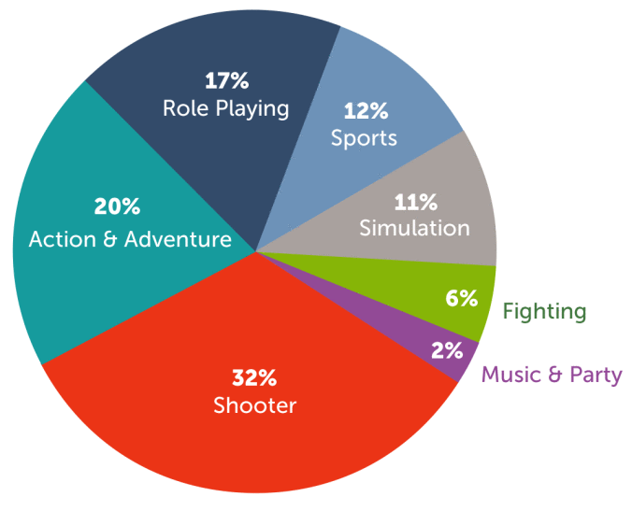

Figure 1. Popular video game genres

Game Analysis

Game Description

The game is mainly based on shooter game, but with finding of new peace of clues in the end of all levels, gamers will play the adventure genre, too. To be more precise, in simplified way it can be said that in the game players will face with the number of snowmen and have to defeat them in the snowball fight in order to get the hints which will lead them to new levels and most essentially the mystic reason for the snow in the summer. Thriller will be the game content; however, some humoristic things will be added to game play to make the game more interesting. In the fantasy-based game some old school fictional characters will be included, while its style can be considered as a real. Storyline is going to be linear, and creators is aiming to satisfy the gamers who love single player story-based games.

Game Reference

During the game some skills will be demanded and the players who have some shooter game experience will felt more comfortable and are expected to have less adaptation process than others. Moreover, the game can be considered as a fiction plus narrative game with the addition of some fictional historical and story heroes. With facing and overcoming opponents during the game players will feel both thrilling and satisfaction emotions together. Even though the exact type of the game that is going to be created is hard to find in the contemporary markets, there are several snowball games like “SnowCraft”[5], which is the source for the idea.

Definitions

In the following table all terms that can be confusing for the newbie readers are included

Term | Definition
TPS | Third-Person Shooter[3] – means the viewpoint of the player is not same with the character’s and character itself is visible.
3D Game | Game type which has 3-dimensional space and objects.
Adventure game | Game genre that emphasizes puzzle-solving and exploration
64-bit | A descriptor for hardware or software that arose during the fifth generation of video game consoles, targeting 64-bit computer architecture.
Achievements | Achievements are a way to reward and encourage players in video games. Achievements, depending on their difficulty, will award you “game score”.
Character design | It deals with aspects of a character within a video game whether in appearance, personality, abilities

Game Atmosphere
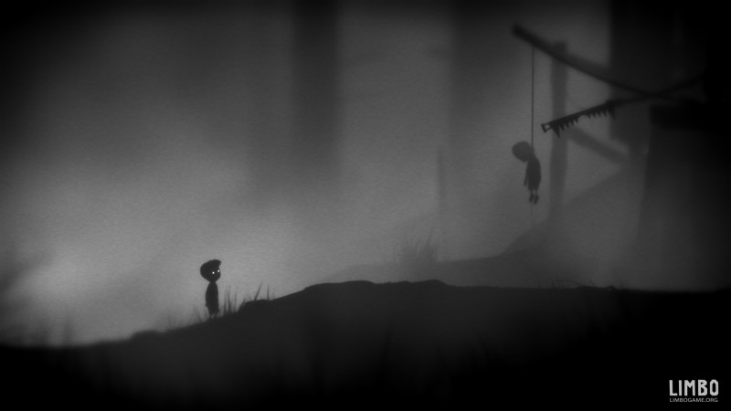

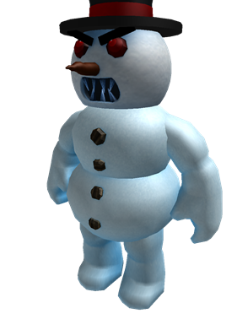

Figure 2. Snowman Figure 3. Gloomy Atmosphere from Limbo video game

Approximate general view of the snowmen in the game will be as shown in the Figure 2. The “Fight” area is the campus of the ADA University, but it should be mentioned that the view in the game will be different even though the most important parts of the campus will be included. Main 4 buildings are in the list of the kept things. Gloomy weather condition similar to Figure 3 and snow is aimed to create the real winter circumstances in the summer, and all levels of the game will have sounds of the wind and snow from start to end. All snowball is going to have sound of throwing and smashing. Furthermore, it can be added that in order to keep gender equality it is targeted to have both male and female characters in the game, and all of them will be have some special features that would differentiate them from each-other.

Game Play

First of all, after the entering the game user will see the initial page of the game where with just clicking any button could pass to the entrance hall. The game has only one game mode for that reason with clicking the play button user will be redirected to the character choosing phase. In here the user will be able to choose main player among 4 characters, and it should be mentioned that all champs have their own special skills and gamers can take any skill combination they want. After all, the game is ready to start. Firstly, game begins with short explanation about the situation. All events are happening in the campus of ADA University that located in the mythical Cirdaxanli village. Some mystical changes occurred in the village, and unexpected snow drastically affected citizens of Cirdaxanli village in the middle of the summer. All places are under snow and all people are frozen, except Uruz, and his fiancé Banuchichek. After realizing the situation, Uruz is looking for ways to solve the problem, and calls his cousin to help. Thence, our adventure is ready to go. The chosen player in this scenario Uruz’s cousin tries to find the reason behind of the sudden change. However, there is one big problem - snowmen. Because their life directly depends on cold weather, they try their best to prevent and start snowball fight against our hero to make our main player freeze forever.

This game initially consist of 4 levels and each level has its own secret item inside the box. In addition, difficulty of game increases while level is going up. In the first level Uruz encounter with easy first level snowmen. After defeating the first level (easy) snowmen Uruz finds a string (Sim) and a pot (Qazan) inside the coffer and adds it to his loot box. Later all collected items will be used to solve a puzzle at the end of third level and this will help player to gain access to the final level. In the second level main player fights against more powerful snowmen, and after defeating them, Uruz finds a pomegranate (Nar) inside the coffer. He again adds this into his loot box. In the third level after defeating the most powerful snowmen he finds a crown.
Then new window pops up in the game screen, and the user has to connect all items and solve the puzzle for gaining access to the final level. After connecting all elements from different levels ( a string, a pot, a pomegranate, a crown) he discovers that Simnar Khan and Qazan Khan gave order snowmen to kidnap fiancé Banuchichek. At the final level, Uruz fights against Simnar Khan and Qazan Khan and defeat them. At the end he recues his fiancé and life comes back to the normal in his village.

Key Features
Because of the adventurous game type, it is accepted that the game will have levels, which is going to be 4, but the number is subject to change any time with some additions to the gameplay. In all levels the number and the levels of the enemies is supposed to be different; therefore, it is hard to say exact number. However, all levels are going to take more or less 10 minutes for average player and most probably more time of the game will be used for snowball fight with bosses. Moreover, the game will save itself after passing all levels, which grant to user opportunity to start from last level he reached, although the player can return to start of the game if it is needed. As it is mentioned above, all game will have game soundtrack and other sounds which have goal to make players feel and live the real snowball shooter, adventure game experience. The game will be created in the Unity game development platform that let creators to make unique high-quality games for all platforms, but specifically for this game first releases is considered only for Windows OS. Moreover, Blender can be used in the creation of some graphics.

Selling Features

Despite the fact that in the game markets snowball games can be found, this new game will be completely different from all others; therefore, it is not expected to have some copyright problems in the future. Furthermore, soundtracks which are going to be used in the game will be taken from NoCopyrightSounds[6], because of the possible copyright issues.
The game will include no violation, thus, people from all ages can be players of new game. Moreover, during the idea generation time, in order to draw the attention of the children all enemies was changed with the snowmen and instead of guns and ammos only snow shooters and snowballs are used, which is obviously one of the children’s favorite. “Fight” arena is university campus; therefore, it is expected to the game will have special interest among the ADAU students. Furthermore, in the game the a lot of features from Azerbaijan’s folklore and tales, hence, the game most probably will be liked among people who have passion to it. This game may also increase interest to Azerbaijani Fairy Tales and Dede Qorqud. Taking into consideration all above mentioned facts, it can be expected that, with combination of these specifications and good graphics and gameplay, the game can have financial success.

References

1) U.S. most popular video game genres 2017. (n.d.).
Retrieved from https://www.statista.com/statistics/189592/breakdown-of-us-video-game-sales-2017-by-genre/

2) The Video Game Debate. (n.d.).
Retrieved from
https://www.researchgate.net/publication/285069015_The_Video_Game_Debate_Unravelling_the_Physical_Social_and_Psychological_Effects_of_Digital_Games

3) Staff, X. W. (2015, October 21). Know Your Genres: Third-Person Shooters.
Retrieved from https://news.xbox.com/en-us/2015/10/09/games-know-your-genres-third-person-shooters/

4) 2016 Library Snowmen. (n.d.).
Retrieved from https://ripleylibrary.com/2016/12/20/2016-library-snowmen/

5) Play. (n.d.). Retrieved from http://nny.com/snowcraft/play/

6) S. (2018, August 30). Copyright Free Music: These Labels Are Changing Up Royalty Free Music. Retrieved from https://www.edmsauce.com/2017/11/09/copyright-free-music/

