<Game project name>
<Game catch phrase>

Technical Document
(Homework No.3)

Project team: <Team Name>
Instructor: Dr. Araz Yusubov

Submitted in partial fulfillment of the requirements of the CSCI 4836: Game Development Fundamentals course project

Version date | Version information
<Date> | Initial draft
<Date> | <Version description>

Other documents in the package
File name | Brief description of the document
<File name> | <Description of the document>
<File name> | <Description of the document>

Team member | Contribution to this homework (NOT the project) | Estimated %
<Student Name 1> | <Description of the work contributed> | <X>%
<Student Name 2>
<Student Name 3>
<Student Name 4>

Table of Contents
<Automatically generate here using Microsoft® Word menu References→Table of Contents>

Introduction
This is part of the Game Design Document for a hypothetical project <Game Project Name> submitted for partial fulfillment of the requirements of the Game Development Fundamentals course in the School of Information Technologies and Engineering at ADA University, Baku, Azerbaijan.

We are planning to create a snow themed game which is taking place at ADA University. [1] Since, shooter gaming is the most popular genre among the video game players, we decided to choose this genre. Users of our game are going to fight against the bots via shooting snowballs to them. Main players will have different abilities based on their roles. Our game will have gloomy atmosphere in order to catch the player’s more attention. In our map 3D models such as buildings of ADA University, Flame towers of Azerbaijan will be included. Our players have to defeat each “snowman” to access new levels. This game basically is going to be “nationalized” version of the Snow Craft.
As mentioned before our game is going to have post-apocalyptic atmosphere and we are planning to reach that kind of atmosphere by using gloomy sky in the game and dark colors. In our game, during the given time main player has to survive from snowmen in order to gain access to the new level. After the each level difficulty is increasing by changing speed and power of snowmen to the higher

“Frozen Summer” activity modules
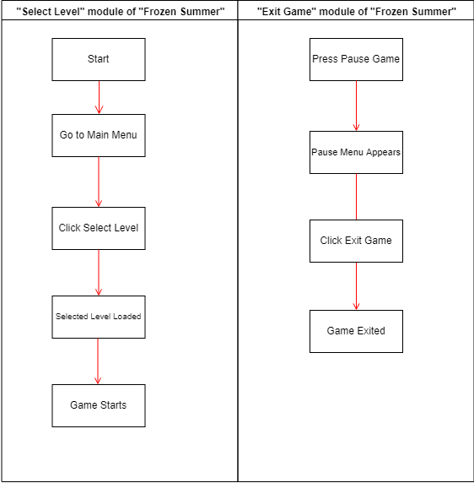

Game Flow Chart
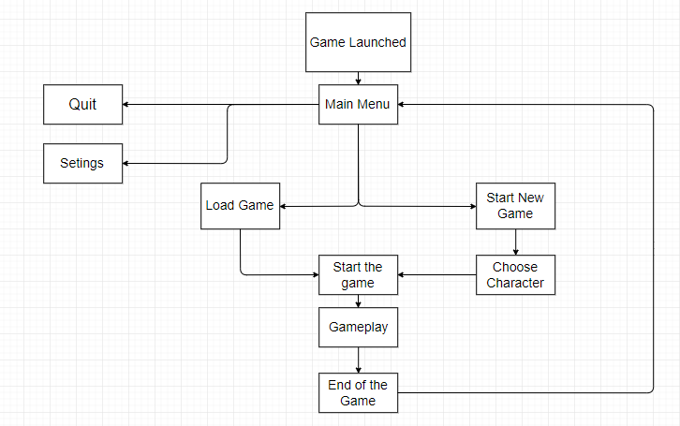

System Requirements

The game is intended to be played in the Windows OS, because currently Windows OS has 88 percent market share dominance [2]. In future we may build the game for PS4 and Xbox One users. More detailed requirements could be find in the down list.

MINIMUM:
OS: Microsoft Windows 7
Processor: 2 GHz Dual Core Intel Core i3
Memory: 4 GB RAM
Graphics: NVIDIA GeForce 220 / ATI Radeon HD 3870 or better
DirectX: Version 9
Network: Broadband Internet connection
Storage: 4 GB available space

RECOMMENDED:
OS: Microsoft Windows 10
Processor: Intel Core i5 2400 @ 2.8 GHz or AMD FX 4100
Memory: 8 GB RAM
Graphics: NVIDIA GeForce GTX 650 / AMD Radeon HD 7870 or better
DirectX: Version 11
Network: Broadband Internet connection
Storage: 6 GB available space

Concerns and Alternatives

We will have DirectX 9 and 11 for an option but DirectX 11 may cause some problems for some players’ PCs. Because some of the graphic cards are not fully support Version 11. That’s why we have 2 option because DirectX 9 is using CPU mostly for gaming (CS: GO) and DirectX 11 is based on GPU mostly. After improving of GPUs developers including us added this feature to our game. Users will have option to change DirectX 9 if they have any problem with
DirectX 11.

Resources

Blender (for map and character creation)
Mixamo (For adding motion)
Unity 3d (as a main game engine)
Fuse (for Character movement creation).
Microsoft visual Studio Code (to work with C#)

Visual Content
<This is a section that lists technical requirements from those in concerned with the visual aspects of the game. All objects should be listed with their generic names.
- General
  - File Size Restrictions
  - File Format Type
  - File Quality Type
  - Visual Scale
- Player Elements
  - Type of States (Default, Damage, Destroyed, ect.)
  - Amount Animation Frames
- Heads Up Display (HUD)
  - Type Icons
  - States
  - Font Type
- Antagonistic Elements
  - Type of States (Default, Damage, Destroyed, ect.)
  - Amount Animation Frames
- Global Elements
  - Background/Texture/Tiles
  - Font Type
>

Audio Content
We are going to use various sound effects in order to increase a user engagement with our game.
- General
  - File Size Restrictions: It is impossible to say exact file size restriction for audio files in our game but we are not expecting to get over 50MB for general audio content,
  - File Format Type: Most of the time we will use MP3 and WAV audio file format.
  - File Quality Type: Between 128 kbps and 320 kbps for high quality audio experience is planned.
- Player Elements
  - Type of Sound – Walking on the snow sound, throwing the ball sound, hitting the target sound
  - Device Vibration – Since our game is going to be PC game, so, we are not intending to put vibration feature.
- Antagonistic Elements
  - Type of Sound f/x
  - Device Vibration: No device vibration feature will be used because of the fact which mentioned above.
- Global Elements
  - Ambient Music
- Splash Screens
  - Ambient Music – Since we are not going to use splash screen feature, music will not be used.
- Menus
  - Psychedelic music genre is going to be used

Programming Content
In Unity for giving some action or psych to the game we need scripts. Scripts can be written in C# JavaScript or B. We are using C# in our project. In order to write and edit code inside a script we need additional environment. As editor we are using Microsoft Visual Studio Code.
- General
  - Requirements
In Unity for giving some action or physics to the game we need scripts. Scripts can be written in C# JavaScript or B. We are using C# in our project. In order to Write and edit code inside Script we need additional environment. As editor we are using Microsoft Visual Studio Code.

  - File Size Restrictions
There is not any file size restriction because we are using lots of scripts and it is not that long in order to need any kind of restriction.

  - File Format Type
Our Scripts Stored as C# file.

  - Specify Coding Conventions [3]
● Write only one statement per line.
● Write only one declaration per line.
● If continuation lines are not indented automatically, indent them one tab stop (four spaces).
● Add at least one blank line between method definitions and property definitions.
● Use parentheses to make clauses in an expression apparent, as shown in the following code.
● Place the comment on a separate line, not at the end of a line of code.
● Begin comment text with an uppercase letter.
● End comment text with a period.
● Insert one space between the comment delimiter (//) and the comment text, as shown in the following example.

  - Language/Device Restrictions
We are developing our games for Windows that’s why we thought C# is best suitable programing language for this. In any way if we want to build cross platform unity has the future to do that and c# is supporting this future as well.

  - Screen Type (Small, Medium, Large)
In unity3D you can choose exact screen size but we prefer to add more option in Video section under Menu to let users change screen resolution for their monitors freely.

- Player Elements
  - Collecting Snow.
Whenever player path throw the special point his Snowball numbers in inventory will be reset.
Death.
If the Snowmen reach our player and hit him he will die.
Stamina.
Our main hero will have stamina bar if it gets 0 he will need some time to reset his stamina for running.
Hitting
Our player will have Cold whenever he or she get close to fire his cold meter will close to 0 (If cold meter show 100 player will die because of cold)
- Antagonistic Elements
  - Weather condition can affect player twice when he has low hp.
- Global Elements
  - Night and Morning can change.
- Splash Screens
  - Game is for pc users so we think that we do not need splash screen feature in our project. For console players we may add this feature in the future.
- Menus
  - Start
Choose hero.
Start with random.
  - Options
Video
Sound
  - Exit Game

Code Structure

In our unity project we are trying to write special scripts for every object in our game and for the game itself we also used C#. Interaction of all game objects are important and need to be coded to prevent bugs. Here are some functions we are using in order to game works.
Public void Die(){}
This method is for snowmen and our characters whenever our characters die game will rest whenever snowman dies they will disappear.
Public void Take(){}
For our character to collect snow for snowballs.
Public Void Time(){}
In this function we are changing the timer in every Level of the game. Whenever Timer ends and our character is alive we pass next level. If not reset the level again.
Public void HedefTap(){}
For our AI agents ( the snowballs) to follow our main character and attack him.
Public void Isin(){}
For our player to heat up whenever he get close to fire points.

Bonus: Get extra 10% points for including Interaction Matrices and/or Class Diagrams.>

References
<Insert here any document referred to in the document. An example might be articles or Web sites that you consulted during the literature search. This is not just a list of used materials, so do not forget to clearly MARK the exact points(s) of reference in the main text.>

Interaction matrix is a spreadsheet listing game objects on sides, and interactions that can occur between them during the game at intersections of rows and columns.

