Aghanatiq – The Game
Xırdalana bir nəfər.

Design Document
(Homework No.2)

Project team: Survivors
Instructor: Dr. Araz Yusubov

Submitted in partial fulfillment of the requirements of the CSCI 4836: Game Development Fundamentals course project

Version date | Version information
10.15.2018 | Initial draft
<Date> | <Version description>

Other documents in the package
CSCI4836-HW01-Concept-Document | The document describes the important parts of the homework 1
<File name> | <Description of the document>
<File name> | <Description of the document>

Team member | Contribution to this homework (NOT the project) | Estimated % | Actual
Durna Zeynalli | Wrote the 1st and 6th part of the report | 25%
Nijat Mursali | Wrote the 2nd and 5th part of the report, edited the 1st part | 25%
Nurana Rafizada | Wrote the 3rd part of the report | 25%
Nuru Nurdil | Wrote the 4th part of the report | 25%

Table of Contents
Contents
Table of Contents 2
1. Introduction 2
Game matrix 3
Game Flow Chart 3
2. Player Elements 3
Player Definition 3
Player Properties 4
Player Rewards (Power-ups & Pick-ups) 4
3. User Interface (UI) 4
Heads up Display (HUD) 4
Player View 4
4. Antagonistic Elements 4
Antagonistic Definitions 5
Antagonistic Properties 5
Antagonistic List 5
Artificial Intelligence (AI) 5
5. Global Game Elements 5
The Story 5
The Story Copy 5
Concept Art 5
Level Design 6
Level Copy 7
Audio & Sound F/X 7
6. Game Architecture 7
Game Architecture Overview 7
Architecture Copy 7
How to Play Copy 7
7. References 7

Introduction

Bonus:

In our first report, we gave the brief introduction about the game which will the taxi-cab simulator which will contain the elements will be related to Azerbaijan culture and cities. Our game will be 2D platform game which the player will driver through multiple roads and architectural monuments of the cities of Azerbaijan. In the following sections, we talked about the genre, elements and other important aspects of the game which will be 2D platform game and we will try to give the educational content by showing the important and beautiful things in Baku. If we also talk about the game atmosphere, our game will include dynamic weather in itself like it will have the day and night cycles, and the game will have sunny, rainy and snowy types of weather inside. We also described how the gameplay will be which is that player will be able to choose several cars in order to play and win. Game itself will contain Main Menu and other scenes; however, Main Menu will also contain several elements like play game, settings and if player wants to quit the game. In our first report, we added the DEMO screenshot from the game itself. We finished the report 1 with the selling features which include our main audience who are the people that have phone or computer and has interest in learning and enjoying seeing the beautiful places and sides of Baku. We also think about putting the game on the Google Play and Appstore if we will finish it successfully.

In this section, there will be shown that the player how will play the game, how will win or lose, and the most especial one how will control the taxi on the game. Main focuses issues that should be addressed here are:
- Menu: this section is divided into three parts: start game, setting, and quit. When player click the start game each time, the new game will start. The volume settings of the game are located on the setting part. Finally, quit is to exit from the game.
- Synopsis: a taxi driver drives a taxi and while driving taxi will take fuel and coins on the way. He also meets with a policeman and may give him money. There will be some obstacles on the way and taxi driver should avoid from obstacles for winning the game. He also should be come on time to the end of the game to win, otherwise he will lose.
- Game play: This section is about how the player will play the game. Our main character will go through the level in order finish the level successfully. Of course, it will not be that simple to finish the levels. Our main character will have several obstacles and especially police officer throughout the level.
- Player control: the game can be played on both computer and smart phone. On computer, used buttons are ‘W’, ‘S’, arrow key – left arrow key, right arrow key. The buttons ‘W’ and right arrow key are for going front side, and ‘S’ and left arrow key are for going back side. Smartphones are touchscreen, for this reason, player will use his/her fingers.
- Game over (Winning & Losing): For winning the game, the player should arrive at a given time to the end of the game; the player should have money how much the game requires. For losing the game, while the player plays the game, the time should finish; player should not avoid from obstacles.

Game matrix

The main object in our game will be our player and the car will contain Rigidbody, Physics, Colliders and scripts for moving throughout the level.
The buildings like Maiden Tower, Flame Towers and other main ones will contain only the background image and they will not contain any physics in the game.
The police officer will contain the colliders because when the player is near the policeman options for the upcoming scene will show up. Thus, the colliders should be added to the policeman.
We will also have other cars like police car that will chase us if we choose one option and because our game is 2D it not will contain colliders; however, it will contain the Rigidbody and scripts for the AI.
Other objects like streetlights will also have the Physics in the game.

Game Flow Chart

Player Elements

The player elements in our car will be the following:
- Headlights
- Siren/horn
- The sound of car itself
- Gearing up by pressing the buttons

As mentioned above, our player will have several amazing options in the car in order to
make the game look more realistic and amazing.

Player Definition

In the beginning of the game player is able to choose the simple car (VAZ 2107) and go through the level. Throughout the levels, our player will be able to choose other cars which are more expensive than the previous one(s). However, in the first level the player should start with VAZ 2107 and try to finish the level successfully.
Player’s actions include these in itself:
- Go throughout the level
- Try to avoid obstacles
- If the police officer catches the player because of speed limit, choose one of the options
- Try to finish the level successfully
- Try to maximize the score in the level

In the menu we will also add the description and instructions for moving the player in the game and doing the right actions throughout the game. In the level itself, player will be able to see the instructions and the best choices that can be done in order to finish the level with highest score.
Our main character, Aghanatiq, starts the game in the beginning position of the level which is the beginning of the road. He will already be inside the car; however, we will try adding option for making the player move and if he presses the button, he will get into the car. However, the main idea will be the man, Aghanatiq, inside the car and driving through the level.
Winning state will happen when the player will finish the game successfully with eliminating all the obstacles like police officer and other barriers. There will be the table for showing the scores for each level when player finishes the game.
Losing state will happen when the player will not be able to finish the game successfully and got hit by barriers throughout the game. As we mentioned in the first report, there will be the police officer and he can take your car to the parking lot if you chose the wrong option (like not having enough money for giving).

Player Properties

Our car will have damage system and when the barrier touches the car the collision detection will be in true state and the health of player will decrease. If the health will reach to zero, player will have to start the level from beginning and the score will be zeroed.
The time management will be another obstacle for our player because when the time goes till zero and player doesn’t finish the game, our player will basically lose. Thus, our player should have good time management in order to finish the game in time by avoiding other obstacles.
As mentioned before, the player will get several amounts of money while going through the level and more money in the end of level in order to buy new cars and other items for the cars.

Player Rewards (Power-ups & Pick-ups)

In our game will make the collectable items to the game in order to make the player’s life easier for finishing the level in time and not losing more money in the end.
These items/rewards include the following:
- Health sprite for refreshing the health of the player/car
- Speed-up sprite for speed of the car for some amounts of time

User Interface (UI)

Functional Requirements

Firstly, splash page is opened while starting the game. Splash Page is initial screen and it introduces game logo “AGANATIQ”. The next step is Main Menu which presents different sections such as NEW GAME, OPTIONS and QUIT GAME for the comfort of the user and shows graphic image of “AGANATIQ” in taxi that gives information about the game. Inside NEW GAME, there is Car Selection section shows the car selection screen for choosing different cars due to their characteristics (prices, models and so on). Additionally, in main menu, there is OPTION section which one includes Sound Volume and Music Volume that user can control. In further step, when game happens, Gameplay screen seems, and it includes fixed Heads Up Display which contains taxi car graphic, health bar, timer, score/total points, resume/pause button, car horn button and gamepad with forward/backward (gas/stop) buttons.

Mock-up Screenshots

- Splash page

AGHANATIQ

- Main Menu
NEW GAME
OPTIONS
QUIT GAME
GRAPHIC IMAGE OF AGHANATIQ

- Character Selection

CAR SELECTION

GRAPHICS OF CARS AND THEIR CHARACTERISTICS

- Options
OPTIONS

SOUND VOLUME IIIIIIIIIIII

MUSIC VOLUME IIIIIIIIIIII

- Game Play
SCORE
PAUSE
TIME

SIREN
LIGHT

G
A
S
S
T
O
P

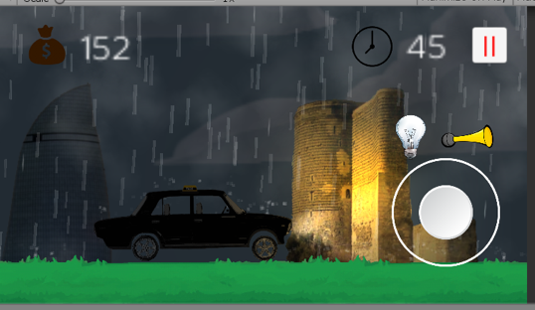

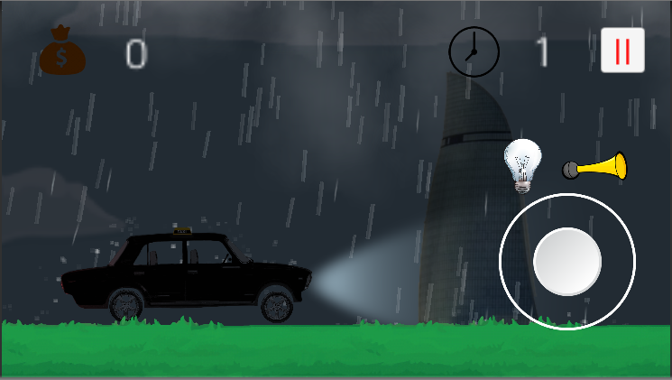

Heads up Display (HUD)

HUD is main part of user interface (UI). It represents the information which appears on the screen while the game is played by player/user. In “AGANATIQ”, heads up display (HuD) includes:

• Taxi Car Graphic– displays the chosen car of AGANATIQ for properties of the car.

• Health bar – demonstrates the total life chances not more than 3 AGANATIQ has and the current number of life chance.

• Score bar – displays the score earned till current time of timer.

• Timer – shows the time which passed from beginning of game till current time.

• Backward and Forward buttons – the user touches these buttons for moving the character in appropriate directions.
• Resume/Pause button– It is a button for pausing game and go to options section for managing music and sound effects or resuming (continuing) game.

• Light Button – turn on/ turn of car lights.

Player View

In Player View section, camera view options and size of screen are demonstrated. As mentioned, camera is in 2D in “AGANATIQ” game and camera follows the player (taxi car).
This game has both computer and mobile versions. Therefore, in computer version of the game, screen size is matching to Windows, and in mobile version, screen size is Mobile optimized.

Antagonistic Elements
<This is where a list of antagonistic (i.e. enemies, opponent) objects should be listed with graphics and written description. Describe the terminology that you used to describe antagonistic properties. Devise two sets of names for player elements. One set is a generic name (or code) and the other is its game name. This is another good place to collaborate with a graphic designer to ensure the game graphics match the game titles, names, and descriptors. >

Antagonistic Definitions
<This where a description goes of what makes an antagonistic element.>

Antagonistic Properties
<This is a list of properties that antagonistic elements have in common.

Antagonistic List
<This is where a list of all the antagonistic elements goes.>

Artificial Intelligence (AI)
<This is where visuals and written description(s) of the antagonistic element’s behaviors. These should be labeled in such a way that they can be used in level design without having to describe them again. Devise generic names for repetitive behaviors. This is how an AI action could be deconstructed:
- Normal State: What is the object doing if it has not come in contact with the player?
- Detection State: What does it take for this object to detect the player?
- Reaction State: What does the object do as an action after passing the reaction state?
- End State: What happens to the object after player has reacted correctly or incorrectly to object?
>

Global Game Elements

As we mentioned in first report, our game is 2D and it will include player, several objects like background element which include background picture, buildings, street lights, stars, rain and dust and other ones. Neutral objects will include the buildings, street lights, roads and other objects.
In our game camera will be also 2D camera which will follow our player throughout the game to complete the levels. We will use perspective projection for the camera. Our main camera includes several scripts in itself like following the player and making the world look better we will also add other scripts into it.

The Story

Story of our game will be something special about showing the beautiful sides of our country (especially the capital city Baku). The story is that our main character, Aghanatiq, is the taxi driver in Baku and his job is taking the passengers and going to the destination in time. However, it will not be that simple because we all know the traffic in Baku and regulations for speed limit. Thus, we will also add these kinds of things into the game to make it more realistic.

The Story Copy

Aghanatiq is the guy that is taxi driver and his job is finishing the levels in time by going through several stages and finishing them successfully. It may seem easy for the player, however, he will have several challenges and quests during the level.

Concept Art

Our main character starts with the Russian car, VAZ 2107, which is so popular in Azerbaijan too and most of the taxi drivers use that. In the following levels, if he has enough money, he can buy new cars like Mercedes, Toyota and other usual ones in Baku. We also thought about the brand restrictions, so made them look different.
For our first level we already created the VAZ 2107 for driving through the level. Here’s the visual representation of it.

Level Design
Start

Play Cut Scene

Cut Scene Finished?
Wait for finish

NO

YES

Player gains the access for character

Drives through the road

Arrived to police officer

Give the money
Go to parking lot

Finished the game || LOSS
Continue

End || WIN

Level Copy
As mentioned above, in our game we have several levels and each level finishes when the player finishes the game successfully by avoiding the obstacles and police officer. We also added the function if the player goes beyond borders he/she has two options: restarting the game and quitting the game.

Audio & Sound F/X

Sounds in the game are one of the most essential things to be considered. Thus, we will add sounds to the game to make it more beautiful.
Audio/Sound system will include the following:
- The car engine sounds
- The horn sounds
- The ambiance that will be in the background
- Police sounds when the player is near police officer
- The song related to Azerbaijan
As seen from the sections, the game will be so realistic which player will enjoy playing more. This is the initial step for sound system; however, we will add other types of sounds when we will design the game levels.

Game Architecture

The game architecture section is identified each section which are four: title screen, option screen, game modes, and end screens.
- Title Screen
On title screen, menu is opened, and it includes in three parts: start, setting, and quit. Start is to begin the game, setting is to set volume of game, and quit is to exit.
- Option Screens
Player has some choices for being able to play the game. He/she should avoid from obstacles and give money to policeman.
- Game Modes
Taxi driver drive the taxi at Baku, Azerbaijan. There are modern and old buildings. The weather can be raining and thunder. Driver can turn on or off the light of taxi.
- End Screens
This screen is opened, when player win or lose the game. If player win, then he/she will see “YOU WIN!!!” on the screen. Otherwise, if player lose the game, he/she will see “Game Over” “Restart the Game” on the screen.

Game Architecture Overview

The player can access the menu very easily with just one click and then he/she will click the “START” button and will start the game. With using ‘W’, ‘S’, and arrow keys – left and right arrow keys, player can move to back and front side on the game. Player also can use ‘H’ button for pressing the horn. During the game, player should collect coins and fuel, and gives money to policeman who meet with taxi driver on the way. Driver should finish the game on time for winning, and he should also avoid from obstacles. But if he can not avoid from obstacles and finish the game on time, then he will lose the game. There is also one more way for winning the game which player must collect lots of money that will be required.

Architecture Copy

Player will click the “START” button and will start the game. With using ‘W’, ‘S’, and arrow keys – left and right arrow keys, player can move to back and front side on the game. Driver should finish the game on time for winning. There will be several obstacles and taxi driver should avoid from them for not losing the game.

How to Play Copy

This section is about how the player will play the game. Our main character will go through the level in order finish the level successfully. Of course, it will not be that simple to finish the levels. Our main character will have several obstacles and especially police officer throughout the level.

References
<Insert here any document referred to in the document. An example might be articles or Web sites that you consulted during the literature search. This is not just a list of used materials, so do not forget to clearly MARK the exact points(s) of reference in the main text.>

