Safe Drive
<Game catch phrase>

Design Document
(Homework No.2)

Project team: <Team Name>
Instructor: Dr. Araz Yusubov

Submitted in partial fulfillment of the requirements of the CSCI 4836: Game Development Fundamentals course project

Version date | Version information
<Date> | Initial draft
<Date> | <Version description>

Other documents in the package
File name | Brief description of the document
<File name> | <Description of the document>
<File name> | <Description of the document>

Team member | Contribution to this homework (NOT the project) | Estimated %
<Student Name 1> | <Description of the work contributed> | <X>%
<Student Name 2>
<Student Name 3>
<Student Name 4>

Table of Contents
<Automatically generate here using Microsoft® Word menu References→Table of Contents>

<This document describes how game objects behave, controlled and properties they have. This is often referred to as the “mechanics” of the game. This documentation is primarily concerned with the game itself. This part of the document is meant to be modular, meaning that you could have several different Design documents attached to the Concept Document.>

Introduction
This is part of the Game Design Document for a hypothetical project <Game Project Name> submitted for partial fulfillment of the requirements of the Game Development Fundamentals course in the School of Information Technologies and Engineering at ADA University, Baku, Azerbaijan.

<This document must be submitted in original Microsoft© Word format.

DELETE each and every instructional paragraph between < and > everywhere in the document and REPLACE ALL of them with your text. Keep the main numbered sections, but feel free to add sub-sections if needed. All consequent homework assignments will be based on this document, so give it enough thought.>

< While doing further planning and getting better understanding of the project you may need to make changes in the HOMEWORK 1 content, such as additions/modifications to the Game Play or to Definitions. In this case edits in the Homework 1 content should be visible by turning the TRACK CHANGES option on through Review→Track Changes menu. Remember that the version information on the title page should be updated.

Bonus: Get extra 5% points for revising and SUBSTANTIALLY improving the Homework 1 content.

All Microsoft© Word documents should be submitted as separate files. Any additional files of other types e.g. diagram and charts will usually be inserted to this document as embedded images, but the source files e.g. Photoshop .psd files should also be submitted. In this case (of having multiple non-Word files) all of them should be submitted as part of a SINGLE .zip archive file.>

< In this section, the definition of the game-play is established. Definitions should include how a player wins, loses, transitions between levels, and the main focus of the game-play. Issues that should be addressed here are:
- Menu
- Synopsis
- Game Play
- Player Control
- Game Over (Winning & Losing)
>

Game matrix
< The game matrix is a spreadsheet containing the generic names of the player and antagonistic elements and their game properties. This should allow an easy cross reference for any elements in the game that have numerical or other descriptive values associated with their name.>

Game Flow Chart
<The game flow chart provides a visual of how the different game elements and their properties interact. Game flow charts should represent Objects, Properties and Actions that are present in the game. Flow chart objects, properties and actions should have a number reference to where they exist within the game mechanics document.>

Player Elements

Player Definition

- Default (Status): As default, at the beginning of the game player has zero points gained.
- Actions: Player is driving the car along the road trying to do it by obeying the traffic regulations. Player can gain/collect objects on the road for increasing his/her score.
- Information (Status): In the main screen of the game, the score of player and the level in which the game is being played on are always shown. And also, player is going to be informed by labels and hints about some of the road signs when he/she faces them for the first time.
- Default Properties: Player begins the game with zero point as a score.
- Winning: Player wins the game when he/she reaches to the end of road in the level with the enough points for passing the limit for particular level.
- Loosing: Player loses the game when his/her score goes below zero because of penalties for not obeying the rules and not passing obstacles successfully. And also, if he/she has reaches to the end of level with the score below the limit for the level it also results with losing the game, so it has to be restarted.

Player Properties

- Score: The main property of player during the game. It is a property that is dependent on how successfully player plays the game. Thus, it can increase if player obeys the traffic rules and collects the items during the game and it can decrease if player does not obey the rules and cannot pass the obstacles successfully.
- Level: It is shown on top of the main game screen and demonstrates in which level player is playing. The level is changing if the player has enough score to pass it.
- Actions: Player uses arrow keys in order to control the game. Left and Right keys are used to turn car to the mentioned directions respectively. Up arrow key is used to move the car forward and down key is used to slow down and stop the car.

Player Rewards (Power-ups & Pick-ups)

- Gasoline can: Player will find it on the road during the level and picking up that item increases score by 10 points.
- Oil can: Player will find it on the road during the level and picking up that item increases score by 5 points.

User Interface (UI)
< This is where a description of the user’s control of the game can be placed. It is also recommended to think about which buttons on a device would be best suited for the game. Consider what the worst layout is, then ask yourself if your UI is it still playable?
A visual representation can be added, where we relate the physical controls to the actions in the game. When designing the UI, it may be valuable to research quality control and user interface (UI) design information.>

Heads up Display (HUD)
<The HUD section is where a description of any graphics that will represent information during game play should be described. A visual representation (mock-up screenshot) here would be useful. This is another good place to seek the advice or collaboration of a graphic designer.>

Player View
<A screen shot is very necessary in the player view section. It is also beneficial to include a definition of how the camera moves for the player. Finally, a (mock-up) overview of the level relative to the screen size will help create a perspective of a levels size compared to what is actually seen.

Antagonistic Elements

Game Name: Pedestrian (moving object)



Game Name: Road Repair (construction sign)


Antagonistic Definitions
Antagonistic elements are obstacles during the game, in which user should obey no to lose his/her score.

Antagonistic Properties
Common property of antagonistic elements is that whenever user do not consider these signs, he/she loses stamina percentage.

Antagonistic List
- Pedestrian
- Road Repair Sign

Artificial Intelligence (AI)

- Normal State: As player goes by the sign, it stands out of the road.
- Detection State: As player move by the sign, it can detect player only when user break the rule (both player and object are at the same point).
- Reaction State: Player gather points as it passes the reaction states such as Road Repair sign and Pedestrian
- End State: Player reacting: correctly – road sign stays behind the player as it passes it, and it disappears at the end of the screen. Player reacting incorrectly – as player passes by the sign and neglect it, user loses score according to rules.

Global Game Elements

The game has its preset boundaries which helps us to keep players inside the game frame. Boundaries are set from all 4 sides. The game will have camera view from only one point, and it will be view from the top. The camera will move accordingly as the player moves through the game. Game has several neutral objects. These objects will be trees buildings which are located at the right and left sides of the roads.

The Story
Traffic is a big problem in Baku as in other big cities. Drivers are often complaining about problems they face every day in Baku traffic.
Mahmud is a man who lives and works in Baku. He uses his car for transportation. Mahmud should drive from home to work during week days in Baku city. He has several alternative ways to go from home to office. He should drive to work and home at peak time of traffic every day, so he faces with the problems too often. Since there are many roads under construction almost every day in Baku, he should be careful while driving through those roads. Besides there are several pedestrian crossings on his way to work. He should be very careful with pedestrian crossings as well, if there are people crossing the road, he should wait for them. On his way to office he may need to refill fuel tank to reach the destination.

The Story Copy
Today is a usual week day for Mahmud. He needs to drive to work. As always there are several constructions on the roads and crowds on roads where pedestrian crossings located. Help Mahmud to get to the work by using your driving skills. You can help him by collecting useful items through road. Save the day and help Mahmud to get work safely.

Concept Art
------------------

Level Design
Our game is designed in a form that players can level up depending on their performance. Game has several levels which are ordered by their difficulty (from easy to hard). To complete a level and pass to the next level, players are required to collect some amount of score by collecting items on the road and obeying given traffic rules.

Level Copy
The main character of game is Mahmud. Mahmud is a guy who is working and needs to drive to work every weekday. We still have not created any cut scenes for our game.

Audio & Sound F/X

Name | Description | Time
main_theme | Game’s theme music | Plays when game launched.
game_music | Background music of game | Plays during the levels.
collect_fuel_sound | Fuel collection sound | Plays when player collects fuel items.
hit_road_sign | Road sign crash sound | Plays when player collides road sign.
low_score_alert | Warning signal | Plays when score is close to 0.
game_over_sound | Game over music | Plays when player score drops below 0 or get low scores at the end.
winning_sound | Winner ring tone | Plays when player gets enough points at the end of level.

Game Architecture

Below there are shown the main screens of the game with flow chart diagrams:

Main Menu Screen:

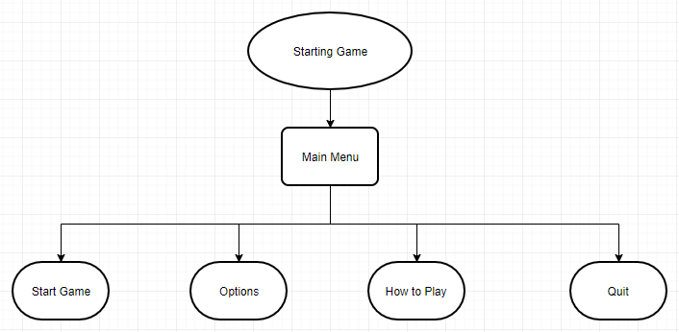

Options Screen:

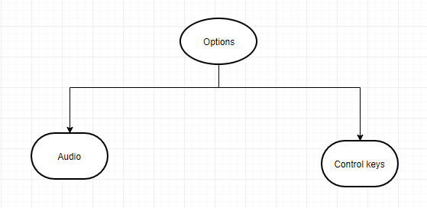

How to Play Screen:

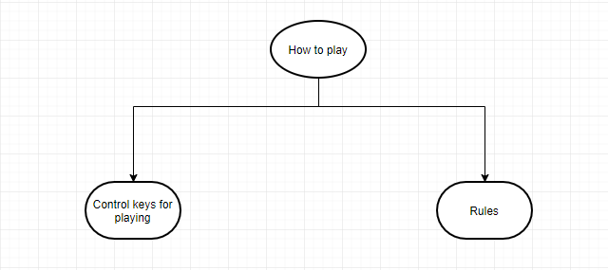

Game Architecture Overview
<The splash screens or video clips need to be in accordance to game story and style. If cut scenes use video then story boards should be created.
Menus should be designed with the most important options easily accessible. Be aware how many clicks it takes to accomplish a task. The game Instructions should be written so that the player understands how to play the game. Mock-ups should be made so that the game programmers get the correct layout of the menu. It is a good idea to mention and describe the high score screen in this section.>

Game is designed in a user-friendly way that, it is clearly understandable from the very first screen – Main menu of the game about the instructions, rules and story of how to play the game. Player will start playing the game after clicking on “Start Game” button on Main menu screen. Instructions about how to play the game is provided on “How to play” section and there is provided hints about street signs and obstacles during the game. The main architecture of the game is shown on the below flow chart diagram:

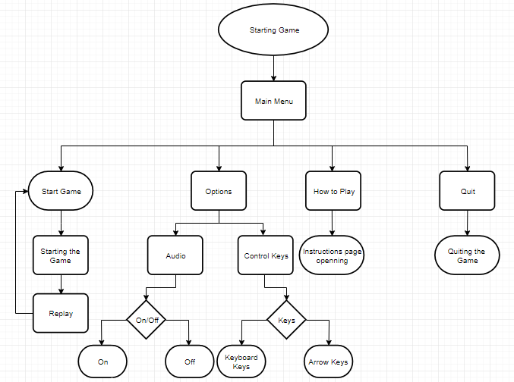

Architecture Copy

Start menu: It is the main screen which is shown when the game is started. There will be buttons labeled as “Start game”, “Options”, “How to play” and “Quit” on that screen.
Start game: This button is for starting the game.
Options: By the entering that section, player will see 2 headings as “Audio” and “ Control keys” to change audio options (turning the theme music on/off) and game control keys(using arrow keys or W,A,S,D for controlling).
How to play: This section will include the basic information about how to play the game. This is basically the overall information about the game, the role of items in the game and the control keys for how to control the car during the game.
Hints: There will be hints during the game in order to make player aware of the rules that he/she should obey. Below there are the hints that are planned to use during the game:

References
<Insert here any document referred to in the document. An example might be articles or Web sites that you consulted during the literature search. This is not just a list of used materials, so do not forget to clearly MARK the exact points(s) of reference in the main text.>

This template is based on the Unity Curricular Framework ©May 2015 Unity3d.

