Find a Master

Process Modeling and Data Modeling /   
System Proposal / Analysis Phase   
(Homework No.3)

Project team: Team 01

Instructor: Dr. Araz Yusubov

Submitted in partial fulfillment of the requirements of the INFT 2303: Systems Analysis and Design course project

|  |  |
| --- | --- |
| GitHub repository | <https://github.com/ADA-SITE-INFT2303-2022-Spring/systems-development-project-team-01> |
| Version date | This is our final version for homework 3. We submitted all the parts and diagrams in one file on 20.04.2022 |
| 08.04.2022 | Initial draft |
| 20.04.2022 | Final draft. We concluded our parts, discussed, and put together all of them in one document to prepare a detailed Process Modeling and Data Modeling document for our Find a Master project |

|  |  |
| --- | --- |
| Other documents in the package | |
| File name | As it is mentioned above, we have only one document for the whole Homework 3 |
| <File name> |  |
| <File name> |  |

|  |  |  |
| --- | --- | --- |
| Team member | Contribution to this homework (NOT the project) | Estimated % |
| Arzuman Alakbarli | Level 0 diagram, Bonus 2, References | 25% |
| Aytaj Najafova | Divided parts between team members, arranged meetings, actively participated all brainstorming. Commented and helped team member’s parts for improving.  Completed Introduction, Process Modeling | 25% |
| Faraz Bagher Nezhad | Crud matrix, Data Modeling | 25% |
| Unal Imanov | Contributed to brainstorming | 25% |

# Table of Contents

Table of Contents

Table of Contents 3

1. Introduction 3

Definitions 3

2. Process Modeling 3

Level 0 diagram 5

Level 1 diagrams 6

3. Data Modeling 6

CRUD matrix 6

4. References 6

# Introduction

This is part of the System Proposal for a hypothetical project Find a Master submitted for partial fulfillment of the requirements of the Systems Analysis and Design course in the School of Information Technologies and Engineering at ADA University, Baku, Azerbaijan.

This project consists of 4 parts. To see each part, you can use the Table of Contest which we put above.

Initially, we arrange a meeting online and decided to separate all the parts among different team members. After each member prepared draft versions, we arranged another meeting and discussed all the parts, and mentioned our comments and additions about each of our parts. After that, we came to a decision to organize another meeting and do more brainstorming to improve our Process Modeling and Data Modeling document. After several online discussions, we did our final meeting and, in this meeting, we worked on the final draft and combined them into one document.

**Bonus 1:** Get extra **15%** points for revising and SUBSTANTIALLY improving the Homework 1/2 document.

## Definitions

We did not use any project-specific term in this assignment

|  |  |
| --- | --- |
| Term | Definition |
| <Term> | <Detailed term definition> |

# Process Modeling

As we know business processes can be visualized by using Process modeling. It allows them to be inspected more cozily. Users are easily able to figure out how the processes run in their current state. Moreover, it helps to understand how the processes can be upgraded.

For that reason, I decided to draw process modeling in a way that easy to understand and more comprehensive. This is our context diagram which describes the roles in our system and how they perform.

In total there are 5 entities in our system.

Also, there are 9 data stores in which the data processed on the system is stored in these stores.

In addition, the process begins with the entry of the user and the repairer into the system. The customer demands the repair person, then he/she assigns the job to the appropriate master and operators. If the repairer does not accept the assigned work, the process ends. But if he accepts, the process continues, and finally, the customer pays, and the technician receives the payment. In the end, both parties give feedback to each other, and the entire process ends.

**Bonus 2:**

This the flow for our system which shows how process must go on and describe steps to implement for using our system.

**NOTE: PLEASE ZOOM IN 180% FOR CLEAR UNDERSTANDING!**

## Level 0 diagram

## Level 1 diagrams

<**Bonus 3:** To get extra **15%** points also draw all Level 1 data flow diagrams. >

# Data Modeling

In the Data Modeling part, we wanted to explain our information in tables that are in the database. We have 8 tables which are Service, Operator, Order, Master, Rating, Payment, and Customer. These tables are connected to each other by different relations. In our Data modeling, we use two options, which are many to many (optional and mandatory), one to many, and our tables linked by foreign keys.

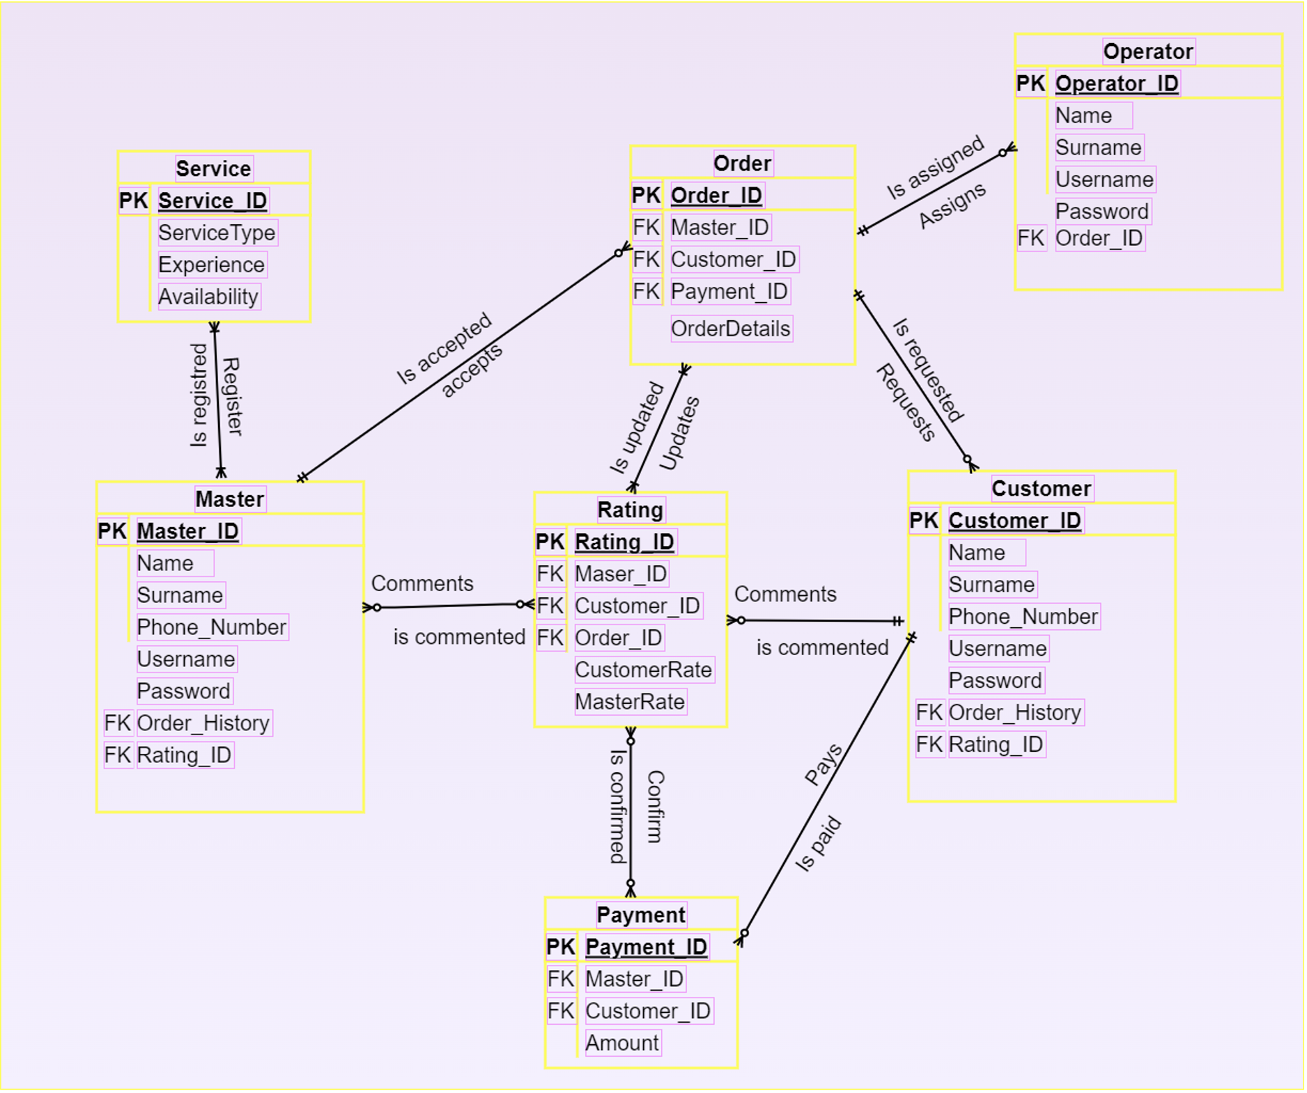

## CRUD matrix

|  |  |  |  |  |  |  |
| --- | --- | --- | --- | --- | --- | --- |
|  | Customer Info | Master Info | Request Info | Payment Info | Feedback Info | Notification Info |
| Register Customer | **C** |  |  |  |  |  |
| Register master |  | **C** |  |  |  |  |
| Request Fir master | **R** |  | **U** |  |  |  |
| Master Accept Request |  | **U** | **U** |  |  |  |
| Payment By customer | **R** | **U** |  | **U** |  |  |
| Setting available time by master |  | **U** |  |  |  |  |
| Feedback and Rating | **R** | **R** |  |  | **U** |  |
| Notification system | **R** | **R** |  |  |  | **U** |
| Customer Cancel request | **R** | **D** |  |  |  |  |

# References

* <https://www.calebcurry.com/cardinality-and-modality/#:~:text=As%20cardinality%20is%20the%20maximum,is%20not%20required%20or%20required>.
* Shared PDFs - <https://resources.sei.cmu.edu/asset_files/TechnicalReport/1989_005_001_15728.pdf>
* (Mainly chapters – 4,5 and 6)