<System/Project name>

Process Modeling and Data Modeling /   
System Proposal / Analysis Phase   
(Homework No.3)

Project team: <Team Name>

Instructor: Dr. Araz Yusubov

Submitted in partial fulfillment of the requirements of the INFT 2303: Systems Analysis and Design course project

|  |  |
| --- | --- |
| GitHub repository | https://github.com/ADA-SITE-INFT2303-2022-Spring/<name of the repository> |
| Version date | Version information |
| <Date> | Initial draft |
| <Date> | <Version description> |

|  |  |
| --- | --- |
| Other documents in the package | |
| File name | Brief description of the document |
| <File name> | <Description of the document> |
| <File name> | <Description of the document> |

|  |  |  |
| --- | --- | --- |
| Team member | Contribution to this homework (NOT the project) | Estimated % |
| <Student Name 1> | <Description of the work contributed> | <X>% |
| <Student Name 2> |  |  |
| <Student Name 3> |  |  |
| <Student Name 4> |  |  |

# Table of Contents

<Automatically generate here using Microsoft® Word menu References🡪Table of Contents>

# Introduction

This is part of the System Proposal for a hypothetical project <System/Project Name (use the name you used in Homework 1/2)> submitted for partial fulfillment of the requirements of the Systems Analysis and Design course in the School of Information Technologies and Engineering at ADA University, Baku, Azerbaijan.

**<DELETE each and every instructional paragraph between (and including) < and > everywhere in the document[1] and REPLACE ALL of them with your text. Keep the main numbered sections, but feel free to add sub-sections if needed.**

**All consequent homework assignments will be based on this document, so give it enough thought.>**

<Briefly describe the content of the document and work done to prepare it. This document must be submitted in original Microsoft© Word format.>

<While doing analysis and getting better understanding of the system you may need to make changes in the HOMEWORK 1/2 document, such as additions/modifications to product functions or use cases. In this case Homework 1/2 document should be submitted, too. Edits in the Homework 1 document should be visible by turning the TRACK CHANGES option on through Review🡪Track Changes menu and version information on the title page should be updated.

**Bonus 1:** Get extra **15%** points for revising and SUBSTANTIALLY improving the Homework 1/2 document.

All Microsoft© Word documents should be submitted as separate files. Any additional files of other types e.g. diagram and charts will usually be inserted to this document as embedded images, but the source files should also be submitted in a SINGLE .zip archive file.>

< **Submit your assignment** through the course website:

* **Use your GitHub** repository to keep all your project files and make sure all team members update it regularly. The teams are expected to submit their homework through Blackboard, at the same time their work must be traceable through the GitHub Classroom.
* **Submit** to the grader the following files before the deadline:
  + Process Modeling and Data Modeling (this document) as **Microsoft© Word document**s**.**
  + For Bonus 1, System Request and Feasibility Study (Homework 1B) or/and Requirements Determination and Use Case Analysis (Homework 2) as a **Microsoft© Word document with tracked changes**.
  + Any additional files of other types e.g. diagram and charts will usually be inserted to this document as embedded images or tables. At the same time, the source files e.g. Excel .xlsx files or Diagrams.Net .drawio files should also be submitted inside a **single .ZIP archive** file.
* **Do not forget** to inform your team mates, to avoid multiple submissions.
* **You will be graded** based on your contribution to the team submission, which is to be evaluated for its clarity, technical soundness, thoroughness and coverage, relevance and utilization of resources.

>

## Definitions

<Every time you come across a project-specific term (which can be interpreted differently e.g. “terminal”), add a short description of it to the table below. Insert here any technical word for which the meaning may not be known. DO NOT assume that the readers have specialized knowledge. Use a table format for these.>

|  |  |
| --- | --- |
| Term | Definition |
| <Term> | <Detailed term definition> |

# Process Modeling

<Draw the context-level diagram for the system. In this section you will refer to use cases you identified in Homework 2 to create data flow diagram fragments that eventually will be combined into data flow diagrams.

Here and in the following sub-sections list all processes, data flows, data stores and external entities with a short textual description. Indicate related use case number and name in the description.

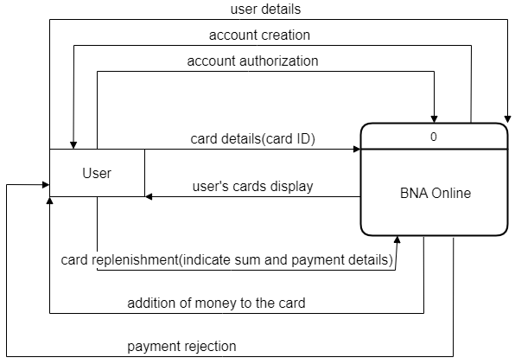

An account is created after the User inputs his details, after that he is authorized evey time he types them correctly. At the home menu a User will be able yo mange his cards by adding and deleting them. And of course, the User can replenish the balance of his cards by indicating sum and payment details.

**Bonus 2:** Get extra **10%** points for complementing all process descriptions with UML activity diagrams. For the context-level diagram it must be in a form of a swim lane diagram.>

## Level 0 diagram

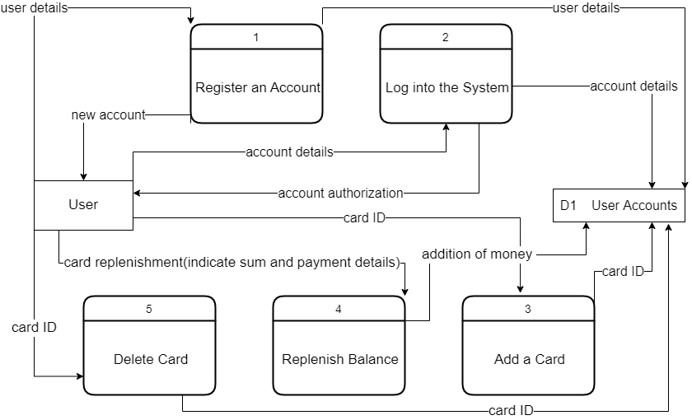

The system consists of 5 main processes. Firstly, a user needs to register by sending his details. After registation the system will ask for account details for authorization. The main purpose of the system is replenishing BakiKart easily. For replenishing the user will need to indicate sum, method of payment and then payment details. If there are no issues with payment the money will immedeatly land on your BakiKart. To replenish his cards a user must be able to manage them. A user can add a card and bound it to his account by simply writing cards ID located on BakiKart’s back side. Moreover, a user can delete it it the same way(pressing delete button).

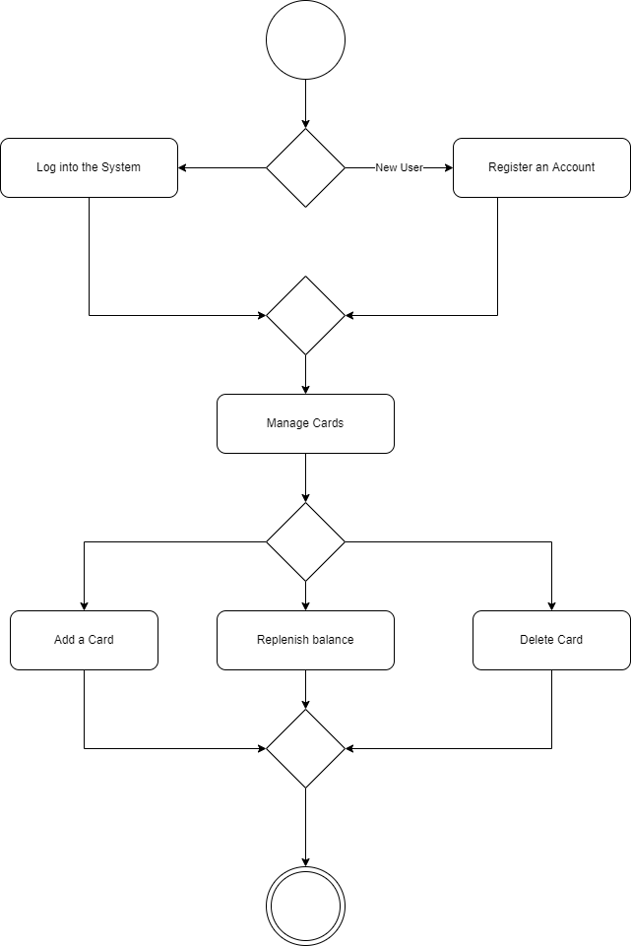

## Level 1 diagrams

**Register an account**

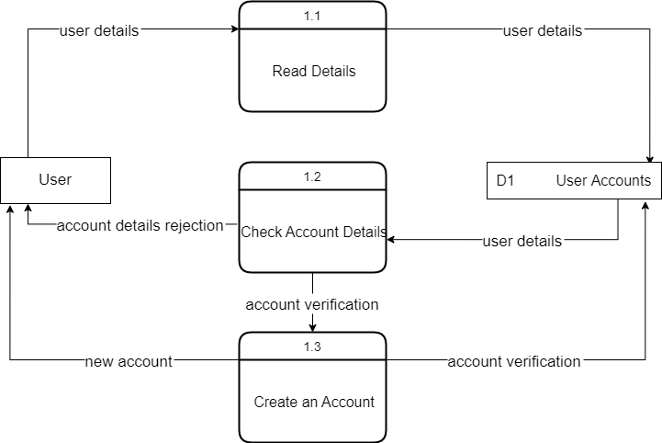

User first must input his details into the form so the system can read it. After that the information needs to be processed and checked for errors. There can be several errors, such as incorrect email or phone number or email and number that are already used by other account. If there is no errors new account is created and added to database.

**Log into the System**

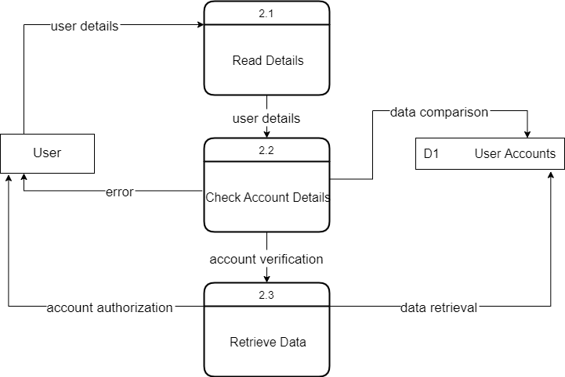

This process is somewhat like Register an Account process. A user inputs hist account details. Those details are checked and if correct a user gains access to his account.

**Add a Card**

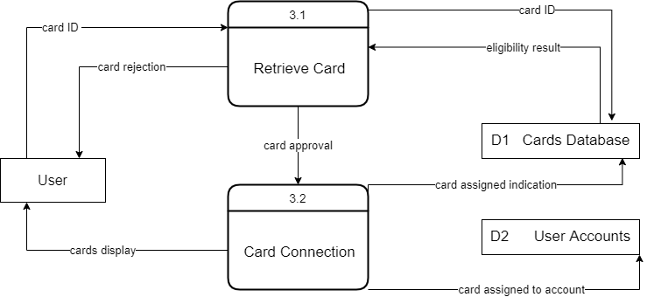

The user inputs ID of the card he wants to connect to his account, this card is then checked in Cards Database which is different from User accounts database. In Cards Database none of the cards have an owner when created, so the system bounds the card to the user itself. However, before assigning a card to a user system checks if the cards is free. If the card is taken or ID is incorrect a user will get an error. If the card is free the card is bound to the user.

**Replenish Balance**

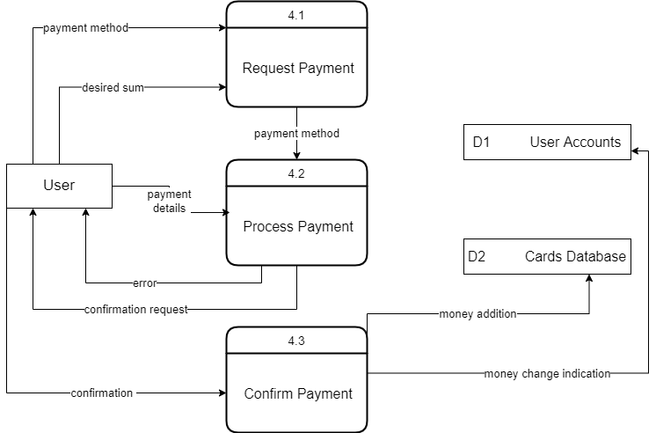

Firstly, a user indicates a sum that he wants to replenish and payment menthod. After process method is identified the payment is processed and confirmation message is sent to the user. If the details provided by user are incorrect the payment will be cancelled. After confirmation te sum is added to the balance.

**Delete Card**

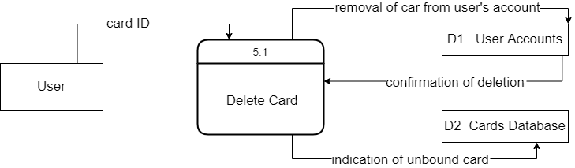

A user indicates card that he wants to delete. The card is then detached from User’s Accont, and indication of card’s bussiness is removed from Cards Database.

# Data Modeling

<This section specifies the logical requirements for any information that is to be processed by system. Draw the UML entity relationship diagrams that will be useful here to show complex data relationships.

In this section list all entities with a brief description including all attributes explained. Indicate initial entities and those added later in the process of normalization e.g. intersection entities. Discuss the relationships, including their modality and cardinality.>

## CRUD matrix

# References

<Insert here any document referred to in the document. An example might be articles or Web sites that you consulted during the literature search. This is not just a list of used materials, so do not forget to clearly MARK the exact points(s) of reference in the main text.>

1. This template uses some materials by Rochester Institute of Technology Software Engineering Department.