BNA Online Optimization
System Request and Feasibility Study / Planning Phase
(Homework No.1B)

Project team: Team 10
Instructor: Dr. Araz Yusubov

Submitted in partial fulfillment of the requirements of the INFT 2303: Systems Analysis and Design course project

GitHub repository | https://github.com/ADA-SITE-INFT2303-2022-Spring/systems-development-project-team-10
Version date | Version information
21.02.2022 | Initial draft
22.02.2022 | Added Introduction part
22.02.2022 | Added Feasibility Analysis.
22.02.2022 | Added Overall description
22.02.2022 | Finished

Team member | Contribution to this homework (NOT the project) | Estimated %
Farhad Khidirli | User Characteristics, Constraints, Assumptions and Dependencies. | 25 %
Bakhtiyar Guluzade | Product perspective, product functions | 25 %
Kanan Ibrahimli | introduction part, Organizational feasibility | 25 %
Kanan Gafarov | Technical feasibility, Economic feasibility | 25 %

Table of Contents
<Automatically generate here using Microsoft® Word menu References→Table of Contents>

Introduction
This is part of the System Proposal for a hypothetical project BNA Optimization system submitted for partial fulfillment of the requirements of the Systems Analysis and Design course in the School of Information Technologies and Engineering at ADA University, Baku, Azerbaijan.

List of individual System Request:
- Centralized health database by Kanan Gafarov
- Online Canteen by Kanan ibrahimli
- BNA Optimization by Farhad Khidirli
- Bravo supermarket optimization by Bakhtiyar Guluzade

As a final decision, we selected the project offered by Farhad Khidirli because there is huge need for improvement in this field, the percentages of risk is low and it covers much broader scopes. It seems very beneficial from the passenger's perspective. However, we need more resources to build such a system in every public transport that uses “Bakı Kart”. As a result, public transport can give an excellent service.
The content of the document includes overall description of the system which covers the perspective and functions of the product, user characteristics, constraints, assumptions, dependencies, and the feasibility analysis. Generally, this document is about planning phase of BNA Optimization System.

Definitions
Term | Definition
NFC | Near-field communication is a short-range wireless technology that makes your smartphone, tablet, wearables, payment cards, and other devices even smarter.

Overall Description

Product Perspective

Similar to “Baki Kart” in Europa people can buy tickets by using apps or GooglePay, ApplePay, and other methods to use public transportation. If we can make this method popular among citizens, then it will be productive as the European method. They built an automatic system (app or site) for paying transport costs. For example, in Germany there is an app for public transport it is very convenient to use. Even elder people learned it because of the education from the German government.

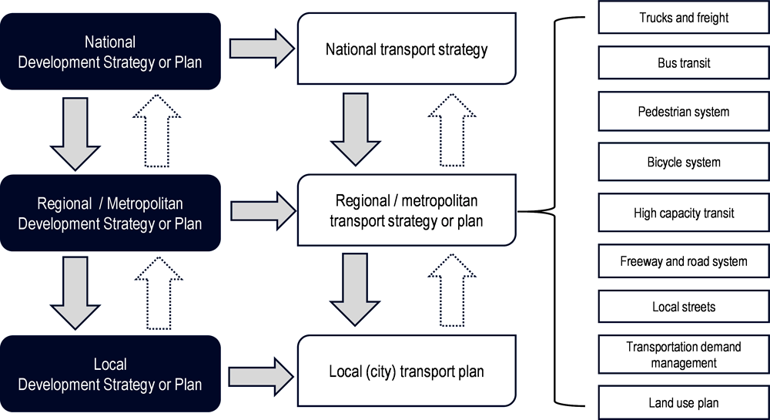Product Functions

- The system must allow registered customers to top-up “Baki Kart” balance and review their own payment history for past month.
- The system must allow customer to top-up “Baki Kart” balance throughout mobile application.
- The system should allow customer to use monthly loan of 0.3azn.
- The system must process requests to replenish the balance of “Baki Kart” from mobile operators.
- The system should provide a choice for customer to how balance should be topped-up (Apple Pay / Google Pay / Manually)
- The application should allow customer to pay using NFC system.
- The system should allow customer to pay using debit card instead of “Baki Kart”.
- The application must allow customer to check current balance on “Baki Kart”.

User Characteristics
The target user must:
Have basic experience using mobile phone and payment applications.
Have a mobile phone with access to internet, NFC is optional.
Have a “Baki Kart” and additionally debit card to use application.
Be willing to share information such as phone number / email address and Name & Surname.
Be at least 18 years old to use this application.

Constraints

- The application will run both on Android and IOS mobile devices (On the first stage of production placed Android OS).
- The system should be able to integrate with existing Transport Agency system.
- The application must be available both on Play Market and Play Store.
- The system response to the client should be later that 1.5 seconds.
- The system should be available from 6:00 AM to 1:00 AM.
- The system supports 2500 simultaneous users basically; from 6:00 PM to 8:00 PM – 5000 simultaneous users should be managed.
- Client’s personal information will be secured.
- Payments throughout Apple Pay / Google Pay / Manual online payment will be secured.
- The application should be in AZN currency.

Assumptions and Dependencies

The idea is built on the fact that would speed up and facilitate the process, therefore, the presence of a bank card is necessary for online replenishment.

If there is a need to distribute the application on Windows systems, the usage policy will be changed accordingly.

NFC System might take too many efforts and expenses such as creation of new generation “Baki Kart”, implementing new system for databases etc., so in case of statistics will be provided and NFC system policy postponed, requirements will change.

Feasibility Analysis
Technical feasibility:
As it was mentioned in System Request, it is already possible to top up your “Baki Kart”s online the system is already familiar to the developers of the system.
When it comes to user’s familiarity with the technology, in our project’s case no problems are going to occur since we do not intend to remove an old system where you simply put your card in the machine and upload how much money you want. This project’s intension is to add new, more modern ways of replenishment of the balance, such as app/website, where you replenish your balance through your credit card, mobile operator, or other ways. So, we believe that there shouldn’t be a problem with users’ familiarity with the applications and technology.

The project’s size is medium, mainly because the online payment system already exists. Moreover, the project’s risk decreases because there is not an urgent need to replace the current cards. However, the systems need to be overhauled and optimized. The biggest change with the existing system is the introduction of new payment ways(bank applications, Apple Pay, Google Pay. The next biggest change that will affect the system drastically is the new application with the help of which it will be possible to replenish your balance quickly.

When it comes to compatibility the system that accepts replenishments online already exists. Since we will mainly work on optimizing and adding new features to it, which means compatibility won’t be a problem.

Economic feasibility:
It is hard to estimate the cost of the system. However, the fact that the system won’t need to build from scratch and such technologies, such as Apple Pay and Google Pay, are already being implemented suggests that development price could be much higher.

When it comes to operating costs the only costs after implementing the system will be connected to the future maintenance of the system. Wages to cyber security specialists and system analysts that will surveil the system will be the primary costs. Of course, there may be some expenses due to accidents.

The number of people using public transport is certainly not going to decrease after these changes. However, it may increase because some people may find such system easy and convenient to use. The existing profit is only going to increase if we do not take take into consideration costs spent on implementing the system.

Organizational feasibility:
As it was mentioned before, current users of public transport in Baku are not going to stop from using it since the old ways of replenishing their cards will be still working. However, the fact that new choices will be introduced may sway many users to using them. Websites and apps where people pay their bills online have been introduced several years ago, Apple Pay has been introduced recently as well. Population of Baku keeps catching up with modern trends and more and more people start using technology to ease their lives. Replenishing their cards with the help of an app is just one of those trends that is going to replace the current ways in the future. And hypothetically, more people will try it out after hearing about it. Furthermore, the project is strategically aligned with the business since its purpose the same: replenishment of public transport access card as fast as possible.

References

http://www.bna.az/en

https://blog.ballard.com/4-ways-to-improve-public-transport

https://www.masstransitmag.com/management/press-release/21133994/masabi-us-ltd-public-transportation-survey-finds-riders-rank-convenience-as-highest-priority-when-choosing-transit

https://thedocs.worldbank.org/en/doc/963521580136216965-0080022020/original/BakuUrbanMobilityPolicyNoteJune2018.pdf

