RestoGenie
System Request Statement / Planning Phase
(Homework No.1A)

Student: Fahmin Mahili
Instructor: Dr. Araz Yusubov

Submitted in partial fulfillment of the requirements of the INFT 2303: Systems Analysis and Design course project

GitHub repository | https://github.com/ADA-SITE-INFT2303-2023-Spring/homework-1a-fahminmahili.git
Version date | Version information
07.02.2023 | Initial draft
12.02.2023 | Restaurant Reservation Management Information System

Project sponsor
The project sponsor for the Restaurant Reservation System is “Saffron.az” group.
This company is the most ideal sponsor for restaurant reservation system because it has a lot of experience. Saffron.az is the largest chain of restaurants in Azerbaijan, and it has many projects such as SAHIL bar&restaurant, ZAZU food&mood, CUBAR, HARD ROCK CAFE, AMBURAN restaurant, ELEKTRA events hall, and this picture demonstrates its path of success.
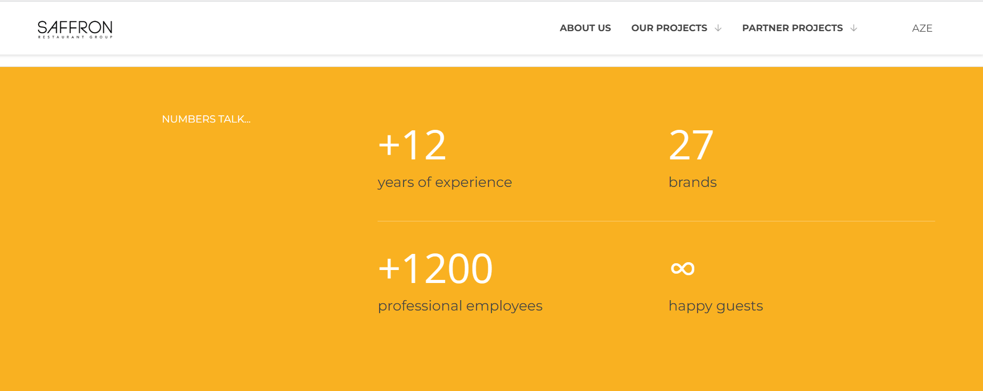
Address:
BEGOC Business Center, 93, Zarifa Aliyeva str. 3rd floor
AZ1000, Baku, Azerbaijan

Phone:
+994 12 404 48 00

E-mail:
info@saffron.az

Business Need
The business need of the restaurant reservation management system is to give customers a simple and effective platform to reserve tables at restaurants in advance. Additionally, customers can easily track the situation of each restaurant visually using RestoGenie App. By doing so, this reservation system will enhance the customer experience by enabling them to quickly and easily identify open tables at the desired place and time and then make a reservation.

Business Requirements
When it comes to business requirements, the system has several specific features and functionalities in order to meet business needs of the restaurants. The following are some examples of important business requirements for a restaurant reservations system:

- Accessibility: The system is available as an App for all smart mobile devices, and also customers can reach the system using website of the system.
- Availability for Many Restaurants in Baku: The system contains almost all restaurants in this platform.
- Real-Time Availability: The system gives real-time information so that customers can see which tables are available and when they can be reserved.
- Real-360 Degree Visuality: The system shows its places visually. For example, the place where the customer wants to sit is near the window or not, or whether that place is a sofa seat or an ordinary table.
- A visual Menu: The system shows each restaurant’s menu in this platform and customers can see beforehand.
- Ordering in Advance: The system allows users to order in advanced before sitting at the table.
- Delivering Food: The system has the ability to deliver the ordered food to customers' homes or offices.
- Connection Between Restaurants Management Software: The system has an integration with restaurants’ existing software to figure out information about the situation of the tables.
- Multiple Reservation Options: Mobile App and Website
- Reservation Confirmation: The system send confirmation to each customer when they reserve a table.
- Reservation Reminder: The system informs every 20 minutes as the reservation time approaches.
- Customer Database: The system stores all customer information such as contact details, card details, and reservation history.
- Customer Feedback: The system also creates feedback options for customers to understand what customers think.

Business Value
By using the RestoGenie system, the organization will have several benefits. It is categorized by tangible and intangible
For Tangible Benefits:
- Increasing revenue: The RestoGenie system allow customers to make online reservations, and many people want to use its comfort. The number of reservations, therefore, are increased day-by-day, and by doing so, the restaurant's income increases too.
- Reducing errors: The technology makes sure that all reservations are reliably and securely recorded by removing the possibility of manual errors.
- Improving productivity and performance: As it is clear that system automates reservations via RestoGenie app. This leads to reducing the time allocated to the reservation, and ultimately, restaurants staffs focus on other tasks.

For Intangible Benefits:
- Improving customer satisfaction: By using this RestoGenie system, it makes customers job easy. As a result, customers are less likely to feel dissatisfied when reservations are reliable and effective.

- Making better decisions: It is easy for the system to make a decision with the help of analyzing and tracking customer preferences. (E.g. making changes in restaurant’s menu)

Special Issues or Constraints:
When generating a system, it is likely to encounter several issues and constraints.
For the RestoGenie system, there are also some issues which are:
- Integration with Restaurants’ Management Software: how to connect restaurant internal software to the new system. It is concerned about connecting the internal system of the restaurant with the new system because it is a difficult and time-consuming task, and when the waiter takes the order from the table, it should be automatically displayed in the RestoGenie system without any problems.
- Budget Constraints (Economic feasibility): Generating this kind of Restaurant Reservation System is expensive.
- Timeframe: It is concerned about how much time does this system take.
- Adaption process: It can somehow be difficult to be accepted by a big number of customers, especially in Azerbaijan.

https://saffron.az/
https://deonde.co/blog/restaurant-reservation-system/
https://deonde.co/blog/restaurant-reservation-system/
https://www.touchbistro.com/blog/how-your-restaurant-can-benefit-from-reservations/
https://www.mews.com/en/blog/advantages-central-reservation-system

