Online Taxi Sharing System
Process Modeling and Data Modeling /
System Proposal / Analysis Phase
(Homework No.3)

Project team: Team - 01
Instructor: Dr. Araz Yusubov

Submitted in partial fulfillment of the requirements of the INFT 2303: Systems Analysis and Design course project

GitHub repository | https://github.com/ADA-SITE-INFT2303-2023-Spring/sys-dev-project-team-01
Version date | Version information
20/04/23 | Initial Draft
23/04/23 | Final Draft

Other documents in the package
File name | Brief description of the document
sources.zip | contains context, level 0, all level 1 and ERD diagrams inside (each separately)

Team member | Contribution to this homework (NOT the project) | Estimated %
Anar Bayramov | CRUD Matrix | 25%
Nargiz Bayramova | Introduction, Context Diagram Description, Formatting document | 25%
Nigar Salayeva | Context Diagram, Level 0 & Level 1 Diagrams, References | 25%
Sanan Mardanli | ERD Diagram | 25%

Table of Contents
Table of Contents 2
1. Introduction 2
Definitions 2
2. Process Modeling 2
Context Diagram 2
Level 0 Diagram 3
Level 1 Diagrams 3
3. Data Modeling 5
ERD Diagram 5
CRUD matrix 5
4. References 5

Introduction

This is the part of the System Proposal for a hypothetical project Online Taxi Sharing System submitted for partial fulfillment of the requirements of the Systems Analysis and Design course in the School of Information Technologies and Engineering at ADA University, Baku, Azerbaijan.

The aim of the Online Taxi Sharing System is to help passengers find and share taxis with fellow passengers travelling with the same routes and share ride fees as well (pay either online or card) and it helps in terms of time and affordable price. In the system, passengers will be able to see the nearest drivers. As a result, there will be no need to wait for a driver or a passenger. Also, the system will automatically queue registered drivers to avoid congestion.

In this document, we will cover the process and data modeling where data flow diagrams are visualized to frame up the system to be implemented. Data modeling and entity relationship diagrams are contained as well to picture how data is combined and linked and how specifically functional it is to build structured and relational databases. Lastly, the crud matrix is also included to visualize and picture activities within a system.

Definitions
Term | Definition
DFD | Data Flow Diagram
CRUD Matrix | Create-Read-Update-Delete
ERD | Entity Relationship Diagram
Context Diagram | Describes system’s context and scope
Level 0 Diagram | Known as context diagram, however, level 0 diagram is the form of visualization of system to be implemented and analyzed as a single process
Level 1 Diagram | More detailed representation of system’s main processes

Process Modeling

Context Diagram
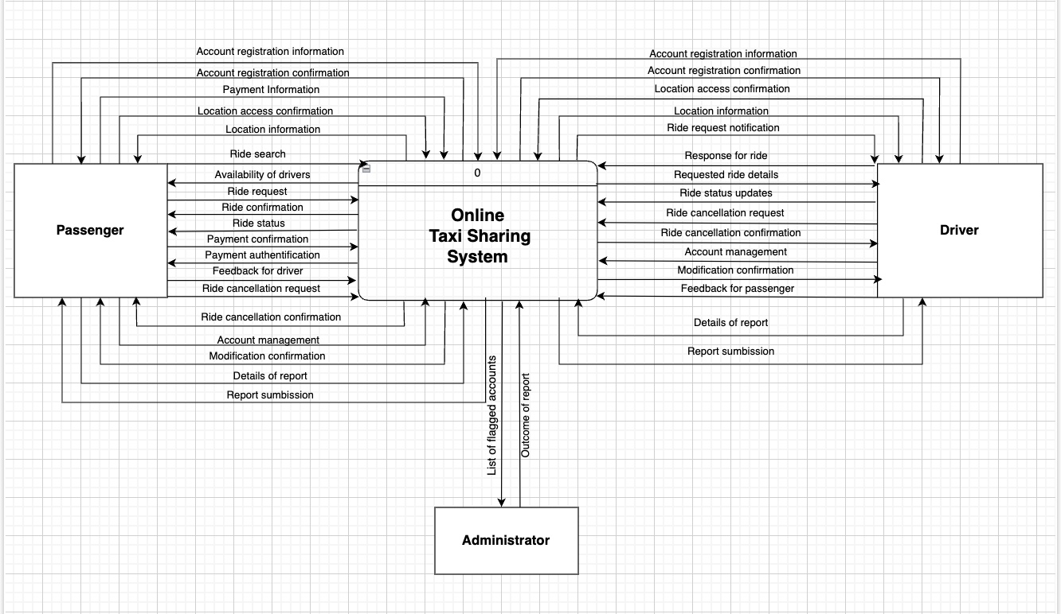

In the following context diagram, there are 3 external entities - Passenger, Driver and Admin using the system for account registration, managing ride requests, and reviewing report/feedback results.

In this diagram ingoing data flow - “list of flagged account” and
outgoing data flows - “outcome of report” for administrator are highlighted as well.

The primary users of the system are passengers and drivers. Passenger registers to use the system for searching available drivers, ride statuses and travel routes, paying ride fee and reporting an issue with service. Driver also registers the system as a user to constantly update their availability status, and modify ride requests.

Level 0 Diagram
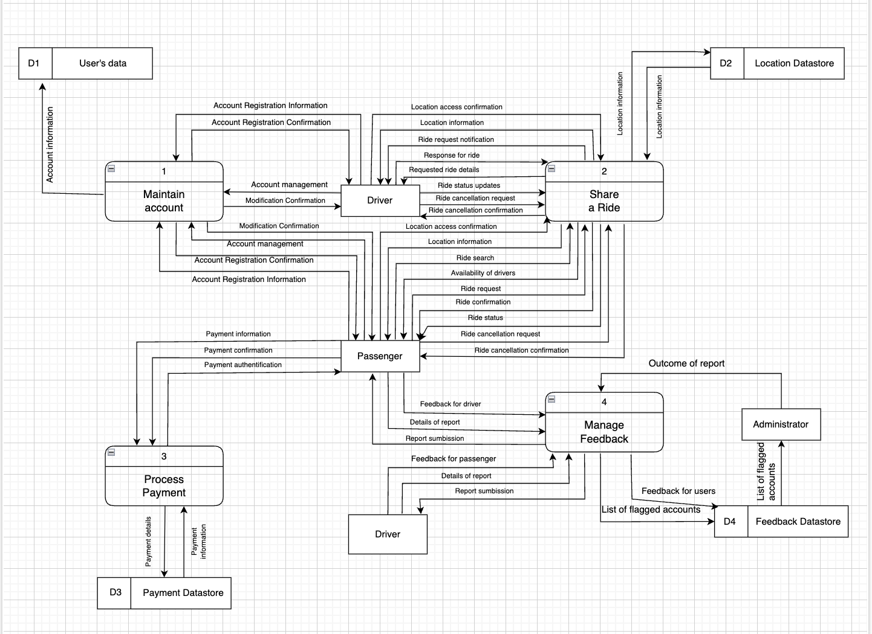

Level 1 Diagrams
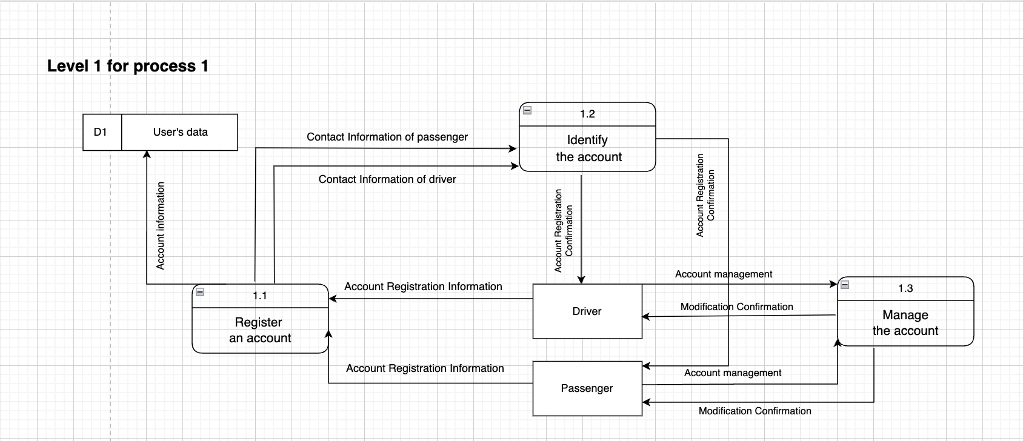

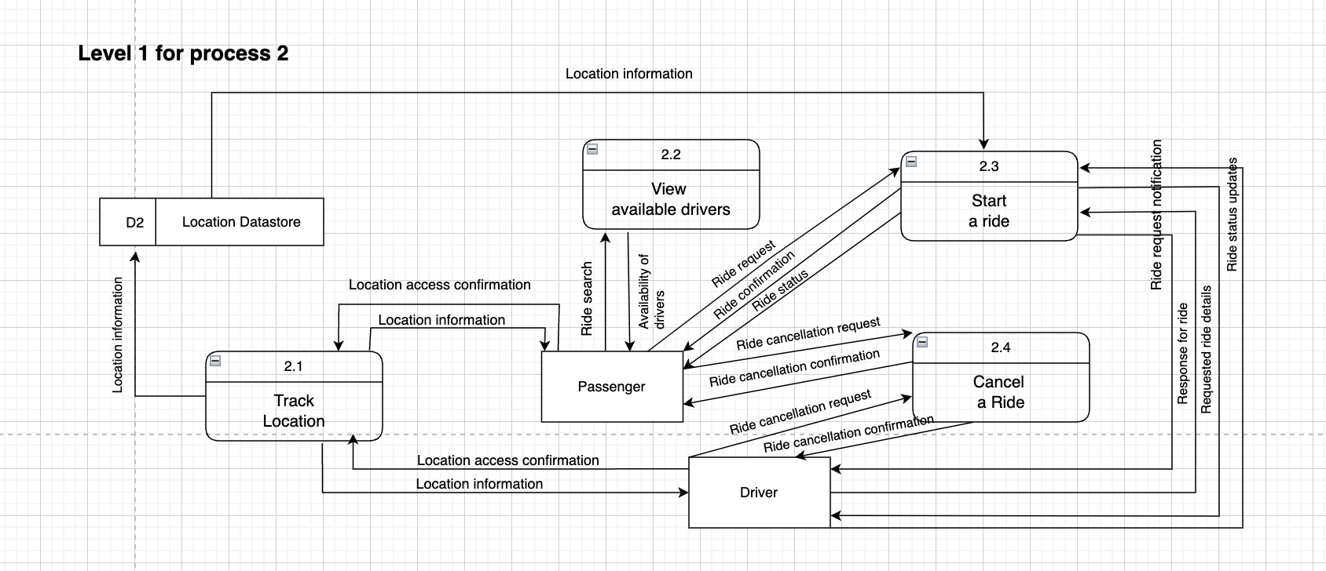

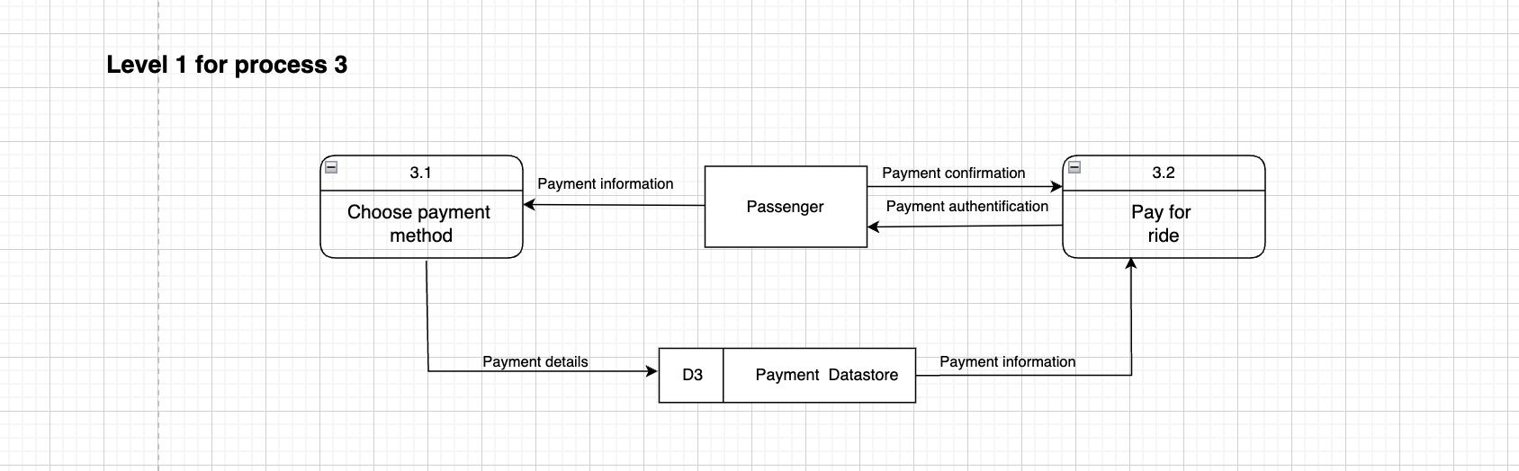

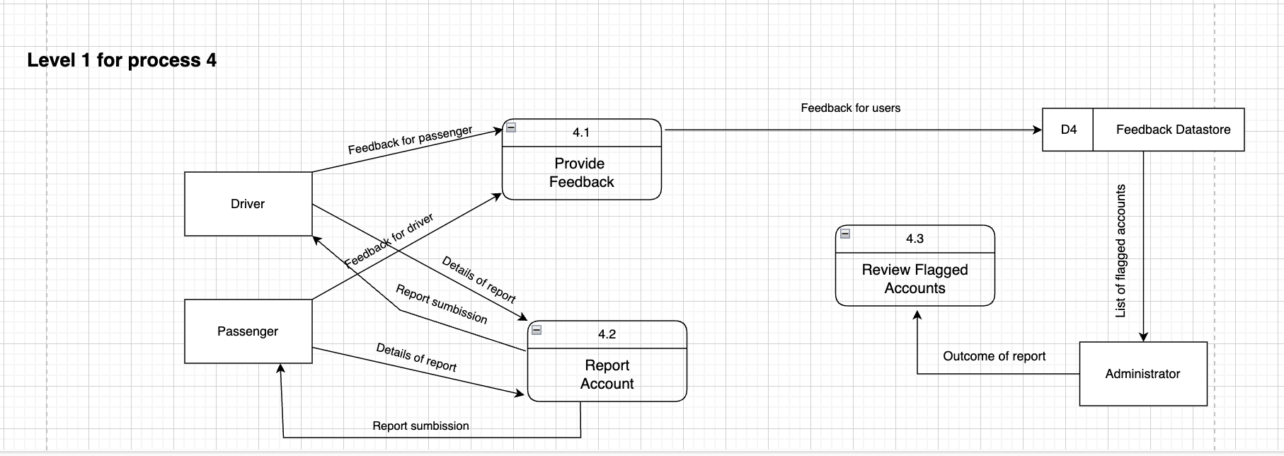

Data Modeling

ERD Diagram
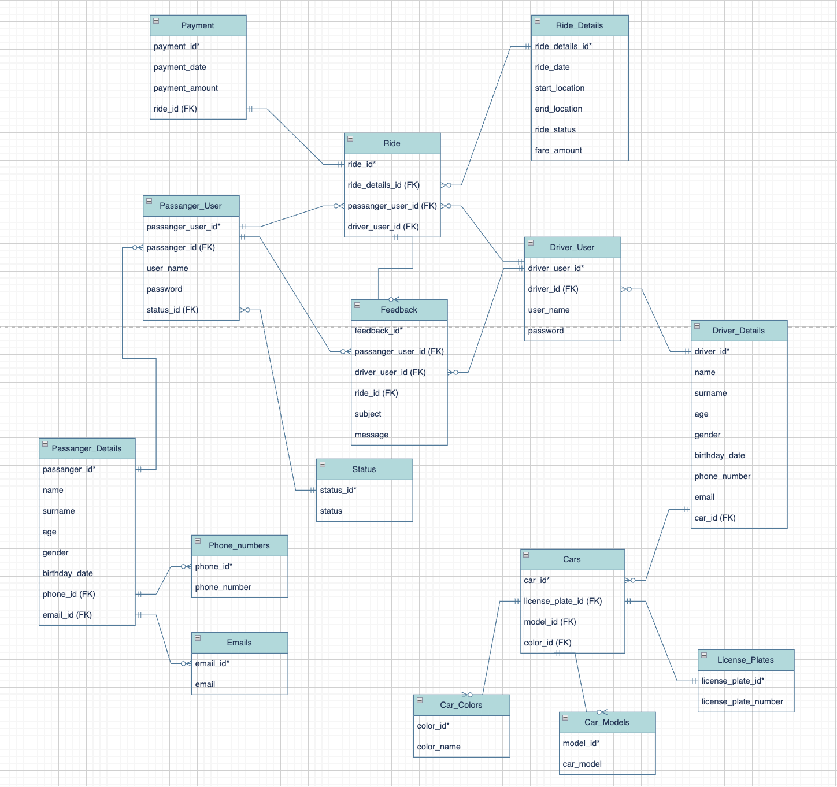

CRUD matrix

References

