Online Budget Management System

System Request and Feasibility Study / Planning Phase
(Homework No.1B)

Project team: Team 04
Instructor: Dr. Araz Yusubov

Submitted in partial fulfillment of the requirements of the INFT 2303: Systems Analysis and Design course project

GitHub repository | https://github.com/ADA-SITE-INFT2303-2023-Spring/sys-dev-project-team-04.git
Version date | Version information
16.02.23 | Initial draft
03.03.23 | Working on introduction and overall description.
04.03.23 | Working on feasibility analysis and definitions.
05.03.23 | Final version

Team member | Contribution to this homework (NOT the project) | Estimated %
Aynur Yeganzada | Has collaborated on introduction, definitions, business value, product functions, product perspectives and diagrams. | 25%
Farid Mehdiyev | Has collaborated on introduction, definitions, constraints, some parts of business value and functions. | 25%
Gulnara Azizova | Has collaborated on introduction, user characteristics, constraints, assumptions and dependencies, and feasibility analysis. | 25%
Narmina Karimova | Has collaborated on introduction, definitions, overall description, part of product functions, user characteristics and feasibility analysis | 25%

Table of Contents

Table of Contents
Table of Contents
1. Introduction
Definitions
2. Overall Description
Product Perspective
Product Functions
User Characteristics
Constraints
Assumptions and Dependencies
3. Feasibility Analysis
4. References

1. Introduction
This is part of the System Proposal for a hypothetical project Online Budget Management System submitted for partial fulfillment of the requirements of the Systems Analysis and Design course in the School of Information Technologies and Engineering at ADA University, Baku, Azerbaijan.

The Team 04 has modified one of the system requests - Hesabla.az and decided on the project of Online Budget Management System which is a mobile application system that helps to make more informed decisions in terms of spending money and to improve overall financial management of people who perform their cash flow operations through card. The factors for selecting this project over others are following:

There were 4 individual System Requests of each member of the team:

Aynur Yeganzada- SheCares: Women’s Support System- application for girls and women that provides a tool that can help keep them safe and secure anytime in various settings, including public transportation, crowded and unsafe places, and even in their own homes. By downloading this application, women and girls can log in with their ID number and get help by simply pressing a button when help is needed.

Farid Mehdiyev- Hesabla.az - application that provides a financial management system for budgeting, cash flow, costing controls and helping to manage their financial accounts more effectively.

Gulnara Azizova- Train Ticket Reservation System - application that provides a system aimed to save passengers’ time waiting in queues to buy train tickets. Eventually, they can get to their destinations on time.

Narmina Karimova- Online Health System- application that provides potential patients with the test to define the specialist they should refer to and conduct the online consultations with the defined doctor at the nearest clinic/hospital.

Definitions

Term | Definition
Data Storage  Budget  Cash Flow  Cash Inflow  NFC  Flutter  Dart  Data Analytics  Overview Dashboard  Data storage  Payment Processor  Firewall  Encryption  Report/  Forecast  Generator  BEP  ROI  CSV | This entails deciding on the proper data storage structures, such as file-based or database-based storage, as well as the suitable storage media, such as cloud storage, solid-state drives, and hard drives.  A budget is a plan for how you will spend your money. It usually includes a list of your expected income (how much money you will earn) and expenses (how much money you will spend) over a certain period, like a week, month, or year.  The amount of money that comes in and goes out of an individual's accounts.  Cash inflow refers to the amount of money that comes into a business or individual's bank account over a specified period.  Near Field Communication, a technology that allows two devices to communicate with each other when they are close together. It is commonly used for contactless payment systems, such as mobile payment systems like Apple Pay or Google Pay or for data transfers between two devices.  Flutter is an open-source development kit for the developing both IOS and Android mobile applications from the single codebase.  Dart is an object-oriented programming language for building both web and mobile applications, and it is used by the Flutter framework.  Process of extracting raw data and analyzing it for the various statistical and computational techniques for patterns, trends etc.  It displays data in charts, graphs, tables, or other visual formats that are easy to understand.  This entails deciding on the proper data storage structures, such as file-based or database-based storage, as well as the suitable storage media, such as cloud storage, solid-state drives, and hard drives.  In order to safely authorize and settle transactions, payment processors serve as a middleman between retailers and financial institutions including banks, credit card companies, and digital wallets.  Security system that helps to protect a computer network from unauthorized access and potential security threats.  Process of converting information or data into a secret code or cipher to protect it from unauthorized access or use.  By automating the process of data analysis and report or prediction generation, report/forecast generators free up users to concentrate on comprehending the results and making wise decisions based on the insights offered.  Break-Even Point is the point at which a business or project generates enough revenue to cover all of its expenses, including fixed and variable costs.  Return on Investment is a financial metric used to measure the profitability of an investment which represents the amount of money gained or lost on an investment relative to the amount of money invested.  Comma Separated Values, It is a file format for exchanging data across various software applications.

2. Overall Description
- Identify the system to be produced by name.

System that is going to be produced is called “Online Budget Management System” which is a self-explanatory name.
- What the system will do?

The system will create a budget template for users. Particularly, the system will ask registered users to choose their categories of expenses as well as the daily/weekly/monthly limit of money that user would like to spend. As users perform contactless payment (ex. Google Pay, Apple Pay) using their phones, NFC-enabled payment terminals send notifications to users' phones (many banks in Azerbaijan have added the feature of NFC payments). Based on that notification, the system will automatically track the transaction and deduct the amount from the appropriate budget category. App will display users spending in the corresponding category of expenses. Moreover, the application will track the income of users by reading the transaction notification of another app through which cash inflow was performed. Online budget management tool will create a daily/weekly/monthly report that shows the users’ spending patterns over time, which can help them to identify areas of overspending. To prevent that, the system will provide alerts when users are approaching the spending limit for a particular category.

- Describe the application of the system being specified, including relevant benefits, objectives, and goals.

One of the benefits of using an online budget management tool is improvement of users' understanding of their financial situation by constantly tracking their cash flow. Another benefit of this system is saving time because users do not have to calculate their budget manually, but rather allow the system to do that. Visualizing the financial situation in terms of charts, graphs, and maps also can be considered as one of the benefits of the system. The main aim of creating an online budget management tool is to empower individuals to take control of their finances and achieve their financial goals. By managing their finances more effectively, users can reduce debts, make savings, and plan for the future.

- Business need

Nowadays, the increasing complexity of personal finances is considered to be one of the main problems of budget management. With the growth of digital transactions and the rise of subscription-based services, it has become more difficult to keep track of expenses and manage finances effectively. Thus, people are not aware of how they are spending their money in fields such as food, entertainment, maintenance fees, emerging costs, unused subscription, transportation, etc. which leads to overspending, debt, and financial stress. However, the development of online budget management tools can help individuals manage their finances more effectively and achieve their financial goals.

- Business requirements

These are common business requirements that the chosen system should have:

- Providing accessibility through mobile devices (both iOS and Android).
- Tracking transactions through notifications from NFC payments.
- Using data analytics tools to analyze the data coming from notifications.
- Highly developed user interface and user experience design (UI/UX).
- Providing security policies to protect sensitive data.

- Business value
Tangible:
- The system may make money by charging membership fees or by partnering with financial institutions or other companies.
- Users may prevent overspending through notifications by making smarter financial decisions and keeping track of their costs.
- Reduction of time spent on tracking and calculating expenses.
Intangible:
- The simplicity and clarity of the system are likely to be valued by users, and this can create and magnify trust between users and the system.
- By positive user experiences and suggestions, the system might increase brand reputation and consumer loyalty.
- Improved financial management of users.
- Special issues or constraints

Skills and experience of the users in using similar systems are different, thus if an application performs a user interface that is not understandable by all users it will create a constraint in terms of using it.

Security of the user’s data can also be considered as one of the constraints for the system. Financial app contains all of the users' details including systematic expenses and card credentials. Therefore, if an application does not have strong security aspects such as encryption of data and usage of firewalls, data of users can be compromised.

Product Perspective
- Like other budgeting and spending monitoring apps like You Need a Budget (YNAB) and Personal Capital, Online Budget Management System will be used to track expenses. These applications also allow users to track their spending, create a budget, and view spending patterns. Online Budget Management System will have the added feature of using NFC to track payments, which is not currently offered by most budgeting applications.
- Data analytics techniques will be used by the online budget management system to offer insights into client behavior and spending habits. This function distinguishes it from conventional budgeting software, which mostly concentrates on tracking and classifying costs. The mobile application would function stand-alone connected with NFC.

There are researches on budgeting and expense tracking applications:
According to research conducted by the Journal of Consumer Affairs, adopting budgeting software can increase financial literacy and enable users to make wiser financial decisions. Another research by the Journal of Financial Planning found that utilizing a budgeting tool can lead to improved savings and a better understanding of spending patterns.

Block diagram:
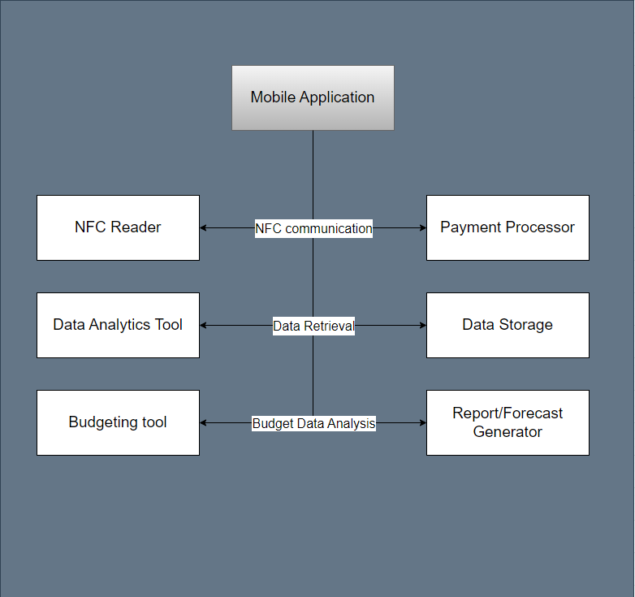

Product Functions

Income and Expense Tracking
- Expenses may be automatically categorized into a variety of categories, such as transportation, entertainment, and food.
- Provide a real-time overview of users’ revenue and costs.
- The system shall calculate the user's overall expenses.
- Make it possible for users to keep track of their earnings and outgoings through NFC payments.
Reading Notifications
- Using algorithm to read notifications of NFC payments and other application through which cash inflow was performed.
- The system shall be able to read the amount of cash inflow/outflow, merchant name/location, date of transaction from NFC notification.
- The system shall be able to differentiate the expenses and income read from NFC notification.
Analyzing Notifications
- Using algorithm to analyze notifications of NFC payments and other application through which cash inflow was performed.
Savings Planning
- Provide advice on how to help users save money and how to reduce expenditure and increase savings.
- Assistance in creating a savings strategy and helping people set savings objectives.
Reports and Data Analysis
- Examine payment information to produce insights on consumer spending and behavior.
- Provide recommendations that are based on your spending habits and financial objectives.
- Use pie charts, bar graphs, and line graphs to provide reports and projections.
Budget Management
- Let users to create different budget categories.
- Let users create spending caps for each category.
- Users should be able to cancel the creation of a budget category and its details using the system.
- The system shall allow users to edit and update their budget categories and spending limitations at any time.
- After the user creates a budget category, the system should show a success message.
- The system shall allow users to set up the alerts for reaching expenses limit.
- Alert and notify consumers when their budgetary restrictions are exceeded.
- Let users make a budget plan for their daily, weekly, and monthly costs.
User Interface
- Allow people to submit feedback and recommendations for changes by providing customer support and feedback alternatives.
- Provide settings and preferences that users may modify.
- User feedback and enhancement recommendations should be accepted via customer service channels.
Securing Data and Maintaining Application
- Providing encryption to protect user data from unauthorized users.
- Using firewalls to monitor network traffic.
- The system should be scalable and capable of supporting a high number of users and transactions.
- Provide the access control through user authorization (login and password) and authentication.
- Fixing technical issues through enabling regular updates.
- Providing cloud backups.

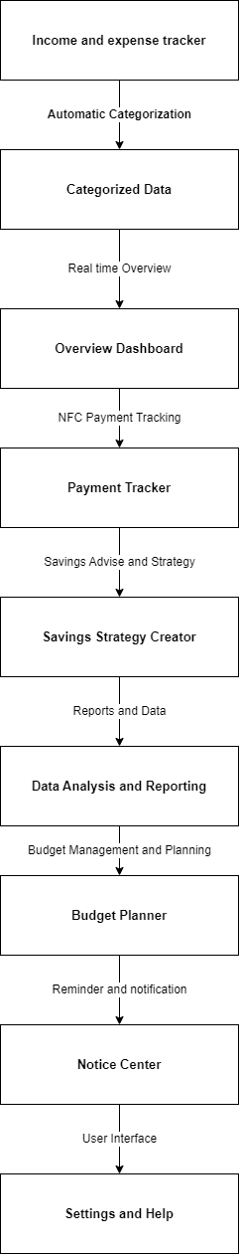

User Characteristics

Common user characteristics are listed below:
- Age of the users is quite broad due to majority’s potential interest of financial management. Obviously, young generation- millennials, Gen Z and Gen A would be more comfortable with using the system due to their digital awareness, whereas baby boomers and generation X may experience difficulties. Overall, the age range of potential users is 18-75 years.
- Considering income of users, it should not be at any specific level since application will be available at App Store and Google Play Store with minimal potential subscription fee in future. Moreover, expense tracking will be available to people of all income levels.
- Users should have basic technology knowledge to track their online payments, to control all their expenses over a mobile app on their phones and to set limits on their budget spendings

Constraints

Even though our mobile application has high-quality functionalities and user-friendly structure, using a budget management app could have certain drawbacks that labeled in below:

- Confidentiality issues: Comparable mobile apps for managing money demand an access to users’ personal data, including their debit cards information, spendings and incomes records maintained in the system. All user data may be at risk when creating a mobile app with the team if a developer must take security concerns into account.
- Lack of functionalities: It is expected that the developed mobile application may lack sufficient features to retain all the users’ financial data and card expenses. The created mobile application might be unable to offer solutions if the customer is dealing with complex financial issues.

Assumptions and Dependencies

The app is alleged to provide stable internet access for users wherever they are using it. At the same time, both Android and iOS users are anticipated to have no trouble downloading the app from Google Play or the App Store into their devices. From the dependencies side of this app ensures that the developer team’s ongoing upgrades and maintenance efforts may be crucial to guarantee the accuracy and reliability of the app. Ultimately, the app will consistently classify expenses and incomes.

3. Feasibility Analysis
Technical feasibility:
Since the main functionalities of the system already have been developed, it is technically feasible to develop a budget management mobile application to create high-performance, native-looking apps for both Android and iOS platforms based on cloud development and Flutter framework with the help of Dart programming language. However, if the development team has little experience with creating similar mobile applications, they may encounter challenges so that this can increase technical issues, including security risks, system bugs because of not using a proper cloud size, which can cause the problem for the users in terms of viewing their report/forecast during the usage of the app.

- Even though similar tracking applications, such as Personal Capital and You Need a Budget (YNAB) has been developed, the proposed application - Online Budget Management System will include a feature, the ability to track NFC payments, that most budgeting applications do not currently have, thus having a medium level risk at some point when connecting the application to transaction notifications.
- The project team will consist of approximately 8-10 people which will not create high risks due to the small size of the project.
- The compatibility of the system is high since the mobile application will support both iOS and Android devices.

Economic feasibility:

Development costs for the budget management app contain project management, business analysis, design (UI/UX) of mobile application, front-end, backend and cloud development, and flutter-based development. They take around the following costs to build mobile app:
- Infrastructure including cloud storage - $10,000.
- Employees- 50,000$
Total costs: $60,000
Annual operating costs comprise server, development team and other related costs to develop the app:
- Hosting app on the server - $5,000
- Other costs - $20,000
Total costs: $25,000
Annual benefits (cost savings and/or increased revenues):
- Advertisement of app - $85,000
- Subscription Fee - 5000$
Total costs: $90,000
Intangible benefits and costs:
- Customer relationship
- Reputation (Customer Satisfaction)
- Brand Value which is recognition of customer loyalty

Necessary calculations:
ROI = ($90,000 - $85,000)/85,000= 5.88%
BEP: (25,000+60,000)/(1-0.6)= 217,000$
In years, BEP= 60,000/217,000 = 0.28 years, thus in 3-4 month the system will generate enough revenue to cover all the costs.

Organizational feasibility:

- With reasonable marketing, this application can reach a sizable user base in Azerbaijan because there is not much competition for the precise concept.
- It is important to have c-level management in order to successfully develop the application, meaning that positions such as CEO, CTO, CFO and CMO are needed. Due to the team’s lacking skills this can create an obstacle to have professional senior management.
- Because of the project’s significant benefits such as saving time and money, improving the financial literacy, and convenience it is expected that the target audience will use the application.

4. References

- Xiao, J. J., & Wu, J. (2008). Using Personal Financial Management Software to Improve Financial Literacy. Journal of Consumer Affairs, Volume 42 Number 2, 274–296.
https://onlinelibrary.wiley.com/doi/epdf/10.1111/j.1745-6606.2008.00108.x

- O’Neill, B., Sorhaindo, B., Xiao, J. J., & Garman, E. T. (2005). Financially Distressed Consumers: Their Financial Practices, Financial Well-being, and Health. Journal of Financial Counseling and Planning, Volume 16 Number 1, 73–87. https://www.researchgate.net/publication/256060226_Financially_Distressed_Consumers_Their_Financial_Practices_Financial_Well-Being_and_Health

- A. (2022, January 7). Hansı banklar təmassız ödəmə texnologiyalarını dəstəkləyir? Banco.az. https://banco.az/az/news/hansi-banklar-temassiz-odeme-texnologiyalarini-destekleyir

- A. Dogtiev. (2023). App Development Cost. https://www.businessofapps.com/app-developers/research/app-development-cost/

- Average Technical Project Manager with Mobile Applications development skills Salary. PayScale.
https://www.payscale.com/research/US/Job=Technical_Project_Manager/Salary/430efc0b/Mobile-applications-development

- L. Ceci. (2022). Global app store commission rates 2022 - Statista. Commission rates for leading app stores worldwide as of July 2022.
https://www.statista.com/statistics/975776/revenue-split-leading-digital-content-store-worldwide/

- T. Bhatt. (2022). Flutter. How Much Does it Cost to Make a Flutter App for Your Business? (Cost Breakdown by App Types & Features).
https://www.intelivita.com/blog/flutter-app-development-cost/

- M. Lahn. (2019). ServerMania Hosting Empowered: How much does a server cost for app hosting? . https://www.servermania.com/kb/articles/server-cost-for-apps/

- The psychology of spending and why you may be spending so much money. (n.d.). State Farm. https://www.statefarm.com/simple-insights/financial/the-psychology-of-spending-habits-and-mistakes

