Personal Budget Management System
Process Modeling and Data Modeling /
System Proposal / Analysis Phase
(Homework No.3)

Project team: Team 04
Instructor: Dr. Araz Yusubov

Submitted in partial fulfillment of the requirements of the INFT 2303: Systems Analysis and Design course project

GitHub repository | https://github.com/ADA-SITE-INFT2303-2023-Spring/sys-dev-project-team-04.git
Version date | Version information
16.04.23 | Initial draft
23.04.23 | Final Draft

Other documents in the package
File name | Brief description of the document
Team 04_INFT2303-HW01B-System-Request-Feasibility | HW1B
Team04_INFT2303-HW02-Requirements | HW2
Use_case_diagram.drawio | Use Case Diagram
Analysis phase all diagrams .drawio  CRUD.xlsx | Context level,level 0, level 0, ERD  CRUD Matrix

Team member | Contribution to this homework (NOT the project) | Estimated %
Aynur Yeganzada | Has contributed to context diagram, level 0 diagram, ERD, CRUD, drawing level 1 diagram, improving hw2 | 25%
Farid Mehdiyev | Has contributed to context diagram, level 0 diagram, ERD, CRUD, drawing level 1 diagram, definitions | 25%
Gulnara Azizova | Has contributed to introduction, context diagram, level 0 diagram, ERD, CRUD, drawing level 1 diagram, short textual representation | 25%
Narmina Karimova | Has contributed to context diagram, level 0 diagram, ERD, CRUD, drawing level 1 diagram, short textual representation, improving of hw1/2 | 25%

Table of Contents
Table of Contents
Table of Contents 2
1. Introduction 3
Definitions 3
2. Process Modeling 5
Context diagram 5
Level 0 diagram 6
Level 1 diagrams 7
3. Data Modeling 9
CRUD matrix 10
4. References 11

1. Introduction
This is part of the System Proposal for a hypothetical project Personal Budget Management System submitted for partial fulfillment of the requirements of the Systems Analysis and Design course in the School of Information Technologies and Engineering at ADA University, Baku, Azerbaijan.

The system will create a budget template for users. Particularly, the system will ask the users who registered from the application to select their budget categories of expenses on a daily/weekly/monthly basis limit of money that users would like to spend. Basically, the system will demonstrate the overall expenses to the users in an appropriate expenditure category. The mechanism of the mobile application will allow the users to set, alter, and update the users’ spendings limits for each budget category, providing them with the capability to modify budget categories and expenditure whenever they observe appropriate. As users perform contactless payment, such as on Google Pay and Apple Pay, using their own devices, NFC-enabled terminals and notifications to the users’ phones (many banks in Azerbaijan added the function of NFC payments). Furthermore, users should be able to export information regarding their both expenses and incomes from the system in a variety of formats for backup and external analysis needs (such as Excel, PDF, and CSV). Based on the notification, the system will automatically track the transaction and deduct the amount from the appropriate budget category. Application will display the users spendings in the corresponding category of expenses. Moreover, the application will track the incomes of users by reading transaction notification of another app through which an inflow was performed. The system will enable the users to select from quarterly or annual reporting cycles in the system when creating their budget reports. Users may be able to utilize the system to set financial objectives and track their progression using the application.

Personal budget management application will create a daily/weekly/monthly report that shows the users’ spendings patterns over time, which can help them to identify areas of overspending. To prevent that, the system will provide alerts when users are approaching their spendings limit for a particular category.

Definitions

Term | Definition
DFD  Data Flow  Data Store  External Entity  ERD  CRUD Matrix  Context-level diagram  Level 0 diagram  Level 1 diagram | Data Flow Diagram - graphical representation of flow of the data from the information system  Data movement from one part of the system to another  Place where data is stored for use or later retrieval in DFD  Entitiy that transfers data in a system that is modeled as a DFD  Entitiy Relationship Diagram - graphical representation of entities and their relation with each other  Create, Read, Update, Delete Matrix- tool used in system analysis to help identify and track the interactions between data entities and the various operations that can be performed on them.  Shows entire system as a single process in DFD  Shows the major high-level processes of the system, their inputs and outputs, and the interactions between them.  Breaks down each major process from the level 0 diagram into more detailed sub-processes, and shows how data flows between these sub-processes.

2. Process Modeling

Context diagram

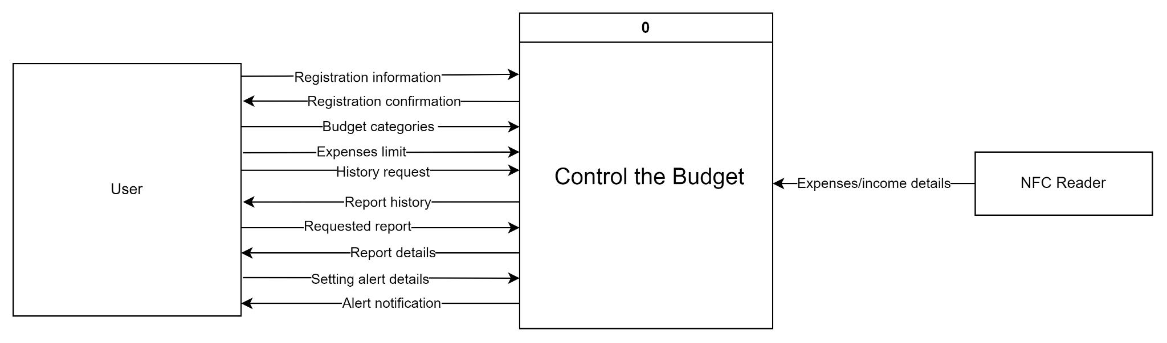
The Context diagram contains two external entites, that are User and NFC Reader. The external entity of User, is the primary user of the system of personal budget management. Users who registered employ the system to create budget categories, put expenses limit, information concerning set alerts, request history and report within a created budget. The input data flows of User entity include “registration confirmation”, “report history”, “report details”, and “alert notification”. NFC Reader uses the system for getting information regarding expenses or incomes details, so that an output data flow from this entity is “expenses/incomes details”.

Level 0 diagram

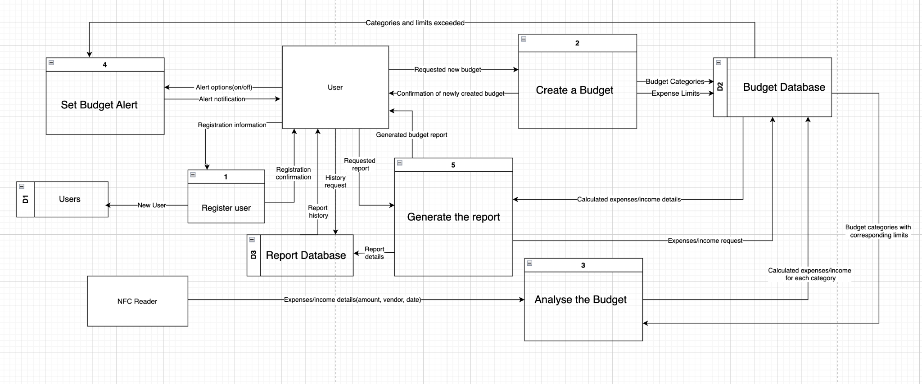

Level 0 diagram consists of 5 main processes: Register User, Create a Budget, Analyse the Budget, Set Budget Alert, and Generate the Report. The external entities are “User” and “NFC Reader”. External entity of “User” is the main user of the system of personal budget management. As output data flow user sends “registration information” to sign up to the system, “requested new budget” to create new budget (including budget categories and expenses limit which are shown as separate processes in level 1 diagram), “requested report” to generate the report of spendings and earnings, “history request” to request the history of all created reports, and “alert options(on/off)” to turn on/off the notification system for alerting the user that he/she has reached the expenses limit for particular budget category. As input data flow user firstly gets “registration confirmation”, then “confirmation of newly created budget ”, “report details”, “report history” , and “alert notification”. The external entity of “NFC Reader” serve as entity that captures transaction, reads payment/income information (including the expense/income amount, vendor and date). As output data flow NFC reader sends “expenses/income details” to the system for further budget analysis. The data stores are Users, Budget Database , and “Report Database”. Data store of Users stores all information about registered users, data store of Budget Database stores all information considering the budget- including all calculated expenses/income, budget categories and expenses limit whereas data store of Report Database represents the history of all reports created.

Level 1 diagrams

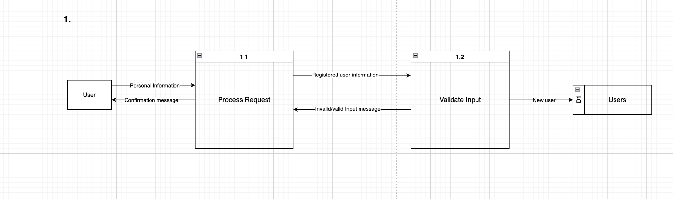

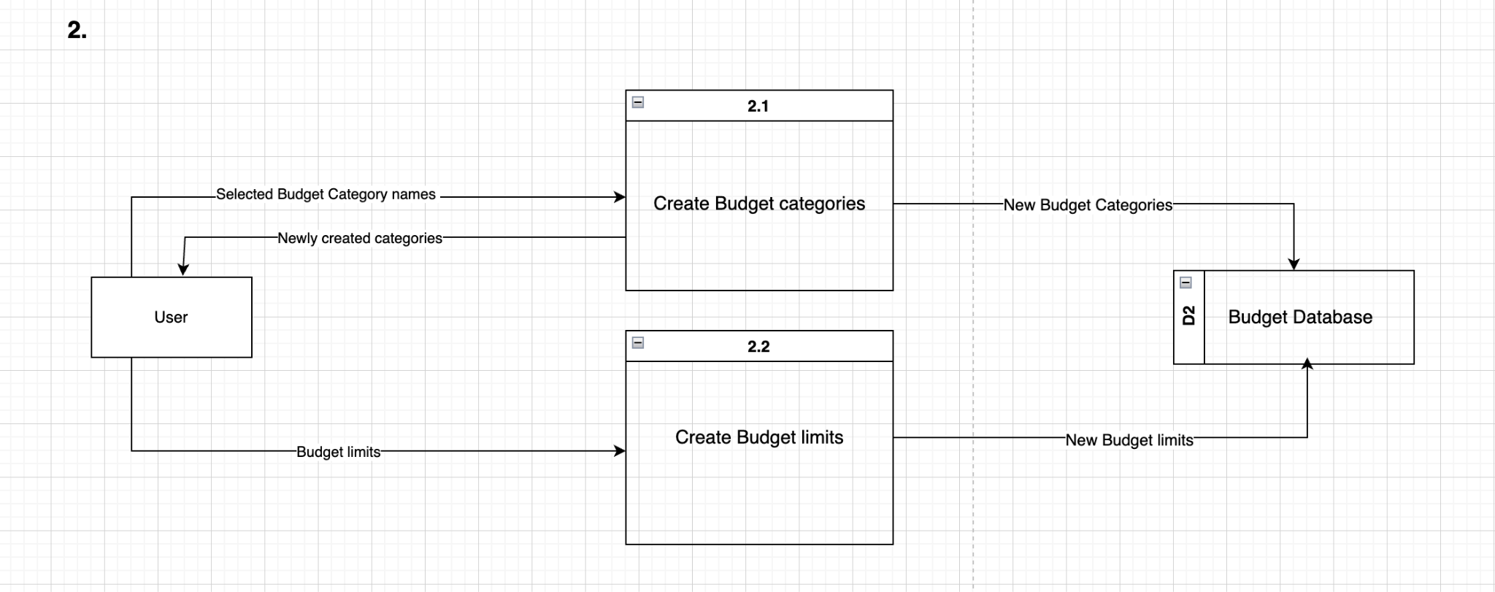

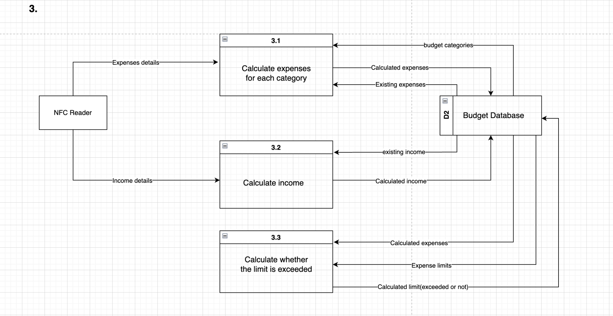

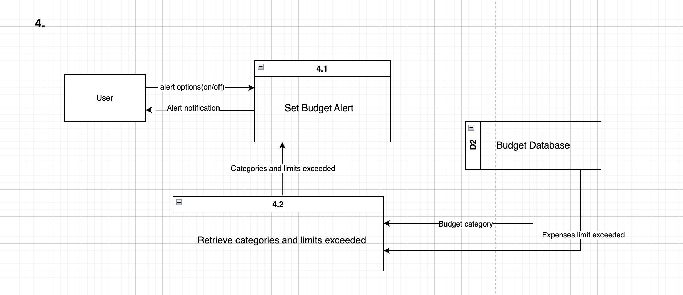

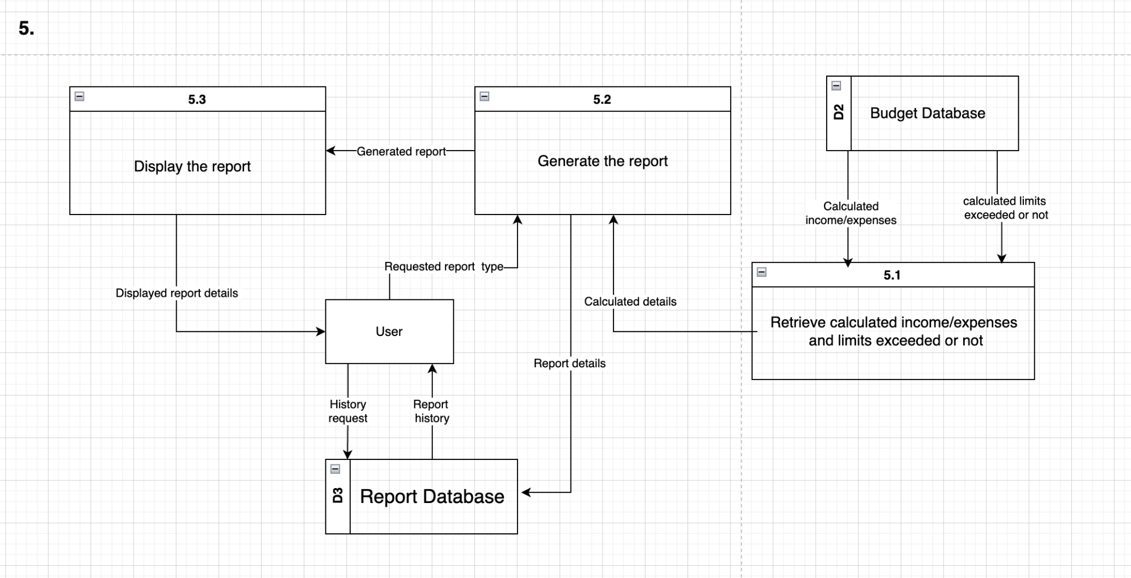

3. Data Modeling

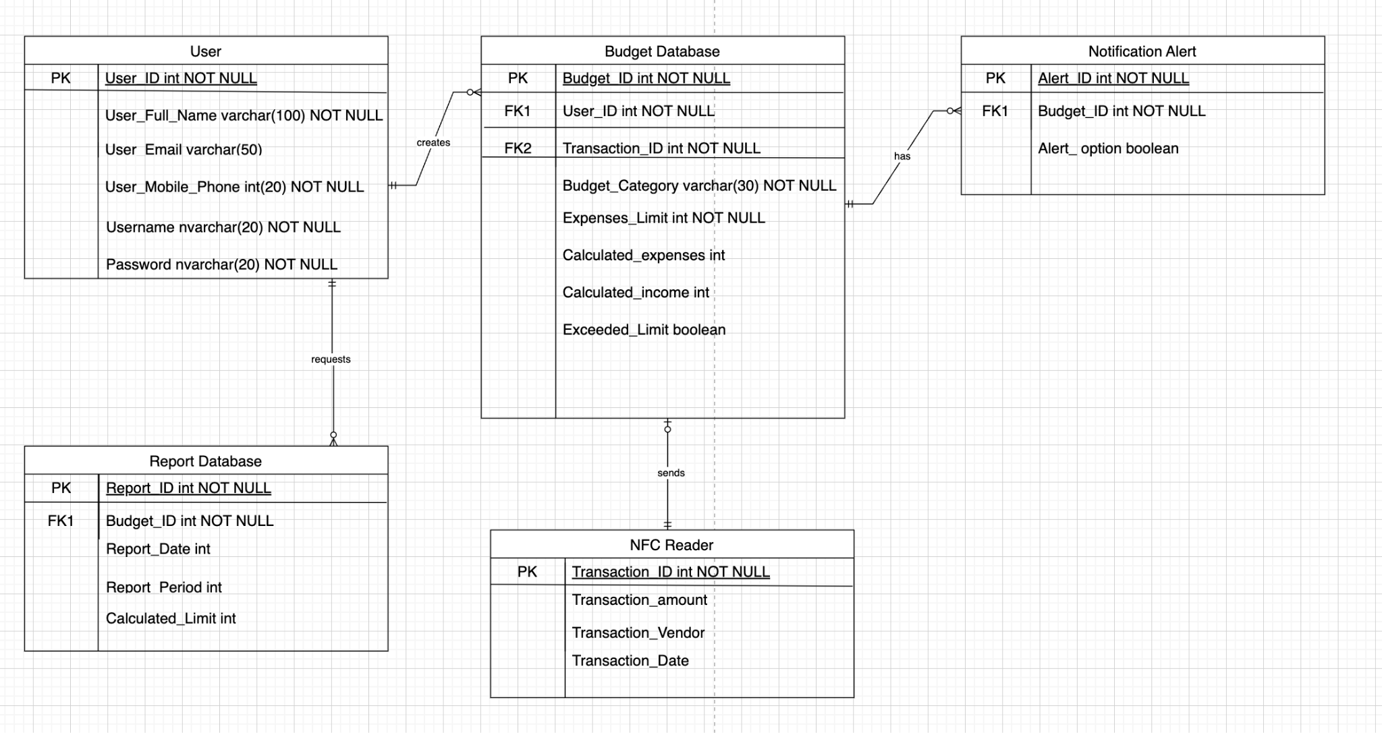

CRUD matrix
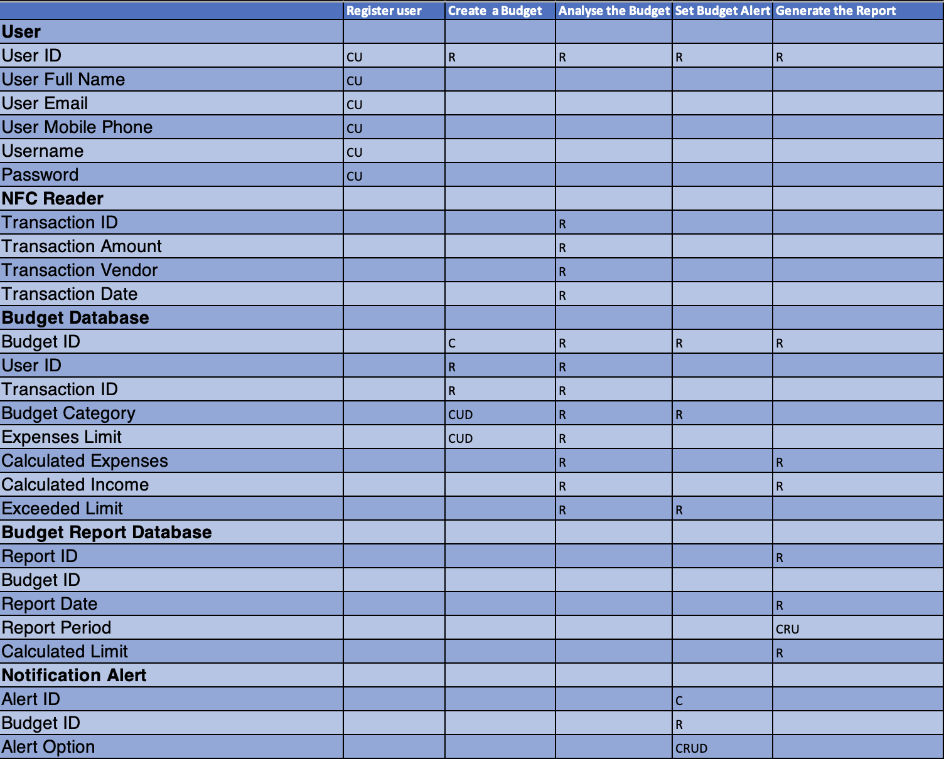

4. References
Chapter-05.pdf

Chapter-06.pdf

Dennis, A., Wixom, B. H., & Roth, R. M. (2012). System analysis and design. Hoboken, NJ: John Wiley.(Chapter 5&6)

^{[1]} This template uses some materials by Rochester Institute of Technology Software Engineering Department.

Chapter-05.pdf
Chapter-05.pdf
Chapter-05.pdf
Chapter-06.pdf

