Electronic Health Record System
Process Modeling and Data Modeling /
System Proposal / Analysis Phase
(Homework No.3)

Project team: Team 05
Instructor: Dr. Araz Yusubov

Submitted in partial fulfillment of the requirements of the INFT 2303: Systems Analysis and Design course project

GitHub repository | https://github.com/ADA-SITE-INFT2303-2023-Spring/sys-dev-project-team-05
Version date | 1.0
16.04.2023 | System Name, GitHub URL and Table of Contents added
23.04.2023  23.04.2023  23.04.2023 | ERD added  Introduction added  Data modeling added and the files are ready to submit.

Other documents in the package
File name | Brief description of the document
ERD.drawio | Contains a visual representation of entities and their attributes used in ERD.
INFT2303-HW02-Requirements.doc | System Requirements of the project including use cases.

Team member | Contribution to this homework (NOT the project) | Estimated %
Abdullah Kazimov | Created ERD and description of entities | 25%
Atakhan Ahmedov | Created and arranges DFDs | 25%
Unal Imanov | Wrote Introduction and put references | 25%
Rafis Yunusov | Created Level 0 DFDs | 25%

Table of Contents
Table of Contents
Table of Contents 2
1. Introduction 2
Definitions 3
2. Process Modeling 3
Level 0 diagram 3
Level 1 diagrams 3
3. Data Modeling 3
CRUD matrix 6
4. References 6

Introduction
Process and data modeling are key components in developing and deploying a new information system. practice modeling is the practice of visualizing a business process, including its inputs, outputs, and stages. It assists in identifying possible inefficiencies and bottlenecks, allowing for process improvement prior to deployment. Process modeling is also helpful in ensuring that all stakeholders comprehend the process and their respective responsibilities within it. In contrast, data modeling entails developing a conceptual or logical representation of data, including its structure, connections, and restrictions. It contributes to the organization, accuracy, and accessibility of data, allowing for improved decision-making and analysis. Data modeling is also helpful in ensuring data security and compliance with regulatory regulations¹. Process modeling and data modeling work together to establish a strong basis for the creation of an effective information system. They contribute to ensuring that the system satisfies the demands of stakeholders, is efficient, and provides significant advantages. As such, they are critical components of every successful information system project², including the proposed project in Azerbaijan.
Process modeling is an important technique in system development because it helps to explain the phases in a process and how data flows between them. The proposed project in the Republic of Azerbaijan to construct a new information system for patient-doctor communication and process automation contains multiple complicated processes that require thorough research and design. Patients, healthcare providers, healthcare provider administrators, mobile devices, desktop/laptop computers, medical equipment, external databases, and a third-party notification service are among the external entities participating in the system at level 0. Registration, profile administration, prescription management, appointment management, notification management, collaboration, user permissions, and search are among the system's processes. At level 1, the processes are subdivided to offer a more thorough perspective of the system's activities. These subprocesses include patient registration, healthcare provider registration, editing personal information, editing medical information, editing professional information, accessing prescription history, creating/modifying prescriptions, automating prescription writing, appointment booking, appointment cancellation, appointment rescheduling, sending appointment reminders, sending provider vacation notices, sending other notifications, sharing patient information, coordinating treatment plans, and discussing treatment plans. Patient profiles, healthcare provider profiles, medications, appointments, alerts, and medical data are all stored in the system. Data flows include registrant data, profile data, prescription data, appointment data, notification data, cooperation data, permission settings, search queries and results, medical data, and notifications to and from other organizations. The project team will create an efficient and effective system that will increase patient care and satisfaction in the Republic of Azerbaijan by modeling these processes and data flows.

Definitions

Term | Definition
ERD  DFD | a visual representation of entities and their relationships to each other, typically used in database design to model and organize data.  DFD stands for Data Flow Diagram, which is a graphical representation of a system or a process that shows how data flows between different entities and processes.

Process Modeling
<This and next section contains all the logical process and data models. Remember this is NOT design. Focus on logical modeling, and do not be distracted by technical implementation details, software packages, etc. >

<Draw the context-level diagram for the system. In this section you will refer to use cases you identified in Homework 2 to create data flow diagram fragments that eventually will be combined into data flow diagrams.

Here and in the following sub-sections list all processes, data flows, data stores and external entities with a short textual description. Indicate related use case number and name in the description.

Discuss the process of validation of data flow diagrams and explain any possible “anomalies”.

<This section is accounting for about 10% of your assignment grade, and the diagrams for about additional 10 %.>

Bonus 2: Get extra 10% points for complementing all process descriptions with UML activity diagrams. For the context-level diagram it must be in a form of a swim lane diagram.>

Level 0 diagram
<Draw Level 0 data flow diagram for the system.>

<This section is accounting for about 10% of your assignment grade, and the diagrams for about additional 20 %.>

Level 1 diagrams
<Bonus 3: To get extra 15% points draw also all Level 1 data flow diagrams. >

Data Modeling

Here are the names of each entity, their attributes with explanations, and special constraints that are needed to consider:
Entity #1: Healthcare Provider
- hp_id: A unique identifier for each healthcare provider in the system.
- first_name: The first name of the healthcare provider.
- last_name: The last name of the healthcare provider.
- specialty: The specialty of the healthcare provider.
- email: The email address of the healthcare provider.
- phone: The phone number of the healthcare provider.

Email and phone number are optional attributes. Healthcare providers may prefer one to use, therefore, these attributes can be defined as NULL.
Entity #2: Patient
- patient_id: A unique identifier for each patient in the system.
- mh_id: A foreign key that links the patient to their medical history.
- hp_id: A foreign key that links the patient to their healthcare provider.
- first_name: The first name of the patient.
- last_name: The last name of the patient.
- email: The email address of the patient.
- birth_date: The date of birth of the patient.
- address: The address of the patient.

Relationships:
- Each healthcare provider can have many patients, and each patient can be associated with many healthcare providers (many-to-many relationship).
- Each patient has a one-to-one relationship with their medical history.

Email and phone number are optional attributes. Patients may prefer only one to use, therefore, these attributes can be defined as NULL.

Medical history can be empty if there is a new patient, therefore this corresponding attribute can be defined as NULL.
Entity #3: Appointment
- appointment_id: A unique identifier for each appointment in the system.
- hp_id: A foreign key that links the appointment to the healthcare provider who created the appointment.
- patient_id: A foreign key that links the appointment to the patient who scheduled the appointment.
- date_and_time: The date and time of the appointment.
- duration: The duration of the appointment.
- title: The title of the appointment.
- location: The location of the appointment.
Relationships:
- Each healthcare provider can schedule many appointments, and each appointment is associated with only one healthcare provider (one-to-many relationship).
- Each patient can schedule many appointments, and each appointment is associated with only one patient (one-to-many relationship).
Entity #4: Prescription
- prescription_id: A unique identifier for each prescription in the system.
- hp_id: A foreign key that links the prescription to the healthcare provider who prescribed the medication.
- patient_id: A foreign key that links the prescription to the patient who received the medication.
- prescription_date: The date the prescription was written.
- medication: The name of the medication prescribed.
- dosage: The dosage of the medication prescribed.
- instructions: Any additional instructions provided with the prescription.
Relationships:
- Each healthcare provider can prescribe many medications, and each medication is associated with only one healthcare provider (one-to-many relationship).
- Each patient can receive many prescriptions, and each prescription is associated with only one patient (one-to-many relationship).
Entity #5: Medical History
- mh_id: A unique identifier for each medical history in the system.
- hp_id: A foreign key that links the medical history to the healthcare provider who created it.
- patient_id: A foreign key that links the medical history to the patient to whom it belongs.
- description: A field that stores the description of the patient's medical history.
- Each healthcare provider can create many medical histories, and each medical history is associated with only one healthcare provider (one-to-many relationship).
- Each patient has only one medical history, and each medical history is associated with only one patient (one-to-one relationship).
Entity #6: Healthcare Provider Administrator
- hpa_id: A unique identifier for each healthcare provider administrator in the system.
- username: The username of the healthcare provider administrator.
- password: The password of the healthcare provider administrator.
Relationships:
- This entity has no relationships with other entities.

Here is the ERD for Electronic Health Records System:

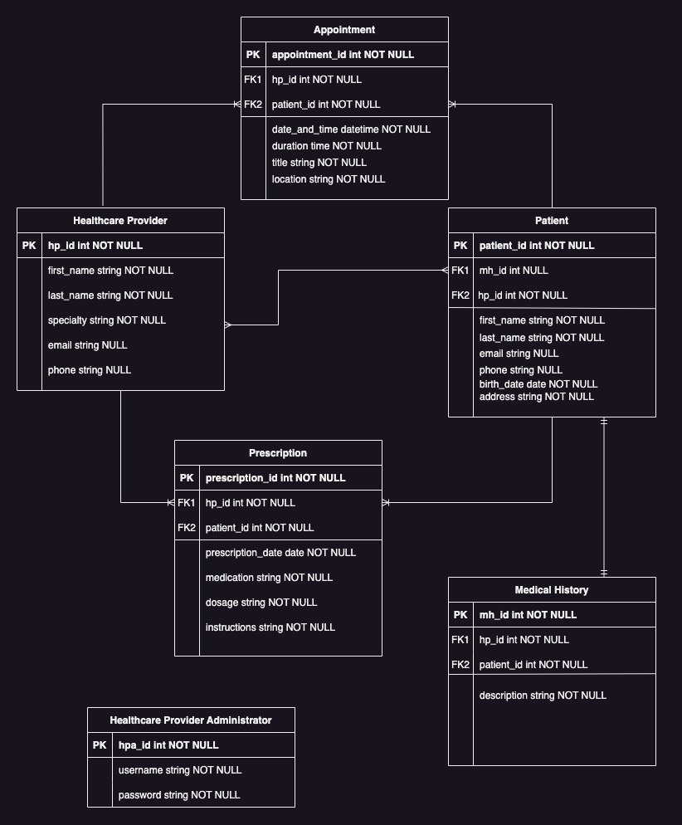

CRUD matrix

 | Appointment Management | Prescription Management
Healthcare Provider | CRUD | CRUD
Patient | CRUD | R

References

¹ https://www.ncbi.nlm.nih.gov/pmc/articles/PMC3824370/
² https://www.academia.edu/5962814/Electronic_Health_Record_Data_Model_Optimized_for_Knowledge_Discovery

