EduFinder
Process Modeling and Data Modeling /
System Proposal / Analysis Phase
(Homework No.3)

Project team: Team-08
Instructor: Dr. Araz Yusubov

Submitted in partial fulfillment of the requirements of the INFT 2303: Systems Analysis and Design course project

GitHub repository | https://github.com/ADA-SITE-INFT2303-2023-Spring/sys-dev-project-team-08/tree/main/03-Analysis-Models
Version date | Version information
17.04.2023 | Initial draft
<Date> | <Version description>

Other documents in the package
File name | Brief description of the document
Context diagram | Html Document that shows the context diagram of the system
INFT2303-HW02-Requirements | Document of the previous homework
Level 0 DFD | Html Document that shows level 0 data flow diagram
Level 1 DFD | Html Document that shows level 1 data flow diagram
ERD | Html Document that shows Entity relationship diagram

Team member | Contribution to this homework (NOT the project) | Estimated %
Elvin Garayev | Context diagram, introduction | 20%
Ali Ahmadli | Level 0 diagram | 20%
Ulviyya Mammadova | Entity Relationship diagram | 20%
Ziyavaddin Zeynalli | Level 1 diagram, definitions | 20%
Sama Zeynalova | CRUD matrix | 20%

Table of Contents
1. Introduction 3
Definitions 3
2. Process Modeling 3
Level 0 diagram 5
Level 1 diagram 6
3. Data Modeling 7
CRUD matrix 7
4. References 7

Introduction
This is part of the System Proposal for a hypothetical project Edufinder submitted for partial fulfillment of the requirements of the Systems Analysis and Design course in the School of Information Technologies and Engineering at ADA University, Baku, Azerbaijan.

This document shows the necessary diagrams for creating the system. Each of the sections was divided among five people, and all five people had their own deadline to finish the part of the work that was given to them because some of the sections depended on other sections.

Definitions

Term | Definition
Payment Gateway  User Authentication  Search prompt  CRUD matrix | This external system responsible for payment transactions between the system and a user.  Verifying the identity of users who are accessing the system.  A search prompt is a data flow that provides a keyword or search criteria to the system.  Chart that shows how a system allows users to create, read, update, and delete different types of data or information.

Process Modeling

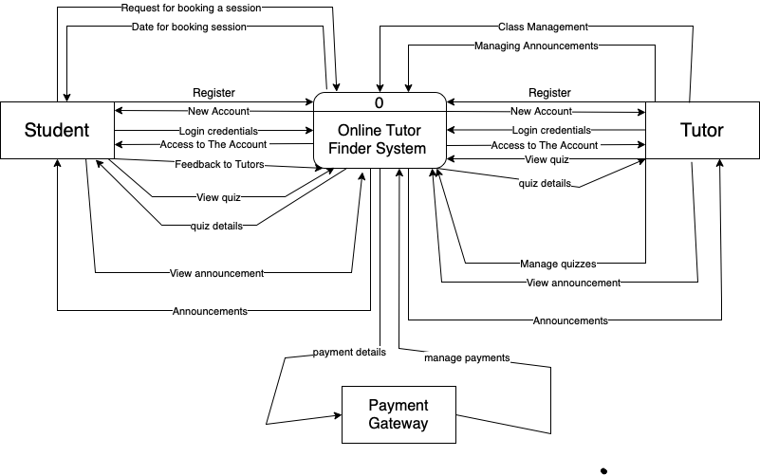
- Online Tutor Finder System: Main process of the system which will directly interact with all entities.
- Student: someone who is seeking educational services such as enrollment.
- Tutor: someone who provides academic assistance or guidance to students.
- Payment Gateway: third-party service that handles the payment transactions between the system and the students.
- Quizzes: data flow that carries information about quizzes, exams or assessments that the students need to take.
- Announcements: data flow that carries information about any important messages or updates that need to be communicated to students or tutors.
- New account: data flow that carries information about new user accounts that are being created in the system.
- Login credentials: data flow that carries information about user IDs and passwords that students or tutors use to access the system.
- Payment Details: data flow that carries information about payment transactions made by students or tutors.
- Feedback to Tutors: data flow that carries information about feedback or reviews provided by students to tutors.

Bonus 2: Get extra 10% points for complementing all process descriptions with UML activity diagrams. For the context-level diagram it must be in a form of a swim lane diagram.>

Level 0 diagram
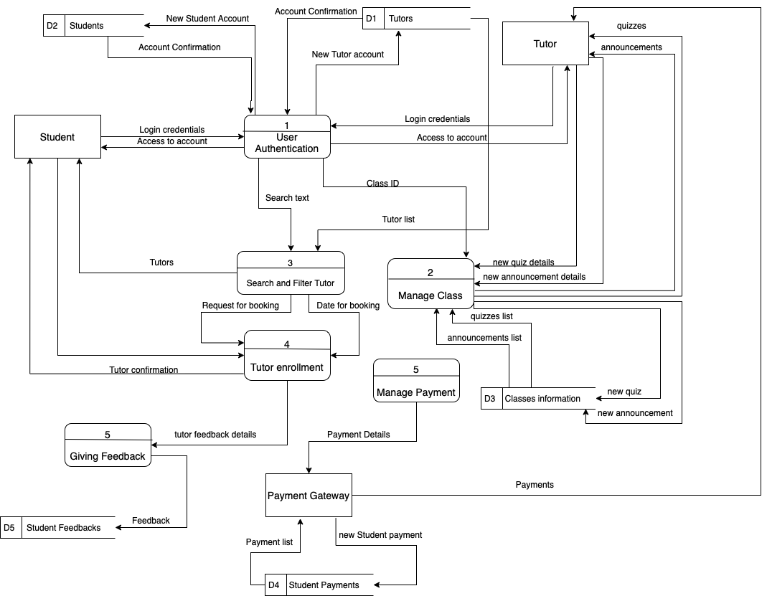

Data stores:
- Student payments: it stores payment records of students.
- Classes information: it contains information about classes.
- Student feedbacks: this data store stores the feedback that students give for the specific class.
- Tutors: it stores all Tutor accounts’ credentials
- Students: it stores all Tutor accounts’ credentials
External entities:
- Student: someone who is seeking educational services such as enrollment.
- Tutor: someone who provides academic assistance or guidance to students.
- Payment Gateway: third-party service that handles the payment transactions between the system and the students.
Processes:
- Manage Class: process that involves managing the details of a class. This process may include tasks such as creating new classes, modifying existing classes, deleting classes, assigning instructors, managing class schedules, and updating class information.
- Give Feedback: process that involves providing feedback or reviews to tutors. This process may include tasks such as collecting feedback from students, evaluating feedback, and sharing feedback with tutors.
- Manage payment: process that involves managing payment transactions in the system.
- User Authentication: process that involves verifying the identity of users who are accessing the system. This process may include tasks such as validating user credentials, verifying user information, and authenticating users based on their roles.
- Tutor Enrollment: process that involves enrolling students in classes offered in the system. This process may include tasks such as verifying student eligibility, registering students for classes, updating student enrollment status, etc.
- Search and Filter Tutor: process that involves allowing users to search for and filter tutors based on specific criteria. This process may include tasks such as defining search criteria, querying tutor information, displaying search results, filtering tutor information, etc.

Level 1 diagram
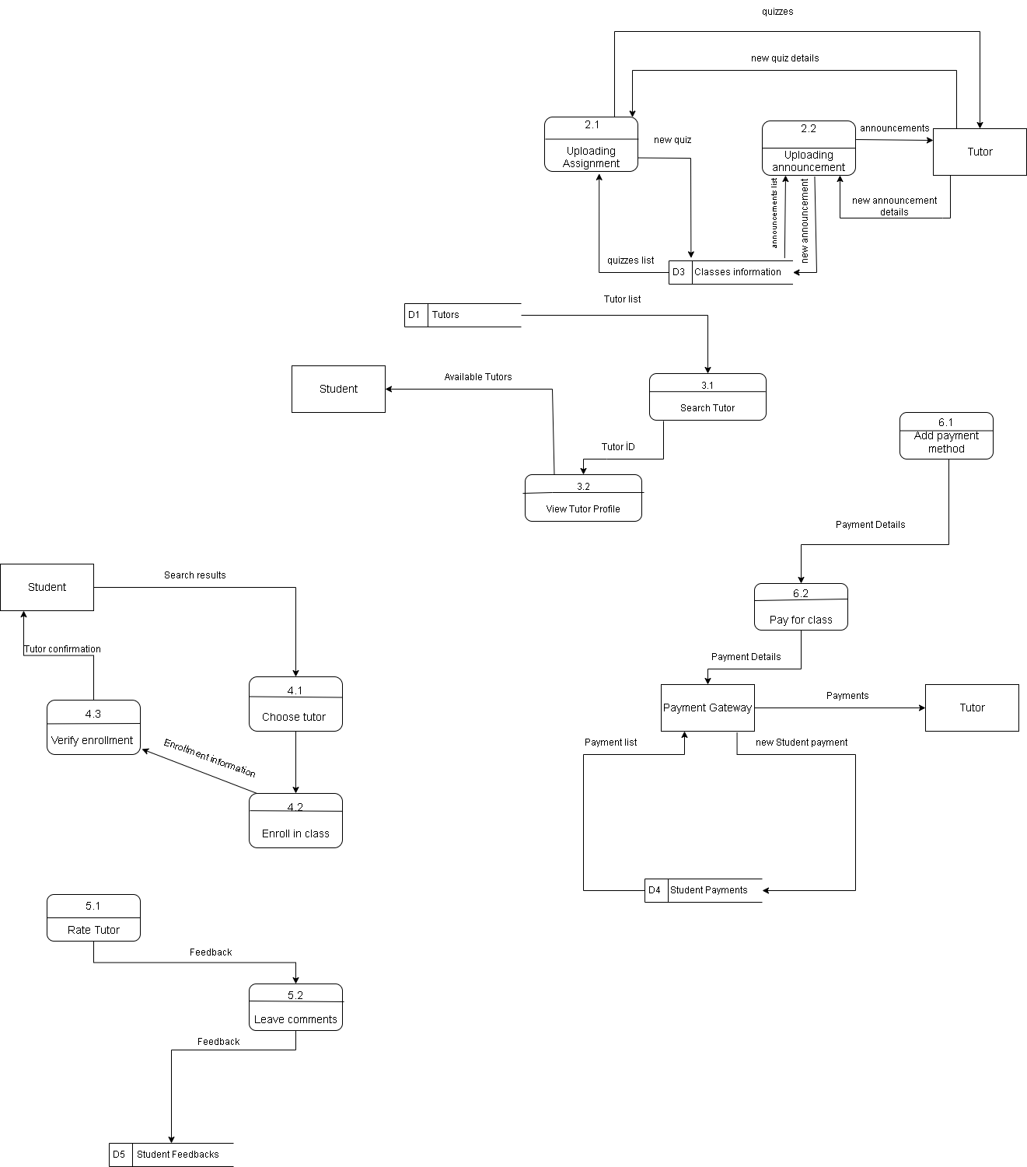

Data Modeling
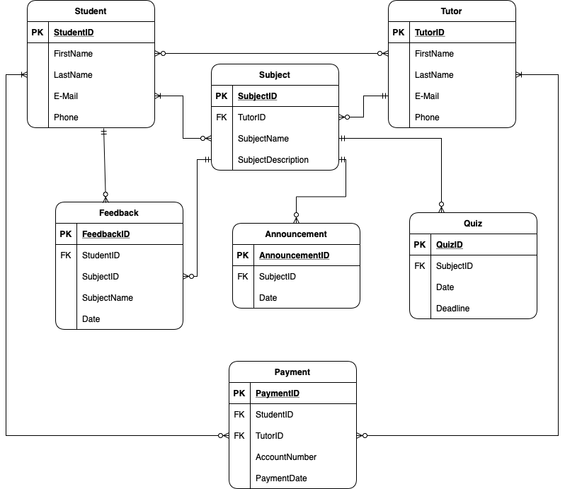

CRUD matrix

