**Online Multivendor Shopping Platform**

Process Modeling and Data Modeling /   
System Proposal / Analysis Phase   
(Homework No.3)

Project team: Team09

Instructor: Dr. Araz Yusubov

Submitted in partial fulfillment of the requirements of the INFT 2303: Systems Analysis and Design course project.

|  |  |
| --- | --- |
| GitHub repository | https://github.com/ADA-SITE-INFT2303-2023-Spring/sys-dev-project-team-09 |
| 4/23/2023 | Everything finalized |
| 4/15/2023 | Initial draft |
| 4/23/2023 | Final |

|  |  |
| --- | --- |
| Other documents in the package | |
| INFT2303-HW02-Requirements | Modifications on HW02-Requirements assignment. |
| Context_Diagram.drawio | The context-diagram for the project |
| Level_0.drawio | The level-0 diagram for the project |
| Activity_Diagram.drawio | The activity diagram for the project |
| Swim_lane.drawio | The swim-lane diagram for the context-diagram |
| Level_1.drawio | The level-1 diagram for the project |
| Entity_Relationship.drawio | The entity-relationship diagram for the project |
| CRUD_matrix.drawio | The CRUD matrix for the project |

|  |  |  |
| --- | --- | --- |
| Team member | Contribution to this homework (NOT the project) | Estimated % |
| Sabina Veyisli | Introduction, Process Modeling, Bonus1+Bonus2, References. | 25% |
| Rauf Rasulzada | Introduction, Process Modeling, Bonus1+Bonus2, References. | 25% |
| Manaf Aghazada | Definitions, Data Modeling, Bonus3, References. | 25% |
| Zaur Khudiev | Definitions, Data Modeling, Bonus3, References. | 25% |

**Table of Contents**

1. **Introduction**

This is part of the System Proposal for a hypothetical project Online Multivendor Sales Platform submitted for partial fulfillment of the requirements of the Systems Analysis and Design course in the School of Information Technologies and Engineering at ADA University, Baku, Azerbaijan.

To prepare this document, the team examines the demands and preferences of potential customers and sellers, by focusing on process modeling and data modeling. The main attributes and capabilities of the platform are also described, including product listings, payment processing, and order management. Additionally, necessary e-commerce trends, online sales platforms, and Azerbaijani market conditions were examined thoroughly.

The process modeling part which includes DFD diagrams, and all the steps involved will be explained to create a new system. For a better understanding of the system, process modeling is helpful. A DFD can be made to visualize the complete system and all of its components by analyzing the data between the processes. Other than that, this document will cover data modeling and all entity relationships diagrams which show the information that is created, stored, and used. Finally, the document will conclude with a Crud Matrix, which is a useful tool to depict the interrelationship between the process and the system's framework.

**Definitions**

|  |  |
| --- | --- |
| Term | Definition |
|  |  |

1. **Process Modeling**

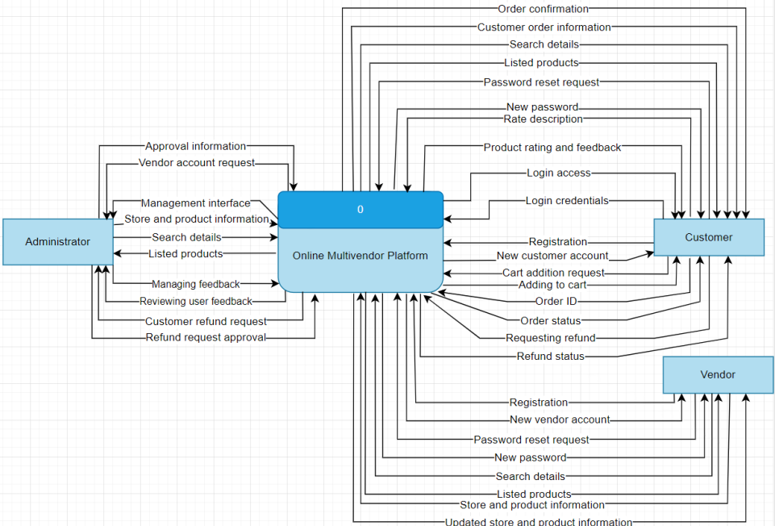

**Processes**:

1. Register for a customer account: This process enables customers to register for an account on the Online Multivendor Platform. By requiring customer credentials, including username, password, email, etc., the system stores the new account on the customer accounts database (UC-01: Register as a Customer).
2. Register for a vendor account: This process enables vendors to register for an account on the Online Multivendor Platform. The main difference between a customer account and a vendor account is the ability to create a market and sell products on the platform. Through requiring credentials, the system stores the new account on the vendor accounts database (UC-02: Register as a Vendor).
3. Login to a user account: This process allows users to log in to their accounts. This process includes the verification step from the system; the system verifies the account credentials and lets the user get access if the credentials are correct (UC-03: Login to user account).
4. Reset password: This process allows users to reset their password in any case of issues related to their login access or account credentials (UC-04: Reset password).
5. Search & View products: This process allows users to search for any products and based on the provided lists, let them view the products on the Online Multivendor Platform (UC-05 & UC-06: Searching the products, Viewing the product).
6. Add to cart: This process allows customers to select any products and add those products to their shopping cart for further purchasing. Customers have the authority to select products and manage their quantities to add to the cart (UC-07: Add to cart).
7. Manage store & products: This process allows administrators and vendors to manage the stores and products on the Online Multivendor Platform. The administrator approves the vendor information and lets the vendor create and manage the store. Administrators can also manage that store. Vendor has the authority to add products to the store and sell them; so, the vendor has the ability to manage the products. This also refers to the administrator as well for checking the product through managing (whether it is an appropriate product or not) (UC-11: Manage store).
8. Manage payments: This process enables customers to select any payment method for the purchasing phase. The system confirms the credentials and indicates to the customer whether the payment method's credentials are approved or not; and, the system stores the payment details in the payment information database (UC-14: Manage payments).
9. Add feedback: This process allows customers to give feedback about products. This includes product ratings, comments, etc (UC-12: Rate the product).
10. Managing feedback: This process allows the administrator to regulate the feedback by checking the feedback details and approving the feedback if it is appropriate (UC-13: Manage the feedback).
11. Proceed to checkout: This process enables customers to complete every step and proceed to checkout for making a purchase. The phase involves validating the payment details and generating the order confirmation (UC-09: Checkout).

**Data flow:**

1. Provide customer credentials: This data flow represents the customer credentials (such as name, email, and password) provided during the customer registration process.

2. Provide vendor credentials: This data flow represents the vendor credentials (such as name, email, and password) provided during the vendor registration process.

3. New customer account: This data flow represents the new customer account information generated during the customer registration process, including customer ID and account credentials.

4. New vendor account: This data flow represents the new vendor account information generated during the vendor registration process, including vendor ID and account credentials.

5. Search product: This data flow represents the information entered by customers to search for products, which includes keywords and filters, during the product search process.

6. Added product name: This data flow represents the product name of the product added to the customer's shopping cart.

7. New cart information: This data flow represents the modified cart information, including the updated list of products, quantities, and prices, resulting from adding or removing products from the customer's shopping cart.

8. New store and product information: This data flow represents the new store and product information provided during the store creation and product listing, including store details, product details, and pricing information.

9. Search & view products: This data flow signifies the product listings obtained from the product information data store, filtered based on the customer's search criteria. It is then passed to the search products process for a display to the customer.

10. Purchasing products: The data flow represents the process of a customer selecting and purchasing products from the Online Multivendor Platform. It includes the product details, quantities, prices, and payment information provided by the customer during the checkout process.

11. New order ID: This data flow represents the newly created order ID during the purchase phase.

12. Confirming credentials: This data flow represents the validating of credentials provided by customers or vendors, such as username, password, payment credentials, etc.

13. Approve payment: This data flow represents the result of whether the provided credentials are approved or not.

14. Finalize shopping: This data flow represents that the shopping is finalized and is ready for checkout.

15. Feedback details: This data flow represents the feedback details provided by customers during the feedback process, including product ratings, comments, and other feedback information.

16. Manage feedback: This data flow represents the regulation of the administrator on the feedback provided by customers.

17. Manage store and products: This data flow represents the process of managing stores and products by the platform administrator or vendor. This data flow includes managing pricing and inventory, adding or removing products from stores, updating store information, adding new stores, and performing other store and product management tasks. It involves activities related to managing the stores and their associated products.

**Data stores:**

1. Vendor accounts: the data store collects new vendor accounts and their credentials on the database. It is used by the register for a vendor account process to store vendor data and can be accessed for authentication and other vendor-related activities.

2. Customer accounts: the data store collects new customer accounts and their credentials on the database. It is used by the register for a customer account process to store customer data and can be accessed for authentication and other customer-related activities.

3. Store and product information: the data store collects new store and product information on the database.

4. Cart information: the data store represents the temporary storage of products and quantities selected by customers for purchase. It is used by adding to cart and checkout processes for updating the customer's shopping cart and indicating the cost for the purchase phase.

5. Order information: the data store represents the order confirmation generated after finalizing the shopping; it includes order details, payment methods, order ID, etc.

6. Payment information: the data store collects the customer's payment method details and sends the approval to manage the payments process to indicate whether the credentials are confirmed or not; the details are further utilized by the checkout phase to finalize everything.

**External entities:**

1. Customer: This external entity represents the user who interacts with the Online Multivendor Platform to find products, add selected products into cart, continue orders, purchase, provide feedback, etc.

2. Vendor: This external entity represents the user who has authorization for creating a store and listing their products to sell; they have the ability to manage pricing, managing the store and products, etc.

3.. Administrator: This external entity represents the system administrator who is responsible for managing the Online Multivendor Platform. The administrator has access to control user accounts, stores and products, configuration, customer feedback, etc.

**Bonus 2:**

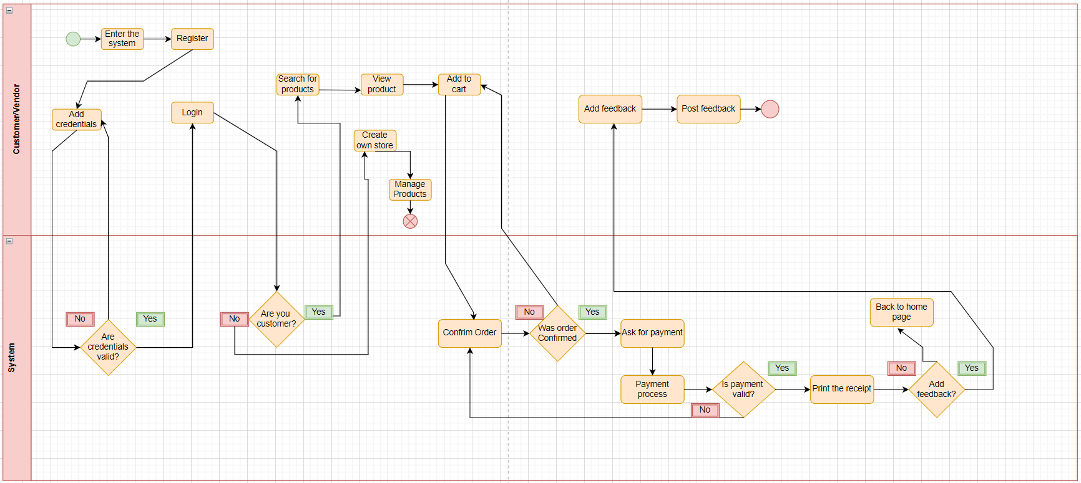

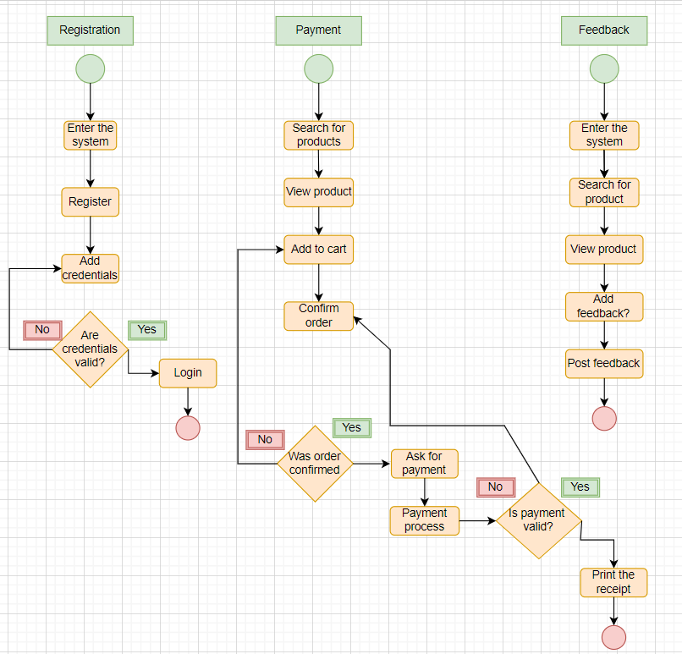

**Level 0 diagram**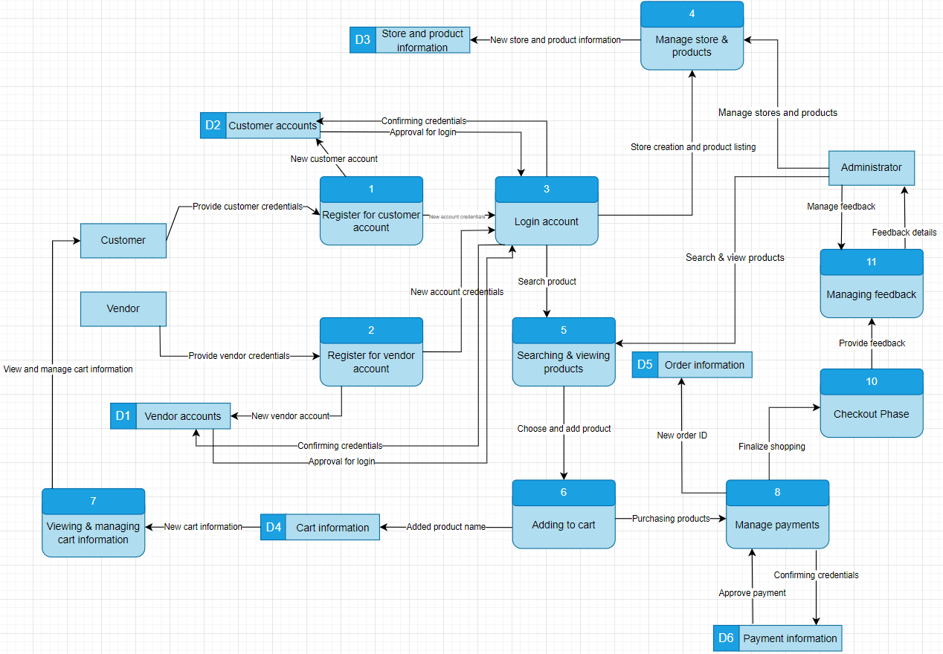

**Level 1 diagrams**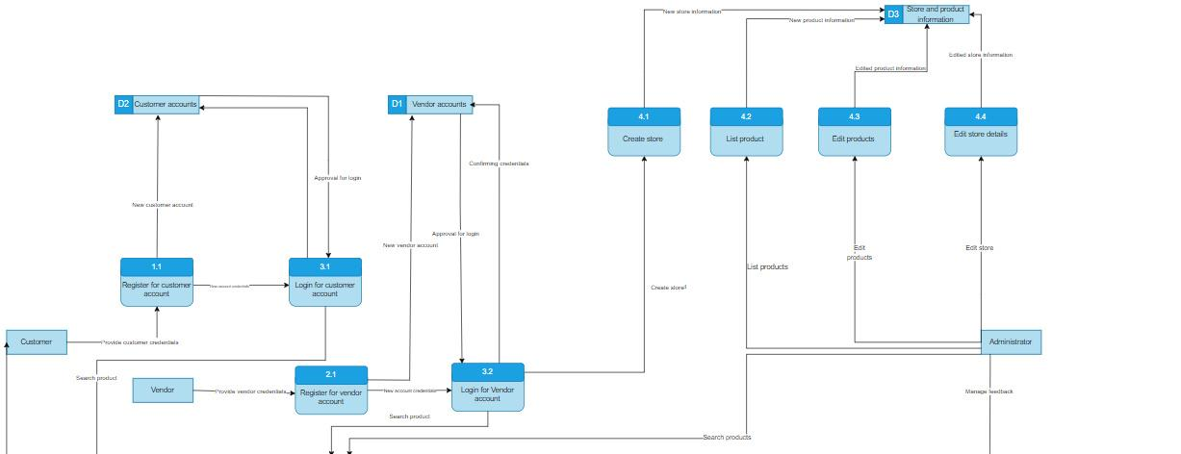

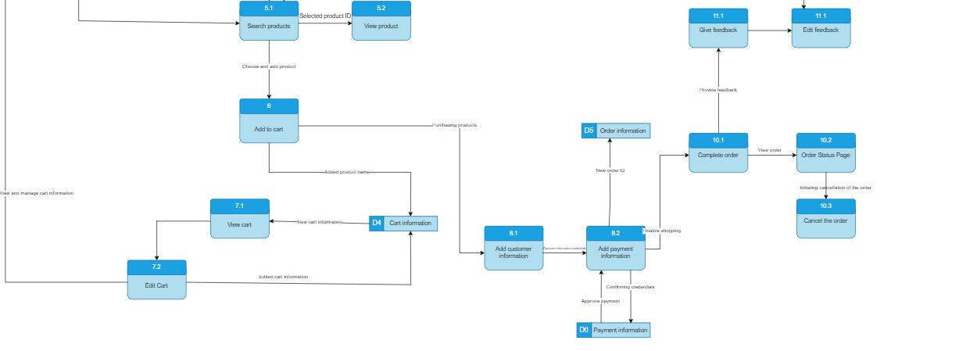

1. **Data Modeling**

Complex data relationships. 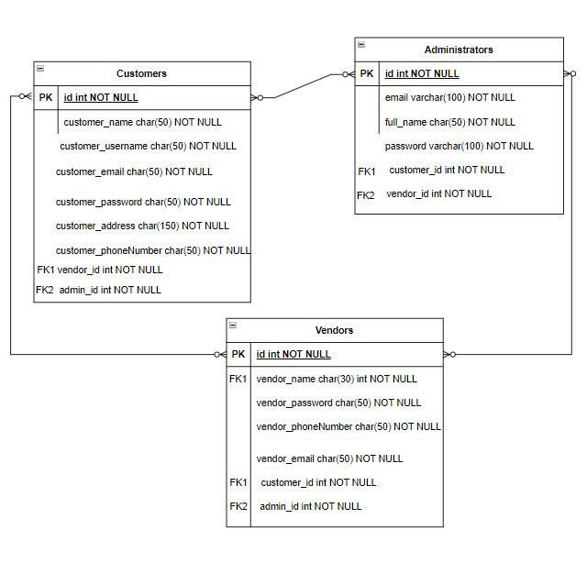

Administrators - There can be more than 1 administrators, therefore, there should be full name and email authentication.

Vendors - Vendor should have email and password to login their vendor accounts.

Customers- Additionally, customers should have address and phone number, they are needed because while deliver courier service or vendor may call them.

There are some types of attributes such as simple,composite, multi-valued or single-values, in our ERD all of the attributes are simple except “vendor_phoneNumber”, “customer_phoneNumber” and “customer_address” attributes. Phone number is multi-valued attribute, on the other hand, address attribute is composite attribute because an entity has more than one component that can be further divided into smaller attributes.

**Cardinality:**

Also, there should be “many to many” relationship with all entities.

Admin can manage multiple Customers and a Customer can be managed by multiple Admins.

Admin can manage multiple Vendors and a Vendor can be managed by multiple Admins.

Customer can purchase from multiple Vendors and a Vendor can have multiple Customers purchasing from them.

**Modality:** A Vendor may or may not supply products or services to a Customer, and a Customer may or may not purchase products or services from a Vendor. It is correct for all entities(Customers, Vendors and Admins) as well.

**CRUD matrix**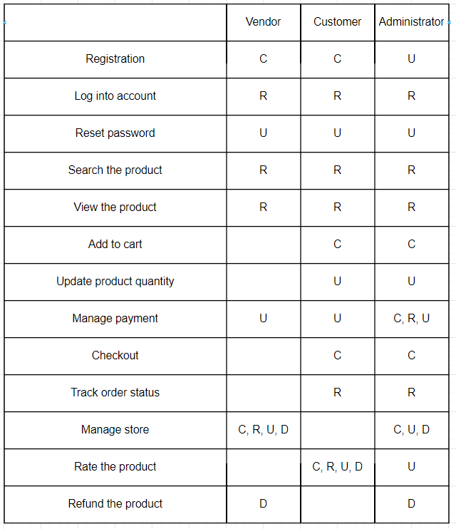

1. **References**
2. Dennis, A., Wixom, B. H., & Roth, R. M. (2015). Systems analysis and design (6th ed.). Wiley.