Online Bike Renting System
Requirements Determination and Use Case Analysis / System Proposal / Analysis Phase
(Homework No.2)

Project team: Team 10
Instructor: Dr. Araz Yusubov

Submitted in partial fulfillment of the requirements of the INFT 2303: Systems Analysis and Design course project

GitHub repository | https://github.com/ADA-SITE-INFT2303-2023-Spring/sys-dev-project-team-10
Version date | Version information
28.03.2023 | Initial paper
01.04.2023 | Final paper

Other documents in the package
INFT2303-HW02-Requirements.doc | Word file of Requirements Determination and Use Case Analysis / System Proposal / Analysis Phase
onlinebikerentingsystem.drawio | Diagram
INFT2303-HW01B-System-Request-Feasibility updated version.doc | Updated word file of System Request and Feasibility Study / Planning Phase

Team member | Contribution to this homework (NOT the project) | Estimated %
Afsana Mammadova | Introduction, use case analysis(user story descriptions) + use case diagram, Use case | 34%
Ahmad Huseynli | Functional Requirements, Use Case | 24%
Fredasif Maharramli | Requirement Definition, Nonfunctional Requirements, Use case | 24%
Leyla Novruzova | Definition, Design Constraints, Use case analysis (External actor descriptions) | 18%

Table of Contents
Table of Contents
Table of Contents 3
1. Introduction 3
Definitions 3
Requirements Definition 4
Functional Requirements 4
Nonfunctional Requirements 6
Design Constraints 6
2. Use Case Analysis 7
External Actor Descriptions 7
User Story Descriptions 7
Use Case Diagram 8
Use Case Descriptions – 8
Use Case 1 8
Use Case 2 9
Use Case 3 10
Use Case 4 10
Use Case 5 11
Use Case 6 11
Use Case 7 12
Use Case 8 13
Use Case 9 15
Use Case 10 16
References 16

Introduction
This is part of the System Proposal for a hypothetical project Online Bike Renting System submitted for partial fulfillment of the requirements of the Systems Analysis and Design course in the School of Information Technologies and Engineering at ADA University, Baku, Azerbaijan.

The objective is creating online system for those who only need a bike occasionally can borrow one for as long as they need it through the system. This document, which will be used in the project's development process during the following phase, is designed to cover all of the requirements that must be satisfied in order to develop the system.

Although the online bike rental system appears to be simple to create, due to the size of the project, it must be done so in a bug-free and expert manner. The document includes potential use cases and requirements determination which will help to design the system.

Definitions

Term | Definition
Use case  SSL encryption  PCI DSS  GDPR  Response time  RAM  GPS | A written description of how users will perform tasks in system  Stands for - Secure Sockets Layer. It is an internet security protocol to keep information you send over internet private and secure.  Stands for - Payment Card Industry Data Security Standard. When you use credit card to buy something, the company should keep the information safe, such as your name and credit card details. PSI DSS provides a framework for companies to follow in order to make sure that they are protecting customers’ information.  Stands for - General Data Protection Regulations. It is set of rules to protect people’s personal data (such as name, address, phone number, etc.) and companies should follow them. If a company violates GDPR, they can face large fines.  The amount of time it takes for the system to respond to a user’s request or input. Fast response times are important because users will less likely get frustrated.  Stands for - Random Access Memory. It is a type of computer memory that stores data and programs that are currently in use by your computer’s processor. The more RAM a computer has, the more tasks the computer can do at once without slowing down.  Stands for – Global Positioning System. It is a system that uses satellites in space to help people for navigations and finding directions.

Requirements Definition

- System shall offer a reliable computerized system for renting bicycles.
- System shall allow customers to hire bicycles without having to use cash.
- System shall give users the ability to look for available bikes, check bike specifications, and hire bikes.
- System shall provide a consumer subscription function to increase the business's revenue.
- System should permit users to control their profiles.
- System shall give system administrators the ability to manage every system component.
- System shall make sure the system is safe and works without bugs.
- System should provide options for several payment types.
- System shall give real-time information about where bikes are and if they are available.
- System should include a way for customers to access the rental system from their phones.
- System should give detailed information about how to rent bikes and how to use them.
- System should allow for the customization of subscription costs and rental rates.
- System may incorporate additional functions like as locking and unlocking and GPS tracking.
- System should be expandable to handle an expanding customer and bike base.
- System should abide by all applicable laws and rules pertaining to renting bikes in Baku.

Functional Requirements

Process-oriented

- User shall be registered to the Online Bike Rental System by filling
  - Name and surname
  - Birth date
  - Username
  - Password
  - Profile picture
  - Email
  - Phone number
  - Location
  - Credit / debit card
- User shall sign into own account by using
  - Username or Email or Phone number
  - Password
- User shall have an access to edit own account information which includes changing
  - Username
  - Email
  - Phone number
  - Password
  - Profile picture
  - Card details
- User shall have an opportunity to sort bikes for their
  - Distance from user
  - Physical condition
  - Production date: from old to new
  - Price
  - Additional features: headlight, horn, manual etc.
  - Bike types: road bike, mountain bike etc.
  - Tire size
- User shall rent the bike that satisfies his/her own requirements.
- User shall pay the renting price
  - Added credit/debit card
  - Directly Apple Pay, Samsung Pay, Google Pay
- User shall have an access to write and read feedbacks as comments, or simply put stars about rented bikes.
- User shall have a support such as,
  - Written user guide
  - YouTube videos
  - Hotline support,
if there are troubles about
- Account details
- Payment
- Bikes

Information-oriented

- User shall enter account password to have an access to see own account information which includes
  - View Security Details
- Name and Surname
- Username
- Phone Number
- Email
- Profile Photo
  - View Payment Details
- Card Number
- Card Expiration Date
- Card Security Code
  - View Renting History
- Bike
- Travelled distance
- Travel time
- Payment for renting
  - View terms of service and user agreement

Nonfunctional Requirements

Operational:

- There should be less downtime for maintenance and the system should be accessible 24/7.
- The system must have a backup and recovery plan in the event of system failure.

Performance:

- The system should respond quickly to requests to rent bikes and to see if bikes are available.
- The system needs to handle data effectively to guarantee real-time information on bike availability and position.
- A thousand people should be able to utilize the system simultaneously without it performing worse.

Security:

- The system should have safe ways to log in and prove who you are so that user information is kept safe.
- The system should have safe ways to pay so that fraud doesn't happen.
- System administrators will be the only ones who can fully access a user's account.

Design Constraints

- Security: To keep members’ personal data and financial transactions safe, the system should be designed with security standards like SSL encryption, PCI DSS, and GDPR.
- User interface: The system’s interface design should be user-friendly and easy to navigate. It should be designed to handle high traffic and provide fast response times.
- Reliability: The system should be reliable and available for 24/7. It also should be scalable in order to accommodate a large number of user and bike rentals.
- Hardware limitations: The system’s design should consider specific hardware requirements such as processor speed, RAM, and storage capacity.
- Budget: The system should be designed to be cost-effective and developed within the budget constraints including costs to develop and maintain the system.

Use Case Analysis

External Actor Descriptions
- Users– As the main external actors of the system, members interacts with the system through the web interface. Members can perform various actions such as registering, logging in, searching for available bikes, renting bikes, and canceling bookings.
- Admin – Human actors that are responsible for controlling the system. They have the authority to add or remove, maintain the membership database, monitor system activities, generate reports, and resolve technical issues.
- GPS Tracking System – A software system actor that tracks the bike locations in real-time using GPS technology. It provides accurate rental information to the system, generates reports and analytics based on bike movements.

User Story Descriptions

User story name | Description | Release
Registering a User | It must be possible for users to set up an account with their required personal information | R1
Logging user in | The user must sign into their account using registered information. | R2
Editing of profile | The user shall have access to change his or her own account information, including updating personal data. | R3
Sorting of bikes | The availability of bikes should be displayed for users based on their features and physical condition. | R4
Ordering a bike | Users will choose a bike that meets their needs and book it. The system's primary task is to keep track of each bike's rental history and avoid overbooking. | R5
Making a payment | A safe payment channel should be available for users to use to pay for the rental with credit/debit card in online format. | R6
Giving feedback | Users should have the ability to post and read reviews as comments or just assign a star rating to the system and improvements provided to them. | R7
Helping user | When users encounter issues, the system must develop instructions on how to utilize it and provide assistance options. | R8
Viewing user account data | The system must keep records of the service and user agreement, as well as security and payment details. User must be able to view them | R9
Viewing renting history | The system needs to record rental history, including payments. These must be viewable by the user. | R10

Use Case Diagram

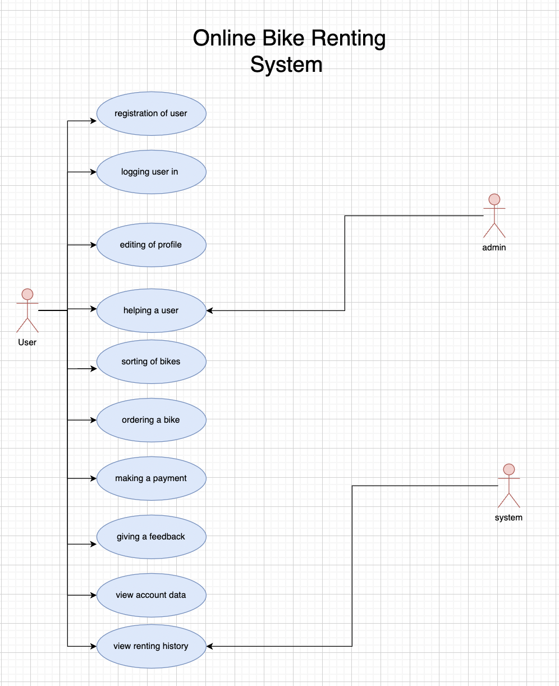

Use Case Descriptions –

Use Case 1

Use Case Number: | UC-01
Use Case Name: | Registration of user
Actor(s): | User
Description: | It must be possible for users to set up an account with their required personal information
Priority (Release) | R1
Trigger: | External - User signs up with the system
Pre-condition(s): | The program has been downloaded, and it is prepared to use and take registrations.
Main (Success) Flow: | - User choses the option for register  - The system asks for personal information to fill the forum.  - User fills the forum with necessary information  - The system verifies that the provided information is accurate.  °If the given information is not valid then user is directed to 2nd step  - A new user account is created by the system  - The user receives confirmation mail/message from the system
Alternate Flows: | 3.a. If there is any wrong-filled section, the system shows red error sign  6.a. When a user doesn’t get any confirmation mail/message they can ask the system to send again.
Post Condition: | If a user has an account, then they don’t need to fill again. The system automatically will send them to log-in option
Requirements: | Personal information required:  - Name and surname  - Birth date  - Username  - Password  - Profile picture  - Email  - Phone number  - Location  - Credit / debit card  The user is able to cancel this flow any time by clicking “back/cancel”

Use Case 2

Use Case Number: | UC-02
Use Case Name: | Logging user in
Actor(s): | User
Description: | The user must sign into their account using registered information.
Priority (Release) | R2
Trigger: | External – User signs in the system
Pre-condition(s): | There is a registered account of the user and the user is able to log in to the system
Main (Success) Flow: | - User chooses the option “Log in” or directed by the system  - The system asks for email/number and password  - User fills the forum with necessary information  - The system verifies that the provided information is accurate.  °If the given information is not valid then user is directed to 2nd step  - The system directs the user to his/her account.
Alternate Flows: | When the users forget their password, they can click the option “I forgot my password”. Then the system will ask their email/number to restore the password.
Post Condition: | After logging in, the user can use the application  • Users can sort&order bikes and make a payment  • Users can make changes in their account  • User can view account details and payment history
Requirements: | Users must enter phone/mail and password  Users can reset their password  Users can be directed to the register section

Use Case 3

Use Case Number: | UC-03
Use Case Name: | Editing of profile
Actor(s): | User
Description: | The user shall have access to change his or her own account information, including updating personal data.
Priority (Release) | R3
Trigger: | External – Users wants to make changes in their profiles
Pre-condition(s): | User must have an account to edit
Main (Success) Flow: | - The user opens the system  - The user opens the profile  - The system shows the current information  - The user clicks “Update profile”  - The user makes changes in the profile  - The user clicks “Save changes”  - The system shows the confirmation message
Alternate Flows: | 5.a After user making a change, if there is a mistake the system shows an error sign
Post Condition: | • The user makes changes  • User can see changes in her/his profile
Requirements: | The user must open the application  The user must have a profile  The user must be able to cancel changing process any time by clicking “Back/Cancel Changes”

Use Case 4

Use Case Number: | UC-04
Use Case Name: | Sorting of bikes
Actor(s): | User
Description: | The availability of bikes should be displayed for users based on their features and physical condition.
Priority (Release) | R4
Trigger: | External: The system user clicks the “Sort Bikes” button.
Pre-condition(s): | - The system user should have an internet connection.  - System should be installed and ready to use.  - User should be logged in to his/her own account.  - User should see the total list of bikes.
Main (Success) Flow: | - User opens the application.  - From main menu, user selects “Sort Bikes”.  - User chooses to sort the bikes on which basis:  - Distance from the system user  - Physical condition  - Tire size  - Bike type  - Price  - Production date  - Features: transmission types, headlight, horn, turning lights.  - The list of bikes in basis of chosen filtering types is shown on the screen of User.
Alternate Flows: | Alternate Flow #1: After Step 3, if there are no any bikes available to display to user, a message will be shown to inform about unavailability.  - User gets message about unavailability.  - The system offers to change the category and try again:  - If the unavailability of needed bikes still exists, the information message will be shown again.  - User can go back to the main menu.
Post Condition: | User will see the list of the sorted bikes.
Requirements: | - User shall have an appropriate device and internet connection to download the application and be sure the system works fine.  - User shall be logged in to the application by using own account.  - User shall click the “Sort Bikes” menu to see the list of bikes with the category in which basis should be sorted.  - The system shall provide a message if anything goes wrong about finding the bikes in sorted list.

Use Case 5

Use Case Number: | UC-05
Use Case Name: | Ordering a bike
Actor(s): | User
Description: | Users will choose a bike that meets their needs and book it. The system’s primary task is to keep track of each bike’s rental history and avoid overbooking.
Priority (Release) | R5
Trigger: | External: User clicks the button “Order a bike”
Pre-condition(s): | - User should be logged in to the application by own account.  - The chosen bike should be available and be ready to be ordered.
Main (Success) Flow: | - The system user chooses the bike that wants to rent.  - System shows the detailed information of the chosen bike.  - User clicks the “order” button to submit the order.
Alternate Flows: | Alternate Flow #1: After 1nd step if user cannot find any suitable bike for renting then can get a text on screen as an alert about it from the system and can return to the system menu.  Alternate Flow #2: After 2th step if user is not satisfied with the features of the shown bike, then user can get back and return to the main menu to see the alternatives for ordering.  Alternate Flow #3: After 3rd step system check if there is a overbooking or not, if there is the system removes the order and sends a notification about the condition.
Post Condition: | The user will be forwarded to the payment page to submit the payment of renting.
Requirements: | - User shall be logged in to the system by own account.  - User must be sure there are bikes on the screen to order.  - User shall click on the bike and “order bike” button.

Use Case 6

Use Case Number: | UC-06
Use Case Name: | Making a payment
Actor(s): | User
Description: | A safe payment channel should be available for users to use to pay for the rental with credit/debit card in online format.
Priority (Release) | R6
Trigger: | External: User wants to complete the rental payment.
Pre-condition(s): | - The system user should be logged in to the system.  - The system user should have added the payment method to the system.  - The system user must have added the valid payment details.
Main (Success) Flow: | - The system asks to user to choose the payment method to complete the renting process.  - User chooses the payment method.  - User submits the order by pressing “Pay” button and submits the order.  - System sends the notification message to the user to inform about succession of order.
Alternate Flows: | Alternate Flow #1: User can cancel the payment process and return to the main page in every steps.  Alternate Flow #2: After 2nd step if the payment method is not valid such as  - wrong card owner name,  - invalid card expiry date,  - wrong CVC,  The system will send a notification to the user about not completed payment and error. The user of the system can take these actions;  - User can check the payment information to be sure if everything correct and submit the payment again.  - User can add a new card as a payment method.  - User can contact to the call center to ask a help and report a bug about the uncompleted payment.  The user will get a notification from the system about successful renting and payment.  - User should be logged in to the system by own account.  - User should add a valid payment method and be sure every information is added correctly.  - User must be sure there are enough sum in the added card to complete the payment.  - User must be received a message about the success of payment and renting.  Alternative Flow #3: After the step 4th, user can use the digital wallet of the device such as Apple Pay, Samsung Pay without adding another payment method.
Post Condition: | The user will see the details of order and fee, and the message about the successful payment will be shown on the screen.
Requirements: | - User shall start the order of renting.  - User shall add the payment method to the system by own account.  - User shall be sure the details of payment method are valid.  - The system shall check the information from user to be sure if it is correct or not and send the notification about the result.  - User shall have at least one valid payment method.

Use Case 7

Use Case Number: | UC-07
Use Case Name: | Giving feedback
Actor(s): | User
Description: | People will comment on their own experiences using the bikes.
Priority (Release) | R7
Trigger: | External Trigger: Customer
Pre-condition(s): | - A working, flexible system is in place.  - User has entered the system and signed in.  - The user's selection for their comments is a bike.
Main (Success) Flow: | - The customer chooses the "Give Comment" option when their rental is over.  - The software shows a form for users to fill out with their opinions.  - The client enters their feedback in the form.  - By pressing the "Save" button, the client enters their feedback.  - The customer's input is added to the list of reviews for that rental by the system.  - The "Reply" button is located next to each comment, allowing other users to view it and leave a response.  - By simply responding to other feedback, users can indicate their agreement with it.  - The system shows the most recent feedback list, along with any new comments or responses.
Alternate Flows: | The system presents the option to cancel feedback after step 4 in the success scenario.  - 1b the consumer chooses option, which is the "Cancel" button adjacent to the "Save" button.  - 2b. The comment area vanishes, and the customer is redirected to the page with the information of the bike rental.
Post Condition: | Main Flow:  - New feedback is shown among the others.  - Changes in the feedback part are visible to all users.  Alternative Flow#1:  - User cancels the operation and directs to the renting page.
Requirements: | - During the procedure, the user must have the option to cancel feedback.  - The system must successfully save the feedback.  - All bicycles must be accessible to the user.  - The user must be logged in before proceeding.  - Each user must have a profile.

Use Case 8

Use Case Number: | UC-08
Use Case Name: | Helping user
Actor(s): | User, Admin
Description: | The system offers explanations and assistance alternatives to consumers who experience difficulties during the bike rental procedure.
Priority (Release) | R8
Trigger: | External - The user encounters a problem while renting a bicycle.
Pre-condition(s): | - The user must log in to the bike rental system.  - The user should have a profile.  - The user must have had a problem during the rental procedure.
Main (Success) Flow: | - The user is sent to the home page.  - In the bike rental system interface, the user taps the "Need Help?" button.  - A menu with numerous alternatives for assistance is displayed by the system.  - The user decides which choice for assistance is most suited.  - How to use the option is explained by the system.  - The user can carry on with the renting procedure if the problem is fixed.  - The user selects "Chat with Administrator" if the problem is still not solved.  - The system alerts the administrator.  - The chat's administrator joins.  - In order to identify the problem, the administrator searches.  - The user provides a thorough explanation of the issue.  - To fix the problem, the administrator offers detailed instructions.  - The issue is fixed if the user follows to the directions.  - The administrator requests the last four numbers of the credit card that was used to make the payment if the problem is still not fixed.  - This data is entered into the system by the administrator.  - The input is checked and verified by the system.  - The system issues a refund to the user's credit card if the entry is accurate.  - The user receives their refund and is then taken to the homepage of the bike rental service.
Alternate Flows: | 1a. If the user chooses "Contact Customer Service," the following will happen:  The system asks the user to give customer service a phone number or email address.  The user gives all the contact information that is needed.  A Customer Service Representative gets in touch with the user and helps them.  Once the problem has been fixed, the system lets the user know that they can move on with the rental process.  2a. If the user clicks on "FAQs,"  System shows a list of questions that are often asked.  The user chooses the right question.  The system shows the answer to the question that was chosen.  User does what the instructions say, and the problem is fixed.  The system lets the user know that the problem has been fixed and that they can move on with the rental process.
Post Condition: | Main Flow: The user received a refund of their money.  -  An Alternative Flow#1: - The system directs the user and administrator to the main page.
Requirements: | - The user is required to have an account with the bike rental system.  - Users must be able to access assistance options via a "Need Help?" button on the system's interface.  - The system must provide a variety of support options, including "Contact Customer Service" and "FAQs."  - Each assistance option must be accompanied by explicit instructions on how to utilize the system.  - During the assisting procedure, the system must validate all information supplied by the administrator to ensure its accuracy.  - If the user is required to provide the last four digits of their credit card number in order to receive a refund, they must have this information handy.  - The system must confirm that the problem has been resolved.  - If the user is unable to verify the requested inputs, the administrator should end the assistance process and suggest alternative means of support.

Use Case 9

Use Case Number: | UC-09
Use Case Name: | Viewing User Account Information
Actor(s): | User
Description: | This use case allows registered users to view their account information, including their rental history, payment details, and personal information.
Priority (Release) | R9
Trigger: | External - The user clicks on the "My Account" button on the bike rental system interface.
Pre-condition(s): | - The user must be registered with the bike rental system and logged in.  - The user must maintain an active account that includes rental history and payment information.
Main (Success) Flow: | - In the bike rental system's user interface, the user clicks the "My Account" button.  - The system shows the user's account details, including personal data, payment information, and rental history.  - The user checks the details of their account.
Alternate Flows: | 2. The system prompts the user to log in if they aren't already if they want to check their account details.  - 2b. The system shows a notice telling the user that they do not have any account information to see if they do not have an active account.
Post Condition: | The user is able to view their account information.
Requirements: | - The system's interface must provide a "My Account" button.  - The rental history, payment details, and personal information of the user must be displayed by the system.  - To view their account information, individuals must be registered and logged in to the system.

Use Case 10

Use Case Number: | UC-10
Use Case Name: | Viewing renting history
Actor(s): | User
Description: | The system needs to record rental history, including payments. These must be viewable by the user.
Priority (Release) | R10
Trigger: | External: User view the renting history.
Pre-condition(s): | - The system user should be logged in to the system.  - The system user should have at least one order which was paid and saved to record.
Main (Success) Flow: | - User opens the system.  - User clicks the “Account details”  - User clicks the “View Renting History”.  - The information about all recorded bike renting history with payment and order reports will be shown on the screen.
Alternate Flows: | Alternative Flow #1: After 2nd step, if there is no any record, user will have an alert message to be informed.
Post Condition: | The user will see the list of the recorded renting history.
Requirements: | - User shall enter the own account details.  - User shall click the “View renting history”.  - The system will provide the records of the user to show them.

References

- https://www.onnbikes.com/bike-rental-bangalore.html
- Hana Ayedi, Alaeddine Zouari, Nadia Hamani. An exploratory study of the bike rental system in Sfax -Tunisia. International Conference on Advanced Logistics and Transport (ICALT) 7th IEEE 2019, Jun 2019, Marrakech, Morocco. ⟨hal-02425222⟩
- Billhardt H, Fernández A, Ossowski S. Smart Recommendations for Renting Bikes in Bike-Sharing Systems. Applied Sciences. 2021; 11(20):9654. https://doi.org/10.3390/app11209654
- Macioszek, Elżbieta & Świerk, Paulina & Wyderka, Agata. (2020). The Bike-Sharing System as an Element of Enhancing Sustainable Mobility—A Case Study based on a City in Poland. Sustainability. 12. 3285. 10.3390/su12083285.
- Journal of Innovative Technology, Vol. 1, No. 1, pp. 13-20, March 2019
  - http://doi.org/10.29424/JIT.201903_1(1).0002
- SHIVARAJ KUMAR T H, et. al. "Online Car/Bike Rental Management System.” International Journal of Engineering Science Invention (IJESI), Vol. 11(07), 2022, PP 22-25. Journal DOI10.35629/6734
- https://pedalergripcovers.com/blogs/gottapedal/bike-sharing-systems
- https://rentrax.com/why-use-bike-rental-software/
- https://medium.com/urbansharing/the-economic-benefits-of-bike-sharing-f69c230e5a9d
- https://stepbystepbusiness.com/business-ideas/start-a-bike-rental-business/

Note: All references are used by all the members

