|  |  |
| --- | --- |
| **Name** | **ID** |
| Adam Muhammed | 211002023 |

**Medical Laboratory Database Project Report**Design and Implementation of a Medical Laboratory Database System

**Objective:**

The goal of this project was to design a database for a medical laboratory that stores and manages data for laboratorians, patients, tests, components used in tests, and test results. The database also needed to support important queries such as checking which patients took a specific test, components that are low in stock, and total cost of tests for a patient.

**Initial conceptual design:**

The database is named (Medical_lab). It includes 5 main tables:

1. **Laboratorian**  
   Stores: ID, first name, last name, phone number, and address  
   Example: 250001, Ahmed, Hassan, 01012345678, Cairo
2. **Patient**  
   Stores: Patient ID, first name, last name, phone number, address, birth date, and job  
   Example: 12527, Nour, Magdy, 01055667788, Cairo, 1990-08-12, Marketing Manager
3. **Component**  
   Stores: Component ID, name, available quantity, and minimum quantity  
   Used to track lab materials like blood test kits and urine test kits.
4. **Medical_Test**  
   Stores: Test ID, name of the test, price, and related component  
   All prices are realistic, and each test is linked to a component.
5. **Test_Result**  
   Stores: Test ID, date, patient ID, laboratorian ID, and result  
   Tracks when each test was taken, by whom, and the outcome.

**Relational database schema:**

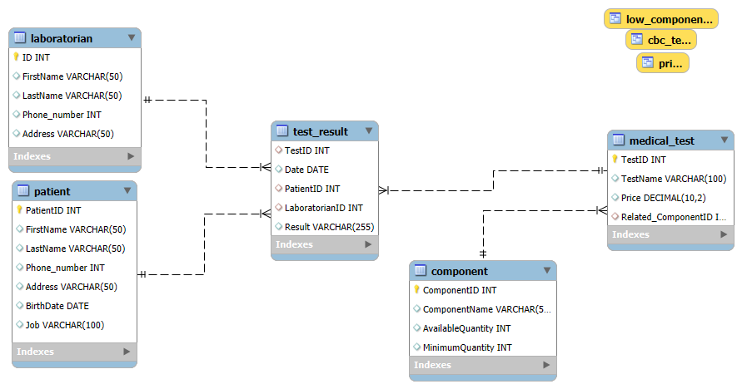

**Figure 1**: Relational Schema showing tables, attributes, primary keys (PK), and foreign keys (FK)

**ER Diagram:**

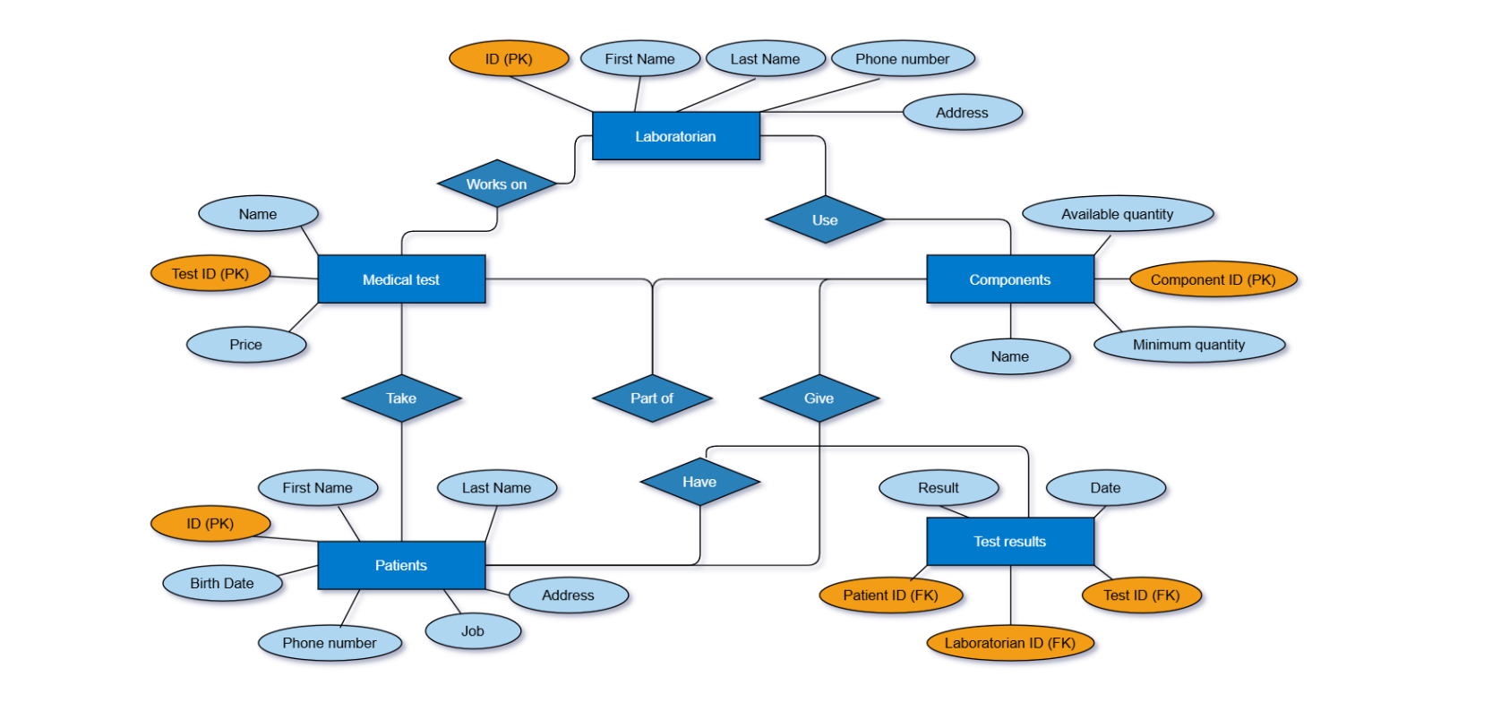

**Figure 2:** Conceptual ER Diagram with cardinality ratios and participation constraints

**DDL & DML Implementation:**

In this project, we used SQL (Structured Query Language) to create and manage our medical laboratory database. SQL helped us define the structure of the tables, insert realistic data, and build useful queries for retrieving information.

**1. Database Creation**

We started by creating the database:

**2.Table Creation**

We created five main tables using CREATE TABLE statements. Each table included a primary key and data type that matches the real-world attributes.

**3. Inserting Data**

We inserted 20 records for each main table using INSERT INTO statements. All data was designed to simulate a real medical lab in Egypt.



**4. Creating Views**

To answer complex queries, we used CREATE VIEW to simplify data access. These views allow us to retrieve filtered results without writing long queries every time.

Examples:

* **CBC_Test** view for patients who took a CBC test last year:

**5. Query Execution**

We tested all SQL statements inside MySQL. Queries returned the correct results and confirmed that our database was working as expected.

**Data Insertion:**

* We inserted 20 laboratorians, 20 patients, 20 components, 20 medical tests, and over 20+ test results.
* Names, phone numbers, addresses, and jobs are realistic and Egyptian-based.
* Component quantities are meaningful and include some items that are below minimum stock, to test that functionality.
* Patient 12527 has more than 5 test results within the last 3 years to allow for advanced cost tracking.

**Conclusion:**

This project successfully demonstrates a complete and functional medical lab database. It can manage real data, handle queries, and support future expansions. All the required tasks were completed with good structure and logical flow. It shows both technical knowledge and practical understanding.