INTRODUCTION TO DATA MANAGEMENT
PROJECT REPORT
(Project Semester January-April 2025)

MGNREGA Employment Dashboard: Insights on Rural Job Generation

Submitted by

Adarsh Barnawal

Registration No 12319124

Programme and Section – P132 & KM007
Course Code- INT217

Under the Guidance of

Maneet Kaur(15709)

Discipline of CSE/IT

Lovely School of Computer Science Engineering

Lovely Professional University, Phagwara

CERTIFICATE

This is to certify that Adarsh Barnawal (student’s name) bearing Registration no.12319124 has completed INT217 <Course Code> project titled, “MGNREGA Employment Dashboard: Insights on Rural Job Generation” under my guidance and supervision. To the best of my knowledge, the present work is the result of his/her original development, effort and study.

Signature and Name of the Supervisor
Designation of the Supervisor
School of Computer Science and Engineering
Lovely Professional University
Phagwara, Punjab.

Date: 12/04/2025

DECLARATION

I, Adarsh Barnawal, student of B.Tech (Program name) under CSE/IT Discipline at, Lovely Professional University, Punjab, hereby declare that all the information furnished in this project report is based on my own intensive work and is genuine.

Date: Signature
Registration No. 12319124 Name of the student
Adarsh Barnawal

Acknowledgement
I would like to express my sincere gratitude to all those who supported and guided me throughout the successful completion of this minor project titled “MGNREGA Employment Dashboard: Insights on Rural Job Generation,” undertaken as part of the INT217 (Data Management) course.
First and foremost, I extend my heartfelt thanks to Ms. Maneet Kaur, my project supervisor, for her constant guidance, valuable suggestions, and unwavering support throughout the duration of this project. Her insights and encouragement were instrumental in shaping the direction and execution of my work.
I would also like to thank the faculty members and technical staff of the School of Computer Science and Engineering, Lovely Professional University, for providing the academic environment and necessary infrastructure that made this work possible.
My special appreciation goes to the National Data & Analytics Platform (NDAP), NITI Aayog, Government of India, for making the dataset publicly available, which served as the core foundation of this analysis.
Lastly, I would like to acknowledge the support of my friends and family, who motivated and encouraged me during each stage of this project.
Adarsh Barnawal
Registration No: 12319124
Lovely Professional University

Table of Contents
- Introduction
- Source of Dataset
- Dataset Preprocessing
- Analysis on Dataset (for each objective
i. Objective 1: Employment Reach Across States & Districts
ii. Objective 2: Job Card Issuance Effectiveness
iii. Objective 3: Female Participation Trend Analysis
iv. Scheduled Caste (SC) and Scheduled Tribe(ST) Participation
v. To analyze the overall gender distribution in MGNREGA from 2011 to 2020
vi. Work Intensity by District (Person Days Analysis)
vii. Bank vs Post Office Mode of Payment
- Conclusion
- Future Scope
- References

1.Introduction
The Mahatma Gandhi National Rural Employment Guarantee Act (MGNREGA), enacted in 2005, is one of the most significant social security initiatives launched by the Government of India. Its primary objective is to enhance livelihood security in rural areas by providing at least 100 days of guaranteed wage employment in a financial year to every rural household whose adult members volunteer to do unskilled manual work. MGNREGA not only aims to improve rural infrastructure and reduce poverty but also seeks to empower marginalized communities, promote gender equity, and ensure sustainable development through inclusive participation.
This project aims to explore and analyze state-wise and year-wise trends in MGNREGA implementation using a structured dataset sourced from official government records. The analysis focuses on key aspects such as job card issuance efficiency, employment generation, inclusion of marginalized groups (Scheduled Castes and Scheduled Tribes), and female participation in the workforce. By leveraging pivot tables, calculated fields, and visualizations, the report provides data-driven insights into the effectiveness and reach of MGNREGA across Indian states over a decade-long period.
Through this analysis, the report highlights the strengths, weaknesses, and areas of improvement in the implementation of MGNREGA, serving as a foundational step for more data-centric policy planning and targeted rural development strategies.
2.Source of Dataset
The dataset used for this project was obtained from the official platform of the National Data & Analytics Platform (NDAP), developed by NITI Aayog, Government of India. NDAP provides high-quality, granular datasets from multiple government ministries and departments, making it a reliable and comprehensive source for public data.
Dataset Title: MGNREGA: State-wise and Year-wise Employment Provided to Households
Source: National Data & Analytics Platform (NDAP) – NITI Aayog
Link: https://ndap.niti.gov.in/dataset/6026
Publisher: Ministry of Rural Development, Government of India
Time Period: Financial Year 2011–12 to Financial Year 2020–21
Format: CSV (Comma-Separated Values)
Access: Open and publicly available
The dataset includes crucial information such as the number of households that demanded and received work, job card issuance, participation of Scheduled Castes (SC), Scheduled Tribes (ST), and women, among other indicators. This rich dataset serves as the foundation for analyzing multiple aspects of MGNREGA's implementation and impact across Indian states over a ten-year period.

3.Dataset Preprocessing
Before performing any meaningful analysis, the dataset underwent a series of preprocessing steps to ensure data consistency, accuracy, and readiness for analytical tasks. The following data cleaning and transformation procedures were carried out using Microsoft Excel:
i. Initial Cleaning:
- Removal of Blank Values: Blank rows and columns within the dataset were identified and removed to prevent errors during filtering and pivot operations.
- Unmerged Cells: All merged cells were unmerged to maintain uniform structure and enable efficient sorting and filtering.
- Duplicate Check: A scan for duplicate entries was conducted and no exact duplicates were found in the relevant columns.
ii. Formatting Adjustments:
- Standardized Cell Format: Cells containing numeric values (such as household counts, percentages, and year-wise data) were formatted correctly (e.g., numbers with comma separators, percentages with two decimal places).
- Column Header Renaming: To facilitate easier reference and analysis, certain lengthy or unclear column headers were renamed. For example:
  - "No. of HHs that demanded employment" → "HH_Demanded"
  - "No. of HHs provided employment" → "HH_Provided"
  - "Job Cards Issued" → "JobCard_Issued"
  - "Percentage of Female Participation" → "%Female_Part"
iii. Derived Columns for Analysis:
To enhance the dataset and support deeper insights, additional calculated columns were introduced:
- % Job Cards Issued=IF(HH_JobCard_Apply=0, (JobCard_Issued/HH_JobCard_Apply)*100)
→ Reflects the effectiveness of job card issuance.
- % Work Allotted = IF(HH_WorkDemanded=0, 0, (HH_WorkAllotted / HH_WorkDemanded) * 100)
→ Measures how many households received employment out of those who demanded it.
- % Work Not Allotted = 100 − % Work Allotted
→ Shows the proportion of unmet demand.
- % Female Participation and % Male Participation were explicitly separated for detailed gender-based trend analysis.
iv. Validation:
Post transformation, the dataset was verified for integrity by spot-checking calculations and totals, ensuring that formulas returned expected results and that pivot tables reflected accurate aggregations across state and year dimensions.
This preprocessing ensured a clean, reliable foundation for conducting state-wise, year-wise, and category-wise analysis across multiple MGNREGA-related objectives.

4. Analysis on dataset (for each objective)
Objective 1: Analyze Employment Reach Across States & Districts
i. General Description:
This objective focuses on analyzing how effectively MGNREGA (Mahatma Gandhi National Rural Employment Guarantee Act) has reached different states and districts in terms of providing employment. The aim is to assess the geographical performance of the scheme by observing how many households applied for job cards, how many demanded work, and how many were actually allotted work
ii. Specific Requirements:
To measure employment reach, the following metrics were used:
- HH_JobCard_Apply: Households that applied for job cards.
- HH_WorkDemanded: Households that demanded work.
- HH_WorkAllotted: Households that were allotted work.
- % Work Allotted: =IF(HH_WorkDemanded=0, 0, (HH_WorkAllotted / HH_WorkDemanded) * 100)
iii. Analysis Results:
- States like Tamil Nadu, West Bengal, and Uttar Pradesh had significantly high numbers of job card applications and work demand.
- There were noticeable gaps in some states between households demanding work and those actually allotted work.
- Some smaller states and union territories displayed efficient allocation, though the absolute numbers were low.
- The % Work Allotted metric helped identify the effectiveness of the scheme in meeting the employment demands of rural households.
iv. Visualization:
A clustered bar chart was created to represent:
- Total Households Applied for Job Cards
- Households that Demanded Work
- Households Allotted Work
- Average % of Work Allotted
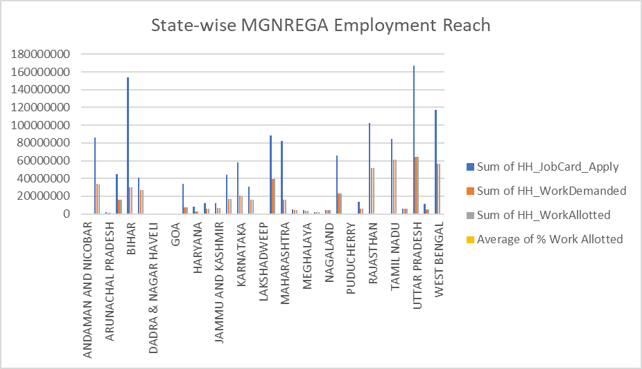

Objective 2: Job Card Issuance Effectiveness
i. General Description
This objective evaluates how effectively job cards are being issued to households that applied for them under the Mahatma Gandhi National Rural Employment Guarantee Act (MGNREGA). A job card is essential for households to receive employment under this scheme. Hence, analyzing the percentage of job cards issued relative to applications helps understand how efficiently the system responds to employment requests.
ii. Specific Requirements
- Dataset Used: Cleaned MGNREGA dataset (State-wise and Year-wise data)
- Columns Required:
  - Households that applied for a Job Card (HH_JobCard_Apply)
  - Job Cards Issued (JobCard_Issued)
  - Year
  - State
- Derived Column:
  - % Job Cards Issued =IF(HH_JobCard_Apply=0, (JobCard_Issued/HH_JobCard_Apply)*100)
iii. Analysis Results
- The bar chart shows state-wise disparities in the percentage of job cards issued. States like [insert example, e.g., “West Bengal”] show consistently high percentages close to 100%, reflecting strong administrative action, while others lag behind.
- The line chart illustrates how the average percentage of job cards issued has changed over the years. The trend line shows improvement, suggesting better awareness, demand handling, and issuance processes in later years.
- These insights help identify underperforming regions where administrative support can be strengthened.
iv. Visualization
A. Bar Chart (Clustered)
- Title: State-wise Percentage of Job Cards Issued under MGNREGA
- X-axis: % Job Cards Issued
- Y-axis: State
- Interpretation: Helps compare issuance efficiency across different states.
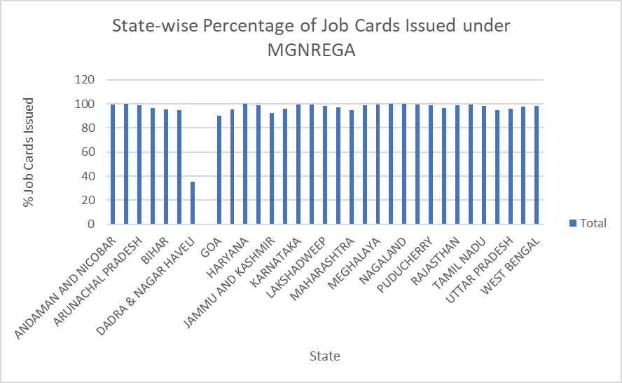

B. Line Chart (Trend)
- Title: Year-wise Trend of Job Card Issuance under MGNREGA
- X-axis: Year
- Y-axis: Average % Job Cards Issued
- Interpretation: Shows whether issuance is improving or declining over time.
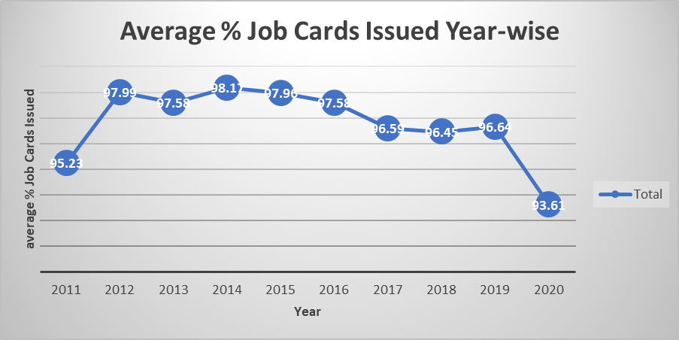
Objective 3
To analyze the trend of female participation in MGNREGA from the year 2011 to 2020 using a pivot table.
Methodology
To assess the trend of female participation under the Mahatma Gandhi National Rural Employment Guarantee Act (MGNREGA), a pivot table was created in Microsoft Excel. The original dataset was refined to focus specifically on the percentage of female participation in MGNREGA across all Indian states and union territories (UTs) from FY 2011 to FY 2020.
- Pivot Table Setup:
  - Rows: States and Union Territories
  - Columns: Financial Years (FY 2011 to FY 2020)
  - Values: Average percentage of female participation
  - A Grand Total column was added to show the average participation across all ten years for each state/UT.
This method provides a clear, year-by-year comparison of gender participation in rural employment schemes, as well as long-term performance per state.

Visualization – Line Chart
To visually represent the national trend of female participation over the years, a line chart was plotted using the national average percentage for each financial year (2011–2020).
- The X-axis represents the Financial Years.
- The Y-axis represents the average female participation percentage.
- The chart line clearly demonstrates a gradual and steady upward trend, highlighting improved gender inclusion over time in rural employment initiatives.
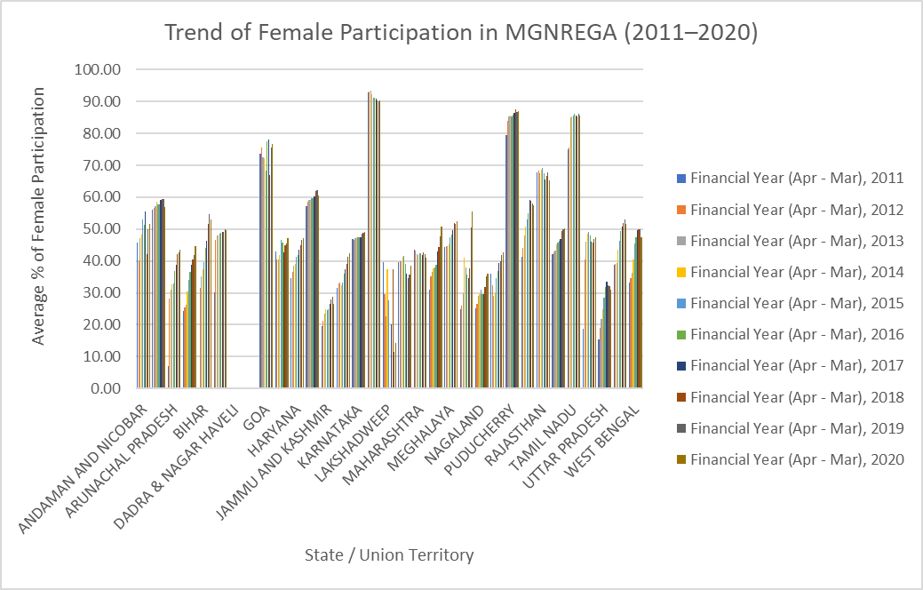

Analysis
The pivot table and line chart revealed several significant insights:
- The national average female participation increased from 36.07% in FY 2011 to 48.23% in FY 2020, reflecting a positive trend.
- The overall national average across the decade stands at 44.18%.
States with the highest average female participation (2011–2020):
State/UT | Avg. Female Participation (%)
Kerala | 91.54%
Puducherry | 85.35%
Tamil Nadu | 83.47%
Goa | 73.69%
Rajasthan | 67.39%
States with relatively low female participation:
State/UT | Avg. Female Participation (%)
Dadra & Nagar Haveli and Daman & Diu | 0.00%
Uttar Pradesh | 26.99%
Arunachal Pradesh | 33.57%
Bihar | 39.35%
States showing noticeable improvement:
- Uttar Pradesh increased from 15.44% (FY 2011) to 31.06% (FY 2020).
- Tripura grew from 18.82% to 47.46% over the same period.
Regional Insights:
- Southern states such as Kerala, Tamil Nadu, and Puducherry consistently reported high female participation, indicating more inclusive policies and better implementation for women in rural employment programs.

Objective 4: Scheduled Caste (SC) and Scheduled Tribe (ST) Participation
- Purpose:
To evaluate the extent of inclusion of Scheduled Caste (SC) and Scheduled Tribe (ST) households in the rural workforce under the MGNREGA scheme across different states.
- Metrics Used:
Scheduled Caste households that worked
Scheduled Tribe households that worked
Other households that worked (derived as: Total HH Worked − SC − ST)
- Methodology:
A calculated column was used to derive HH_Worked_Others by subtracting SC and ST households from the total number of households that worked.
A Pivot Table was created using the following structure:
  - Rows: State
  - Values: Sum of SC households worked, ST households worked, and Other households worked
A Clustered Column Chart was generated to visually compare participation across states.
- Visualization:
A Clustered Column Chart was used to represent SC, ST, and Other household participation per state. Each group is shown side-by-side for direct comparison.
The X-axis represents different Indian states.
- The Y-axis indicates the number of households that participated.
- Blue bars: SC households that worked
- Orange bars: ST households that worked
- Grey bars: Other households that worked
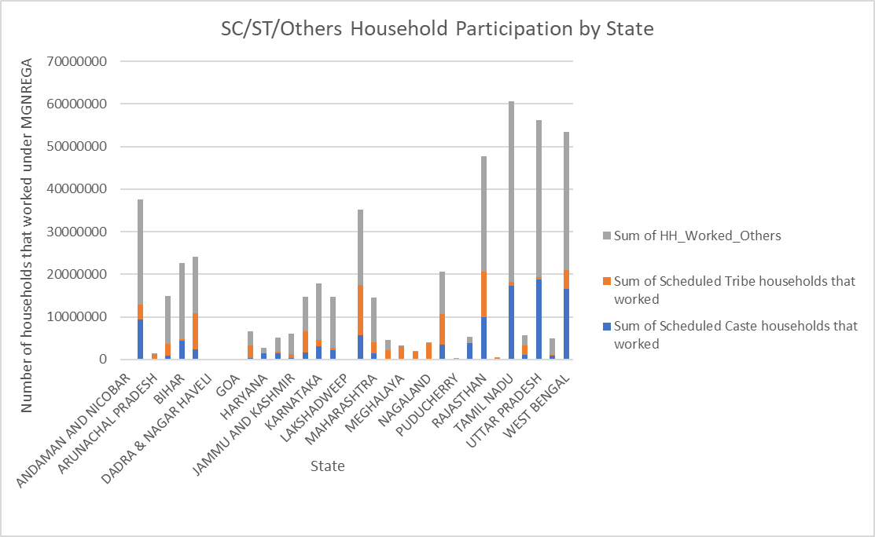
- Insights:
- States like Uttar Pradesh, Maharashtra, Tamil Nadu, and West Bengal have high overall participation.
- In several states, SC and ST participation is visibly lower than Other households, highlighting gaps in inclusive employment.
- Some Northeastern and tribal-dominated states show relatively higher ST participation (e.g., Mizoram).
- The data reflects the need to encourage more inclusive outreach and implementation of MGNREGA to ensure marginalized communities are equally represented.
- Recommendation:
Future planning and allocation should consider targeted interventions in states where SC/ST participation is low to improve equitable workforce inclusion.

Objective 5: To analyze the overall gender distribution in MGNREGA from 2011 to 2020 using a pivot table and donut chart.
i. General Description
This objective focuses on understanding the gender distribution in the Mahatma Gandhi National Rural Employment Guarantee Act (MGNREGA) scheme across India, over a 10-year period from 2011 to 2020. The key purpose is to identify the proportion of male and female participation, analyze gender balance in rural employment, and present the findings in a visually comprehensible format.
ii. Specific Requirements
To perform this analysis, the following steps were carried out:
- The dataset containing percentage participation of males and females under MGNREGA across all states and union territories for each financial year from 2011 to 2020 was used.
- A Pivot Table was created to calculate the average male and female participation percentages for each year and across all states/UTs.
- From this, the overall national average participation of each gender was calculated for the full 10-year period.
- A Donut Chart was created to clearly visualize the proportional representation of male and female participants in the scheme.
iii. Analysis Results
- Average Female Participation (2011–2020): 44.18%
- Average Male Participation (2011–2020): 55.82%
These figures indicate that female workers constitute nearly 44% of total MGNREGA participants over the decade. The relatively high share of female participation highlights the schemes effectiveness in supporting gender-inclusive rural employment. While male participation remains higher, the gap is not extreme, reflecting progressive improvement in gender parity in labour allocation under the scheme.
iv. Visualization
A donut chart was used to visually represent the gender distribution:
- The chart consists of two slices representing male and female participation.
- Female share is shown as 44.18%, and male share as 55.82%.
- Data labels display both percentage and gender category, offering clear insight at a glance.
- This visual format was chosen for its effectiveness in illustrating part-to-whole relationships in gender data.
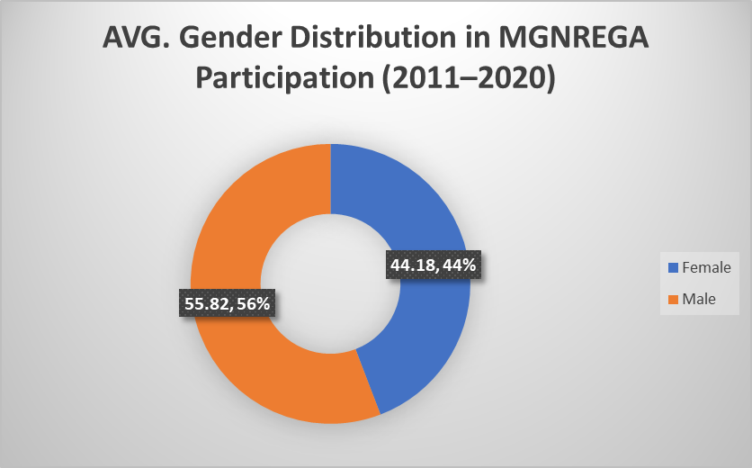

Objective 6: Work Intensity by District (Person Days Analysis)
i. General Description
This objective aims to evaluate the work intensity under MGNREGA by analyzing the total person-days generated in various districts across India. Person-days represent the number of workdays provided to beneficiaries, making it a critical metric to assess rural employment engagement.
ii. Specific Requirements
- A Pivot Table was created with:
  - Rows: Districts
  - Values: Sum of Total Person Days Worked
- The Pivot Table was sorted to identify:
  - Top and bottom districts based on total person-days.
- Charts used:
  - Funnel Chart: Displays the top 5 or 10 districts with the highest person-days.
iii. Analysis Results
- The analysis revealed significant disparities between districts.
- A small number of districts contributed to a major share of total person-days, indicating concentrated implementation of the scheme.
- Lower-performing districts were identified, suggesting areas that may need targeted improvement or evaluation.
iv. Visualization
- Funnel Chart: Highlighted the top-performing districts, helping to quickly identify high-intensity regions.

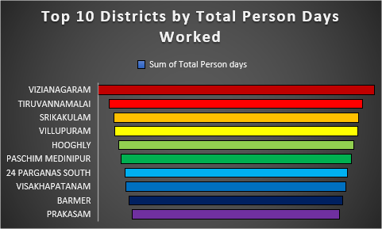

Objective 7: Bank vs Post Office Mode of Payment
i. General Description
This objective analyzes the mode of wage payment to MGNREGA beneficiaries — either through bank accounts or post office accounts. This helps assess the scheme's financial inclusion and digitization reach.
ii. Specific Requirements
- A Pivot Table was created with:
  - Rows: State or Year
  - Values: Amount Disbursed via Bank, Amount Disbursed via Post Office
- Charts used:
  - Pie Chart: Overall share of bank vs post office disbursement.
  - Clustered Bar Chart: Year-wise or state-wise trend comparison.
iii. Analysis Results
- Bank payments dominated, with over 90% of the total wage disbursement routed through banks in recent years.
- Post Office usage has declined, indicating a shift towards more digitally enabled transactions.
- Some states still rely partially on post office payments, pointing to regional infrastructure gaps.
iv. Visualization
- Pie Chart: Provided a clear breakdown of mode of disbursement, showing the dominance of bank accounts.
- Clustered Bar Chart: Displayed year-wise adoption trends, highlighting the growing preference for bank transactions.
5.Conclusion
This project aimed to analyze the implementation and performance of the Mahatma Gandhi National Rural Employment Guarantee Act (MGNREGA) across Indian states using data sourced from the National Data & Analytics Platform (NDAP). Through detailed preprocessing, pivot table analysis, calculated metrics, and interactive visualizations in Excel, key insights were extracted regarding employment trends, administrative efficiency, and social inclusion under the scheme.
The study covered a decade-long timeframe (2011 to 2020) and focused on critical indicators such as job card issuance rates, work demand fulfillment, SC/ST and gender-based participation, and state-wise comparisons of sanctioned funds. The results highlighted that while many states demonstrated effective implementation and rising female participation, others still lagged in areas such as job card delivery, equitable work allotment, and inclusion of marginalized communities.
Visualizations such as clustered bar charts, line charts, and pivot-based summaries provided a clear and intuitive understanding of regional disparities and temporal trends. Additionally, calculated metrics such as % Job Cards Issued, % Work Allotted, and % Female Participation helped quantify the impact of MGNREGA in measurable terms.
Overall, this analysis supports the view that while MGNREGA has achieved significant milestones in rural employment and gender inclusion, there remains scope for targeted improvements in policy execution, especially in underperforming states. Data-driven decision-making, supported by continuous monitoring and interactive dashboards, can further enhance the reach and efficiency of such transformative welfare schemes.
6.Future Scope
While this project successfully analyzed key performance indicators of MGNREGA across a ten-year period using Excel dashboards and visual analytics, there remains considerable potential to extend and deepen the scope of this work in the future. The following directions are proposed for further development:
- Integration with Real-Time Data:
Future projects can include integration of live or regularly updated datasets through APIs or web-based tools, enabling dynamic dashboards that reflect real-time performance across states and districts.
- Expansion to Block-Level or Village-Level Data:
This study was conducted at the state and district level. With the availability of more granular data, further insights can be gained by analyzing employment trends, inclusivity, and fund utilization at the block or panchayat level.
- Use of Advanced Data Visualization Tools:
While this project used Microsoft Excel for dashboard creation, future work can be enhanced by using more powerful BI tools such as Tableau, Power BI, or Python libraries like Plotly or Seaborn for deeper interactivity and automated reporting.
- Machine Learning for Predictive Insights:
Applying regression models and classification algorithms to the dataset can help predict future demand for employment, identify high-performing regions, and detect anomalies in fund disbursement or workforce participation.
- Comparative Scheme Analysis:
MGNREGA can be compared with other government schemes targeting rural employment or social security (e.g., PM-KISAN, NRLM) to assess overlaps, impact, and effectiveness across different states.
- Policy Recommendations Module:
Based on analytical findings, a recommendation engine can be added to suggest targeted actions or highlight regions that require administrative attention, thereby assisting policymakers and government stakeholders.
In conclusion, this project lays the foundation for a broader exploration of public welfare programs through data-driven approaches. Future extensions can contribute significantly to data transparency, accountability, and the design of more inclusive rural development policies.
7.References
[1] National Data & Analytics Platform (NDAP), “MGNREGA: State-wise and Year-wise Employment Provided to Households,” NITI Aayog, Government of India. [Online]. Available: https://ndap.niti.gov.in/dataset/6026
[2] Ministry of Rural Development, Government of India, “Mahatma Gandhi National Rural Employment Guarantee Act (MGNREGA),” [Online]. Available: https://nrega.nic.in
[3] Microsoft Excel, “Excel Help and Learning – PivotTables and Charts,” Microsoft Corporation. [Online]. Available: https://support.microsoft.com/excel
[4] NITI Aayog, “Data Portal User Guide,” National Institution for Transforming India (NITI Aayog). [Online]. Available: https://ndap.niti.gov.in/resources
[5] Lovely Professional University, “INT217 – Data Management Course”

