Data Intelligent NoSQL Databases
PROJECT REPORT
(Project Semester August-December 2026)
“SuperMarket Sales Prediction & Analytics Intelligence System”
Submitted by
Adarsh Barnawal
Registration No - 12319124
Programme and Section – B.Tech CSE (Section: K4P23HK)
Course Code – CSE494
Under the Guidance of
Dr. Ashu (UID: 23631)
Discipline of CSE/IT
Lovely School of Computer Science and Engineering
Lovely Professional University, Phagwara

CERTIFICATE
This is to certify that Adarsh Barnawal bearing Registration no. 12319124 has completed the course project titled, “SuperMarket Sales Prediction & Analytics Intelligence System” under my guidance and supervision. To the best of my knowledge, the present work is the result of his original development, effort and study.
Dr. Ashu
Designation of the Supervisor
School of Computer Science and Engineering
Lovely Professional University
Phagwara, Punjab.

Date: 29-10-2026

DECLARATION
I, Adarsh Barnawal, student of B.Tech (Computer Science and Engineering) under CSE/IT Discipline at Lovely Professional University, Punjab, hereby declare that all the information furnished in this project report is based on my own intensive work and is genuine.
Date: 29-10-2026 Signature: 

Registration No. 12319124 Name of the student
Adarsh Barnawal

Acknowledgement
I would like to express my sincere gratitude to all those who have supported me throughout the completion of this SuperMarket Sales Prediction & Analytics Intelligence System project.
First and foremost, I would like to thank my project guide for valuable guidance, continuous encouragement and expert advice throughout this project. The guidance and support provided helped me stay focused and complete my work effectively.
I would also like to thank the faculty members of Lovely Professional University for providing a strong academic foundation and the necessary resources to undertake this project successfully.
I am deeply thankful to my family and friends for their constant motivation and support throughout this journey.
Finally, I would like to acknowledge the importance of technologies such as Python, Pandas, Scikit-learn, MongoDB, MongoDB Compass and PyMongo, which helped me manage data, perform data preprocessing, develop machine learning models and present the results.
This project has been a valuable learning experience and an important step toward my career in the field of Data Science.
Thank you all.

TABLE OF CONTENTS
1. Introduction
2. Source of Dataset
3. Exploratory Data Analysis (EDA)
4. MongoDB and PyMongo Implementation
5. Data Preprocessing
6. Model Implementation
7. Evaluation Results
8. Visualizations
9. Conclusion
10. Future Scope
11. References

1. Introduction
This project develops a MongoDB-based sales analytics and machine learning system that studies supermarket invoices and estimates the sales value of a purchase. A supermarket records what was bought, where, by whom and how it was paid on every invoice. Analysing this history can reveal which branch earns the most, which product lines perform well, and how large an invoice is likely to be.
The project integrates Python, MongoDB, PyMongo and scikit-learn. MongoDB acts as the storage layer, PyMongo connects the Python program to the database, and Pandas and scikit-learn are used to prepare the data and train models that predict the sales amount of an invoice and classify invoices as High-value or Low-value.

Motivation
- Retail businesses generate thousands of invoices, and manual analysis of this data is slow and error-prone.
- A document database such as MongoDB stores an invoice naturally as one self-contained record.
- Aggregation queries help identify patterns in sales across cities, branches, product lines and months.
- Machine learning provides a way to estimate invoice value from purchase details.
- The project gives practical experience in database design, validation, CRUD, aggregation, preprocessing and model evaluation.

Objectives
- Design a suitable document structure and upload the supermarket CSV data into MongoDB.
- Apply MongoDB JSON Schema validation rules to protect data quality.
- Perform Create, Read, Update and Delete operations using PyMongo.
- Run meaningful aggregation pipelines such as total sales by city and average rating by product line.
- Retrieve data from MongoDB into Pandas and encode categorical variables.
- Train a regression model to predict Sales and a classification model to identify High-value invoices.
- Evaluate the models using R², MAE, Accuracy, Precision, Recall and F1-score, and present the results with visualizations.

Scope
- Dataset: 1,000 supermarket invoices from three branches covering January to March 2019.
- Database: Storage and management of invoices in a MongoDB collection with validation rules and an index.
- Analysis: Comparison of sales by city, branch, product line, customer type, payment method and month.
- Machine Learning: Linear Regression, Random Forest Regression, Logistic Regression and Random Forest Classification.
- Deliverable: A fully working Python program, MongoDB collection, charts and this project report.

Data Overview
- The dataset contains invoice ID, branch, city, customer type, gender, product line, unit price, quantity, tax, sales, date, time, payment method, cost of goods sold, gross margin, gross income and rating.
- The Sales column is used as the target variable for the regression model.
- For classification, an invoice is labelled High-value if its Sales is at least the median (253.85) and Low-value otherwise.
- The dataset contains 1,000 records and 17 columns with no missing values.

Tools & Techniques
- Python: Used for data processing, model development and database operations.
- MongoDB and MongoDB Compass: Used to store, view and manage the invoice documents.
- PyMongo: Used to connect Python to MongoDB and run CRUD and aggregation operations.
- Pandas: Used for loading, cleaning and analysing the data.
- Scikit-learn: Used for encoding, model training and evaluation.
- Matplotlib and Seaborn: Used for creating charts.

2. Source of Dataset
The dataset used in this project is the SuperMarket Analysis dataset, a publicly available supermarket sales dataset. It contains invoice-level records from three supermarket branches and is used to analyse sales patterns and to train machine learning models.
Item | Details
Dataset Name | SuperMarket Analysis
Dataset File | SuperMarket Analysis.csv
Dataset Size | 1,000 records, 17 columns
Period Covered | January 2019 to March 2019
Branches / Cities | Alex / Yangon, Giza / Naypyitaw, Cairo / Mandalay

Dataset Attributes
Column | Type | Description
Invoice ID | Text | Unique invoice number (format 123-45-6789)
Branch, City | Categorical | Store branch and the city in which it is located
Customer type | Categorical | Member (565 invoices) or Normal (435 invoices)
Gender | Categorical | Female (571) or Male (429)
Product line | Categorical | Six categories, such as Health and beauty
Unit price | Numeric | Price per item
Quantity | Numeric | Number of items bought (1 to 10)
Tax 5%, cogs, gross income, gross margin percentage | Numeric | Values derived from the sales amount
Sales | Numeric | Invoice total including 5% tax (target variable)
Date, Time | Text | Date and time of purchase
Payment | Categorical | Cash, Ewallet or Credit card
Rating | Numeric | Customer satisfaction score from 1 to 10

The dataset supports both numerical prediction of the sales amount and classification of invoices into High-value and Low-value groups. It also provides enough categorical fields to demonstrate MongoDB document design and aggregation.

3. Exploratory Data Analysis (EDA)
Exploratory Data Analysis was performed to understand the structure, distribution and patterns in the supermarket data before applying machine learning. The data was first summarised using Pandas and MongoDB aggregation queries, and then presented through charts.

3.1 Sales Distribution
The histogram shows how invoice sales values are spread. Most invoices fall in the lower and middle ranges, and fewer invoices have very large totals, with the highest invoice at 1,042.65.
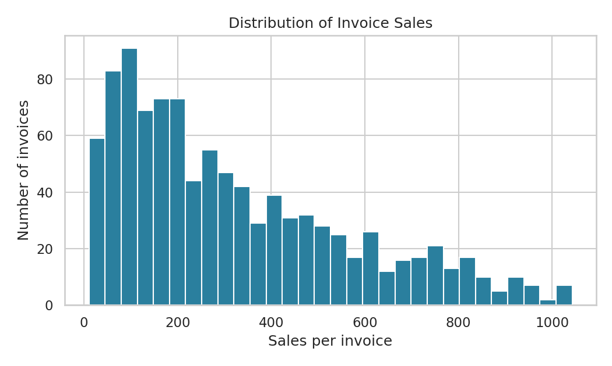
Figure 3.1: Distribution of Invoice Sales

3.2 Total Sales by City
This chart is produced from the MongoDB aggregation that groups invoices by city and sums the sales. Naypyitaw (branch Giza) has the highest total, while Yangon and Mandalay are almost equal.
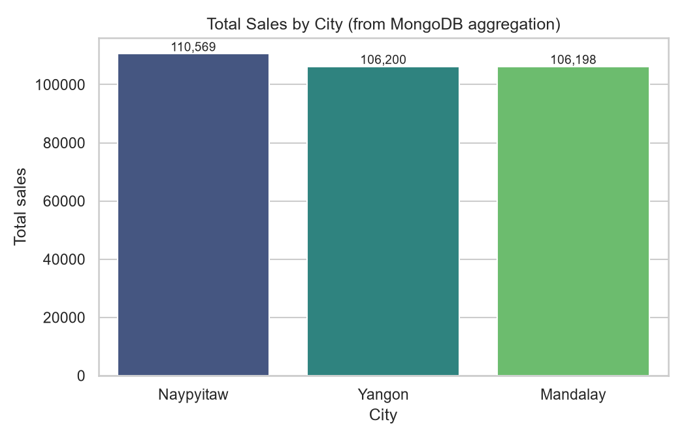
Figure 3.2: Total Sales by City

3.3 Impact of Product Line on Sales
This chart compares the average sales per invoice for each product line. Home and lifestyle has the highest average invoice value and Fashion accessories the lowest, but the differences between product lines are small.
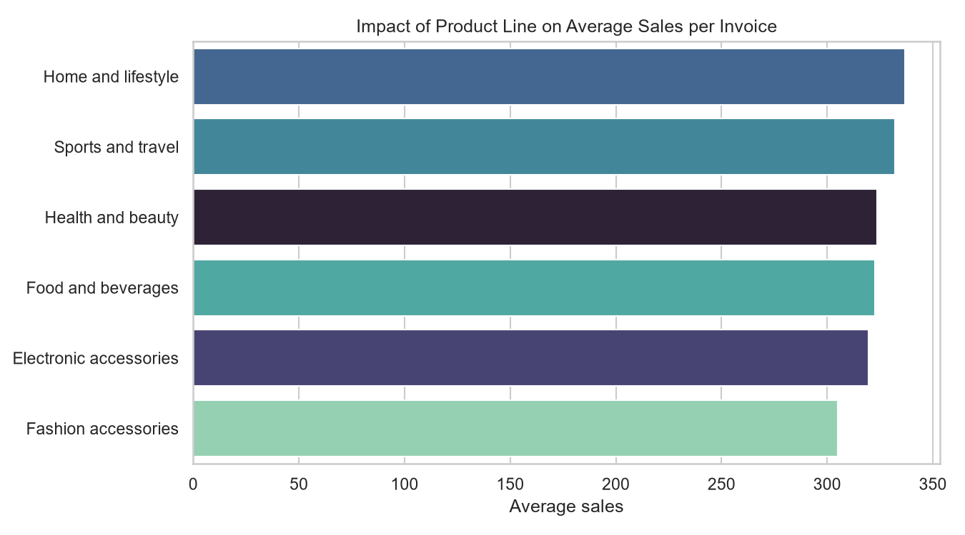
Figure 3.3: Average Sales per Invoice by Product Line

3.4 Customer Type and Payment Method
The dataset has more Member invoices (565) than Normal invoices (435). The three payment methods are used in similar proportions, with Ewallet and Cash slightly ahead of Credit card.
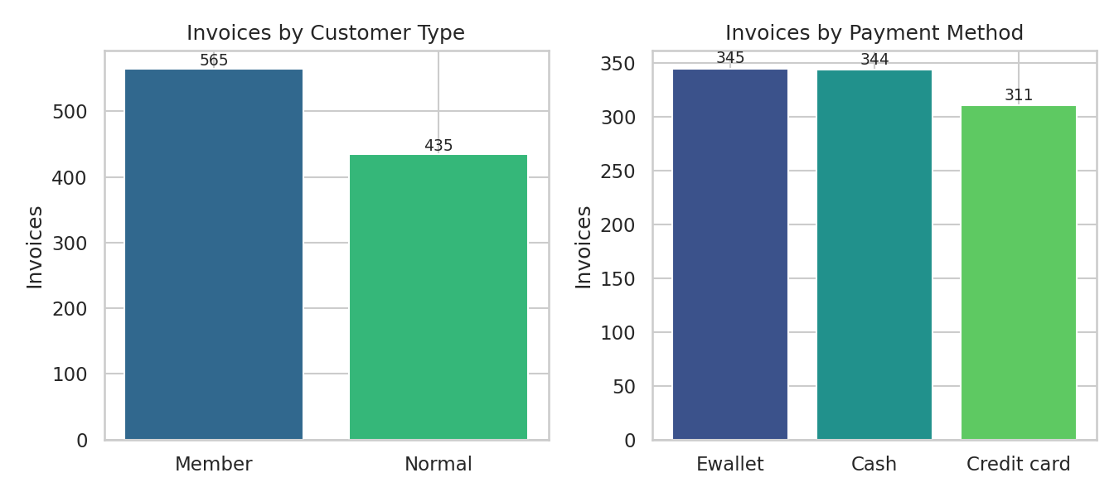
Figure 3.4: Invoices by Customer Type and Payment Method

3.5 Monthly Sales Trend
Total sales are highest in January (116,291.87), fall in February (97,219.37) and recover in March (109,455.51). Only three months of data are available, so this should be treated as a short-term observation and not a seasonal rule.
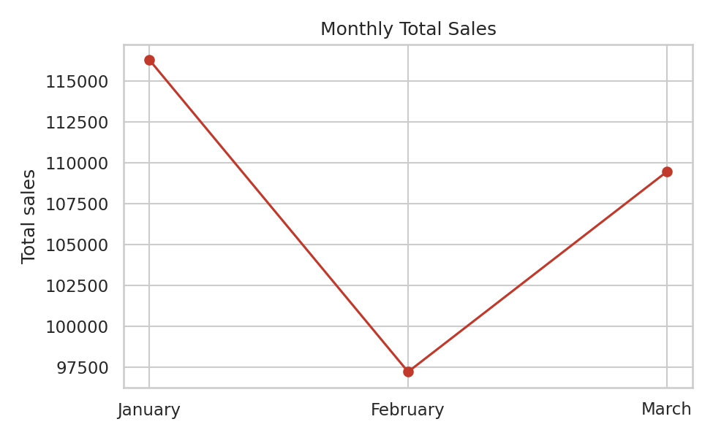
Figure 3.5: Monthly Total Sales

3.6 EDA Findings
- Naypyitaw (branch Giza) has the highest total and average invoice value.
- Members spend more per invoice than Normal customers.
- Differences between product lines and payment methods are small.
- January is the strongest month of the three.
- These findings guide the choice of features for the machine learning models.

4. MongoDB and PyMongo Implementation
MongoDB is a NoSQL document database used in this project to store and manage the supermarket invoices. PyMongo is the official Python driver that connects the program to MongoDB and performs database operations programmatically. MongoDB Compass is used as the graphical tool to view the stored data.

4.1 Introduction
An invoice is naturally one self-contained record: a customer buys products at a store and pays for them. MongoDB stores such a record as a single document, so reading an invoice needs no joins. This makes it a suitable choice for supermarket sales data.

4.2 Database Structure
The project uses a MongoDB database named supermarket_db with a single collection named sales. Each of the 1,000 invoices is stored as one document. Related fields from the flat CSV file are grouped into embedded sub-documents:
- store { branch, city }
- customer { type, gender }
- product { line, unit_price, quantity }
- financials { sales, tax, cogs, gross_margin_pct, gross_income }
- invoice_id, payment_method, purchase_datetime (stored as a real date) and rating at the top level
The Date and Time columns of the CSV were combined into one date value so that MongoDB date operators such as $month can be used directly.
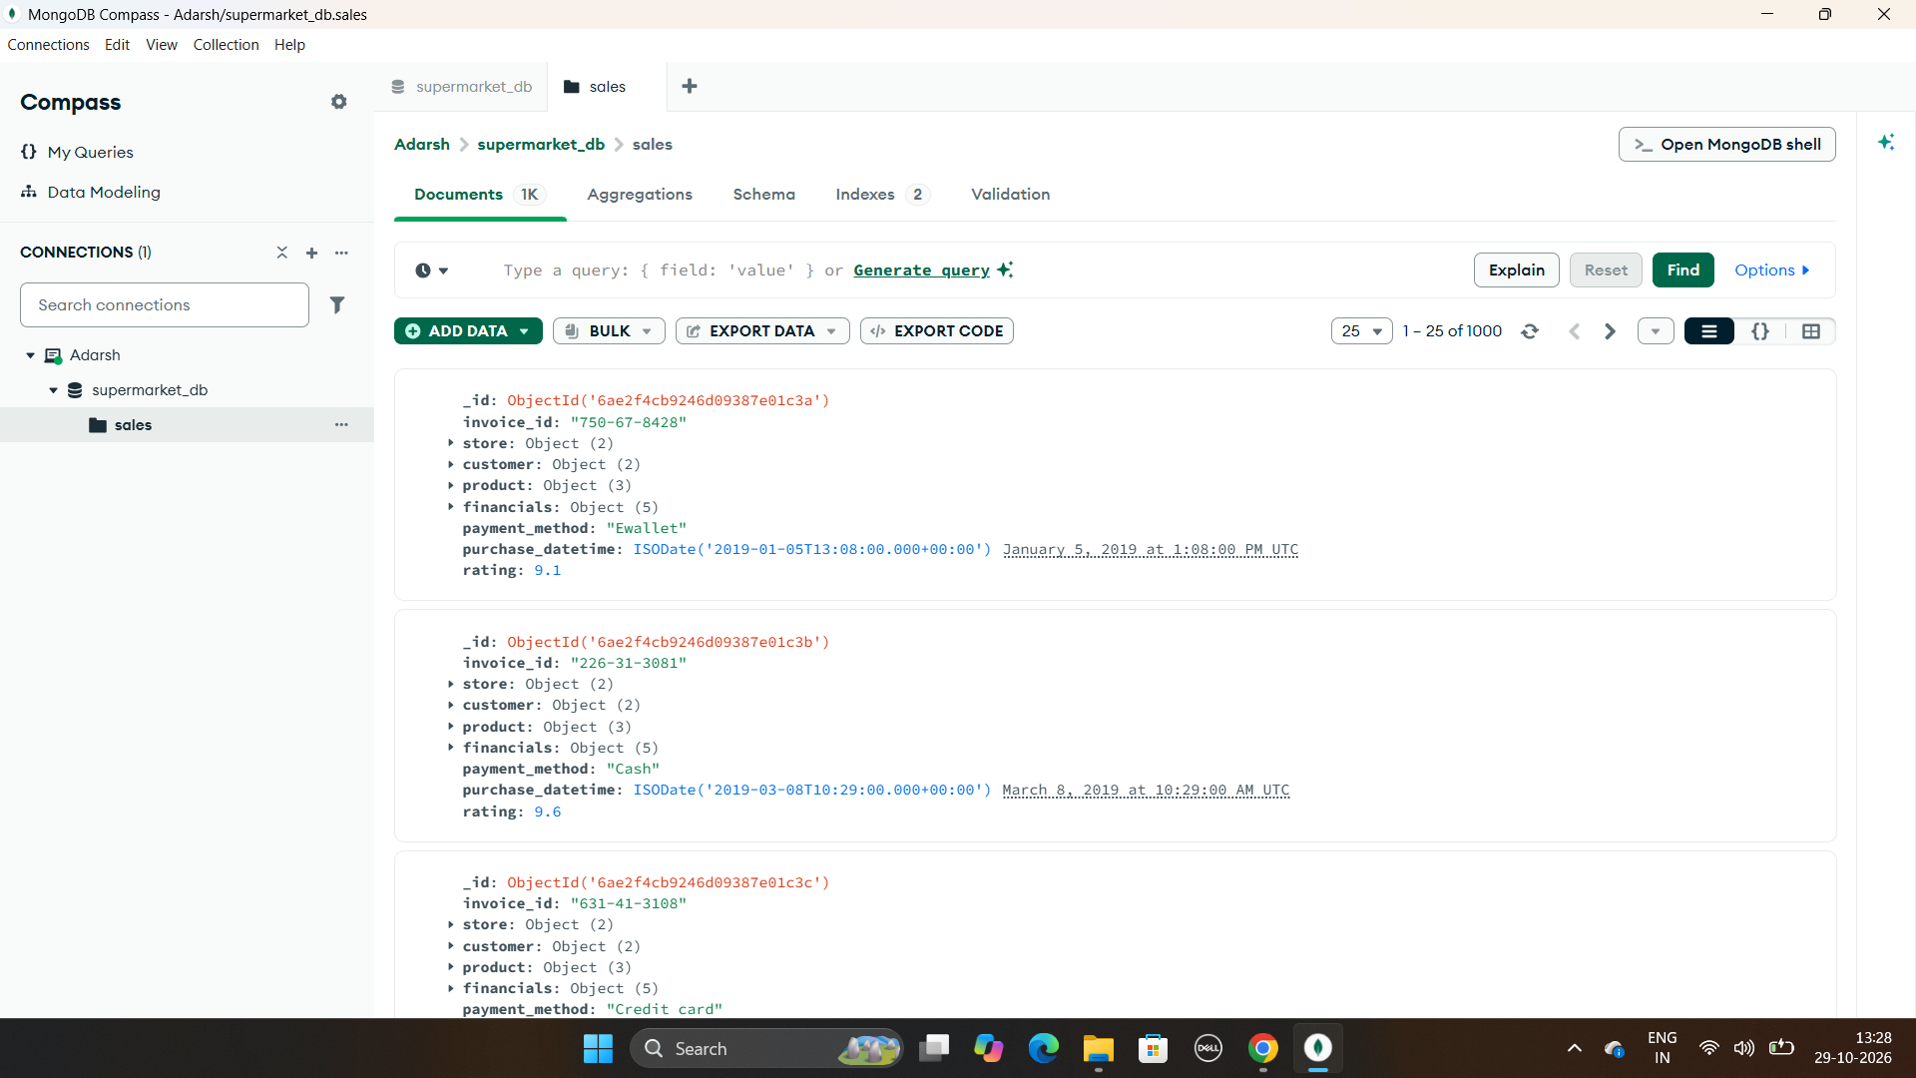
Figure 4.1: Invoice Documents in the sales Collection (MongoDB Compass, 1,000 documents)

4.3 MongoDB and PyMongo Connection
The program connects to a MongoDB server running on the local machine at mongodb://localhost:27017 using PyMongo. The following steps are carried out:
- Create a MongoClient using the connection URI and check the server with a ping command.
- Select the database supermarket_db.
- Create the collection sales with a validator and a unique index.
- Insert, query, update, delete and aggregate documents through PyMongo methods.

4.4 Validation Rules
MongoDB is schema-flexible, so without rules incorrect data would be stored silently. A JSON Schema validator was applied to the sales collection with validationAction set to error and validationLevel set to strict, so invalid documents are rejected. The rules are:
- Required fields: invoice_id, store, customer, product, financials, payment_method, purchase_datetime and rating.
- invoice_id must match the pattern of three digits, two digits and four digits separated by hyphens.
- Branch, city, customer type, gender and payment method must be one of the allowed values (enum).
- quantity must be an integer from 1 to 10; unit price and all financial amounts must be numbers of at least 0.
- rating must be a number from 1 to 10.
A unique index was also created on invoice_id to prevent duplicate invoices. The Indexes tab in Compass shows 2 indexes: the default _id index and the invoice_id index. The program proves that validation works by trying to insert a document with rating = 25, which MongoDB rejects:
Validation test: invalid document (rating = 25) was REJECTED -> error code 121
(DocumentValidationFailure).
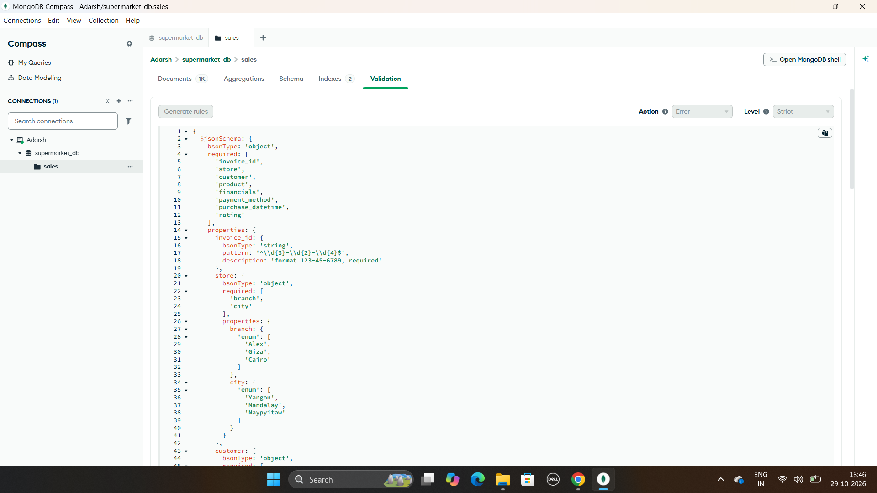
Figure 4.2: JSON Schema Validation Rules in MongoDB Compass

4.5 Data Loading (Create)
The CSV file was read with Pandas (using the utf-8-sig encoding because the file starts with a byte-order mark), cleaned, and converted into nested documents. NumPy types were converted to native Python types because BSON cannot encode them. All 1,000 documents were inserted using a single insert_many call.
Loaded 'SuperMarket Analysis.csv': 1000 rows x 17 columns
Inserted 1000 documents into MongoDB.

The Schema tab of Compass analyses all 1,000 stored documents and confirms the structure and data types of each field, including the nested customer, financials, product and store documents, the date type of purchase_datetime, and the rating range from 4 to 10.
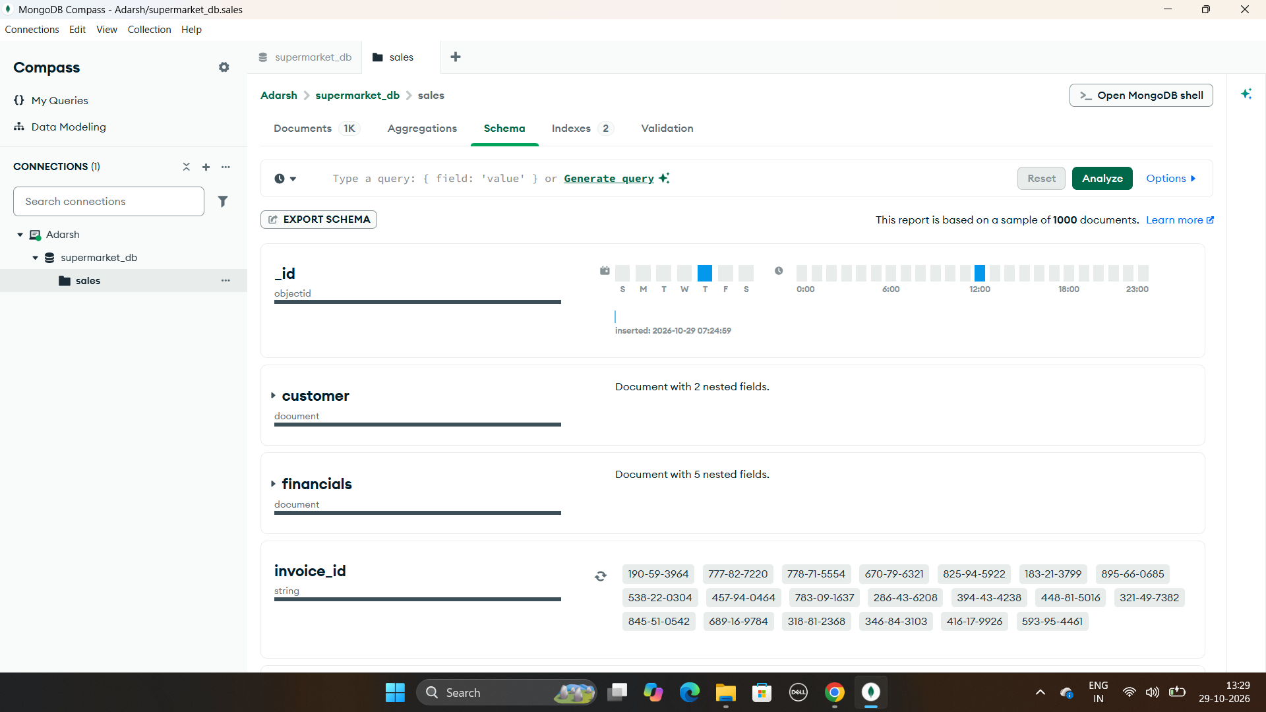
Figure 4.3: Schema Analysis of the sales Collection (1)
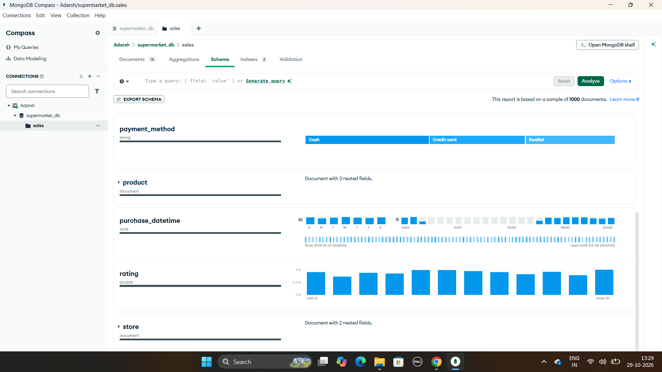
Figure 4.4: Schema Analysis of the sales Collection (2)

4.6 CRUD Operations
CRUD operations were demonstrated on a dedicated test invoice (999-99-9999), so the real data remained exactly 1,000 documents.
Operation | PyMongo method | Result
Create | insert_one(new_doc) | Test invoice inserted
Read | find_one({invoice_id}); find({sales > 1000}).sort().limit(3) | Document returned; top 3 invoices with sales above 1000
Update | update_one({invoice_id}, {$set: {rating, payment_method}}) | matched = 1, modified = 1
Delete | delete_one({invoice_id}) | deleted_count = 1; collection back to 1,000 documents

[CREATE] Inserted invoice 999-99-9999
[READ] Top 3 invoices with sales > 1000:
{'invoice_id': '860-79-0874', 'store': {'city': 'Naypyitaw'}, 'financials': {'sales': 1042.65}}
{'invoice_id': '687-47-8271', 'store': {'city': 'Yangon'}, 'financials': {'sales': 1039.29}}
{'invoice_id': '283-26-5248', 'store': {'city': 'Naypyitaw'}, 'financials': {'sales': 1034.46}}
[UPDATE] matched=1, modified=1 -> {'payment_method': 'Ewallet', 'rating': 9.0}
[DELETE] deleted_count=1; documents now = 1000
Figure 4.5: CRUD Operations Output

4.7 Aggregation Pipelines
Four aggregation pipelines were run using collection.aggregate(). They use the $group, $project, $sort and $month operators.

Pipeline 1: Total and average sales per city / branch
[{"$group": {"_id": {"city": "$store.city", "branch": "$store.branch"},
"total_sales": {"$sum": "$financials.sales"},
"avg_sale": {"$avg": "$financials.sales"}, "invoices": {"$sum": 1}}},
{"$sort": {"total_sales": -1}}]

City | Branch | Invoices | Total sales | Average sale
Naypyitaw | Giza | 328 | 110,568.71 | 337.10
Yangon | Alex | 340 | 106,200.37 | 312.35
Mandalay | Cairo | 332 | 106,197.67 | 319.87

Pipeline 2: Average rating and total sales per product line
Product line | Average rating | Total sales
Food and beverages | 7.11 | 56,144.84
Sports and travel | 6.92 | 55,122.83
Electronic accessories | 6.92 | 54,337.53
Fashion accessories | 7.03 | 54,305.90
Home and lifestyle | 6.84 | 53,861.91
Health and beauty | 7.00 | 49,193.74

Pipeline 3: Average sale by customer type and payment method
Customer type | Payment | Invoices | Average sale
Member | Credit card | 187 | 339.73
Member | Cash | 192 | 335.03
Member | Ewallet | 186 | 332.46
Normal | Cash | 152 | 315.00
Normal | Ewallet | 159 | 302.86
Normal | Credit card | 124 | 300.30

Pipeline 4: Monthly sales trend
This pipeline groups invoices by the month of purchase_datetime using the $month operator.
Month | Invoices | Total sales
January | 352 | 116,291.87
February | 303 | 97,219.37
March | 345 | 109,455.51

4.8 Role of MongoDB in the Project
MongoDB provides a structured and validated way to store the invoices, while PyMongo acts as the bridge between the database and Python. The data used for machine learning is retrieved directly from MongoDB, which shows how a NoSQL database can be combined with data processing and predictive analytics in a practical project.

5. Data Preprocessing
Data preprocessing prepares the raw data for model training. In this project all modelling data was retrieved from MongoDB into a Pandas DataFrame and then cleaned, encoded and split.

5.1 Dataset Loading and Inspection
The documents were retrieved using collection.find({}, {"_id": 0}) and flattened with json_normalize, so the nested fields became columns such as city, product_line, unit_price and sales. The result was a DataFrame of 1,000 rows.
Shape retrieved from MongoDB: (1000, 19)
Missing values: 0
Duplicate invoices: 0

5.2 Feature Engineering
Three new features were extracted from purchase_datetime: hour, month and weekday. This allows the models to use time-related information.

5.3 Feature Selection
The following ten features were selected as inputs:
- City
- Customer type
- Gender
- Product line
- Payment method
- Unit price
- Quantity
- Hour of purchase
- Month
- Weekday
The target variable for regression is Sales.

5.4 Features Excluded
- Branch was dropped because every branch maps to exactly one city, so it carries the same information as city.
- Tax 5%, cogs, gross income and gross margin percentage were excluded because they are calculated from Sales. Using them would cause data leakage.
- Rating was excluded because it is only known after the purchase is complete.
Cities per branch (1 = perfect one-to-one mapping): {'Alex': 1, 'Cairo': 1, 'Giza': 1}
Sales / (unit_price x quantity) = [1.05] (i.e. price x qty x 1.05 tax)

5.5 Encoding Categorical Features
Machine learning algorithms need numerical input. The categorical features city, customer type, gender, product line and payment method were converted using OneHotEncoder, which suits nominal categories because it implies no order. The setting handle_unknown = "ignore" keeps prediction safe for unseen categories. The numerical features were passed through the pipeline unchanged, except for Logistic Regression where StandardScaler was applied.

5.6 Preparation of Value Classes
For the classification task, each invoice was labelled High-value (1) if its Sales was greater than or equal to the median value of 253.85, and Low-value (0) otherwise. This gives exactly balanced classes of 500 invoices each.

5.7 Train-Test Split
The data was split 80% for training (800 invoices) and 20% for testing (200 invoices) using train_test_split with random_state = 42. The classification split was stratified so both classes appear equally in the training and test sets. The encoder and model were combined into one scikit-learn Pipeline, so the encoder learns only from training data.

6. Model Implementation
Machine learning models were developed to predict the sales value of an invoice and to classify invoices as High-value or Low-value. Two algorithms were compared for each task.

6.1 Regression Models (predict Sales)
Linear Regression is a simple and interpretable baseline that fits a straight-line relationship between features and Sales. Random Forest Regressor (200 trees) is an ensemble of decision trees that averages many tree predictions and can capture non-linear relationships and interactions between features. Both used the same preprocessing pipeline with One-Hot Encoding.

6.2 Classification Models (High-value vs Low-value)
Logistic Regression is a linear classifier that estimates the probability of an invoice being High-value. Random Forest Classifier (200 trees) uses many decision trees and takes a majority vote. These models predict whether Sales is at or above the median value.
Predicting Customer type (Member vs Normal) was also considered, but in this dataset it is almost unrelated to the other columns, so any model would barely improve on always predicting Member. The High-value and Low-value target gives a more meaningful business question.

6.3 Model Summary
Task | Model | Purpose
Regression | Linear Regression | Baseline fare estimate
Regression | Random Forest Regressor | Final sales prediction
Classification | Logistic Regression | Baseline classifier
Classification | Random Forest Classifier | Final value-class prediction

All models were trained on 800 invoices and evaluated on 200 unseen invoices. The regression models were also checked with 5-fold cross-validation.

7. Evaluation Results
The models were evaluated using suitable metrics. The regression models were assessed using R² Score and Mean Absolute Error (MAE), and the classification models using Accuracy, Precision, Recall and F1-score.

7.1 Regression Model Evaluation
R² Score measures how much of the variation in Sales the model explains. MAE is the average absolute difference between actual and predicted sales. RMSE is also reported because it penalises large errors more strongly.
Model | R² Score | MAE | RMSE | 5-fold CV R²
Linear Regression | 0.9015 | 59.58 | 80.07 | 0.8832
Random Forest Regressor | 0.9985 | 6.59 | 9.77 | 0.9984

A baseline that always predicts the average sales value has an MAE of 209.77. Linear Regression reduces this to 59.58 and Random Forest to 6.59. Random Forest is the better model: an R² of 0.9985 means it explains about 99.9% of the variation in Sales, and its predictions are off by only about 6.59 on average on invoices averaging about 323. The cross-validation score of 0.9984 (standard deviation 0.0002) shows that the result is stable and not the effect of a lucky split.
Why is the score so high? Sales in this dataset is calculated as Unit price × Quantity × 1.05. A straight line cannot represent the product of two variables, so Linear Regression stops near 0.90, while Random Forest approximates the interaction by splitting on both features. The high R² therefore reflects the structure of the data and should not be read as hidden customer behaviour.
Train size = 800, Test size = 200 (80/20 split)

Linear Regression: R2 = 0.9015 | MAE = 59.58 | RMSE = 80.07 | 5-fold CV R2 = 0.8832 +/- 0.0146
Random Forest Regressor: R2 = 0.9985 | MAE = 6.59 | RMSE = 9.77 | 5-fold CV R2 = 0.9984 +/- 0.0002

Baseline (always predict the mean) MAE = 209.77
Figure 7.1: Regression Model Evaluation Output
Sample predictions from the Random Forest Regressor are shown below.
City | Product line | Unit price | Qty | Actual | Predicted
Naypyitaw | Home and lifestyle | 83.17 | 6 | 523.97 | 529.78
Naypyitaw | Electronic accessories | 58.76 | 10 | 616.98 | 579.68
Naypyitaw | Home and lifestyle | 55.61 | 7 | 408.73 | 405.19
Mandalay | Sports and travel | 42.97 | 3 | 135.36 | 140.07
Mandalay | Sports and travel | 21.87 | 2 | 45.93 | 48.19

7.2 Classification Model Evaluation
Accuracy is the share of all invoices classified correctly. Precision is the share of invoices predicted High-value that really are High-value. Recall is the share of truly High-value invoices that were found. F1-score is the harmonic mean of precision and recall.
Model | Accuracy | Precision | Recall | F1 Score
Logistic Regression | 0.9200 | 0.9468 | 0.8900 | 0.9175
Random Forest Classifier | 0.9500 | 0.9688 | 0.9300 | 0.9490

Random Forest Classifier correctly classifies 95% of the test invoices. Its confusion matrix shows 97 true negatives, 3 false positives, 7 false negatives and 93 true positives. A precision of 0.969 means that when it predicts High-value it is right about 97% of the time, and a recall of 0.930 means it finds 93% of the truly High-value invoices. The F1-score is 0.949. Logistic Regression is slightly weaker (accuracy 0.92) because the boundary between High and Low value depends on the product of price and quantity, which a linear model captures only approximately.
High-value invoice = Sales >= median (253.85); class balance: {1: 500, 0: 500}

Logistic Regression: Accuracy = 0.9200 | Precision = 0.9468 | Recall = 0.8900 | F1 = 0.9175
Confusion matrix [[TN FP] [FN TP]]:
[[95 5]
[11 89]]

Random Forest Classifier: Accuracy = 0.9500 | Precision = 0.9688 | Recall = 0.9300 | F1 = 0.9490
Confusion matrix [[TN FP] [FN TP]]:
[[97 3]
[ 7 93]]
Figure 7.2: Classification Model Evaluation Output

7.3 Overall Performance
Both models serve different purposes. The regression model estimates the exact sales value of an invoice, while the classification model provides a simple High or Low category. Random Forest was the best model for both tasks.

8. Visualizations
Visualizations were created using Matplotlib and Seaborn to present the main findings of the model evaluation. The exploratory charts are shown in Section 3.

8.1 Actual vs Predicted Sales
Each point is one test invoice. Points close to the dashed line represent accurate predictions. Almost all points lie along the line, which agrees with the high R² score.
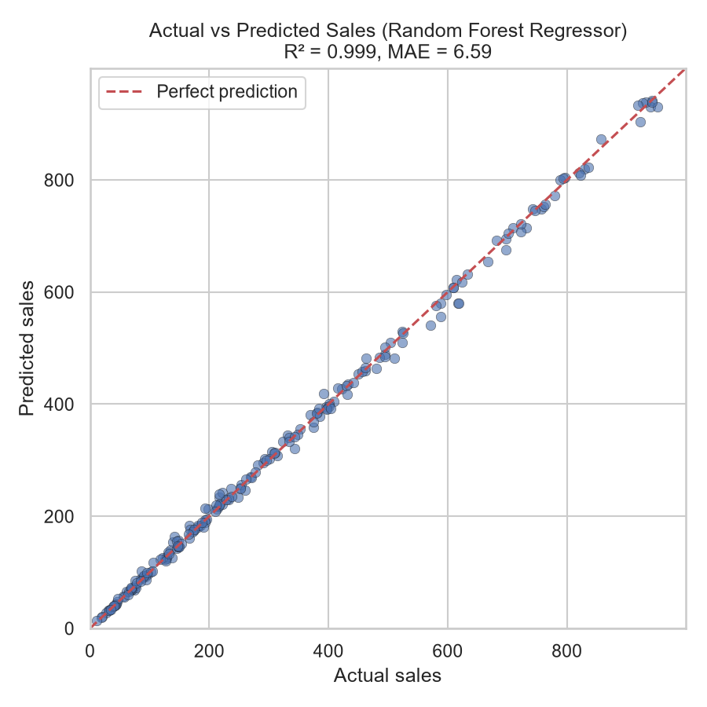
Figure 8.1: Actual vs Predicted Sales (Random Forest Regressor)

8.2 Feature Importance
Quantity and unit price together account for almost all of the importance, while city, product line, hour, month and weekday contribute very little. This matches the finding from the aggregations that these categories differ only slightly in sales.
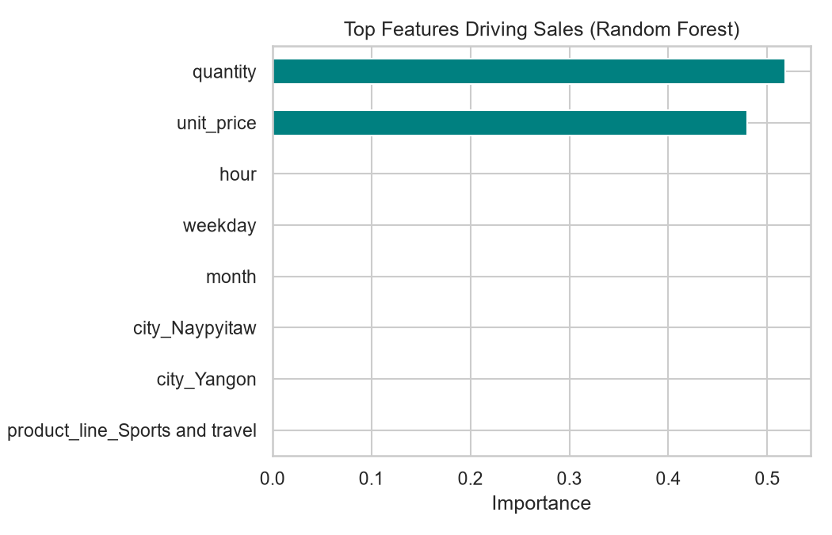
Figure 8.2: Top Features Driving Sales (Random Forest)

8.3 Confusion Matrix
The confusion matrix of the Random Forest Classifier shows that most invoices were classified correctly, with only 3 Low-value invoices predicted as High-value and 7 High-value invoices predicted as Low-value.
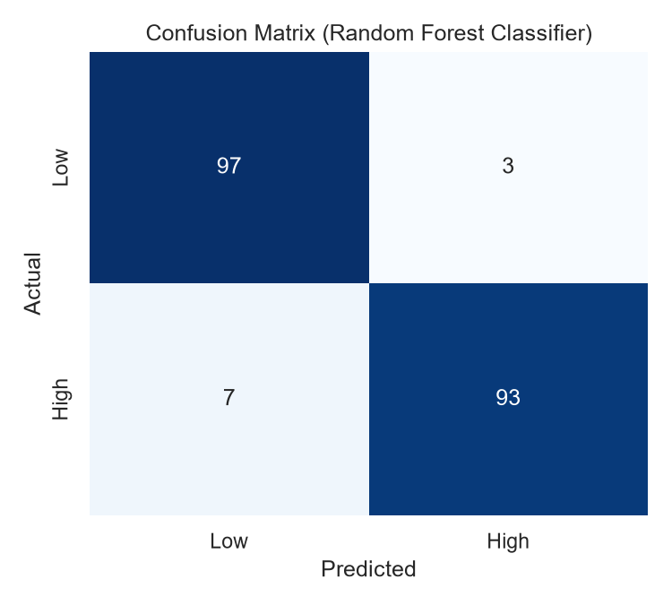
Figure 8.3: Confusion Matrix of the Random Forest Classifier

9. Conclusion
The SuperMarket Sales Prediction & Analytics Intelligence System demonstrates how MongoDB can be combined with machine learning to analyse retail data. The 1,000 supermarket invoices were stored as nested documents in MongoDB, protected by JSON Schema validation and a unique index, handled through PyMongo CRUD operations, and analysed using four aggregation pipelines.
The data was then retrieved into Pandas, encoded and used to train models. Random Forest was the best model for both tasks: the regression model achieved an R² score of 0.9985 and an MAE of 6.59, and the classification model achieved an accuracy of 95% with an F1-score of 0.949. Unit price and quantity are the dominant drivers of the sales value, while city, product line, customer type and payment method have little influence.
Overall, the project provided practical experience in database design, validation, CRUD and aggregation in MongoDB, data preprocessing, exploratory data analysis, machine learning model development and evaluation. It shows how a NoSQL database and machine learning can work together in a practical analytics system.

Limitations
- The dataset has only 1,000 invoices from three months, so seasonal behaviour cannot be learned.
- Because Sales is calculated from unit price and quantity, the regression task is easier than real-world demand forecasting.

10. Future Scope
The system can be improved in several ways:
- Larger and Real-Time Data: Connecting the system to live point-of-sale data to analyse more invoices and longer periods.
- Demand Forecasting: Predicting daily or weekly sales per branch instead of single invoice values.
- Advanced Models: Exploring XGBoost, Gradient Boosting and hyperparameter tuning.
- Customer Segmentation: Using clustering to group customers by buying behaviour.
- Dashboard: Building a Streamlit or web dashboard to display the analytics and predictions interactively.
- Cloud Deployment and Indexing: Moving the database to MongoDB Atlas and adding indexes on city and date for faster queries.

11. References
[1] SuperMarket Analysis dataset (SuperMarket Analysis.csv), publicly available supermarket sales dataset.
[2] Python Software Foundation, “Python Documentation.” Available: https://docs.python.org/3/
[3] MongoDB, Inc., “MongoDB Documentation.” Available: https://www.mongodb.com/docs/
[4] MongoDB, Inc., “PyMongo Driver Documentation.” Available: https://www.mongodb.com/docs/languages/python/pymongo-driver/current/
[5] Scikit-learn Developers, “Scikit-learn: Machine Learning in Python.” Available: https://scikit-learn.org/stable/
[6] Pandas Development Team, “Pandas Documentation.” Available: https://pandas.pydata.org/docs/
[7] Matplotlib and Seaborn Documentation. Available: https://matplotlib.org/ and https://seaborn.pydata.org/

