ADARSH SINGH, [adarsh.singh1@wipro.com](mailto:adarsh.singh1@wipro.com)

1. Sample project in eclipse

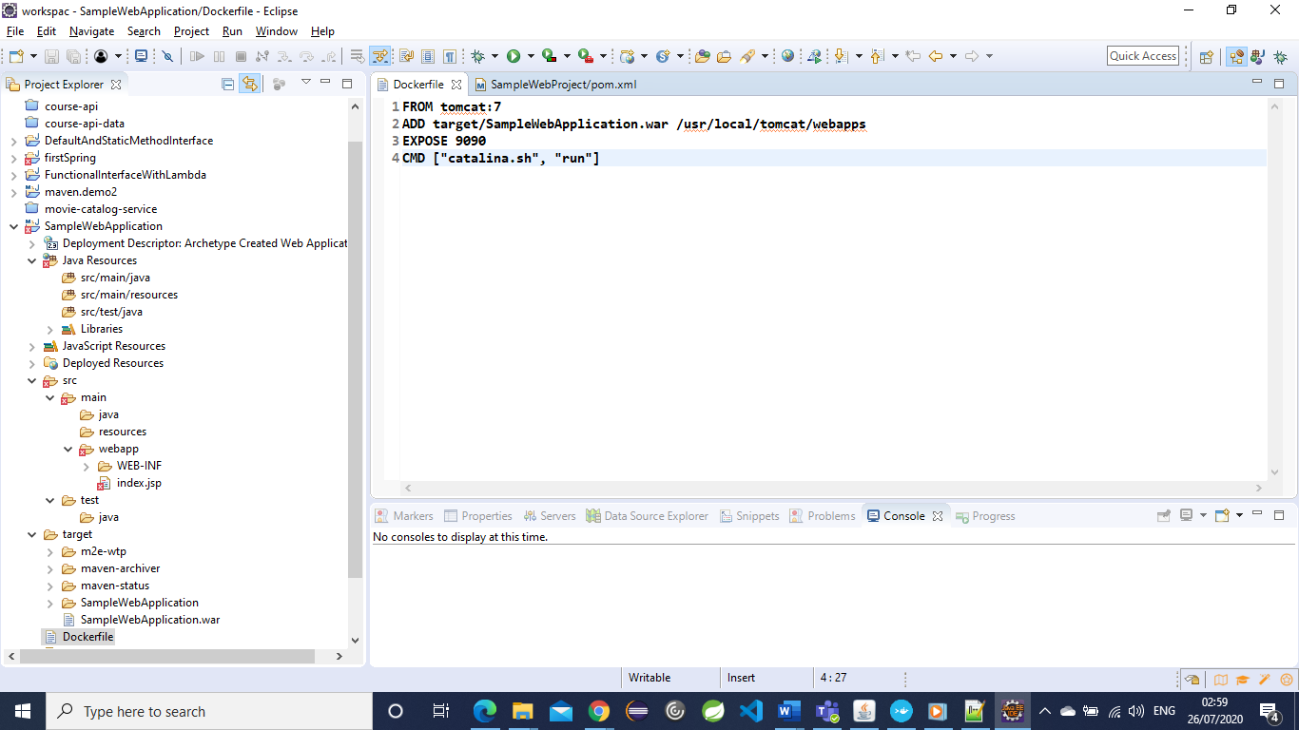

1. Build success output –

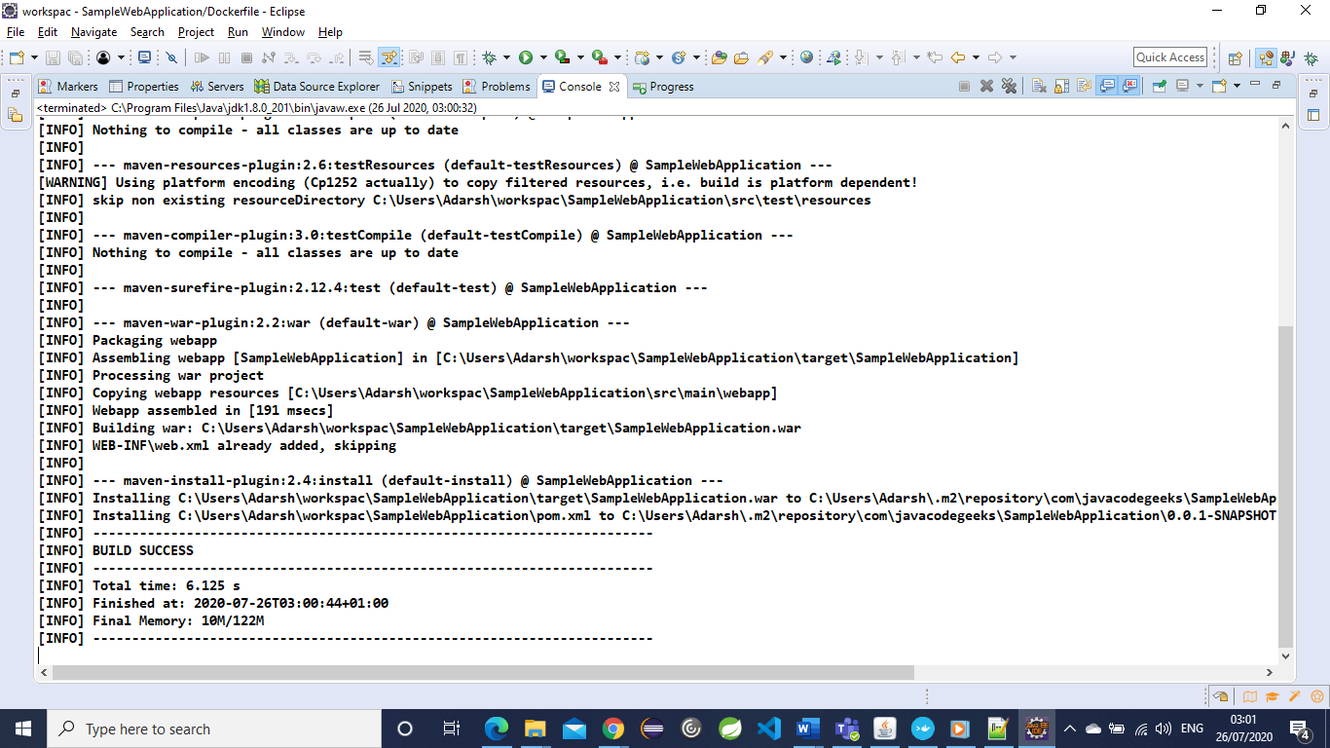

1. Local Git repository (.git)

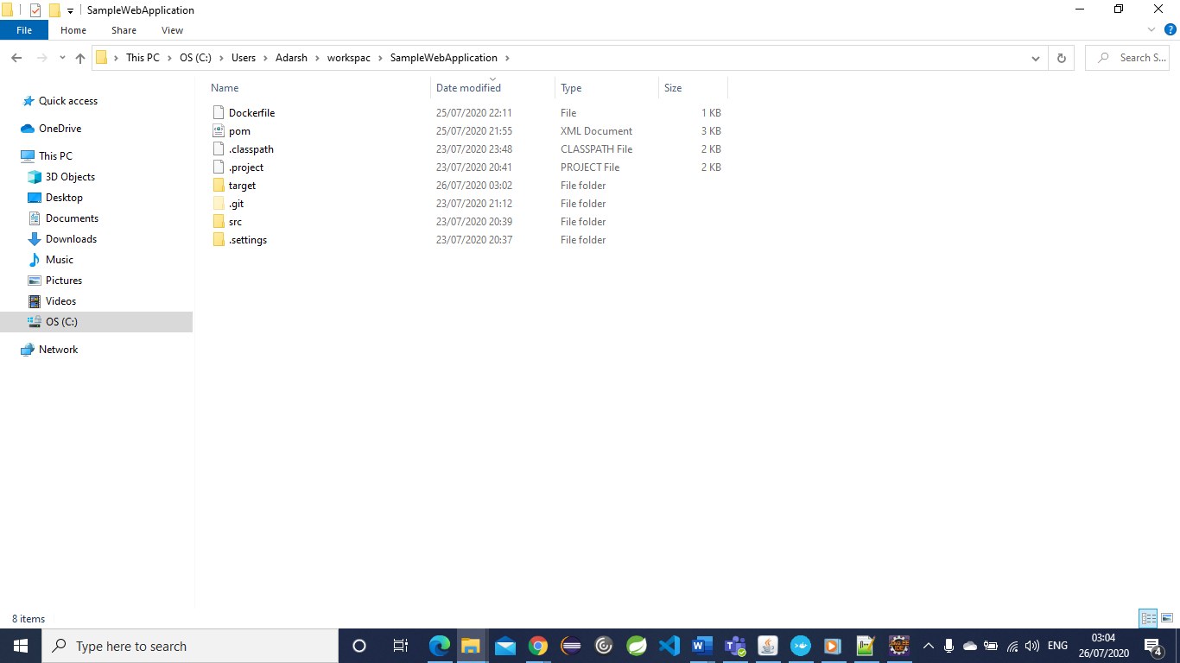

1. Relevant tools –

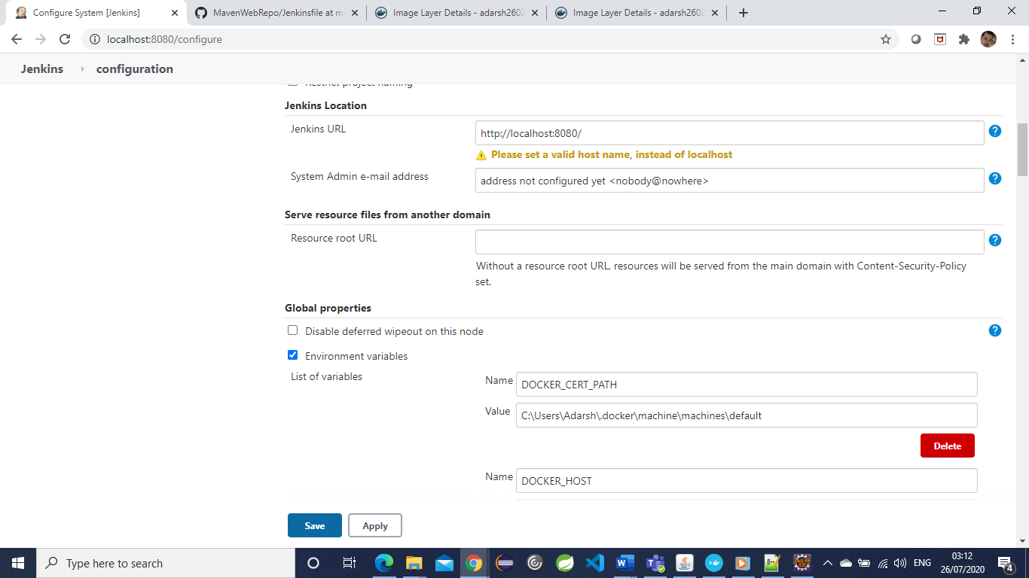

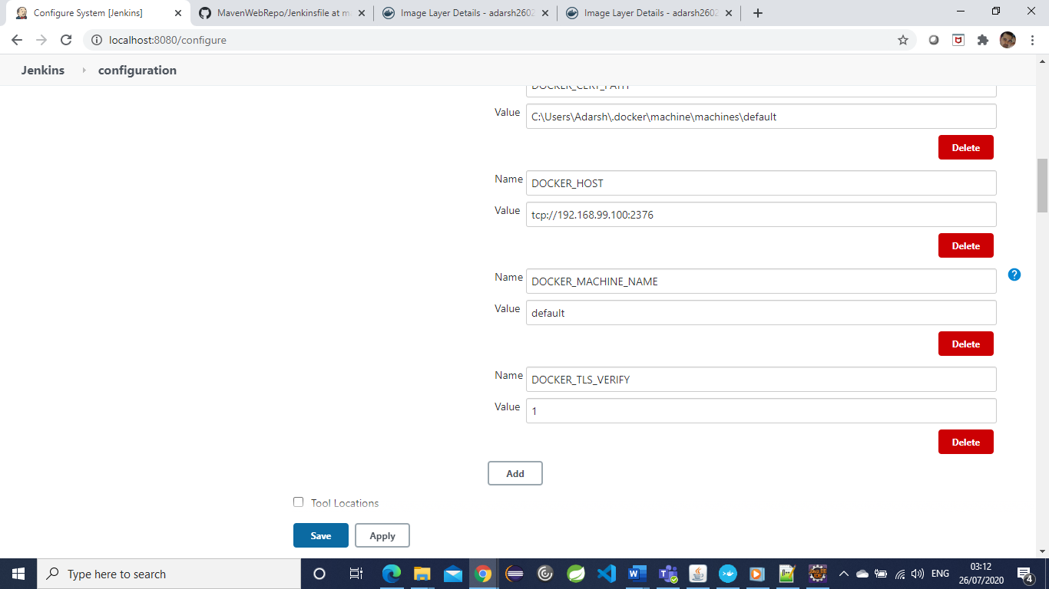

Jdk –

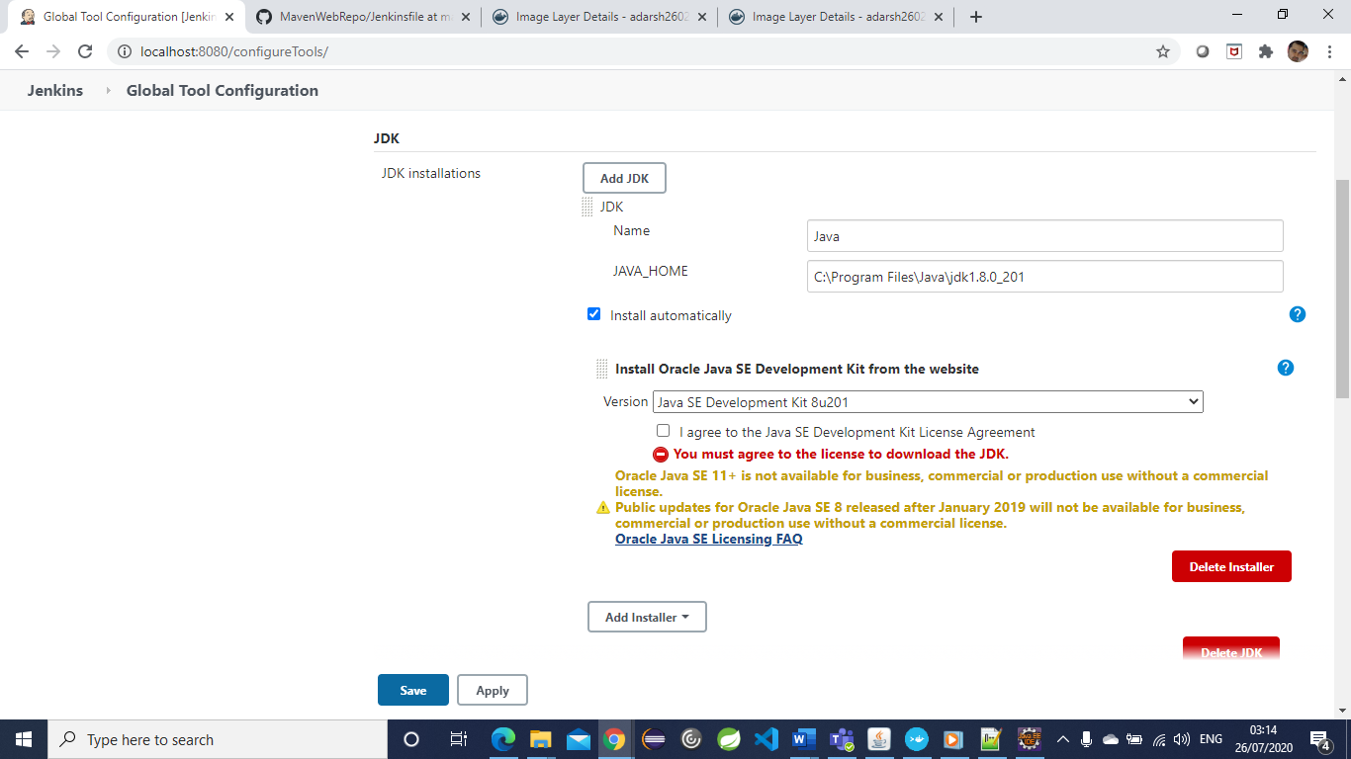

Git

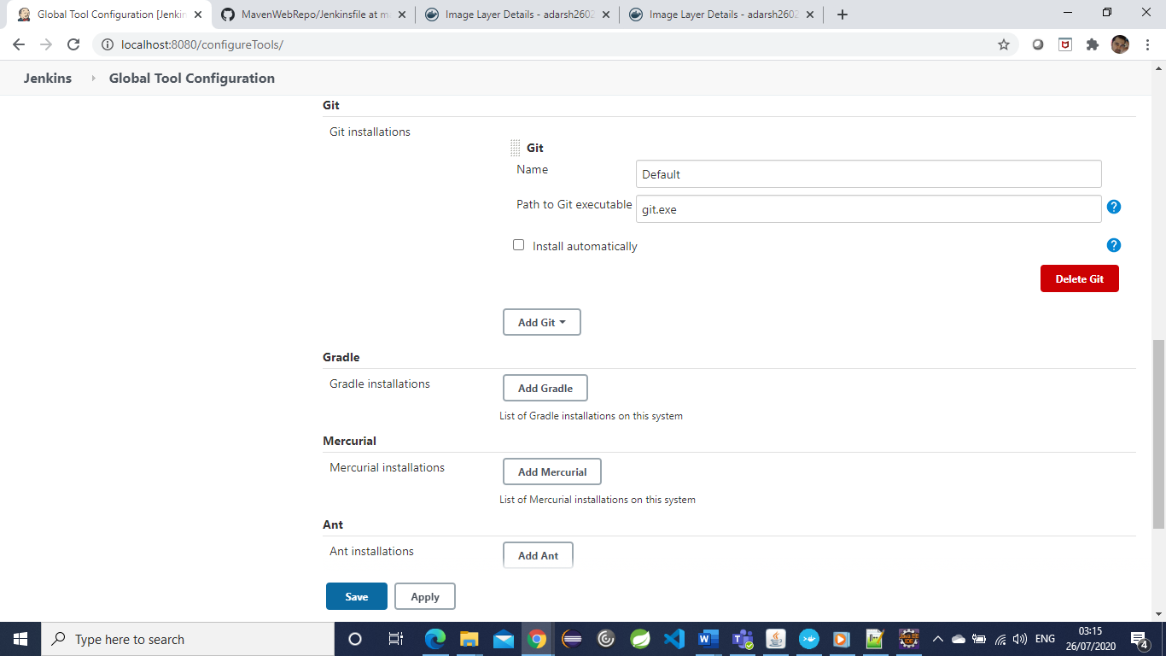

Maven and Docker installations –

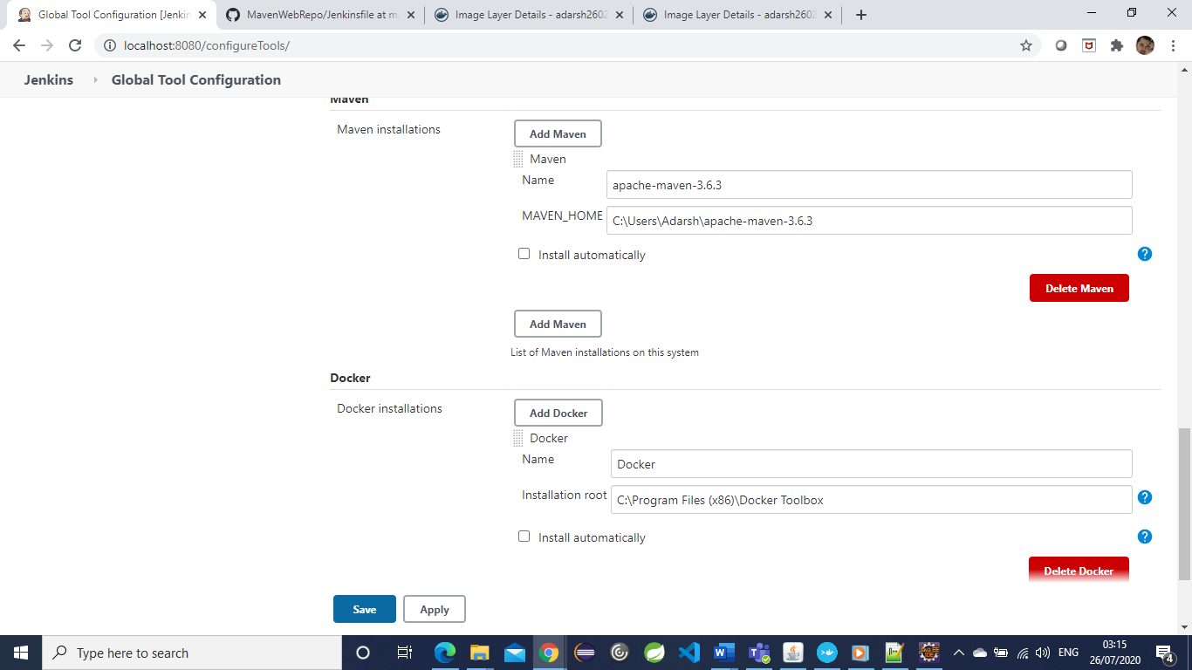

5) Appropriate plugin

Blue Ocean, Build Timeout, CloudBees Docker Build and Publish, Deploy to container, Docker plugin, docker build step, Matrix, Oracle Java SE Development Kit, Pipeline etc.

6) Credentials on Jenkins to connect Git Hub and Docker Hub

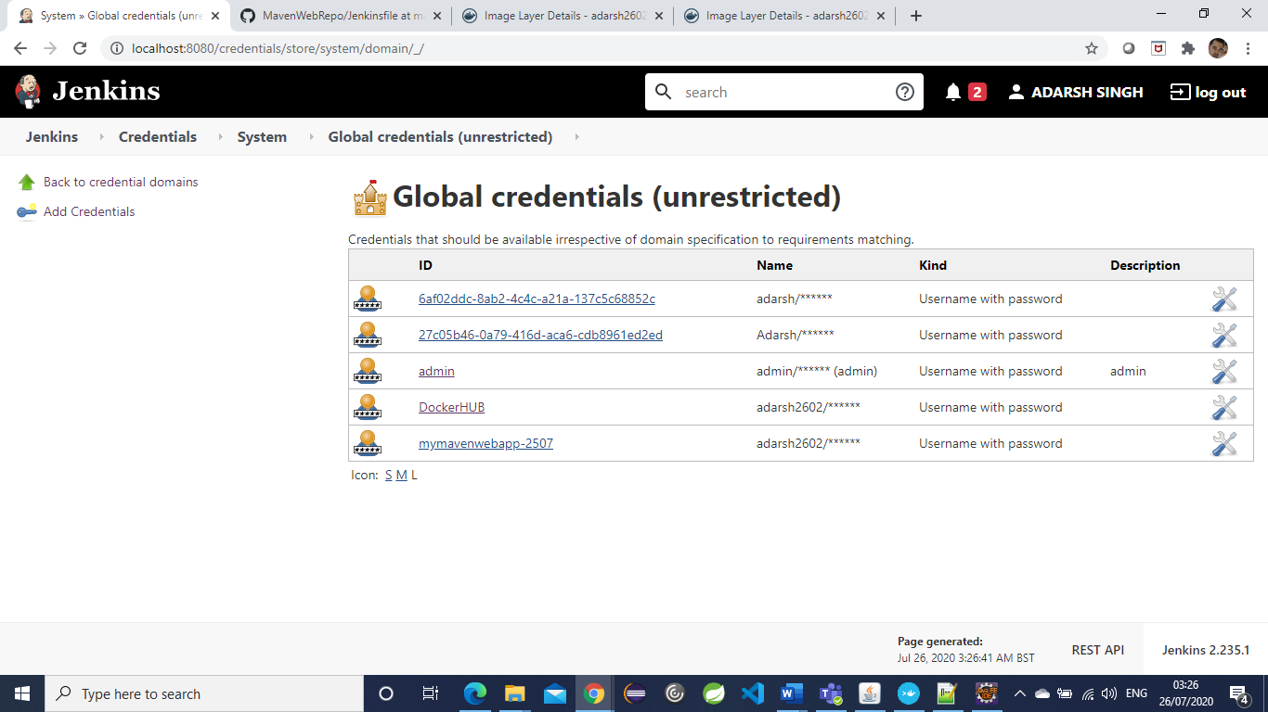

7) Jenkins file with Build with maven and deploy to tomcat

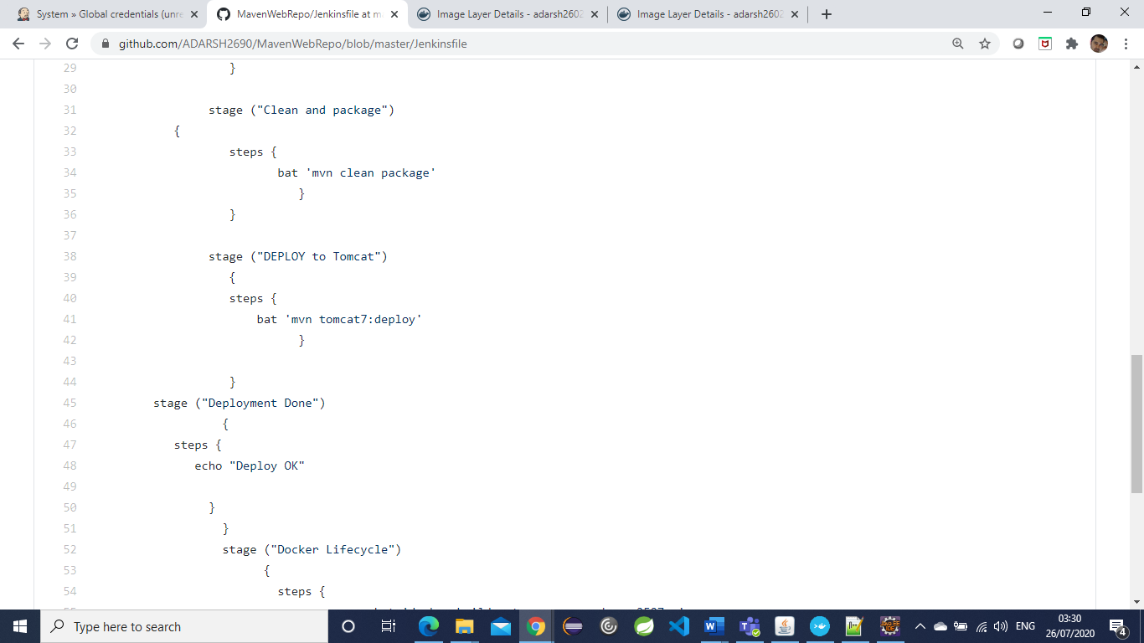

8) Post deployment run the check using URL of the webapp

<http://localhost:9090/SampleWebApplication/>

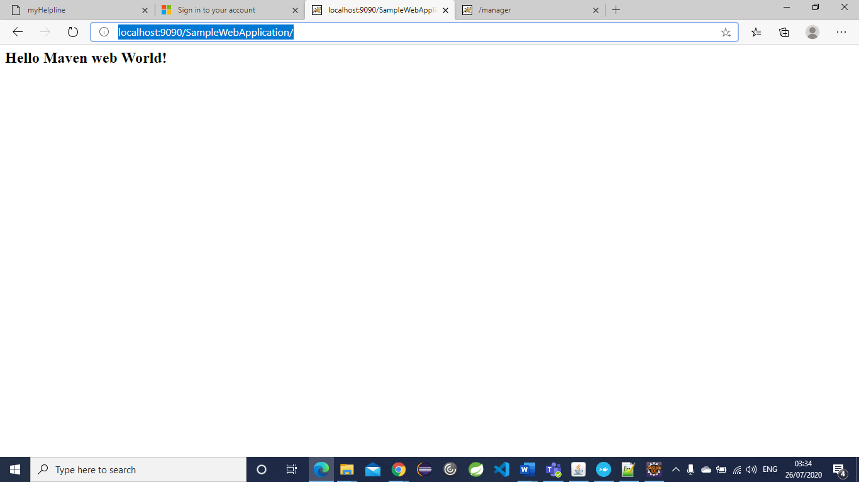

<http://localhost:9090/manager/html/list>

2 Apps deployed – JenkinsWar and SampleWebApplication

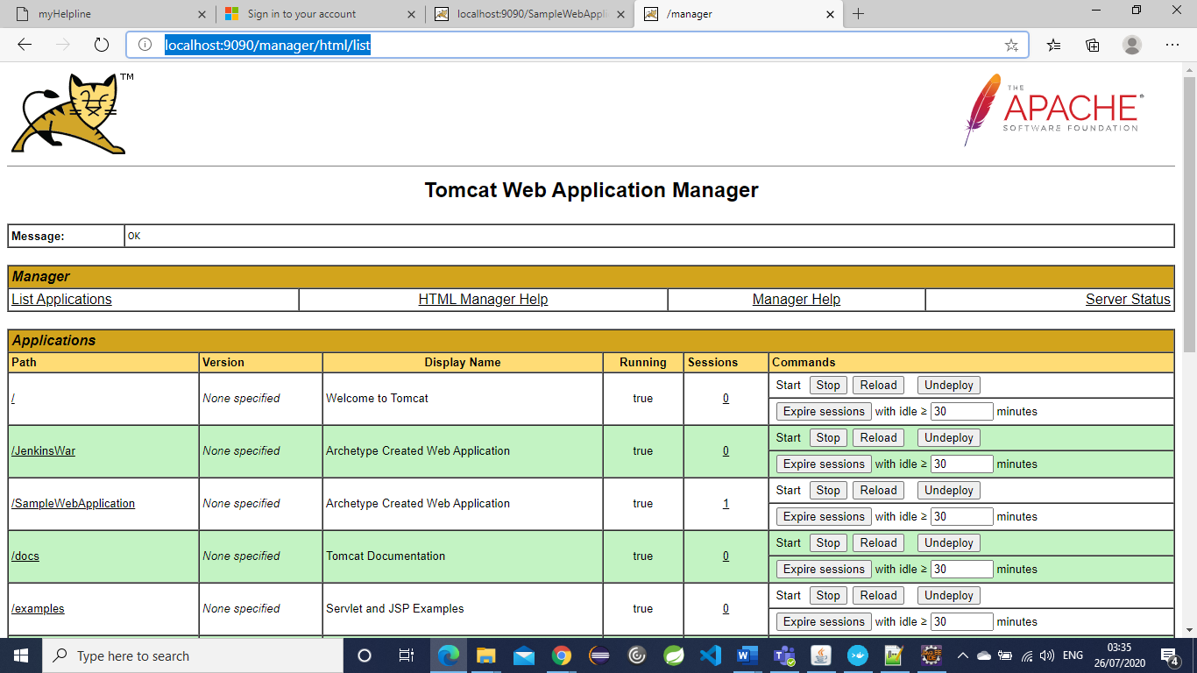

9) Jenkinsfile extended to included Docker deployment steps

stage ("Docker Lifecycle")

{

steps {

bat 'docker build --tag=mymavenwebapp-2507 .'

bat 'docker tag mymavenwebapp-2507 adarsh2602/test100:mymavenwebapp-2507-v1'

bat 'docker login -u adarsh2602 -p xxxxxxx'

bat 'docker push adarsh2602/test100:mymavenwebapp-2507-v1'

}

}

10) Display the repository and image on hub.docker.com

<https://hub.docker.com/repository/docker/adarsh2602/test100>

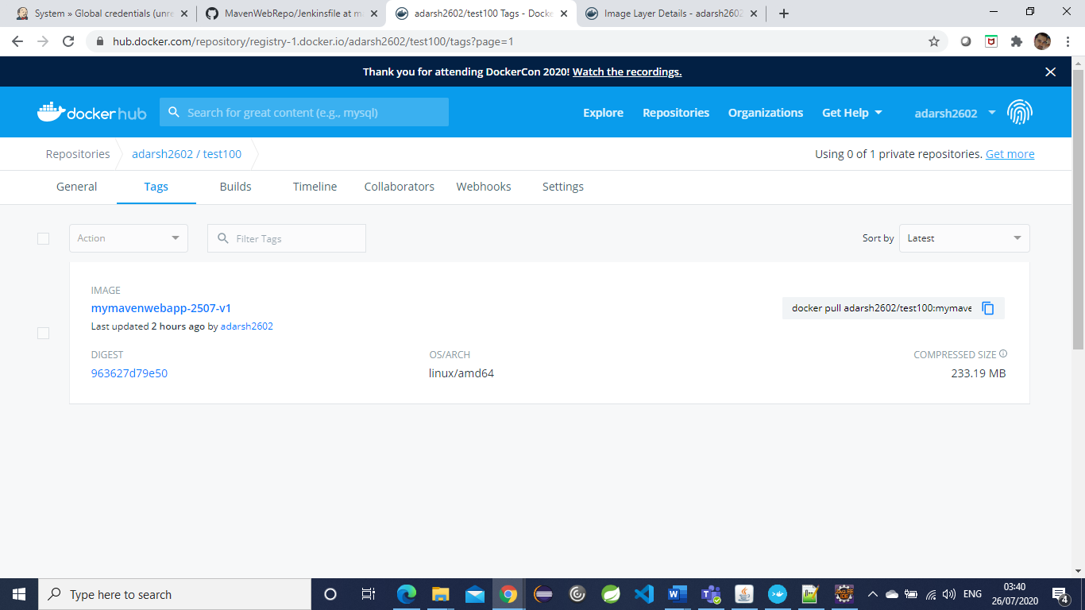

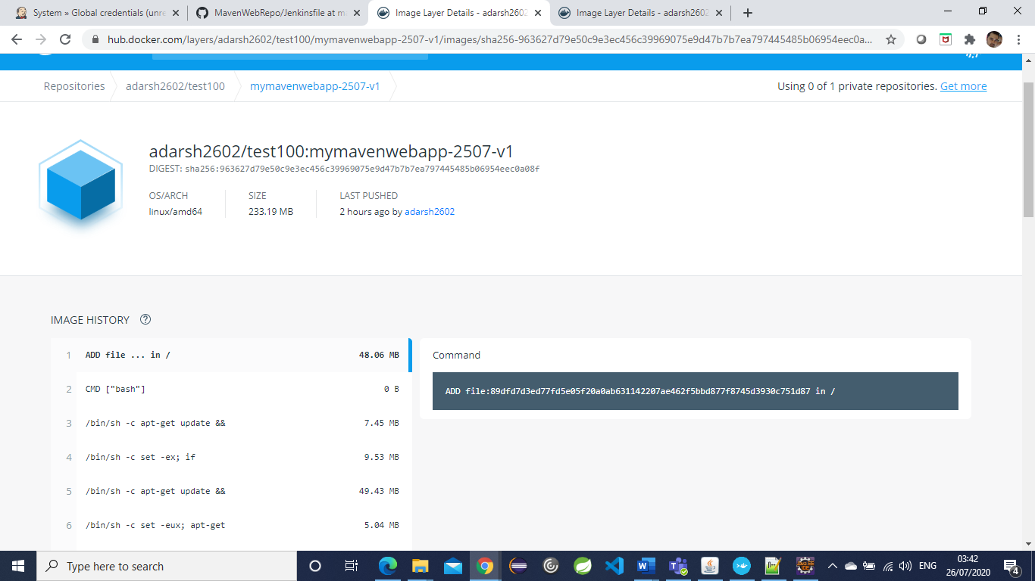

My Git Hub url –

<https://github.com/ADARSH2690/MavenWebRepo>