LOVELY PROFESSIONAL UNIVERSITY
Phagwara, Punjab | Master of Computer Applications (MCA)

CAP455: Object-Oriented Programming using C++
MCA Programme | CA1 (Phase 1): Design and Create
MUSIC PRACTICE GOAL AND
REPERTOIRE TRACKER
Project Proposal and Design Document
Registration Number | 12605178
Teacher / Faculty | Adarsh Kumar Singh
Course | CAP455 – Object-Oriented Programming using C++
Programme | Master of Computer Applications (MCA)
Assessment | CA1 (Phase 1): Design and Create
Github Link | https://github.com/ADARSH29112003/MusicPracticeTracker.git

1. Introduction and Project Overview
The Music Practice Goal and Repertoire Tracker is a console-based application written in C++ using the Object-Oriented Programming concepts of course CAP455. It helps a music learner, a teacher or a small music academy keep one clear record of every piece being studied: its title, its composer, the hours the learner wants to practise, the hours already completed and the difficulty level. Each piece is stored as an object of one main class named Practice.

1.1 Problem Statement
Learners usually handle several pieces at once, such as a scale routine, examination pieces and a performance number, each with its own target hours. Paper diaries scatter this information and are easily lost. Spreadsheets accept duplicate serial numbers, negative hours and impossible level values because nothing checks the data when it is typed. The completion percentage has to be calculated by hand for every piece, so a teacher cannot quickly see which pieces are finished and which are lagging behind.

1.2 Proposed Solution
The proposed system accepts data only through a controlled menu. Every value is validated before it is saved, the new ID is compared with all stored IDs so that duplicates never enter, records are searched with an object pointer, and a friend function calculates progress automatically. A static counter always shows how many pieces are stored.

1.3 Objectives
- Design one entity class, Practice, that encapsulates all details of a practice piece.
- Store pieces in a fixed-size array of objects using validated input.
- Prevent duplicate IDs by checking every existing record with a flag variable.
- Display all pieces and search by ID using pointers to objects.
- Calculate progress with a friend function and count records with a static member.

1.4 Project at a Glance
6  Modules | 5  Menu options | 6  Data fields per piece | 50  Records (CA1 limit) | 42  Days, 4 phases

How this proposal reads a console project. The application runs in the console, so it has no web server or SQL database. In this document the frontend is the console menu layer (cin / cout), the backend is the C++ logic layer built around the Practice class, and the database is the array of Practice objects in memory in CA1, followed by a binary file in CA2 and a CSV backup in CA4.

2. Features of the Application
The application offers the following features. Core, validation and reporting features are delivered in CA1; planned features are added in later phases on the same codebase.
# | Feature | What it does | Category
1 | Add new piece | Stores ID, title, composer, goal hours, hours done and level as one Practice object. | Core
2 | Display all pieces | Lists every saved record on one line each and shows the total number of pieces. | Core
3 | Search piece by ID | Walks through the array with an object pointer and shows the matching record, or a clear not-found message. | Core
4 | Practice progress | A friend function calculates completion % from done and goal hours and reports when a goal is complete. | Reporting
5 | Record counter | A static member keeps the number of saved pieces and the next free array position. | Core
6 | Duplicate ID prevention | Compares the new ID with all stored IDs using a flag variable; duplicates are refused. | Validation
7 | Input validation | Rejects ID ≤ 0, goal ≤ 0, negative hours, levels other than B / I / A and non-numeric input (cin.fail()). | Validation
8 | Storage-full protection | The 51st piece is refused with a “Storage is full” message instead of overwriting memory. | Validation
9 | Permanent file storage | CA2: fixed-size binary records using fstream, with seekg for search and seekp for update. | Planned
10 | Update and Delete | CA3: safe editing and removal of records with user confirmation. | Planned
11 | Sort, count and CSV backup | CA4: STL vector / list, sort, find_if, count_if and a CSV export for backup. | Planned
12 | Exception handling | CA4: try, catch, throw with a custom exception class for reliable error handling. | Planned

2.1 Quality Attributes
Simple  One class, one menu, easy to trace on paper | Reliable  Every input is checked before it is saved | Extensible  Same class grows through CA2 to CA4 | Portable  Standard C++ that compiles with g++

3. Modules of the Application
The application contains 6 modules. Each module has one clear responsibility, and main() acts as the controller that connects them through the menu loop.
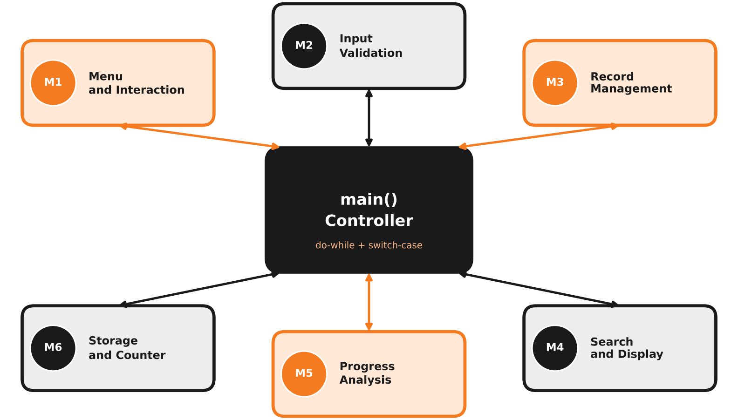
ID | Module | Responsibility | Implemented by
M1 | Menu and Interaction | Shows the menu, reads the choice and routes it to the right operation. | main(), do-while, switch-case
M2 | Input Validation | Checks each value before it reaches an object and asks again if it is wrong. | loops, cin.fail(), cin.clear()
M3 | Record Management | Creates records, blocks duplicate IDs and handles the full-array case. | setData(), flag variable, this
M4 | Search and Display | Displays all records and finds one record by its ID. | show(), getId(), ptr++
M5 | Progress Analysis | Calculates the completion percentage of a piece and flags completed goals. | friend showProgress()
M6 | Storage and Counter | Holds the array of objects and the shared record counter. | Practice arr[50], static cnt

3.1 What Each Module Does

M1 Menu and Interaction  Displays the five-option menu inside a do-while loop, reads the user’s choice and uses a switch-case to call the correct operation. The loop ends only when the user chooses Exit.  Input: Menu choice 1 to 5.  Output: Calls the selected module, then shows the menu again.  OOP concepts: do-while, switch-case, cin / cout. | M2 Input Validation  Guards every value before it is given to an object. If the user types a letter instead of a number, the stream is cleared and the question is asked again.  Input: Raw keyboard input.  Output: Clean values: ID > 0, goal > 0, done ≥ 0, level B / I / A.  OOP concepts: cin.fail(), cin.clear(), cin.ignore(), loops.
M3 Record Management  Performs the Create operation. It checks that the array is not full, scans all IDs with a flag variable and, if the ID is new, saves the piece in the next free position.  Input: Validated ID, title, composer, hours, level.  Output: A new Practice object and the counter increased by one.  OOP concepts: Class, private data, this pointer, call by reference. | M4 Search and Display  Prints every saved record by moving a pointer through the array, and finds one piece by comparing the searched ID with getId(). An empty list gives “No records found”.  Input: A piece ID (for search).  Output: Record lines, total count or a not-found message.  OOP concepts: Pointer to object, arrow operator, inline getId().
M5 Progress Analysis  The friend function showProgress() reads the private goal and done hours, calculates done ÷ goal × 100 and prints the percentage. It announces when a goal is complete or exceeded.  Input: A Practice object passed by reference.  Output: Completion percentage and status message.  OOP concepts: Friend function, call by reference, encapsulation. | M6 Storage and Counter  Keeps Practice arr[50] and the static member cnt. The static function getCount() returns how many pieces exist and where the next free slot is. File storage joins this module in CA2.  Input: Objects to store; count queries.  Output: Stored objects and the current count.  OOP concepts: Static data member, static function, array of objects.

3.2 What Passes Between Modules
From | To | Data handed over
M1 Menu | M2 Validation | Raw values typed by the user for the chosen operation.
M2 Validation | M3 Records | Clean ID, title, composer, goal hours, hours done and level.
M3 Records | M6 Storage | A filled Practice object saved at index cnt; counter increased.
M1 Menu | M4 / M5 | The ID to search, or the object whose progress is wanted.

Module interaction in one line: M1 receives the choice → M2 validates the input → M3, M4 or M5 performs the operation → M6 holds the data and the counter → control returns to M1.

4. How the Frontend and Backend Communicate
The application is a single C++ program, so there is no network, web server or API between the two layers. The frontend (console menu) and the backend (the Practice class and its logic) communicate inside the same process through ordinary function calls, pointers, references and return values.
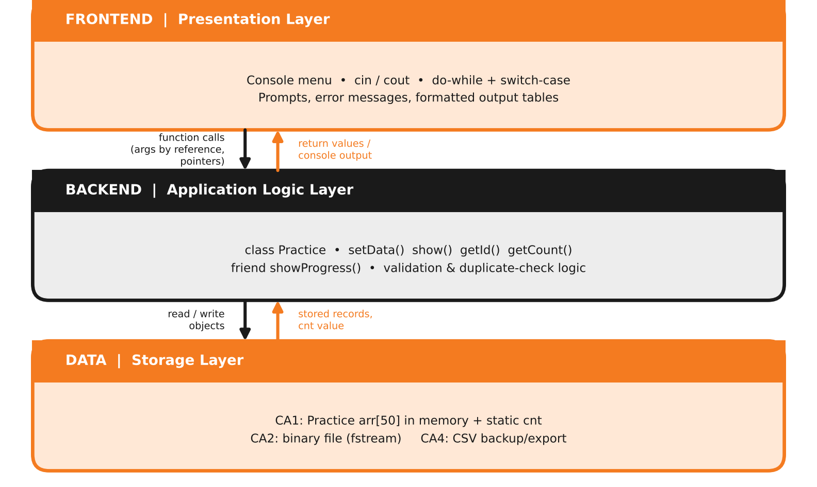
Channel | Example | What travels
Function call with arguments | ptr->setData(id, t, c, g, d, l) | Validated values from the frontend; strings passed by reference to avoid copying.
Return value | ptr->getId(), Practice::getCount() | An int returned to main() for comparison, loops and the “Total pieces” message.
Pointer to object | Practice *ptr = arr; ptr->show(); | The frontend walks through the stored objects and asks each one to print itself.
Friend access | showProgress(*ptr) | The object is passed by reference; the friend function reads its private hours.

4.1 Message Flow for “Add New Piece”
1 | User types 1; the frontend (M1) routes to the Create operation.
2 | Frontend reads and validates the ID and the other fields (M2) using cin and cin.fail().
3 | Frontend asks the backend Practice::getCount(); if it is 50 the piece is refused (“Storage is full”).
4 | Frontend loops with ptr->getId(); any match sets flag = 1 and the piece is refused (“ID already exists”).
5 | Frontend calls ptr->setData(...); the backend stores the values with this-> and executes cnt++.
6 | Control returns to main(), which prints “Piece added” and shows the menu again.

5. How Data Is Stored
The project does not need a separate database server. Data is stored as objects, and the storage method grows with each phase: first in memory, then in a binary file, and finally with a CSV backup.

5.1 CA1 Storage: Array of Objects in Memory
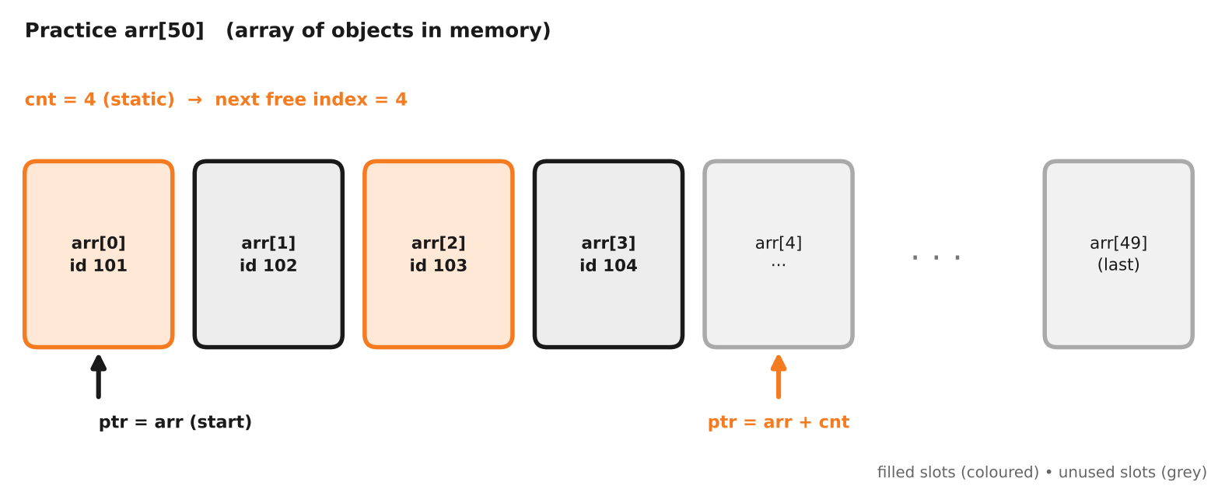

5.2 Data Dictionary of Class Practice
Field | Type | Access | Bytes | Purpose and validation rule
id | int | private | 4 | Unique primary key. Must be greater than 0 and different from every stored ID.
title | string | private | 32* | Name of the piece; read with getline() so spaces are allowed.
composer | string | private | 32* | Name of the composer; read with getline().
goalHrs | float | private | 4 | Target practice hours; must be greater than 0 (also avoids division by zero).
doneHrs | float | private | 4 | Hours already practised; 0 or more, and may exceed the goal.
level | char | private | 1 | B = Beginner, I = Intermediate, A = Advanced; anything else is rejected.
cnt | static int | private | 4 (shared) | One shared copy: number of saved pieces and the next free index.
*On 64-bit g++ a std::string object occupies 32 bytes; sizeof(Practice) is about 88 bytes including padding.

5.3 How Storage Evolves
Phase | Storage | Technique | Result
CA1 | In-memory array | Practice arr[50], static cnt | Fast, but lost at exit
CA2 | Binary file | fstream, fixed-size records, seekg / seekp | Data survives restarts
CA4 | CSV backup | STL containers and CSV export | Readable backup copy

6. How Users Interact with the Application
Users work through a text menu. The learner enters pieces and checks progress; a teacher or academy staff member uses display, search and progress to review the repertoire. The menu repeats until the user chooses Exit.
SAMPLE SESSION: ADDING A PIECE (illustrative)  ==== MUSIC PRACTICE TRACKER ====  1. Add new piece  2. Display all pieces  3. Search piece by ID  4. Show practice progress  5. Exit  Enter your choice: 1  Enter ID: 101  Enter title: River Flows in You  Enter composer: Yiruma  Enter goal hours: 20  Enter hours done: 5.5  Enter level (B/I/A): B  Piece added successfully. | PROGRESS, DISPLAY AND ERROR HANDLING (illustrative)  Enter your choice: 4  Enter ID to check: 101  River Flows in You - Yiruma  Goal: 20 hrs Done: 5.5 hrs  Progress: 27.5 %  Enter your choice: 2  101 River Flows in You Yiruma  20 5.5 B  Total pieces: 1  Enter ID: -5  Invalid ID. Enter again: 101  ID already exists.

6.1 Interaction Steps
# | User action | System response | Concept behind it
1 | Starts the program | Shows the five-option menu | do-while loop
2 | Chooses 1 and types the details | Validates every value, checks the ID, saves and confirms | Validation, flag, setData()
3 | Chooses 2 | Lists all pieces and the total count | ptr++, show(), getCount()
4 | Chooses 3 and enters an ID | Prints the record or “Piece not found” | getId(), found variable
5 | Chooses 4 and enters an ID | Prints completion percentage and goal status | Friend showProgress()
6 | Types a wrong value (letter, −5, level X) | Shows an error and asks again | cin.fail(), cin.clear()
7 | Chooses 5 | Ends the loop and closes the program | do-while condition false

7. Use Case Diagram (UML)
The use case diagram shows who uses the system and what they can do. The Learner is the primary actor and can use every function. The Teacher (or academy staff) is a secondary actor who reviews records through display, search and progress.
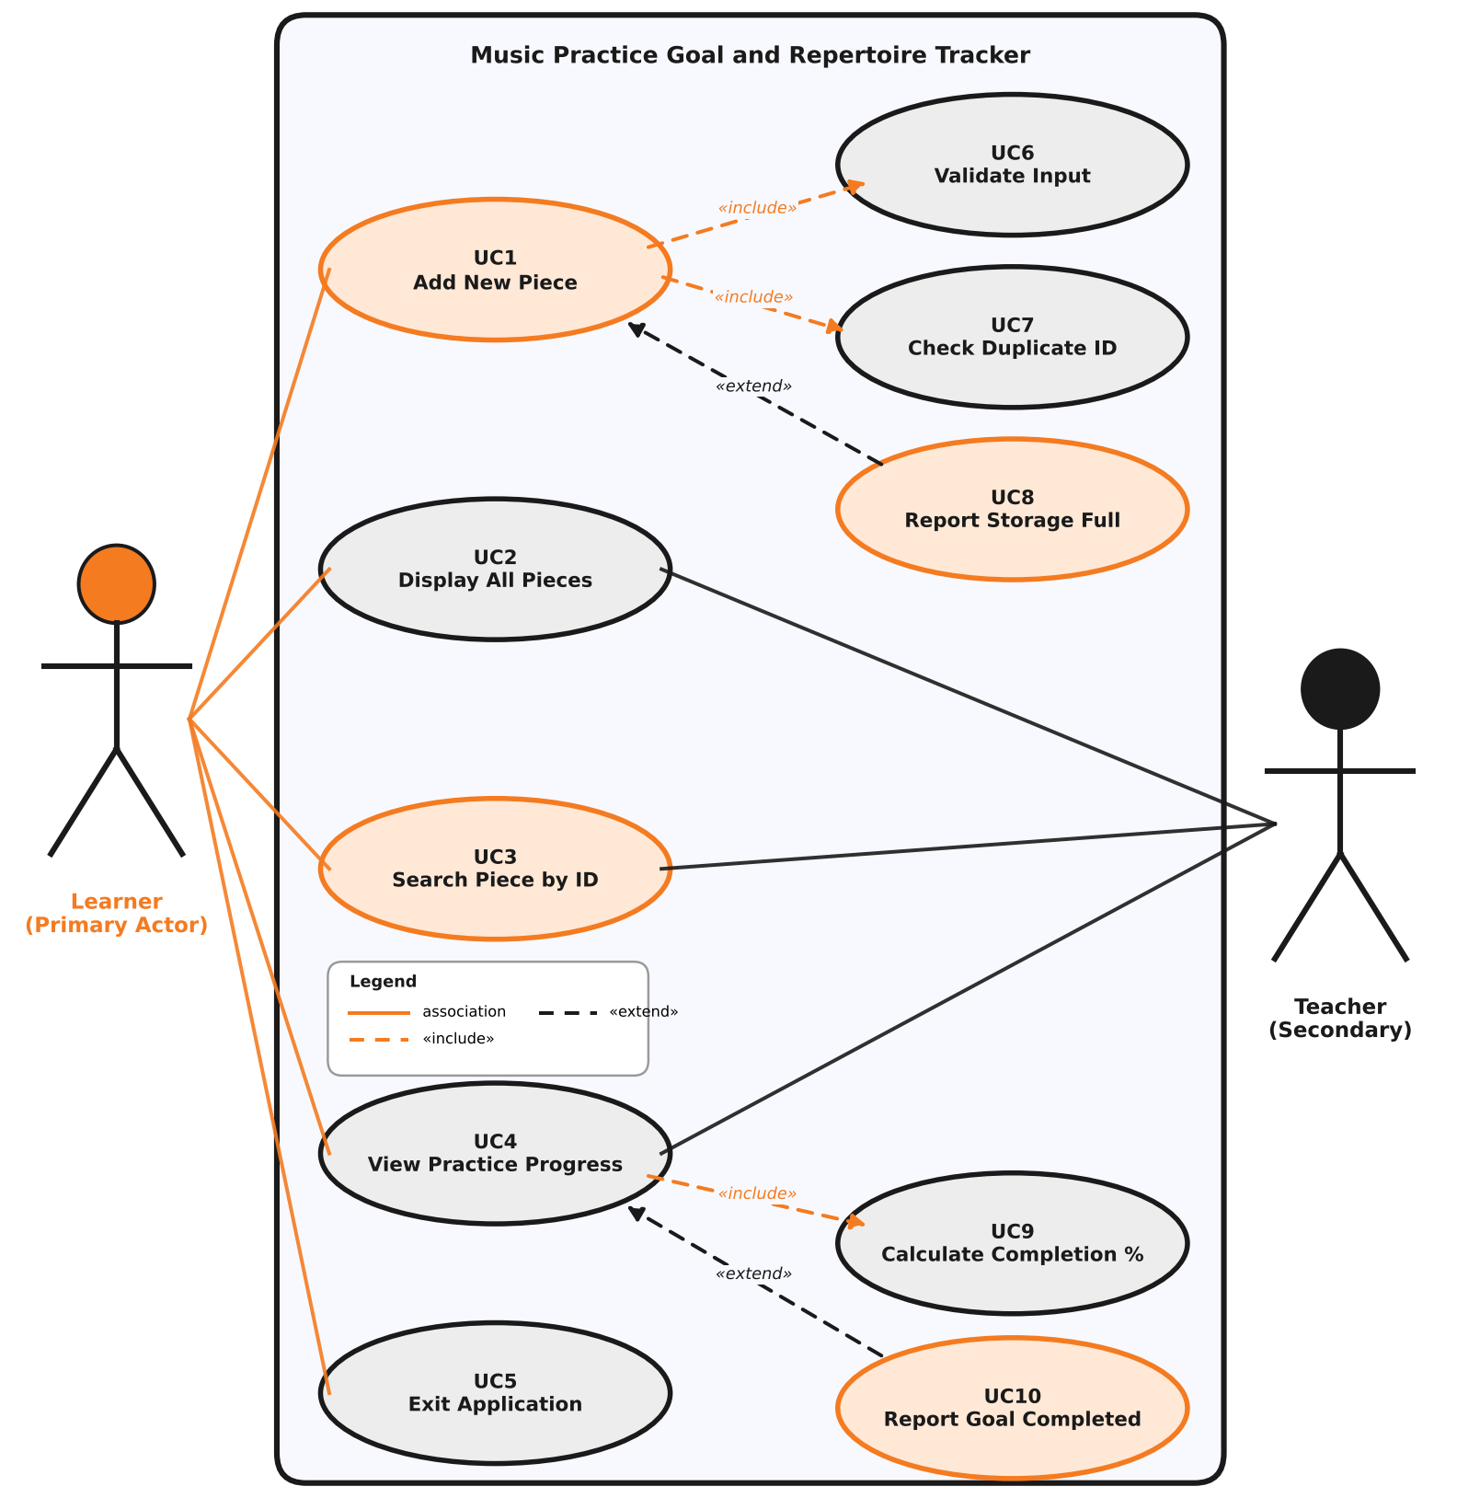
Actor | Role | Use cases
Learner | Primary actor; enters and tracks own pieces | UC1 Add, UC2 Display, UC3 Search, UC4 Progress, UC5 Exit
Teacher | Secondary actor; reviews learner progress | UC2 Display, UC3 Search, UC4 Progress
Relations | «include» = always executed | UC1 includes UC6 and UC7; UC4 includes UC9. «extend» = only in special cases: UC8 extends UC1, UC10 extends UC4.

8. Class Design, Roadmap and Conclusion

8.1 UML Class Diagram
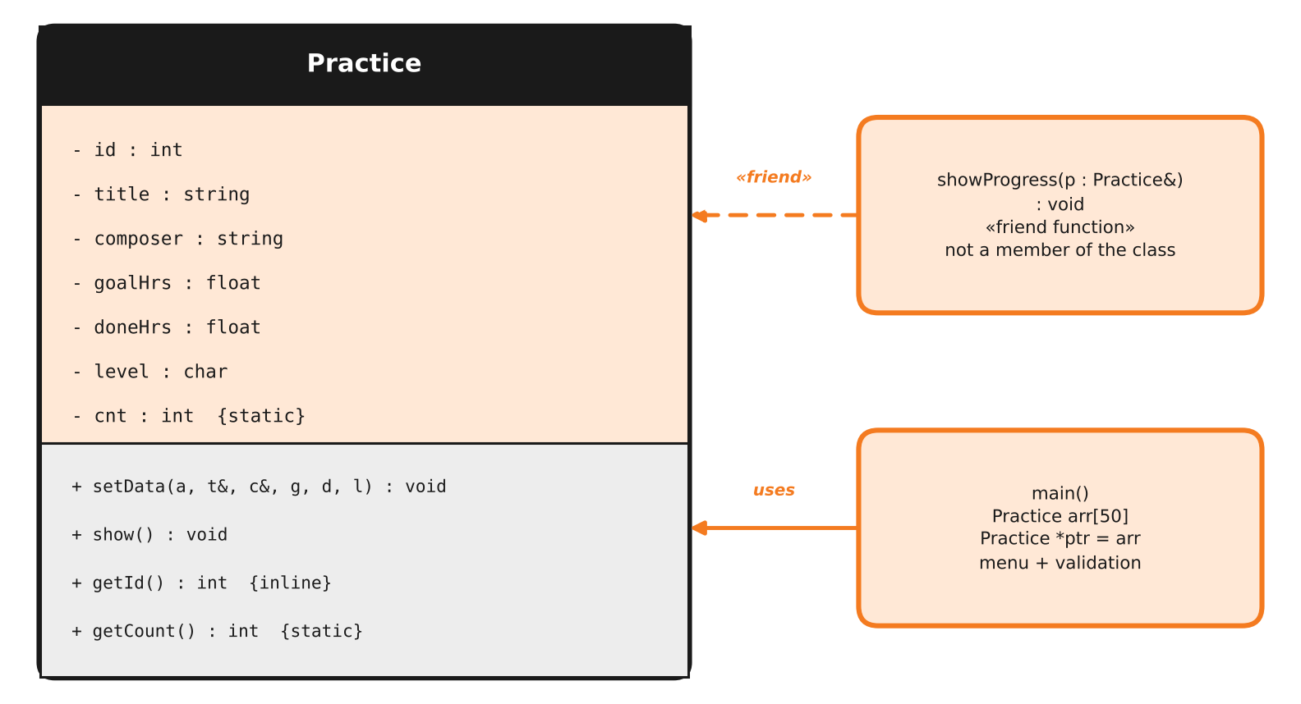

8.2 42-Day, 4-Phase Roadmap
Phase | Syllabus | What is added
CA1 (Day 7) | Units I and II | Class Practice, static member, inline and friend functions, array of objects, pointers, this; in-memory Create and Read.
CA2 (Day 14) | Unit III | Constructors, copy constructor, destructor; binary file storage with fstream.
CA3 (Day 28) | Units IV and V | Base and derived classes, operator overloading, dynamic memory, virtual functions; safe Update and Delete.
CA4 (Day 42) | Unit VI | Exceptions, templates, STL (vector, list, sort), full CRUD and CSV backup.

8.3 Conclusion
The Music Practice Goal and Repertoire Tracker replaces scattered notebooks and unchecked spreadsheets with one validated, object-oriented program. Its six modules, clear frontend–backend separation, object-based storage and simple user interaction give a strong CA1 foundation that grows naturally into a complete repertoire management tool by CA4.
Submitted by Registration No. 12605178 | Teacher: Adarsh Kumar Singh | CAP455, MCA, Lovely Professional University

