Team Walter

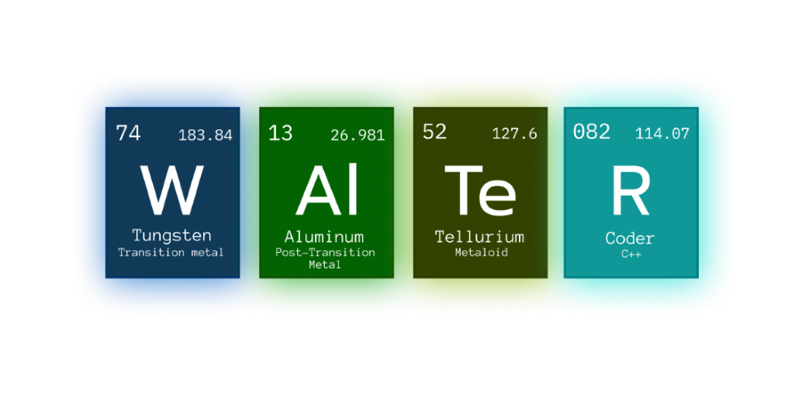





**Table of Contents**

IDEA OF THE PROJECT 2

TEAM MEMBERS 2

PROJECT DESCRIPTION 3

PERFORMED TASKS 3

# IDEA OF THE PROJECT

The idea of the project is to learn about some viruses, and after that do a trivia to check what you've learned.

# TEAM MEMBERS

|  |  |
| --- | --- |
| **№** | **Roles in the team** |
|  | Atanas Atanasov – Scrum trainer |
|  | Ivan Delchilov – Back-end developer |
|  | Nikolay Stoyanov – Back-end developer |
|  | Dimitar Georgiev – QA Engineer |

# PROJECT DESCRIPTION

|  |  |
| --- | --- |
| **№** | **Description** |
|  | Idea in general.  Our assignment was to create a game related to Ecology. |
|  | How can you access the project?  You can find our project on GitHub. <https://github.com/ADAtanasov21/Walter.git> |
|  | Teamwork.  Our main communicating platform is Microsoft Teams. Everybody was working on the project whenever they had time to. |
|  | What technologies are used?  The technologies used are **Visual Studio** as our code editor, **GitHub** for collaborative work, **Microsoft Teams** for communication, **PowerPoint** for making a presentation, **Word** for making a documentation |

# PERFORMED TASKS

|  |  |
| --- | --- |
| **№** | **Completed tasks** |
| **1** | Decide the idea of the project  Everybody gave their idea for the project and then we chose the best one. |
| **2** | Make design  Started working on the code, as we started by adding some of the main elements. |
| **3** | Add structure design  Building graphic libraries. |
| **4** | Create animation  Making animations for the viruses. |
| 5 | Create the menu  Creating the game menu |
| **6** | Make the README file  Make everything in the readme to work. |
| **7** | Make the documentation  The documentation gives us information about the |
| **8** | Make the presentation  We have created a short presentation that gives us information about our team and the programs we used to make the project |