> use employee

switched to db employee db.employees.insert({"eid":101,"ename":"Abhi","dept":"ux","desig":"designer","salary":45000,"yoj":new Date("2020-06-12"),"address":{"dno":"D101","street":"Puzhyayoram","locality":"veedikka","city":"kollam"}})

WriteResult({ "nInserted" : 1 })

db.employees.insert({"eid":102,"ename":"Akhil","dept":"development","desig":"developer","salary":55000,"yoj":new Date("2020-04-12"),"address":{"dno":"D101","street":"Koyikkal","locality":"Sreeramam","city":"kollam"}})

WriteResult({ "nInserted" : 1 })

db.employees.insert({"eid":103,"ename":"Rahul","dept":"development","desig":"developer","salary":65000,"yoj":new Date("2019-03-19"),"address":{"dno":"D102","street":"Vazhakkal","locality":"Pamam","city":"kannur"}})

WriteResult({ "nInserted" : 1 })

1. db.employees.find({salary:{$gt:50000,$lt:75000}}).pretty()

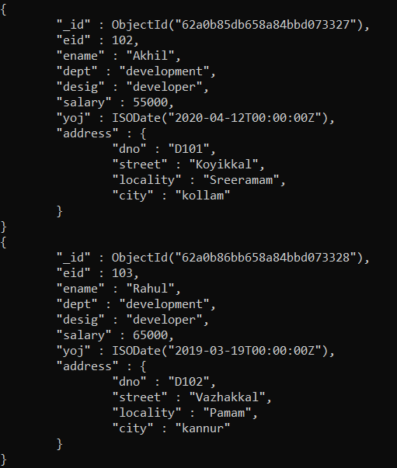

2. db.employees.find({"desig":"developer"}).pretty()

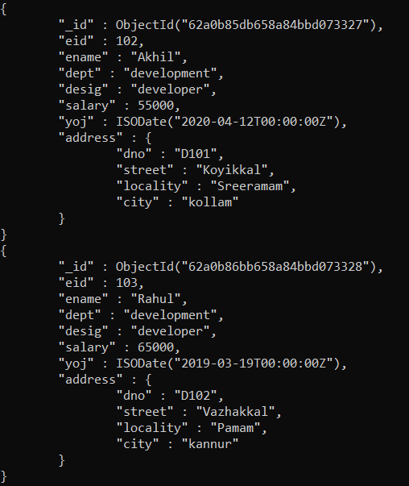

3. db.employees.find({"ename":"Rahul"},{"_id":0,"salary":1}).pretty()



4. db.employees.find({"ename":"Rahul"},{"_id":0,"address.city":1}).pretty()



5. db.employees.updateMany({"desig":"developer"},{$inc:{"salary":5000}})

{ "acknowledged" : true, "matchedCount" : 2, "modifiedCount" : 2 }

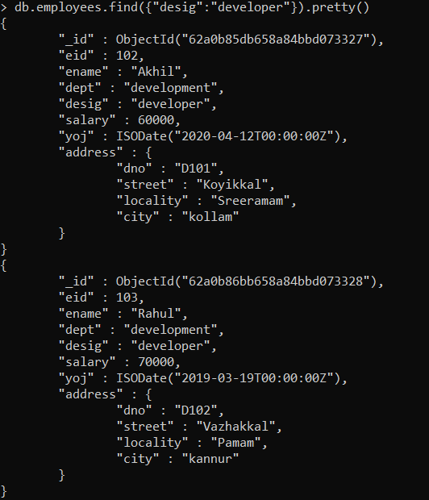

6. db.employees.update({"ename":"Rahul"},{$set:{"age":18}})

WriteResult({ "nMatched" : 1, "nUpserted" : 0, "nModified" : 1 })

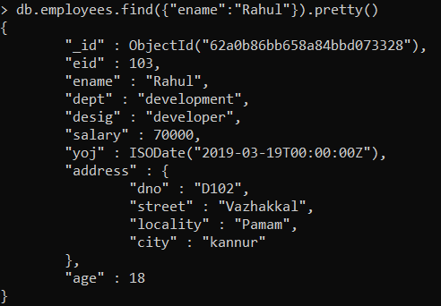

7. db.employees.update({"ename":"Rahul"},{$unset:{"yoj":1}})

WriteResult({ "nMatched" : 1, "nUpserted" : 0, "nModified" : 1 })

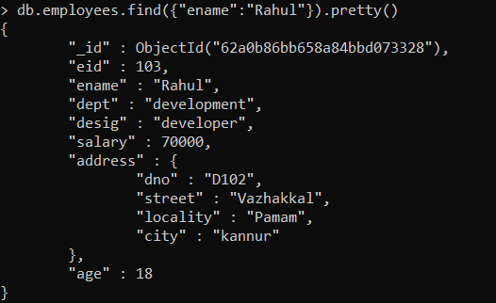

8. db.employees.update({"ename":"Rahul"},{$push:{"project":"p1"}})

WriteResult({ "nMatched" : 1, "nUpserted" : 0, "nModified" : 1 })

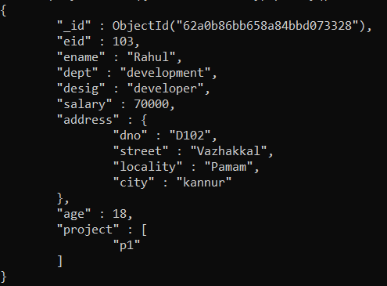

9. db.employees.update({"ename":"Rahul"},{$push:{"project":{$each:["p2","p3"]}}})

WriteResult({ "nMatched" : 1, "nUpserted" : 0, "nModified" : 1 })

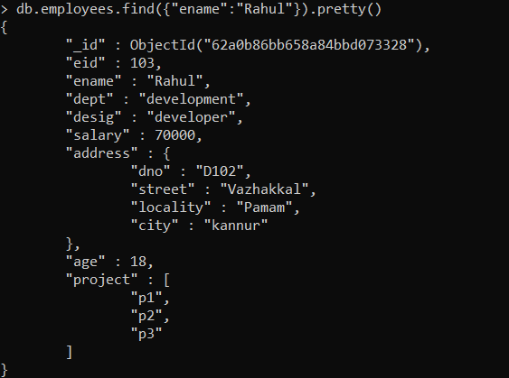

10. db.employees.update({"ename":"Rahul"},{$pull:{"project":"p3"}})

WriteResult({ "nMatched" : 1, "nUpserted" : 0, "nModified" : 1 })

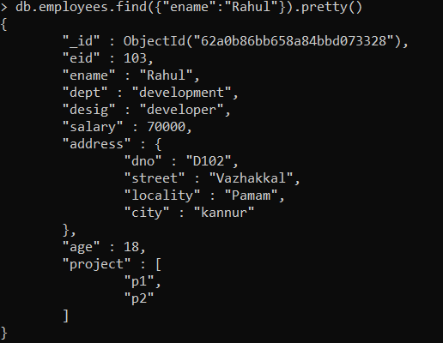

11. db.employees.update({"ename":"Rahul"},{$set:{"contacts":{"email":["rahul@gmail.com"],"phone":[9078564789]}}})

WriteResult({ "nMatched" : 1, "nUpserted" : 0, "nModified" : 1 })

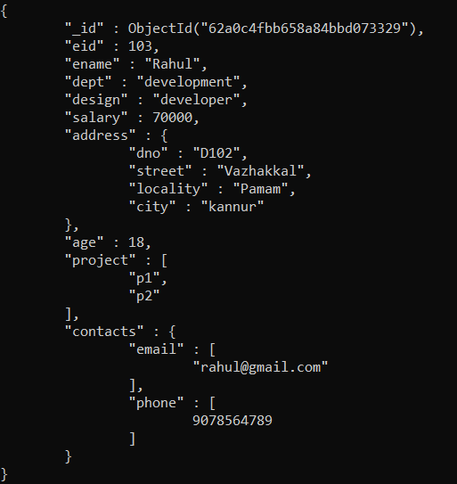

12. db.employees.update({"ename":"Rahul"},{$addToSet:{"contacts.phone":{$each:[7856788968,9876895678]}}})

WriteResult({ "nMatched" : 1, "nUpserted" : 0, "nModified" : 1 })

