**CO2 Lab Assignments**

1. Given an integer i, write a PL/SQL procedure to insert the tuple (i, 'xxx') into a given relation

Hint: CREATE TABLE T2 ( a INTEGER, b CHAR(10))

|  |  |
| --- | --- |
| Create database tbl;  use tbl;  create table details(roll int,name varchar(10));  call name(101);  call name(102);  select * from details;  **PROCEDURE**  CREATE DEFINER=`root`@`localhost` PROCEDURE `name`(roll int)  BEGIN  if(roll=101) then  insert into details values(roll,"sunil");  elseif(roll=102) then  insert into details values(roll,"vyshnav");  end if;  END  **OUTPUT** |  |

1. **W**rite a PL/SQL block to calculate the incentive of an employee whose ID is 110

|  |  |
| --- | --- |
| create database incentive;  use incentive;  create table insc(id int,name varchar(10),target int8);  insert into insc values(101,"sunil",15000);  insert into insc values(102,"vyshnav",20000);  select *,incentive(id,target) from insc where id=101;  **PROCEDURE**  CREATE DEFINER=`root`@`localhost` FUNCTION `incentive`(id int,target int8) RETURNS bigint(20)  BEGIN  declare inscentive int8;  if(target>10000 and target<13000) then  set inscentive=500;  elseif(target>13000 and target<16000) then  set inscentive=700;  elseif(target>16000) then  set inscentive=1000;    end if;  RETURN inscentive;  END |  |

**OUTPUT**

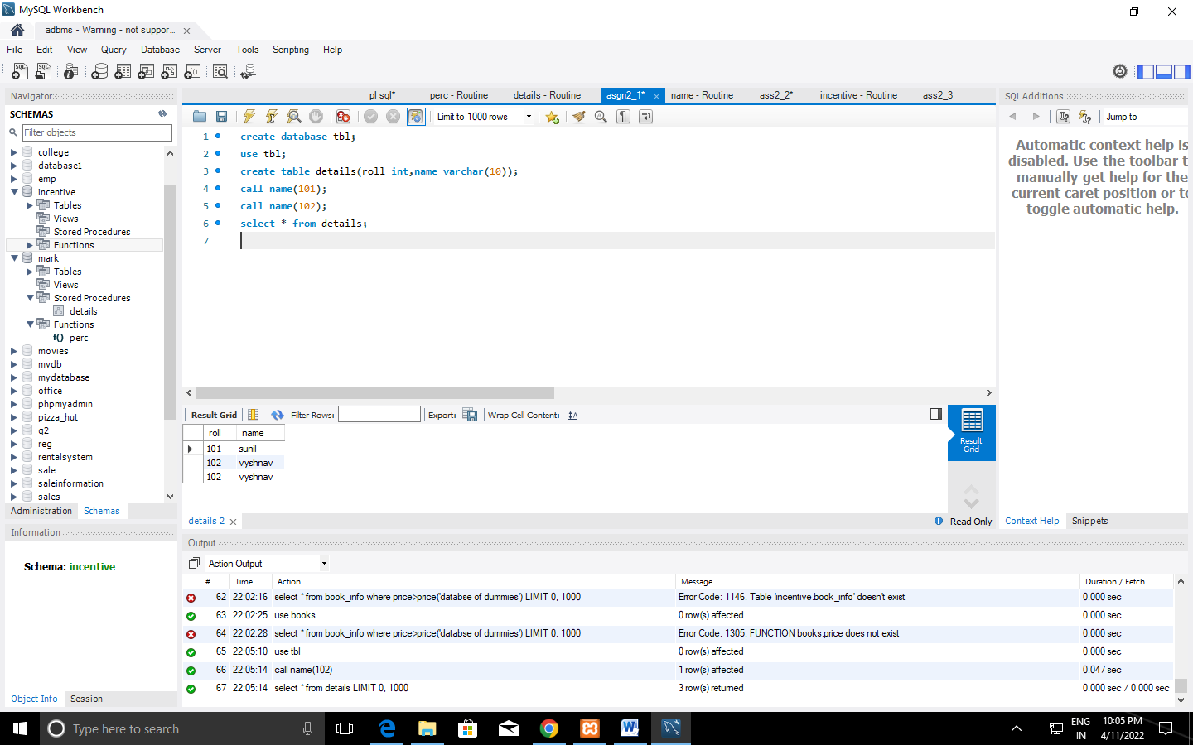

1. Create the Book database and do the following: (Consider the attributes based on the question given)

book(book_name, author_name, price,quantity)

1. Write a query to update the quantity by double in the table book.
2. List all the book_name whose price is greater than those of book named "Database for Dummies"
3. Retrieve the list of author_name whose first letter is ’a’ along with the book_name and price (Explore more about *Like* keyword)
4. Write a PL/SQL Procedure to find the total number of books of same author

create database books;

use books;

create table book_info(book_name varchar (20),author varchar(20),price int,quantity int);

insert into book_info values('randamoozham','MT',300,5);

insert into book_info values('ikigai','hector',500,7);

insert into book_info values('databse of dummies','xyz',250,7);

insert into book_info values('wings of flare','APJ',500,7);

insert into book_info values('oopol','MT',270,3);

select * from book_info;

**OUTPUT**

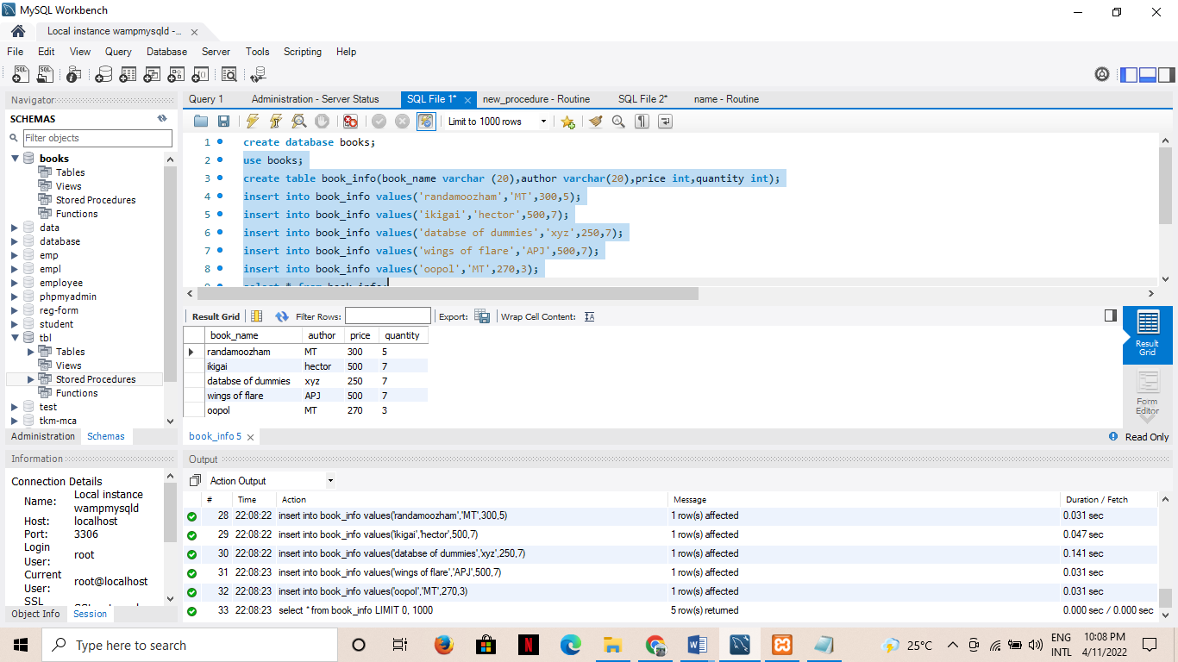

1. set sql_safe_updates=0;

update book_info set quantity=quantity*2;

**OUTPUT**

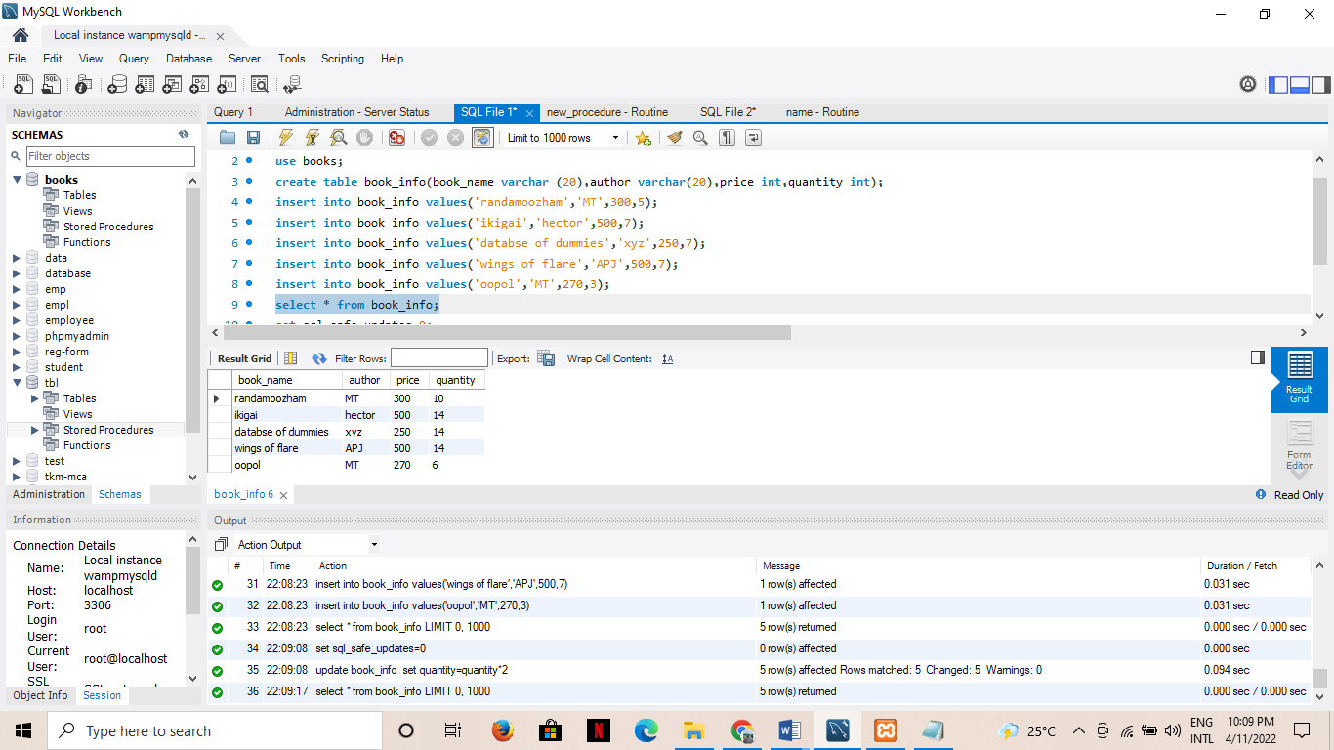

1. select book_name from book_info where price>(select price from book_info where book_name='databse of dummies');

**OUTPUT**

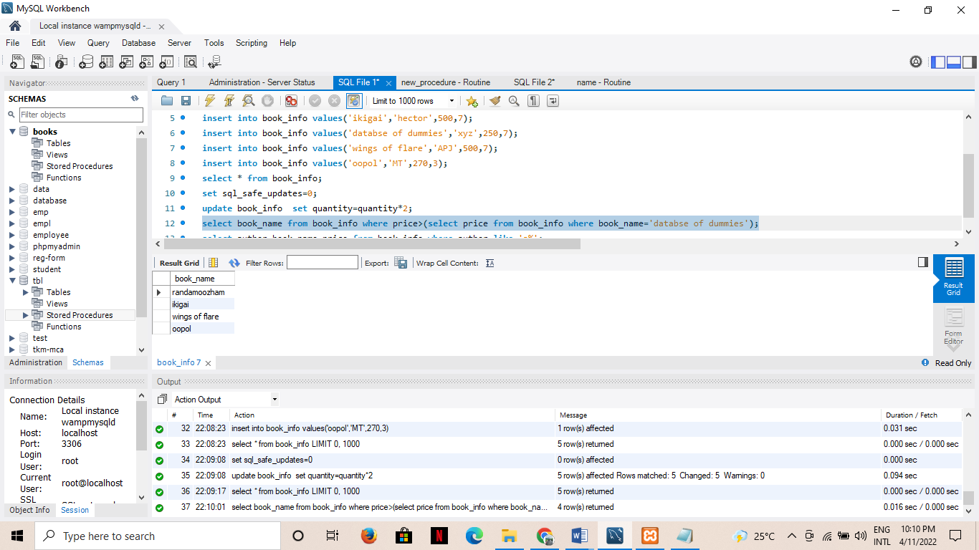

1. select author,book_name,price from book_info where author like 'a%';

**OUTPUT**

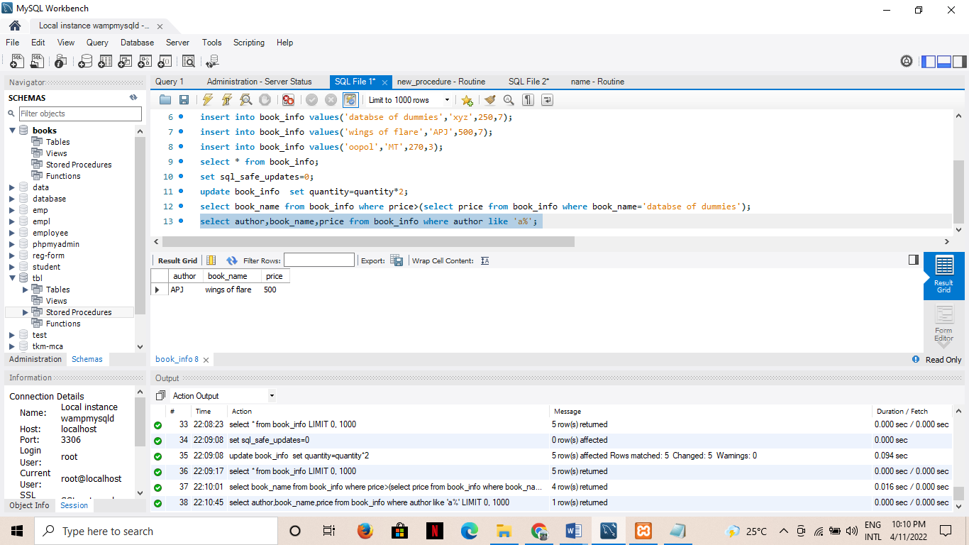

**d)**

**OUTPUT**

4. Create the Company database with the following tables and do the following:

Administration (employee_salary, development _cost, fund_ amount,

turn_over,bonus)

Emp_details (emp_no, emp_name, DOB, address, doj, mobile_no, dept_no, salary).

a. Calculate the total and average salary amount of the employees of each department.

b. Display total salary spent for employees.

c. Develop a PL/SQL function to display total fund_amount spent by the administration

department

**CREATION**

create database company;

use company;

CREATE TABLE Admins(

emp_sal double,

dvlp_cost double,

fund_amount double,

turn_over double,

bonus double);

CREATE TABLE Emp_details(

emp_no int,

emp_name varchar(20),

DOB date,

address varchar(20),

doj date,

mobile_no int8,

dept_no int,

salary double);

INSERT INTO Admins VALUES

(12000,25000,560000,65000,5000),

(70000,55000,860000,15000,1000),

(18000,45000,160000,75000,7000),

(10000,27000,520000,60000,5000),

(18000,27000,360000,35000,3000);

INSERT INTO Emp_details VALUES

(1,"sanal","1999-10-10","Street - 2 xyz","2020-10-10",9865986598,10,12000),

(2,"afy","1997-10-10","Street - 2 abc","2020-10-10",9865986598,10,12200),

(3,"don","1996-10-10","Street nhcjn","2020-10-10",9865986598,11,12500),

(4,"adarsh","1957-10-10","Street jdn","2020-10-10",9865986598,11,17200),

(5,"vyshnav","1948-10-10","gsffj","2020-10-10",9865986598,12,12090),

(6,"shibili","1988-10-10","Snsmk","2020-10-10-",9865986598,12,12050);

**a)** SELECT

dept_no,

avg(salary) 'Average salary',

sum(salary) 'Total Salary'

FROM Emp_details

GROUP BY dept_no;

**OUTPUT**

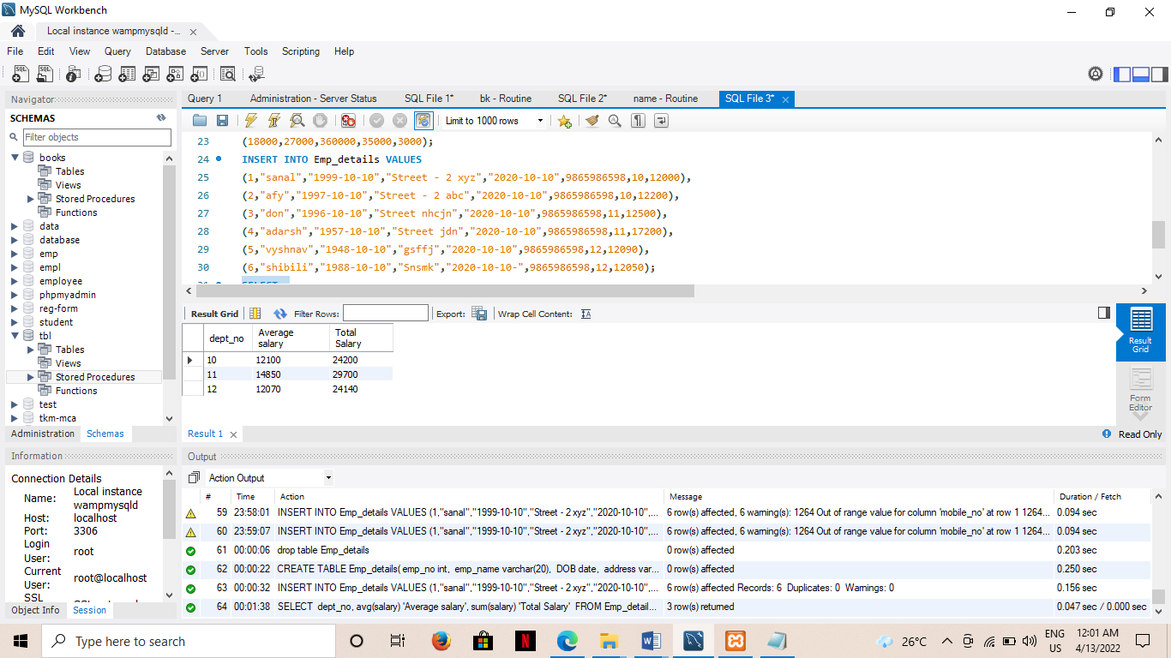

**b)** SELECT

sum(salary) 'SUM OF SALARY'

FROM Emp_details;

**OUTPUT**

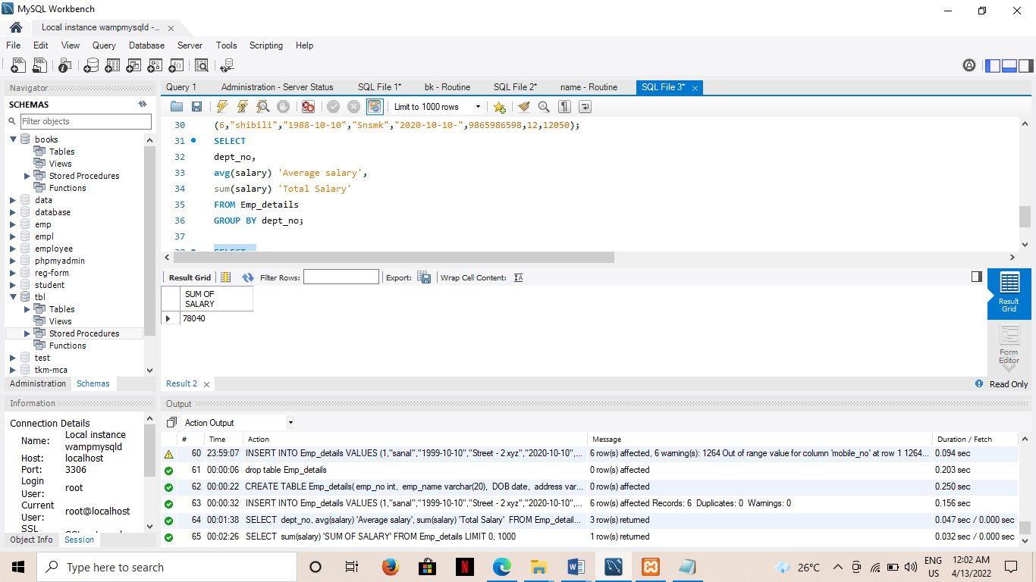

**c)**

**FUCTION**

CREATE DEFINER=`root`@`localhost` FUNCTION `fund_total`() RETURNS double

BEGIN

DECLARE f DOUBLE;

DECLARE i DOUBLE;

SELECT SUM(fund_amount) INTO f

FROM Admins;

RETURN f;

END

**FUNCTION CALL**

SELECT fund_total() from Admins LIMIT 1;

**OUTPUT**

