**LAB ASSIGNMENT DATABASE**

**TKM COLLEGE OF ENGINEERING**

**PROGRAM NO 1:**

1. **Consider the MOVIE DATABASE**

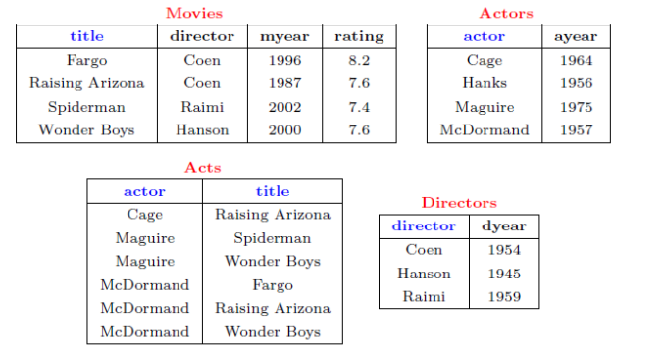

Write following relational algebra queries for a given set of relations.

1. Find movies made after 1997

2. Find movies made by Hanson after 1997

3. Find all movies and their ratings

4. Find all actors and directors

5. Find Coen’s movies with McDormand

**SCRIPT:**

CREATE DATABASE MOVIE;

USE MOVIE;

CREATE TABLE MOVIESS(TITLE VARCHAR(20),DIRECTORS VARCHAR(20),MYEAR INT,RATING FLOAT,PRIMARY KEY(TITLE));

INSERT INTO MOVIESS(TITLE,DIRECTORS,MYEAR,RATING)VALUES('FARGO','COEN',1996,8.2);

INSERT INTO MOVIESS(TITLE,DIRECTORS,MYEAR,RATING)VALUES('RAISING ARIZONA','COEN',1987,7.6);

INSERT INTO MOVIESS(TITLE,DIRECTORS,MYEAR,RATING)VALUES('SPIDERMAN','RAIMI',2002,7.4);

INSERT INTO MOVIESS(TITLE,DIRECTORS,MYEAR,RATING)VALUES('WONDERBOYS','HANSON',2000,7.6);

SELECT * FROM MOVIESS WHERE MYEAR>1997;

SELECT TITLE FROM MOVIESS WHERE DIRECTORS='HANSON';

SELECT TITLE,RATING FROM MOVIESS;

USE MOVIE;

CREATE TABLE ACTORSS(ACTOR VARCHAR(20),AYEAR INT,PRIMARY KEY(ACTOR));

INSERT INTO ACTORSS(ACTOR,AYEAR)VALUES('CAGE',1964);

INSERT INTO ACTORSS(ACTOR,AYEAR)VALUES('HANKS',1956);

INSERT INTO ACTORSS(ACTOR,AYEAR)VALUES('MAGUIRE',1975);

INSERT INTO ACTORSS(ACTOR,AYEAR)VALUES('MCDORMANDS',1957);

SELECT * FROM ACTORSS;

USE MOVIE;

CREATE TABLE DIRECTORSS(DIRECTORS VARCHAR(20),DYEAR INT);

INSERT INTO DIRECTORSS(DIRECTORS,DYEAR)VALUES('COEN',1954);

INSERT INTO DIRECTORSS(DIRECTORS,DYEAR)VALUES('HANSON',1945);

INSERT INTO DIRECTORSS(DIRECTORS,DYEAR)VALUES('RAIMI',1959);

SELECT * FROM DIRECTORSS;

USE MOVIE;

CREATE TABLE ACT(ACTOR VARCHAR(20),TITLE VARCHAR(20),FOREIGN KEY(TITLE)REFERENCES MOVIESS(TITLE));

INSERT INTO ACT(ACTOR,TITLE)VALUES('CAGE','RAISING ARIZONA');

INSERT INTO ACT(ACTOR,TITLE)VALUES('MAGUIRE','SPIDERMAN');

INSERT INTO ACT(ACTOR,TITLE)VALUES('MAGUIRE','WONDERBOYS');

INSERT INTO ACT(ACTOR,TITLE)VALUES('MCDORMAND','FARGO');

INSERT INTO ACT(ACTOR,TITLE)VALUES('MCDORMAND','RAISING ARIZONA');

INSERT INTO ACT(ACTOR,TITLE)VALUES('MCDORMAND','WONDERBOYS');

SELECT * FROM ACT;

SELECT MOVIESS.DIRECTORS,ACT.ACTOR FROM MOVIESS INNER JOIN ACT ON MOVIESS.TITLE=ACT.TITLE;

SELECT MOVIESS.TITLE FROM MOVIESS INNER JOIN ACT ON MOVIESS.TITLE=ACT.TITLE WHERE DIRECTORS='COEN' AND ACTOR='MCDORMAND';

1. SELECT * FROM MOVIESS WHERE MYEAR>1997;
2. SELECT TITLE FROM MOVIESS WHERE DIRECTORS='HANSON';
3. SELECT TITLE,RATING FROM MOVIESS;
4. SELECT MOVIESS.DIRECTORS,ACT.ACTOR FROM MOVIESS INNER JOIN ACT ON MOVIESS.TITLE=ACT.TITLE;
5. SELECT MOVIESS.TITLE FROM MOVIESS INNER JOIN ACT ON MOVIESS.TITLE=ACT.TITLE WHERE DIRECTORS='COEN' AND ACTOR='MCDORMAND';

**Output:**

**1)**

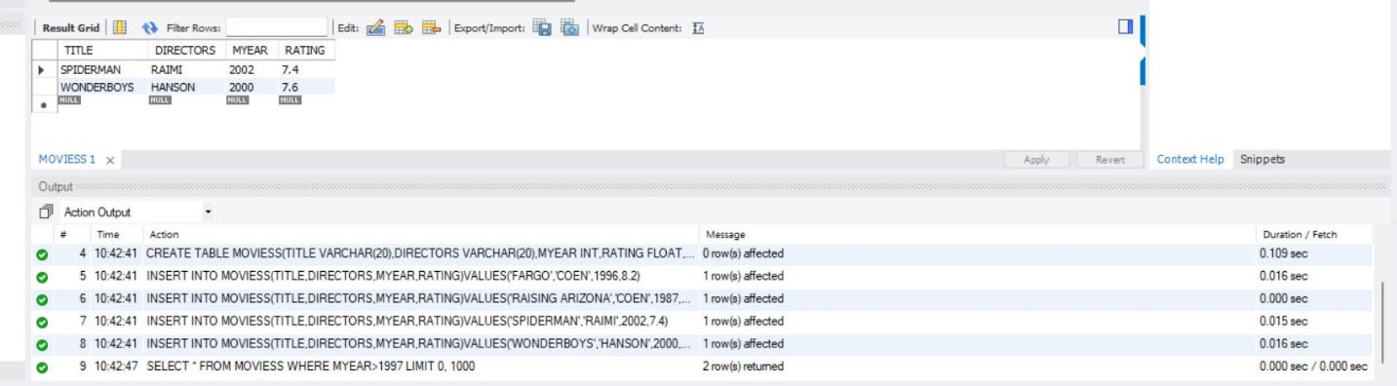

**2)** 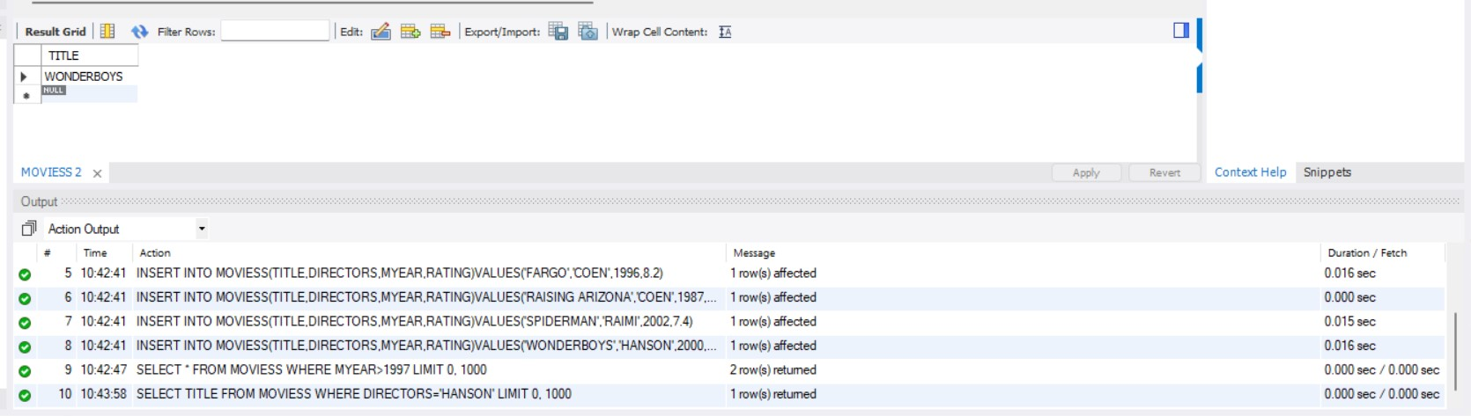

**3)**

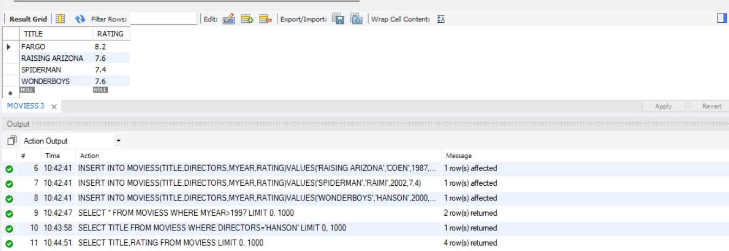

**4)**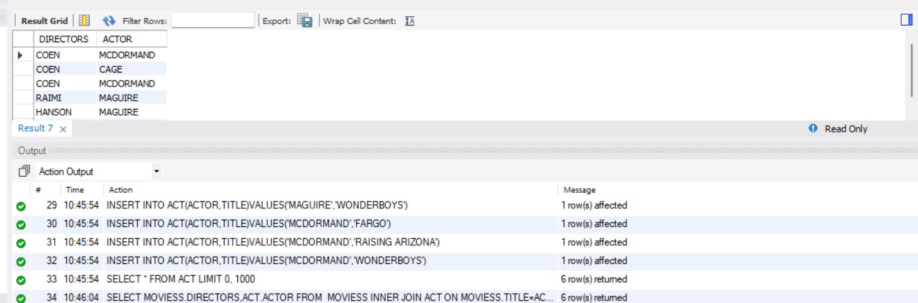

**5)**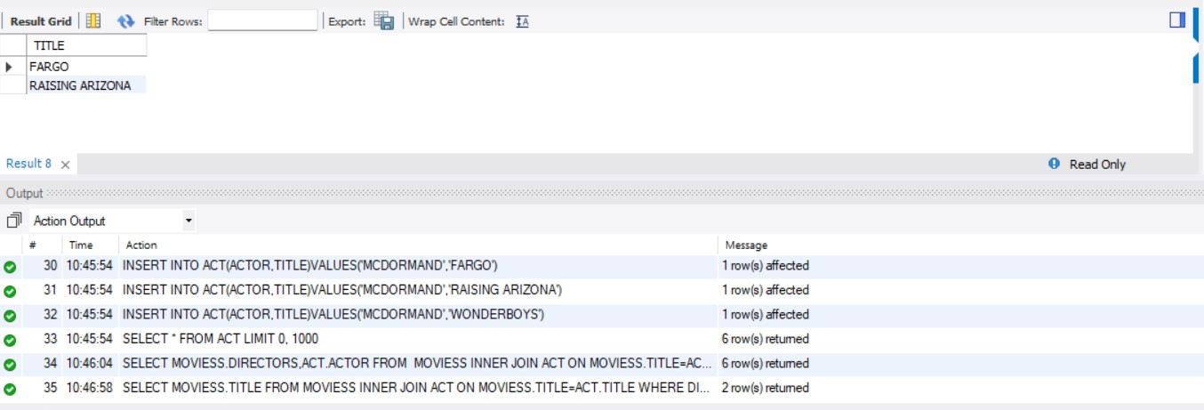

**RESULT:** Output obtained successfully.

**PROGRAM NO 2:**

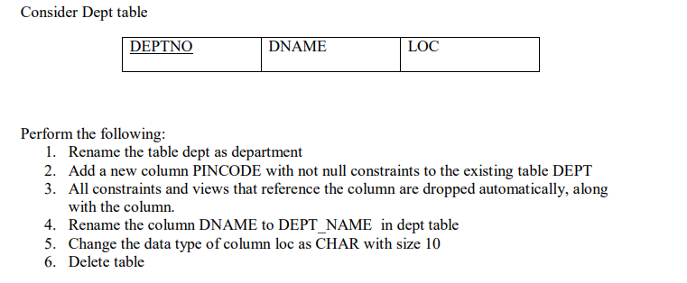

**SCRIPT:**

CREATE DATABASE DEPARTMENTS;

USE DEPARTMENTS;

CREATE TABLE DEPT(DEPTNO VARCHAR(10) NOT NULL,

DNAME VARCHAR(20) NOT NULL,

LOC VARCHAR(20) NOT NULL);

SELECT * FROM DEPT;

SELECT * FROM DEPARTMENT;

RENAME TABLE DEPT TO DEPARTMENT;

ALTER TABLE DEPT ADD COLUMN PINCODE VARCHAR(2) NOT NULL;

ALTER TABLE DEPARTMENT DROP COLUMN PINCODE;

SELECT * FROM DEPARTMENT;

ALTER TABLE DEPARTMENT CHANGE DNAME DEPT_NAME varchar(30);

ALTER TABLE DEPARTMENT MODIFY COLUMN LOC char(10);

SELECT * FROM DEPARTMENT;

USE DATABASENAME;

SHOW TABLES;

DROP TABLE department;

USE DATABASENAME;

SHOW TABLES;

1. RENAME TABLE DEPT TO DEPARTMENT
2. ALTER TABLE DEPT ADD COLUMN PINCODE VARCHAR(2) NOT NULL;
3. ALTER TABLE DEPT ADD COLUMN PINCODE VARCHAR(2) NOT NULL;
4. ALTER TABLE DEPARTMENT CHANGE DNAME DEPT_NAME varchar(30);
5. ALTER TABLE DEPARTMENT MODIFY COLUMN LOC char(10);
6. DROP TABLE department;

**Output:**

**1)**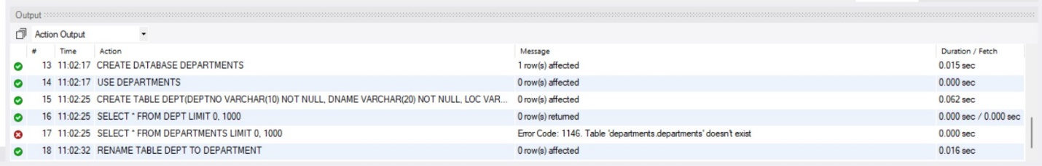

**2)**

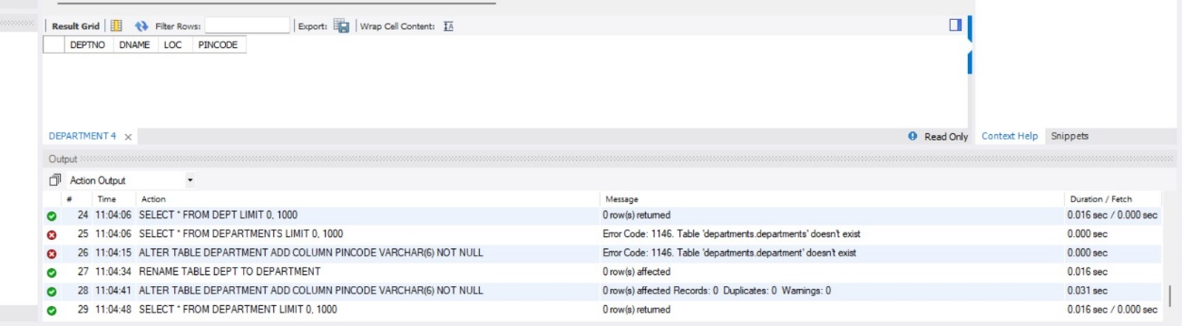

**3)**

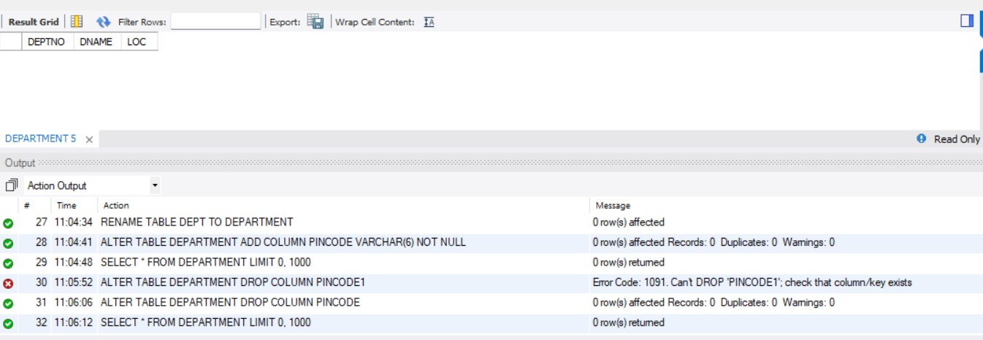

**4)**

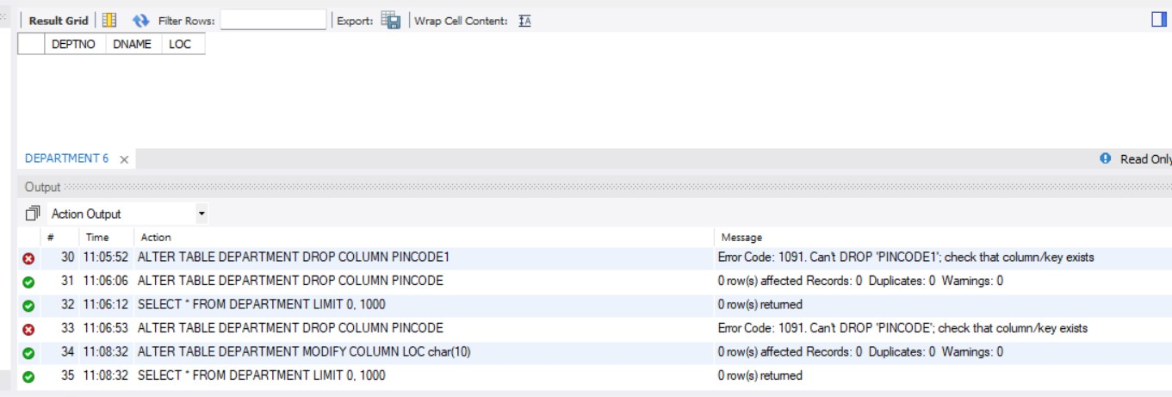

**5)**

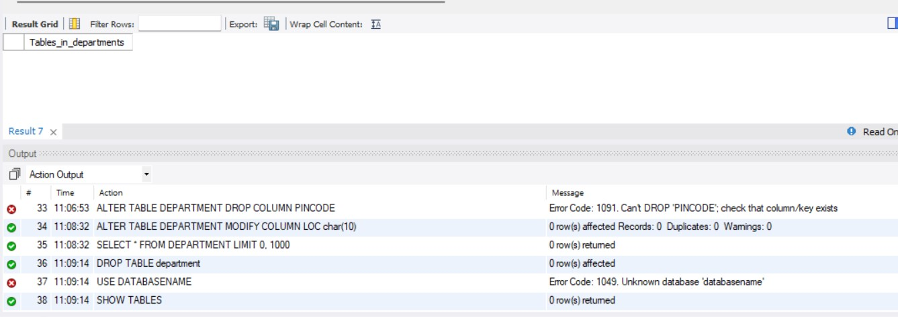

**RESULT:** Output obtained successfully.

**PROGRAM NO 3:**

**Consider Employee table**

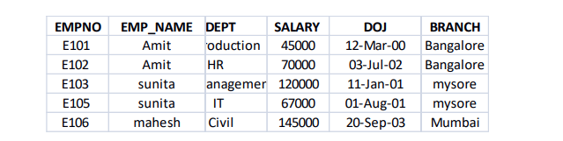

Perform the following

1. Display all the fields of employee table

2. Retrieve employee number and their salary

3. Retrieve average salary of all employee

4. Retrieve number of employee

5. Retrieve distinct number of employee

6. Retrieve total salary of employee group by employee name and count similar names

7. Retrieve total salary of employee which is greater than >120000

8. Display name of employee in descending order

9. Display details of employee whose name is AMIT and salary greater than 50000

**SCRIPT:**

CREATE DATABASE EMPLOYEES;

USE EMPLOYEES;

CREATE table EMPLOYEE(

Empno varchar(5) not null,

Emp_name varchar(20) not null,

dept varchar(30) not null,

salary int not null,

dob date not null,

branch varchar(30) not null

);

insert into EMPLOYEE(Empno,Emp_name,dept,salary,dob,branch)values("E101","Amit","production",45000,"2000-03-12","Banglore");

insert into EMPLOYEE(Empno,Emp_name,dept,salary,dob,branch)values("E102","Amit","HR",70000,"2002-07-03","Banglore");

insert into EMPLOYEE(Empno,Emp_name,dept,salary,dob,branch)values("E103","Sunita","Manager",120000,"2001-01-11","Mysore");

insert into EMPLOYEE(Empno,Emp_name,dept,salary,dob,branch)values("E105","Sunita","IT",67000,"2001-08-01","Mysore");

insert into EMPLOYEE(Empno,Emp_name,dept,salary,dob,branch)values("E106","Mahesh","Civil",145000,"2003-09-20","Mumbai");

SELECT * FROM EMPLOYEE;

SELECT EMPNO,SALARY FROM EMPLOYEE;

SELECT AVG(SALARY) FROM EMPLOYEE;

SELECT COUNT(*)FROM EMPLOYEE;

select COUNT( DISTINCT Emp_name) from employee;

SELECT SUM(SALARY), EMP_NAME,count(*) AS occurence from employee group by Emp_name;

SELECT SALARY FROM EMPLOYEE WHERE SALARY>120000 ;

SELECT DISTINCT EMP_NAME FROM EMPLOYEE ORDER BY EMP_NAME DESC;

select * from employee where Emp_name="Amit" and salary>50000;

**1)** SELECT * FROM EMPLOYEE;

**2)** SELECT EMPNO,SALARY FROM EMPLOYEE;

**3)** SELECT AVG(SALARY) FROM EMPLOYEE;

**4)** SELECT COUNT(*)FROM EMPLOYEE;

**5)** select COUNT( DISTINCT Emp_name) from employee;

**6)** SELECT SUM(SALARY), EMP_NAME,count(*) AS occurence from employee group by Emp_name;

**7)** SELECT SALARY FROM EMPLOYEE WHERE SALARY>120000 ;

**8)** SELECT DISTINCT EMP_NAME FROM EMPLOYEE ORDER BY EMP_NAME DESC;

**9)** select * from employee where Emp_name="Amit" and salary>50000;

**Output:**

**1)**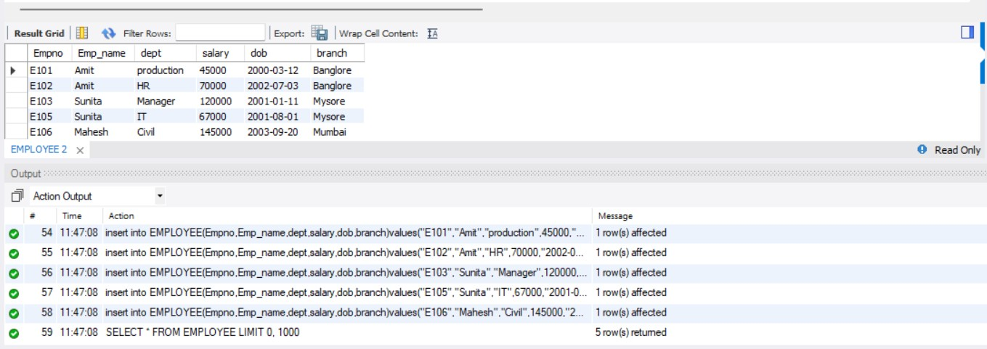

**2)**

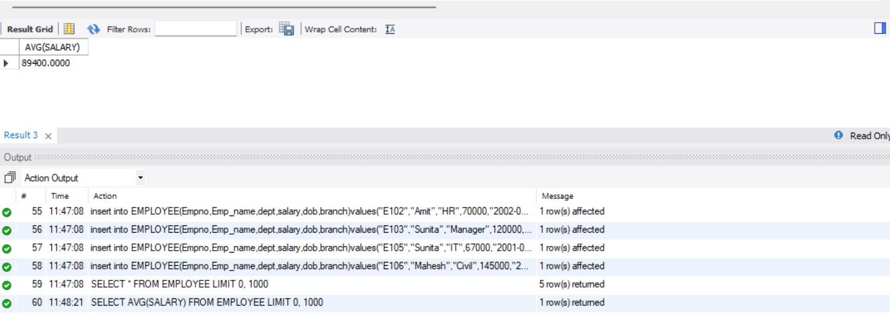

**3)**

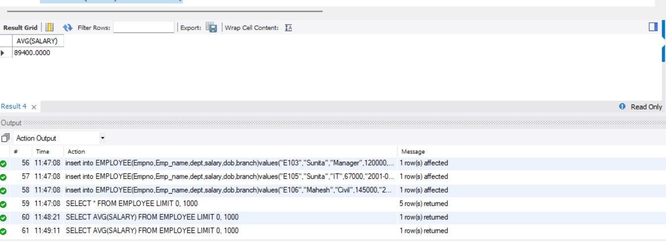

**4)**

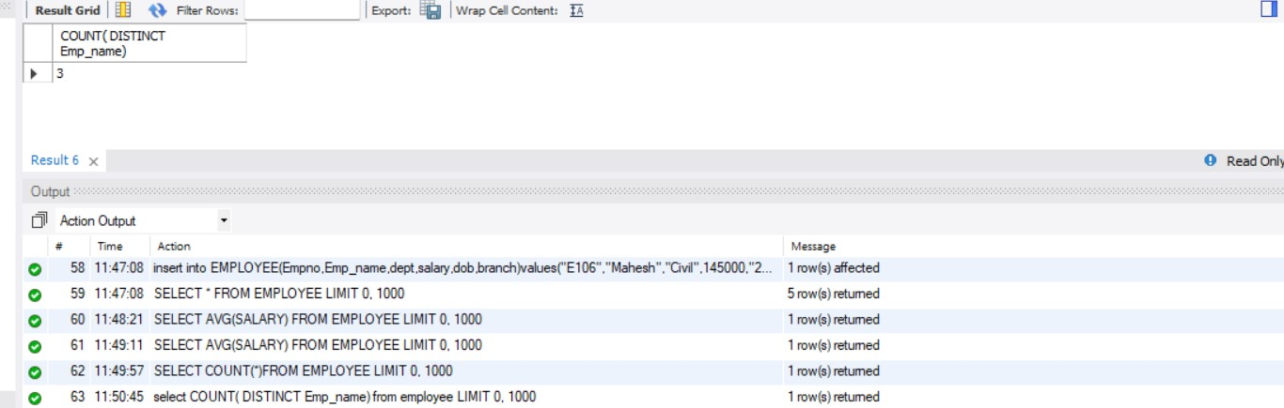

**5)**

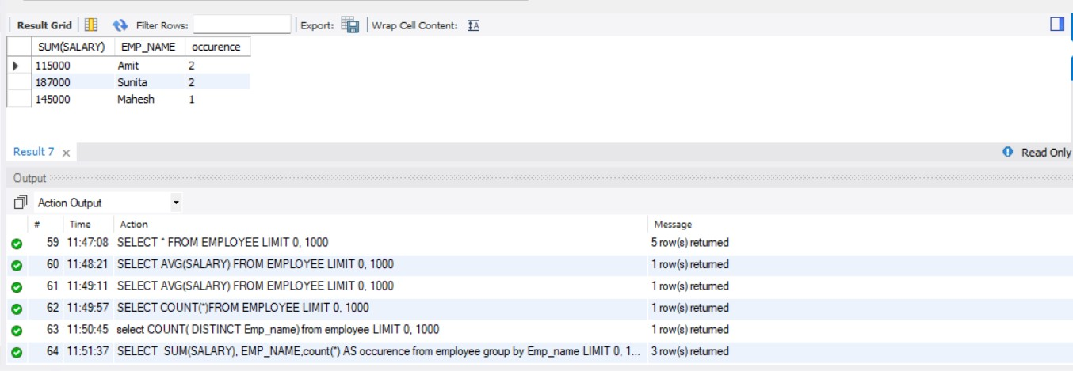

**6)**

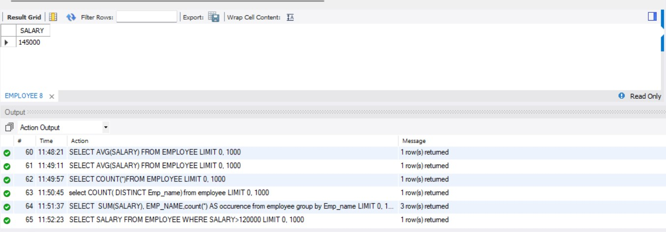

**7)**

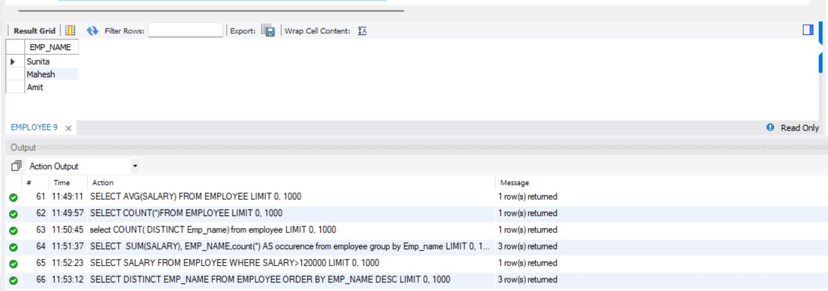

**8)**

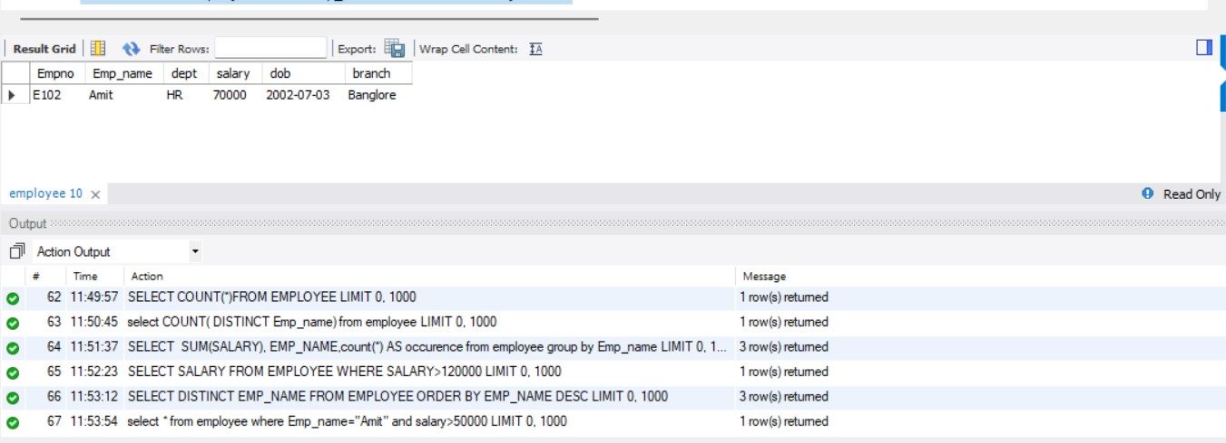

**9)**

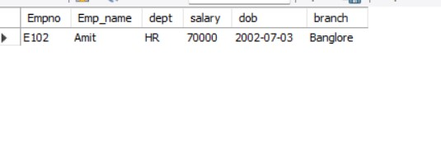

**RESULT:** Output obtained successfully.

**TCL &DCL commands**

**TCL CODE:**

**Script:**

|  |
| --- |
| create database tcl; |
|  |
| create table dept(deptno varchar(20) not null,dname varchar(20) not null,loc varchar(20) not null,primary key(deptno)); |
| insert into dept values("d001","finance","kollam"); |
| insert into dept values("d002","it","ernakulam"); |
| insert into dept values("d003","management","thrissur"); |
| set autocommit=0; |
| insert into dept values("d004","it","kozhikode"); |
| savepoint b; |
| rollback; |
| select *from dept; |
| insert into dept values("d005","finance","kozhikode"); |
| savepoint c; |
| insert into dept values("d006","finance","malappuram"); |
| savepoint d; |
| rollback to c; |
| commit;  **OUTPUT:**    **DCL CODE:** |

|  |  |
| --- | --- |
|  | CREATE DATABASE employee; |
|  | USE employee; |
|  | START transaction; |
|  | CREATE table employee(empno VARCHAR(20) NOT NULL PRIMARY KEY,emp_name VARCHAR(20) NOT NULL,dept VARCHAR(20) NOT NULL,salary INT NOT NULL,dob DATE NOT NULL,branch VARCHAR(20) NOT NULL); |
|  | DESCRIBE employee; |
|  | INSERT INTO employee (empno,emp_name,dept,salary,dob,branch) VALUES ('E101','Amit','Production',45000,'2000-03-12','Bangalore'); |
|  | INSERT INTO employee (empno,emp_name,dept,salary,dob,branch) VALUES ('E102','Amit','HR',70000,'2002-07-03','Bangalore'); |
|  | INSERT INTO employee (empno,emp_name,dept,salary,dob,branch) VALUES ('E103','sunita','Manager',120000,'2001-01-11','Mysore'); |
|  | INSERT INTO employee (empno,emp_name,dept,salary,dob,branch) VALUES ('E104','sunita','IT',67000,'2001-08-01','Mysore'); |
|  | INSERT INTO employee (empno,emp_name,dept,salary,dob,branch) VALUES ('E105','mahesh','Civil',145000,'2003-09-20','Mumbai'); |
|  | SELECT * FROM employee; |
|  | delete from employee where empno="E101"; |

|  |
| --- |
| use employee; |
|  | GRANT DELETE ON employee TO 'heylo'@'localhost'; |
|  | REVOKE DELETE ON employee FROM 'heylo'@'localhost'; |
|  | REVOKE DELETE ON *.* FROM 'heylo'@'localhost'; |
|  | SHOW GRANTS FOR 'heylo'@'localhost';  **OUTPUT:** |